 |  | Automotive Science and Engineering  Journal Homepage: ase.iust.ac.ir |  | 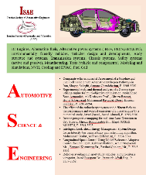
 |  |  | ISSN: 2008-9899

ASE Manuscript Title Should be Short and Informative (Times New Roman 12 Bold)

Author one^{1*}, Author two², Author three³ (Times New Roman 10 Bold)
¹Author one affiliation (Times New Roman 10 Regular)
²Author two affiliation (Times New Roman 10 Regular)
³Author three affiliation (Times New Roman 10 Regular)

ARTICLE INFO |  | A B S T R A C T
Article history:  Received: (Times New Roman 9 Regular)  Accepted: (Times New Roman 9 Regular)  Published: (Times New Roman 9 Regular) |  | Article abstract in maximum of 300 words typed as Times New Roman 10 Regular.  Abstract is a brief summary of the research article. It is used to help the reader quickly ascertain the paper's purpose. Abstract need to conform to a formal structure within a word count of, usually, 250–300 words. The usual sections defined in a structured abstract are the Background, Methods, Results, and Conclusions; other headings with similar meanings may be used (eg, Introduction in place of Background or Findings in place of Results). It is also possible to include additional sections, such as Objectives (between Background and Methods) and Limitations (at the end of the abstract). In the rest of this paper, issues related to the contents of each section will be examined in turn.
Keywords:
Keyword 1 (Times New Roman 9 Regular)
Keyword 2
Keyword 3
Keyword 4
Keyword 5

- Introduction (Times New Roman 12 Bold)
The introduction presents the purpose of the study and its relationship to earlier work in the field.
It should not be an extensive review of the literature. It is usually less than one formatted page.
This will assist in organizing the final structure of the published volume of the journal.
Please check the integrity of the manuscript in a Portable Document Format (PDF) before submission. The journal office may reject your submission if it comes up with problems in its PDF format.

- Approach
Type and label section and subsection headings in the style shown on the present document.
Use numbered sections (Arabic numerals) in order to facilitate cross references.

2.1. Subsections (Times New Roman 11 Bold)
Number subsections and sub subsections with the section number and the subsection number separated by a dot, in Arabic numerals.
Please take note of the following items when proofreading spelling and grammar:

2.1.1. Abbreviations and Acronyms
Deﬁne abbreviations and acronyms the ﬁrst time they are used in the text, even after they have been deﬁned in the abstract. Abbreviations such as ASME, SI, MKS, CGS, sc, dc, and rms do not have to be deﬁned. Do not use abbreviations in the title or headings unless they are unavoidable.

2.1.2. Units
- Use either SI (MKS) or CGS as primary units. (SI units are encouraged.) English units may be used as secondary units (in parentheses). An exception would be the use of English units as identiﬁers in trade, such as 3.5-inch disk drive.
- Avoid combining SI and CGS units. This often leads to confusion because equations do not balance dimensionally. If you must use mixed units, clearly state the units for each quantity that you use in an equation.
- Do not mix complete spellings and abbreviations of units: Wb/m2 or Weber’s per square meter, not Weber’s/m2. Spell out units when they appear in text: . . . a few hernias, not . . . a few H.
- Use a zero before decimal points: 0.25, not .25. Use cm3, not cc. (bullet list)

2.1.3. Equations
The equations are an exception to the prescribed speciﬁcations of this template. You will need to determine whether or not your equation should be typed using either the Times New Roman or the Symbol font (please no other font).
To create multileveled equations, it may be necessary to treat the equation as a graphic and insert it into the text after your paper is styled. Number equations consecutively.
Equation numbers, within parentheses, are to position ﬂush right, as in (1), using a right tab stop. To make your equations more compact, you may use the solidus ( / ), the expunction, or appropriate exponents. Italicize Roman symbols for quantities and variables, but not Greek symbols. Use a long dash rather than a hyphen for a minus sign. Punctuate equations with commas or periods when they are part of a sentence, as in
$α+β=γ$ (1)
Note that the equation is centered using a center tab stop.
Make sure that the symbols in your equation have been deﬁned before or immediately following the equation. Use (1), not Eq. (1) or equation (1), except at the beginning of a sentence:
Equation (1) is . . .

- Method
The procedures are brief but sufficiently complete to permit a qualified reader to repeat the experiments and the methods. Only truly new procedures should be described in detail. Previously published procedures should be referenced. Modifications of previously published procedures should not be given in detail except where necessary to repeat the work. If the study characterizes the activity of new compounds, compound structures must be provided.

4. Results
The results should be presented in figures, tables, or text. Figures (e.g. Figure 1) and tables (e.g. Table 1) are displayed in order after the main article text. Figure and table legends will appear immediately after the corresponding figure or table. References must be cited in text by number only, such as [1–3]. References are to be numbered consecutively in the order of appearance, and must include article titles, as in the examples.

We suggest that you insert a table to inset a Graphic (which is ideally a 300 dpi TIFF or EPS ﬁle, with all fonts embedded) because, in a document, this method is somewhat more stable than directly inserting a picture.
Figure 1: Figure caption (Times New Roman 10 Regular)

Place figures, tables, and photographs in the paper near where they are first discussed, rather than at the end, if possible. Color illustrations are discouraged, unless you have verified that they will be understandable when printed in black ink. Larger figures and tables that will need the whole width of the page should be located at the top or at the bottom of the page in order to stop interfering with the normal flow of the text as in the example Figure 2.

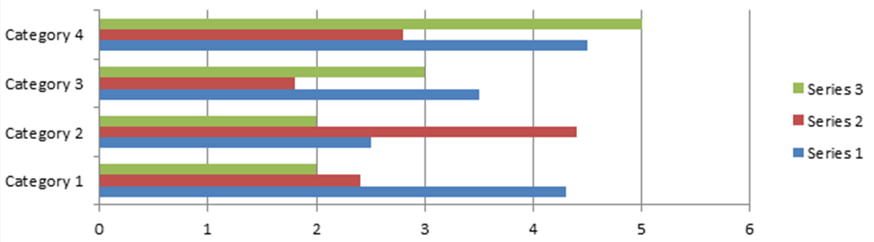
Figure 2: Place larger figures and/or tables at the top or bottom of the page

Provide a caption for every illustration; number each one sequentially in the form: “Figure 1. Caption of the Figure.” “Table 1. Caption of the Table.”
Type the captions of the figures below and tables above the body, using 10 point text.
Within the text and for figure and table captions use “Figure” and “Table” instead of “Fig.” and “Tab.”.
Make sure that the tables appear without the intermediate grid lines as is presented in the following sample Table 1.

Table 1: Table caption (Times New Roman 10 regular)
T(^{ᵒ}C) | E(MPa) | ν | $$σ_{y}(MPa)$$ | α(×10⁻⁶/^{ᵒ}C)
24 | 213 | 0.295 | 423 | 9.91
230 | 201 | 0.307 | 424.5 | 10.79
>450 | 170 | 0.321 | 291.2 | 11.27

- Discussion
The discussion is concise (usually less than two formatted pages) and focused on the interpretation of the results. It should not repeat information in the “Results” section.

- Conclusions
A conclusion section is required. Although a conclusion may review the main points of the paper, do not replicate the abstract as the conclusion. A conclusion might elaborate on the importance of the work or suggest applications and extensions.

Declaration of Conflicting Interests
The author(s) declared no potential conflicts of interest with respect to the research, authorship, and/or publication of this article.

Acknowledgements
The author(s) disclosed receipt of the following financial support for the research, authorship, and/or publication of this article: This section may include funding sources, brief note(s) of thanks to people who helped with the study or preparation of the paper (optional), and database names and accession codes (if applicable).

List of symbols (Optional)
The list of symbols comes after the acknowledgment and before references. The English symbols come first followed by the Greek symbols. Both must be typed in alphabetical order and separated.

$E$ | Modulus of elasticity
$k$ | Stiffness
$p$ | Acoustical pressure
$p_{0}$ | Amplitude of the excitation plane wave
$p_{b}$ | Blocked pressure
Greek symbols
$σ$ | Flow resistivity
$τ$ | Tortuosity

References
References must be numbered in square brackets and be listed in the list of references in the order that they are referred to in the text. To be compatible with journal format, type in all author names. Do not refer to co-authors as el al. (Times New Roman 11 Regular). The complete details of the references will appear in the list of references.
For journal papers, books and conferences papers use the following formats;
[1] A. Ekberg, E. Kabo, H. Andersson, An engineering model for prediction of rolling contact fatigue of railway wheels, Fatigue & Fracture of Engineering Materials & Structures, Vol.1, No.3, (2002), pp.899-909.
[2] A. Ekberg, E. Kabo, H. Andersson, An engineering model for prediction of rolling contact fatigue of railway wheels, Fatigue & Fracture of Engineering Materials & Structures, Vol.1, No.3, (2002), pp.899-909.
[3] A. Ekberg, E. Kabo, H. Andersson, An engineering model for prediction of rolling contact fatigue of railway wheels, Fatigue & Fracture of Engineering Materials & Structures, Vol.1, No.3, (2002), pp.899-909.
[4] H. E. Mazin and W. Xu, “Harmonic cancelation characteristics of specially connected transformers” Int. J. Electric Power Systems Research, Vol.79, No.12, (2009), pp.1689-1697.
[5] A. Ekberg, E. Kabo, H. Andersson, An engineering model for prediction of rolling contact fatigue of railway wheels, Fatigue & Fracture of Engineering Materials & Structures, Vol.1, No.3, (2002), pp.899-909.
[6] Rail Accident Report by RAIB, Derailment at Princes Street Gardens, Edinburg, 27 July 2011.
[7] Cornell Fracture Group, Cornell University, http://www.cfg.cornell.edu.
[8] B.A. Ogunnaike, W.H. Pay, Processes, dynamics, modeling and control. Oxford University Press, Oxford (1994).

