The Identity of the Early Qajarid Architectural Decoration and its Sources
From the Beginning to the End of Fath Ali Shah Period (1785-1834)
M. Zandieh^{1,*}, A. Fahimi Far², I. Khaleghi 3, F. Mohammadi

Abstract
The Qajar dynasty was a time of civil wars as well as the wars against Russia, meanwhile, Qajarid Shahs, understanding the power of sublime art both in internal and external political relations, tried to expand and renew the style of the mural decorations which is the issue of this article. Increasing the relations with European countries like England and France, Fath Ali Shah and his court were influenced by European diplomacy, culture and art. Also they were deeply inspired by pre-Islamic royal and artistic concepts and styles. Early Qajarid murals were the obvious return to tradition; this study tries to identify the sources and socio-political reasons that lead to this movement.
In the other hand, realizing the function of the mural decoration and political determination of the king and his court in early Qajarid period, which moved away from the common Zand theme and function (the Persian former dynasty) and followed the imperial art of the Achaemenid and Sasanid eras, can explain their formation of historical compositions and majesty of their artworks. By the seventeenth century, as a result of extended contacts with Europe the unfamiliar tradition of painting in oil on canvas was gaining currency among Persian artists. Although the medium was borrowed from European painting, the style remained largely indigenous. The influence of imperial Sassanian and Achaemenid themes also appeared on the carved figural reliefs. Mural decoration and art were led to serve political affairs in order to legitimise the Qajar dynasty.

Keywords: Mural Arts, Architectural Decorations, Oil Peinting, Iran, Qajar Dynasty, Agha Muhammad Khan, Fath Ali Shah,

1. Introduction
The Qajar dynasty came to power after the Zand rulers. During this period Persia witnessed some of its most decisive changes, mainly originating from international developments. The rise of the Qajar dynasty brought to an end a long period of political instability that characterized eighteenth-century Persia. During this period Persia was influenced by European diplomacy, frightened by its armies, and fascinated by its culture and artistry. As a result of drastic socio-political and cultural alteration during the Qajar period, art emerged with a new style and theme. The impact of Europe on Qajarid architecture is identifiable more in the façade and murals rather than internal planning and function.
Early Qajarid murals occurred in three media:-rock relief, wall painting and painted tile. The majority of painting during the Fath Ali Shah period is executed at life size an important aspect in assessing the development of early Qajarid art.
This study aims to identify the cultural and artistic of the early Qajarid mural decoration and its sources.
Qajarid mural decoration and painting has been studied by relatively few scholars, but these include Zoka, (1963& 1970), Diba (1989), [1], [2], [3], [4], [5], [6], [7], [8], Sharifzadeh (1994a; 1994b), Najmabadi (1999), [9], and [10]. Some of these examinations have focused on European influence on Qajar art, but in general these mainly analyse Qajar art in technique without specific focus on the environmental factors. Most focus on Qajarid painting rather than mural decoration. Close studies of Qajarid mural decoration have not been carried out.
As a result, much of the Qajar artistic legacy was destroyed during the Pahlavi period, including the Tekkie-Dowlat, (The amphitheater of government) which was destroyed between 1946 and 1949. Another victim was the Emarat-e Nu palace in Isfahan with mural paintings signed by Mihr-Ali, as well as other governmental and private buildings [10], [11], [12].
Because of destroying or changing the original shape of much early Qajarid building much of the royal mural decoration and wall painting was destroyed, badly damaged or displaced (figs. 1 & 2). This study has therefore focused on surviving wall paintings or those which are displaced and now preserved in different museums or private collections.

2. Cultural and socio-political environment
During the Qajarid period Persia underwent drastic changes in its cultural and socio-political environment. The role of cultural factors in developing Persian mural decorations particularly apparent during the Qajarid period. The sources were varied and redefined under the intensive influence of Europe, which opened up an absolutely new phase in Persian architecture and mural decoration. Reform of the cultural environment imposed new characteristics and styles.
Due to its strategic position, foreign powers such as Russia, Britain and France tried to dominate Persia politically, economically and culturally. European encroachment upon Persia first came in the form of conquest and the creation of spheres of influence by rival European powers.
The negative effect of defeat by foreigners is traceable not only in art, architecture and mural decoration but also in many different aspects of Persian life. The war with European powers, particularly Russia, was not conceived simply as a military campaign. Indeed, it was seen as a confrontation between Persian civilization and Europe. Consequently, military defeat accelerated modernization [13]. The social structure of modern Persia took shape in the Qajarid period. The pattern of social and cultural advancement established over a century of development had a profound influence on art. The process of modernization was accompanied by foreign political penetration and a reduction of national self-confidence. The gradual domination of European cultural and artistic values was seen as a national humiliation. The modernization of Persia is widely held to have been started by Abbas Mirza the Crown Prince of Fath Ali Shah [14], [15]. This changed the traditional social, commercial and political climates and led art in new directions. Modernization of art, architecture and mural decoration and painting which had begun during the Safavid period continued to the Qajarid period.
Despite the effects of Europe the early Qajarid School discarded the European style and favoured native traditions. So the court of Fath Ali Shah still followed the traditional concept in terms of politics, culture and art.
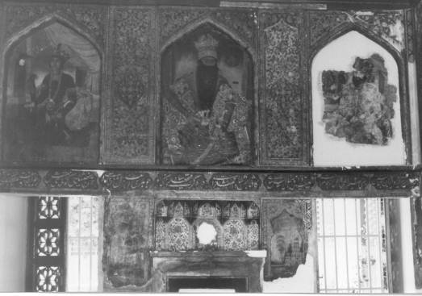
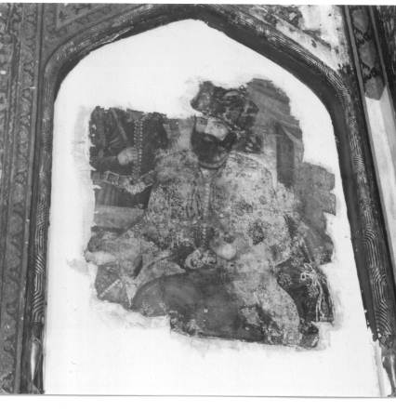
Fig.1&2. A view in the Golestan palace naqhashi khaneh building, showing fragmentary wall paintings dating to the first half of the 19th century. Oil on plaster. Photograph by the author.

3. Art Movement
After the long period of the 18th century in which Persia suffered from invasion and no remarkable architectural projects were produced [2], the rise of the Qajar powers initiated architectural projects and the production of art and mural decoration throughout the country. Qajar wall paintings and mural decorations, like the setting for which they were designed, conveyed a sense of grandeur and opulence. Visitors approached these images through a series of ceremonial spaces, courtyards, gardens and gateways. In this matter early Qajarid art followed pre-Islamic art. Just as Achaemenid or Sasanid art expressed the glories of the Shah and the court the art of Fath Ali Shah functioned in the same way. Images were designed to be viewed from a suitable distance; proportions were elongated, features highly stylised, colours saturated, patterns multiplied, and jewelled effects achieved with gilding, built-up gesso and lacquer. In royal residences painting functioned as units with a rich array of decorative programmes. The number of units per cycle varied according to the format and height of the rooms in which they were located. Open porches (talars) were embellished with three-part cycles; interior spaces, with four part cycles; and polygonal pavilions, most commonly, with eight-part cycles. The impact of each individual painting in a cycle was increased by complex geometric schemes combining different shapes and materials [1].
The Qajar School reached its zenith during the Fath Ali Shah period after which it was transformed by the impact of European art. Early Qajarid art emerged as a result of the patronage of the Qajar king and the royal court [5], [16], [17]. Zand art had been confined to Shiraz, then the capital, whereas the Qajarid school spread across the country. Zand art may be seen as a local school while Qajarid art became national. This achievement was a consequence of Qajar political policy. In contrast to Karim Khan who modestly called himself vakil al roaya (regent) Fath Ali Shah called himself shahanshe (King of Kings). Emulating the Persian kings of antiquity he ordered the personal Shahname which included an exaggerated account of his battle with Russia. Unlike the Zand ruler, who left Mashhad, the centre of the Kurasan province, to Nader’s son because of his respect for Nader, the Qajar rulers spread their political domination by a specific policy called barname Qajari sazy-e Iran (the domination of Iran by the Qajar family). They spread their family network across different parts of Persia and appointed princes to local government [18], [19]. This policy created powerful princes with a more or less similar cultural and artistic backgrounds, tastes and attitudes which made a structure in which Qajarid art became national art. Here we are dealing with Qajarid art as an absolutely royal expression. Agha Muhammad Khan and Fath Ali Shah aimed at the revival of imperial pre-Islamic glories through their imperial art. The objective was to revive traditions but weakness in the cultural sources led early Qajarid art to become an imitator of traditions rather than creative in its own right. As long as Fath Ali Shah intended to restore ancient Persian political supremacy he made use of art as a vehicle leading to an essential similarity between early Qajarid and imperial Sasanid or Achaemenid murals and friezes.
Here we have considered mural decorations in royal and secular buildings rather than religious places. Mural decoration in religious buildings tended to follow past traditional patterns without remarkable evolution. According to [20] religious tile- work declined in comparison with Safavid or Timurid work (fig.5). Hence the Qajarid style is observable chiefly in wall paintings and decoration in secular buildings.

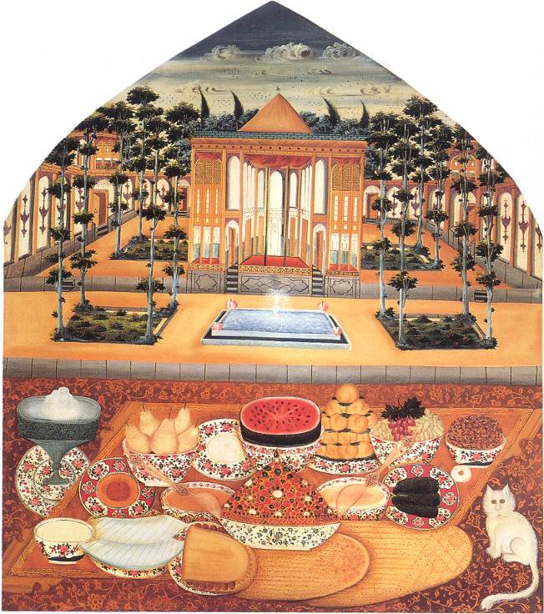
Fig.3. A wall painting dated to the first half of the 19th century by Mirza Baba, showing an idealized still life and landscape. The pavilion has a talar set in a formal garden. A picnic is laid out in the foreground.
Size, 152.5 x 135 cm. Private collection.
Retrieved from the Internet.

Note: Still life and landscape was introduced into early Qajar mural in the eighteenth century. This genre which is familiar in European painting may be traced back to Roman and even Greek art. In the west still life with landscape came into prominence after the renaissance. Since there is no sign of such work in the Persian tradition this development was evidently derived from the influence of Europe. Mirza Baba painted the best existing examples of still life with landscape in the late eighteenth century. Once introduced the composition including still life in the foreground with landscapes in the middle ground and far distance evolved very little in the course of the following century. Despite the European influence however the work has found Persian character. Such works were most used for reception rooms and garden pavilions.
In this figure the tablecloth is covered with the foods served as asrane (the food which was eaten in the afternoon). Such wall paintings decorated specific places such as houzkhane, where such meals were taken.

4. Function
Following the political determination of the king and court, early Qajar art moved away from the common Zand theme and function and followed the imperial art of the Achaemenid and Sasanid eras. This led to the formation of historical compositions and gave majesty to artwork. Hieratic posture and formality with increasingly bold ornamental patterning replaced the informal poses, and the subtler decoration of the Zand style. The uniformity required by the court may be seen in innumerable static compositions balancing vertical and horizontal elements in which the subject is framed in open windows or arches within minutely patterned interiors. The hieratic stylisation of painting of the early Qajarid School marked a decisive break with the neo-Safavid style of the Zand period [1]. While traditional art was commissioned to express the service of God, early Qajarid court art sought to meet the ruler’s personal desires. It moved away from Islamic objectives towards imperial pre-Islamic art. “God is centred in Persian Islamic art” wrote Pope in 1965 with the Safavids in mind. In contrast the real character of the Fath Ali Shah is manifest in large-scale portraits in the European tradition (fig. 19). These large and more formal portraits executed by the royal painters such as Mirza Baba, Mihr Ali, and Abdullah Khan probably hung in the audience halls or official rooms of royal residences. Qajar painting was primarily required to glorify the Qajar rulers and enhance the splendour of their surroundings. In addition to portraits of the monarch, portraits of the previous kings and legends and portraits of princes and lesser nobles were also executed. Dynastic imagery, as inherited in mural decoration and mural painting were the roots of both the archaising movement and of European royal portraiture. The sheer numbers of the participants and the constant repetition of images in decorative cycles evoke the collective and tribal nature of Qajar society [21], [1], [4]). The principal themes of the early Qajar School including the pictures of Royalty, noblemen, hunting scenes, battle, and enthronement- all reflecting court life. They also provide sensual images of the harem. ([8]; [43], [44], [45] & [46].

5. The source of early Qajarid mural decoration and art
Three main sources contributed to early Qajarid art in the pre –Islamic, Safavid- European and Zand conventions. The Zand style influenced early Qajarid art through the transfer of royal Zand painters to the Qajarid court [10]. However during the reign of Fath Ali Shah the style changed and gradually found its own character in technique and subject matters. According to [1], it evolved stylistically from the simpler Zand conventions to the imperial idiom.
Europe was another main source of inspiration for early Qajarid murals. The art of this period shows a tendency to experiment with new media and styles. European models are not imitated; rather they are assimilated into traditional artistic values. By comparison with the Safavid- European style period early Qajarid art was less dependant on European elements. However in the context of increased contact with Europe, early Qajarid mural painting moved towards European models. Their influence particularly appeared in the mural decoration of the courts of Abbas Mirza in Tabriz. The influence of Europe in the court of Abbas Mirza was more intensive than in the court at Tehran. The influence of Tabriz in the province of Azarbaijan, was close to the Russian border with its new rail connection to St. Petersburg (fig.4) [2]. The intensive Russo-European style is more evident in Tabriz than in the court of Fath Ali Shah in Tehran.
Clear reflections of late 18thcentury European court style appear in early attempts to unify the décor of the royal palace in Tehran. In the decorations, with stucco the so-called Italian gach style –was used, either gilded or painted the colour of lapis lazuli. European influences appear in the mural painting and decoration of buildings such as the Golestan Palace, Negarestan, and in the Sulamaniya of Karaj [21].
Both two- and three-dimensional representation were common to art of this period. However, much early Qajarid work was indifferent to naturalistic perspective and documentary techniques.
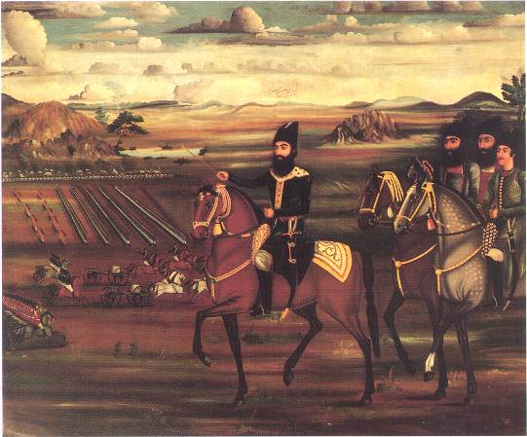
Fig.4. A painting from Tabriz dated to the early 19th century showing Abbas Mirza on campaign. Signed by Allahverdi. Oil on canvas, 125 x 186 cm, now in the Hermitage Museum. After [1].

Note: This large painting was used as a mural originating in the court of Abbas Mirza in Tabriz and now in the Hermitage Museum. The series of such works demonstrate European artistic impact more clearly any other works of Fath Ali Shah’s reign. Allahverdi Afshar, who worked for Abbas Mirza in Tabriz was the artist- the only painter from this court whose name is known.

This work was influenced by both Persian and European traditions. Abbas Mirza is represented at the centre of the picture and the face of the princes is depicted in three-quarter view as in Persian tradition. This also clearly shows the painter’s facility with European techniques such as three dimensionality and demonstrates his remarkably strong sense of colour. Although differing degrees of colour have been used, achieving natural space perspective, the conception of space is still Persian. In accordance with the traditions of Persian painting the different stages have been superimposed.
The common frontiers of Persia and Russia allowed European cultural and artistic influence to infiltrate. It is no accident that a large number of intellectual politicians and artists such as Akhoond Zahed, Taghi Zadeh and Talebof from this area influenced art. Tabriz turned into one of the main centres of intellectual and artistic activity [15], [22]. The war between Persia and Russia was also a point of western impact. Abbasa Mirza, (1789-1833) the crown prince lived in Tabriz as governor of Azarbaijan. From there he led the Persian military campaigns against Russia in the course of the Perso-Russian war of the early nineteenth century [18]. For this reason Tabriz played an important role in absorbing European culture politics and art. In the late Qajarid period a political movement from Tabriz led the party promoting constitutional revolution to victory [23].

6. Agha Muhammad Khan period (1785-1798)
Agha Muhammad Khan, founder the Qajar dynasty, was kept busy with political affairs such as the war against Russia and internal rebellions. His patronage was limited. Two monumental wall paintings dating from 1796, survives from the Agha Muhammad period in the Chehel Sutun (Forty Column) pavilion in Isfahan. The victory of Nadir Shah over the Mughal king at Karnal and the battle of Shah Ismail and the Ottomans are depicted in comparable styles and format. These pictures were added to four existing monumental images of feasting and fighting that decorated the reception hall of the palace (figs. 6&7).
Fig.5. Detail from tile work of the Agha Bozorg seminary, Kashan, dated to the first half of the 19th century. Photograph by the author.
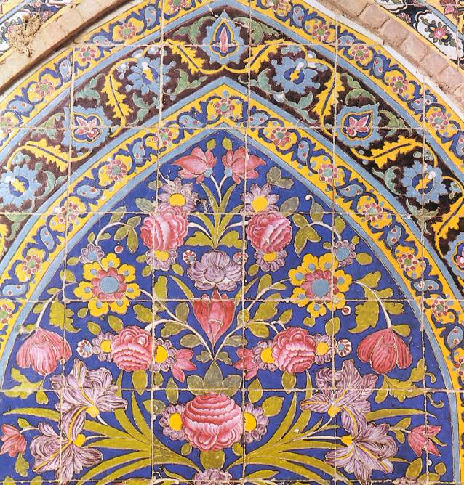

Note: by comparison with Safavid and Timurid tiles some changes are evident here. The predominant pure colour was changed to yellow. The abstract shape of the flowers in the previous periods was replaced by more naturalistic forms. A lot of pink and rose-colour was used.

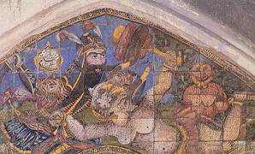
Fig.6. Wall painting from the old public bath dated to the late 17th or the early 18th century showing Rustam killing the Dive-e sefid (the white Devil). Photograph by the author.
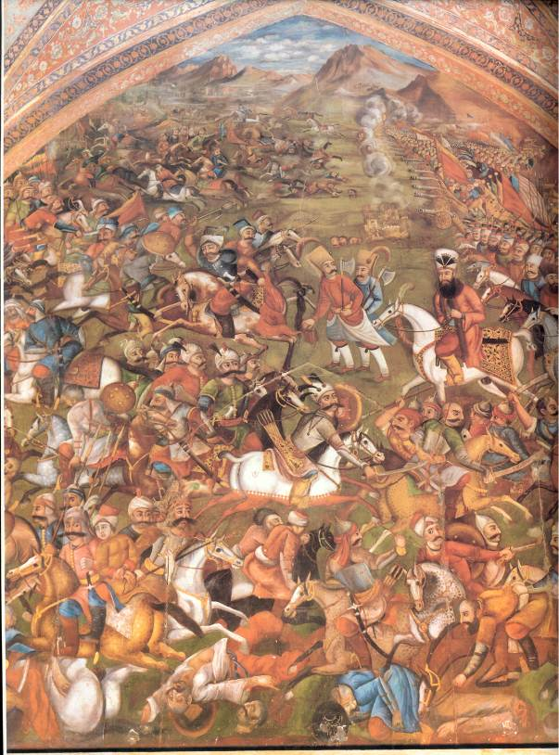
Fig.7. Wall painting signed by Sadiq, dated 1796, in the Chehel Sutun pavilion in Isfahan, showing the triumph of Shah Ismail over the Ottomans. Oil on plaster.

Note: Although The European features of style, shading, modelling, drapery, and perspective are recognizable the subject remains unmistakably Persian. Following the art of previous dynasties Agha Muhammad cleverly required identification of Qajar rule with that of heroic figures of kings such as Shah Ismail and Nader Shah and legendary heroes such as Rustam. According to the report of James Morier, who visited Agha Muhammad’s citadel palace in Astrabad in 1815, battle scenes of the national Persian heroes such as Rustam decorated the lofty gateway while portraits of old Persian heroes graced the audience hall [47]. This artistic attitude also was followed by Agha Muhammad’s successors.

7. Fath Ali Shah Period (1798-1834)
The Qajarid artistic movement started effectively under Fath Ali Shah whose reign ushered in the most fruitful period of post- Safavid mural painting and art [17]. According to), “Persia in the nineteenth century was a land of painting as never before or since”. Following Agha Muhammad Khan’s attempts to legitimise the political domination of the Qajar dynasty, Fath Ali Shah directed art towards a concerted attempt to define a Persian historical background. has argued that because the Qajars possessed neither the aura of divine sanctity nor the support of the royal slave corps of their Safavid predecessors such visual displays were necessary to create a "mystique of authority" and that this mystique was embodied in the person of the ruler. Art became one of the most important instruments for this political purpose. The picture of The Shah appeared wherever possible. As the statues of the Shah increased the proportion of religion in the art work decreased. Unlike the early Islamic period, when the picture of the Shah was reflected, symbolical now, the picture of the Shah refers to the individual person not a prototype. The development of royal portraiture a naturalistic manner with a secular function became propaganda for national governments from the Safavid period onward.
The cultural movement of Fath Ali Shah was associated with the new style of Persian traditional art and literature (sabk-e bazgasht ) and used the visual arts to establish the new school in relation to traditional literature.
During the reign of Fath Ali Shah, a significant movement of literary and artistic revival called sabk-e Bazgasht (literally recovering or return) produced, in Hamid Algar’s phrase, “a consciously promoted minor renaissance” [24]. It demolished the domination of the Indian-Mogul School which had arisen during the eighteenth century, with a return to pure Persian tradition. The School of bazgasht returned to the traditional sources of Persian literature such as epic and love stories and mysticism. These had been the basis of traditional art and now helped early Qajarid art to develop its own techniques and theme. It is important to say that basically the school of bazgasht was not regarded as creative; it imitated past traditions rather than developing and modernizing them, altogether Persian mystical traditions and artistic legacy were interpreted in a very shallow way by this school. The early Qajarid art and wall painting of this school cannot be said to have attained distinction. However, this school was regarded as a movement which revealed the traditional art through the rejection of European art. This movement started during the Zand period and continued into the early Qajarid period.
Fath Ali Shah sponsored a poetical book like the Shahname of Ferdawsi, which described his combat with internal rebels and the foreign (Russian) army. It was called Shahanshahname (letter of the Shahansha, king of kings), composed by the poet laureate, Fath Ali Khan Saba, an epic intended to equate the Qajars with the heroes of Ferdawsi’s masterpiece [25]. It was illustrated by paintings (e.g. fig. 8). This book emulated the Khurasani poets in its panegyrics and the Iraqi school in its lyric poetry. Historians were commissioned by Fath Ali Shah not only to write the histories of his predecessors, but to record his own rule as well. The Shahname of Ferdawsi had been composed to preserve national identity. Now once again during the Qajar period Persians tried to achieve this same end with the same artistic style (Khurasani) in response to foreign threats. As in the Islamic period, interaction between literature and art helped the evolution of a traditional style. Now this source allowed the early Qajarids to reveal an independence of European values.
The book Fath Ali Shah commissioned-the Shahanshahname-which described his campaign against the Russian army, was purposefully illustrated to show the king as a powerful ruler (Figs.8, 9, 10 & 11).
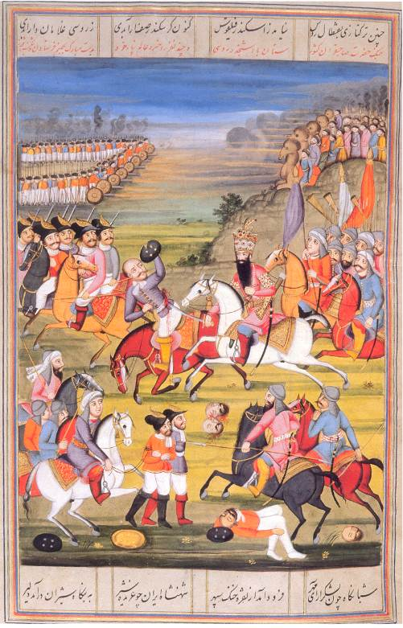
Fig.8. A page of the Shahanshahname, written by Fath Ali Khan known as Saba (poet laureate) of the court, dating from 1810-18, showing Fath Ali Shah fighting Russian troops. Opaque watercolour, ink on paper. After [26]. Unknown artist. Opaque watercolor on paper. Size 40 x 26cm.

Note: this work is a versified history of the early Qajars, documenting their battle with the Zands and the rise of Agha Muhammad. It continues into the early reign of Fath Ali Shah, and ends with Abbas Mirza’s engagements with the Russians.
Following his political objectives Fath Ali Shah offered copies of this work to foreigners such as East India Company, Franz I of Austria, Tsar Nicholas I and Sir George Ouseley. Including another copy in the Majlis (the Iranian national parliament) library in Tehran, so far five examples have been identified. Royal Persian manuscripts rarely occur in multiples like this, which underlines the propaganda value Fath Ali Shah placed on art objects. The East India Company received this copy, which has 38 miniatures, from the committees of Correspondence in 1816, together with a copy of Fath Ali Shah’s poems. ([8], [26].
In spite of the fact that the war was led by the crown prince (Abbas Mirza), while the king stayed in Tehran he was shown here as a warrior and. despite the Persian defeat the account gives victory to the Persians. This work exemplifies the early Qajar style. Fath Ali Shah was depicted in idealized form although he is seen killing a Russian. He is located at the approximate centre of the composition for emphasis. The Persian manuscript miniature traditions and rare European elements are evident in this work, although the character is Persian. The composition of the work is Persian in character (compare with fig.9). Three layers are identifiable in fig.8, which is the same fig.9. The Shah is situated in the middle layer in both works for emphasis. Bright colours were employed in both works. The depiction of objects such as mountains, horses and persons followed the traditions and are based on unique aesthetic sources.
The artist has tried to apply European elements in the background. Basically in early Qajarid works the background utilizes European qualities whereas the foreground is still Iranian. It seems that Persian artists were unable to manage foreground in a naturalistic manner. This inability is observable even in the artists who were called farangikar such as Muhammad Zaman. (farang originated from Franck; this was the title of the painters who followed naturalistic European elements in their works).
Comparison of this work with the wall painting by Sadiq in the Chehel Sutun (fig.7), indicates that artist was under the influence of Sadiq. Composition, theme and technical devices of the fig.8 are very similar to his work. The tradition meant that new generations of artists tried to follow the Ustads (masters) who were still working. This attitude was the cause of continuity in Persian traditional art and ended due to changes in the system of art education.

The cultural and artistic movement of Bazgasht testifies that unlike a number of the Safavid rulers Fath Ali Shah was deeply interested in traditional style and determined to restore it. He sought the revival of many Persian artistic characteristics which had been discarded from late Safavid times onward. Thus Persian mystic sources such as epic and love stories are one of the main themes of early Qajarid mural decoration (fig.10). This school was also turned to a visual display of power through the formulation of appropriate poetic language and visual expression to celebrate the Royal achievements (figs. 11, 13& 14).
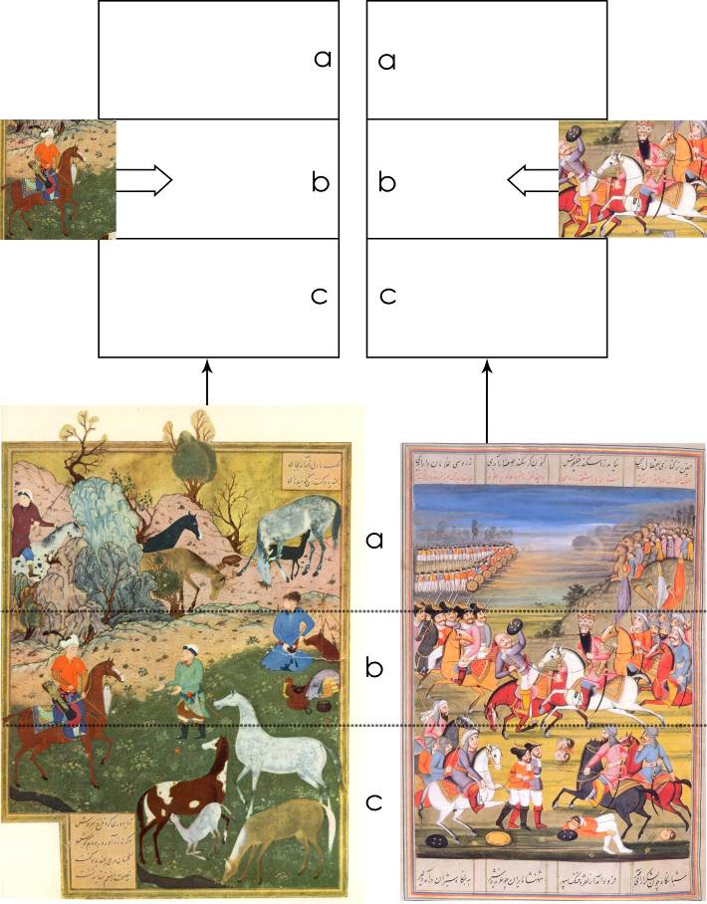
Fig. 9. Book illustration from Khamse of Nizami.

Fig. 8. (Repeat)
Fig. 9.1. Analysing the similarity between fig.8 and fig.9, in terms of composition.

Fath Ali Shah tried to restore lost Persian grandeur but the reality of events, such as the defeats by Russia, was at odds with this aspiration. So he tried to bolster his reputation and legitimise his rulership through works of art (fig.14). Fath Ali Shah’s response to the defeat of his armies by the Russians in 1813 was a strengthened desire to be portrayed with ever increasing magnificence in the hope that the dazzling projection would compensate for lack of military prowess (figs. 8&14).
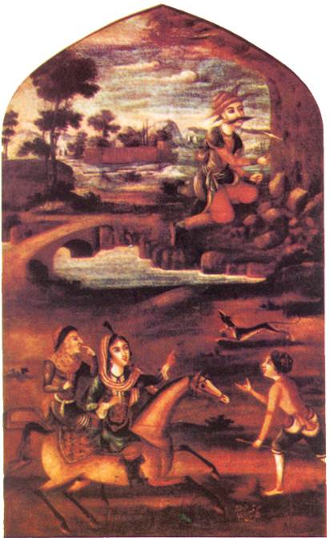
Fig.10. Wall painting on canvas from the early 19th century showing an early Persian love story (Farhad-e Kooh-kan and Shirin). Oil on canvas; it is signed by Mirza Baba, and is now preserved in the Berne Museum. Switzerland after [27].

Note: This scene portrays the popular love story of Shirin and Farhad. In the upper part of the composition Farhad is digging the mountain and Shirin is pointing to him. For this reason he was called as Farhad-e kooh-kan (Farhad the digger of mountain). Because this work belongs to the beginning of the 19th century the Zand style is still evident. The intensive use of dark colours in this work typifies this style. The school of Fath Ali Shah deliberately tried to discard European qualities in favour of Persian traditions.

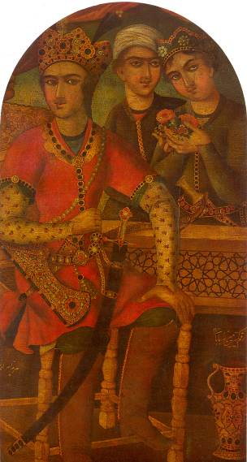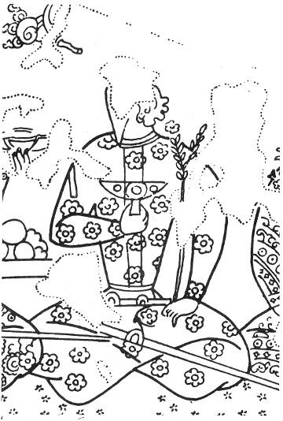
Fig.11 (left). A wall painting from the early 19th century showing Hurmoz the Sasanid ruler. Signed and dated by Mirza Baba, 1790.
Size, 77 X158cm, now preserved at the Fine Art Museum in Sa’d Abad Palace in Tehran. After a photograph by [28].

Note: Since this work came into existence in the early part of Fath Ali-Shah’s reign, the influence of the Zand style is still evident . The Early Qajarid wall painting tried to return to traditions in the Islamic and pre-Islamic periods. By comparing this work and Sasanian work it can be seen that many of traditions such as the posture were repeated in the works of the time.
Compared with fig, 12 from the Sasanid period, the presentation pattern of seating, posture and three quarter presentation, are similar to the Sasanid work. The dark tone and warm colour show the European influence which mostly came from the later Safavid style.

Fig. 12 (right). detail of a wall painting from the Sasanian period, dating to the 6th-7th century, from Sogdian in Panjikent, in Tajikistan, showing a man seated. This detail shows the religious ceremony at Nowruz (After [2]).

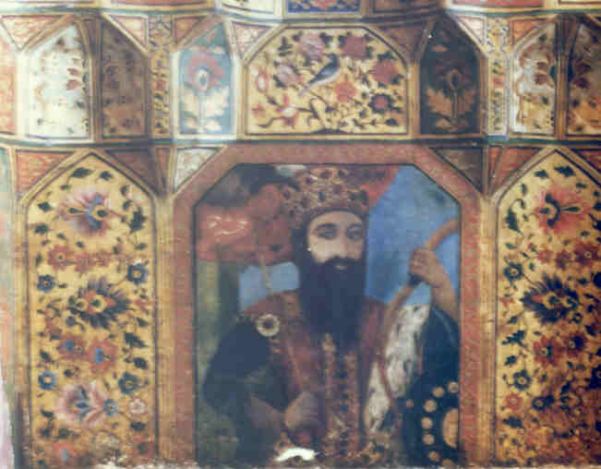

Fig. 13. A wall painting from the Golestan palace, naqashi khane building, dating from the first half of 19th the century, showing Jamshid the mythological first ruler of pretrsia. Oil on plaster. Approximate size, 100 x 50cm, artist unknown. Photograph by the author.

Note: Fath Ali Shah made an imperial image of the past rulers of Persia to legitimize the Qajar dynasty. This dialogue with the past was most obviously expressed in the wall painting and rock reliefs. (see also figs 13.1, 13.2). However his princely credentials were confirmed in some of his palaces, where his portrait was located with paintings purporting to portray the historical rulers of Persia.
Some foreigners such as Morier in 1808-9, Ouseley in 1811, Buckingham in 1825 and Texier in 1840 reported that the different palaces of the Shah were covered in paintings of the past Persian kings such as Jamshid (the first Persian legend king), Chingiz Khan, Timur; Feridun (the mythological king), Iskandar(Alexander), Anushirvan (the Sasanid king), and Afrasiyab (the king of Turan).
Historical portraits were used in the early Qajar period in order to legitimize political domination. The painters made the parallel with the past immediately apparent by giving earlier monarchs the same physique, pose and pendulous beard as Fath Ali Shah [26].

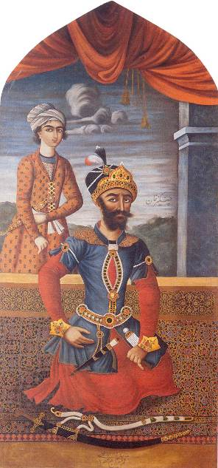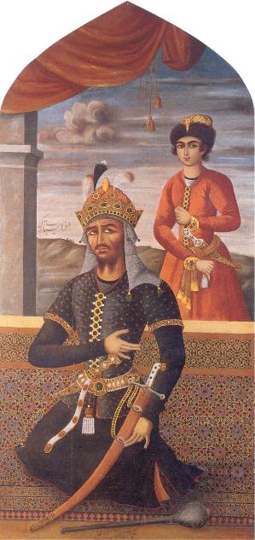

Fig.13.1 (left). A wall painting showing Ghingiz Khan, the Mongul ruler. Signed by Mihr Ali 1803. Size, 289 X 133cm, private collection.

Fig.13.2. (right) A wall painting showing Afrasiyab, the king of Tura. Signed and dated by Mihr Ali 1803. Size, 289 X 133 cm, private collection.

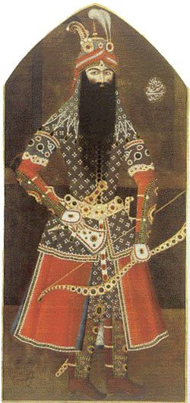
Fig.14. Wall painting dating from 1814-15 showing Fath Ali Shah posing as Rustam, a warrior. Painted and signed by Mihr Ali. Sackler Gallery. The Art and History Trust, courtesy the M. Sackler Gallery, Smithsonian Institution. After [2].

Note: The image of national Persian heroes such as Rustam must have been deliberately chosen to link the royal court to the Persian mythological rulers. Traditionally, Rustam was the protector of Persian monarchs and was instrumental in their rise to power so his image would have been a visible reminder of Qajar legitimacy. This iconography in different media such as tilework signifies the political and cultural aims of early Qajarid mural decoration. The rulers who dominated Persia tried to identify themselves with past heroes.
Here Fath Ali Shah incorporates a lion’s head similar to headgear worn by Rustam. His beard was exaggerated by the painter to be more like Rustam’s beard. Although the Persian army used modern weaponry and did not used traditional war dress (armour) in this period, the king appeared in traditional costume to be linked with the Persian legend. According to [29], the bow was a symbol of overcoming on enemy in Persian legend.
Fath Ali Shah emulated legendary Persian kings such as Kayumarth and drew upon deep-seated traditions associating political power with potency and fruitfulness. The flower and fruit metaphors utilized by Qajar chroniclers to describe Fath Ali Shah‘s children make this association abundantly clear
[13].
Fig.90. ( left). A wall painting from the Golestan palace, naqashi khane building, dated to the first half of 19th century, showing Amir Timur a king of Persia. Oil on plaster. Approximate size, 100 x 50cm. Unknown artist.
Photograph by the author.

Fig. 91 . (right). A wall painting from the Golestan palace, naqashi khane building, dating from the first half of 19th the century, showing Jamshid the mythological first ruler of pretrsia. Oil on plaster. Approximate size, 100 x 50cm, artist unknown. Photograph by the author.

Attempts to revive pre-Islamic grandeur linking the Qajar dynasty with the Sasanid and Achaemenid periods gradually became a strong socio- cultural and artistic movement, lasting until the end of the Reza Khan period (1925-1942) . This powerful movement rooted in different political and social premises, led to a decline in religious faith in society [15]; [30], [31]. It distorted the traditional logical relationship between Persian nationalism and religious faith. Theoretically an inclination towards historicism was associated with the presence of European cultures in Persia but careful reference to many historical and political sources does not reveal any evidence that the early Qajar period was based on European influence. During the early period the motivation was different from the movement of the middle Qajarid period where it was founded on philosophical principles deriving from European ideas. The intellectual movement polarized nationalism and religion. However early Qajar attitudes were not intended to be a counter to Islamic identity; rather to run in parallel with it. This tendency led early Qajarid murals to revive the use of rock reliefs. In the third decade of the nineteenth century the Qajar monarch and his prince–governors such as prince Muhammad Ali Dawlatshah (in Kirmanshah), Husayn Quli Farmanfarma (in Shiraz), and Timur Mirza (in Kazirun) and Husayn Ali Mirza Shuja ul– Saltane commissioned monumental figural rock reliefs in the Neo-Sasanian style depicting Fath Ali Shah in the guise of Khusraw (the Sasanian term for monarch). The best –known reliefs are at Cheshme Ali, at Taq-e Bustan, and in the vicinity of the Quran Gate in Shiraz [32], [6]. They were strategically sited in relation to similar rock carving and reliefs of the Achaemenid and Sasanian past, testifying to the strong motivation of its creators. (figs. 15, 16 & 17). By commissioning these monumental public images of themselves, Qajar patrons appeared to be in direct contravention of Islamic traditions.
Fig. 15. Rock relief by Abdallah Khan dating from 1829-30. The court of Fath Ali Shah at Rayy, near Tehran.

Note: After re-establishing the national domination in Persia by the Safavids, Persian art tried to apply pre-Islamic patterns used to glorify the Persian kings and the court. This was embodied in the large wall paintings in the Safavid palaces. During the Qajarid period this trend appeared in both wall painting and rock-reliefs such as the above example. Although the Shah has been always at the apex of traditional art, this element found a symbolic essence in the pre-Safavid period. There are many paintings from the early Islamic period that show the Sasanid kings such as Bahram Gur and Khusrow but they pointed to a mystic message rather than propaganda for the Sasanid power. During the Qajarid period this viewpoint changed and art took on imperial character and moved away from religious claims.

Comparison of this work with the Sasanid rock-reliefs such as the relief of Bahram in the pre-Islamic period (fig. 41.1) we can see much similarity between them in terms of composition, symmetrical frontality of composition, and two-dimensionality. The composition of this work also is similar to the wall painting of the Negarestan palace in Tehran (fig.18).
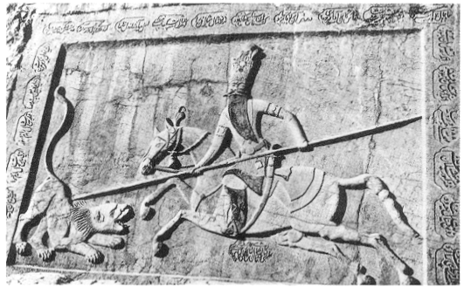
Fig. 16. A rock relief by Abdallah Khan dating from 1829-30. The Court of Fath Ali Shah hunting. Rayy, near Tehran.

Note: Equestrian relief in Persia dates back to pre-Islamic times. Parthian and Sasanian rulers were commonly portrayed in bas-reliefs and on gold and silver vessels sitting astride horses, hunting game with bows and arrows. The horse in Persian painting thus gradually emerged as a ubiquitous royal accoutrement, accompanying rulers, princes, and legendary heroes into battle and in the chase. This tradition continued well into the nineteenth century; Fath Ali Shah was frequently depicted on horseback engaged in the chase or leading his troops into battle (fig. 8).

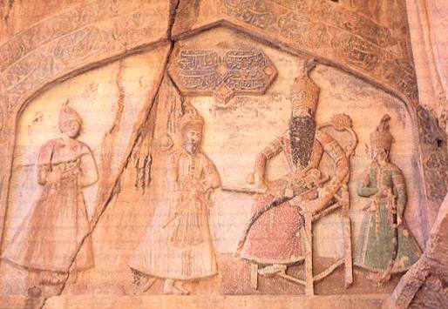
Fig.17. Qajarid relief from Tagh-i-Bustan showing the Qajarid king Fath Ali Shah, After [34].

Note: Fath Ali Shah set out to make an imperial image to rival that of the most illustrious rulers of Persia. This dialogue with the past was most obviously expressed in the rock reliefs that he commissioned to stand alongside those put up by the Parthian and Sasanians at Rayy and Taq-i Bustan.
The composition and subject matter of this work is also similar to the Achaemenid reliefs.

8. Oil painting
By the seventeenth century, as a result of extended contacts with Europe the unfamiliar tradition of painting in oil on canvas was gaining currency among Persian artists. According to [7] & [8], Qajar artists used portraits in preference to other media. During the Qajar period artists showed increasing tendencies to absorb European artistic experience. This forced art to harmonise itself to new aesthetic requirements. Due to the fact that early Qajarid art consciously and deliberately pursued native traditions this influence could not change the Persian character of early Qajar mural painting. Life size murals in oil on canvas were in favour and helped artists capture the personality of the sitter, at the loss of symbolic expression. Persian painters, once urged to express celestial beauty through symbolism were now obliged to depict nature with a high degree of accuracy. This required specific training. So oil painting was promoted intensively during the Qajar period, when it had more prestige than any other technique. Major court painters such as Mehr Ali were no longer illustrators working in opaque watercolours but oil painters. The mural painting of the Qajar period is most commonly associated with the western technique of oil on canvas. Although the medium was borrowed from European painting, the style remained largely indigenous. However, this gradually imposed new aesthetic elements and gave opportunities to express feelings realistically. At first, artists respected the two dimensional conventions of manuscript painting and maintained their acquired taste for slightly more realistic portraiture. However, by the death of Fath Ali Shah, as a result of the constant use of European techniques, artists moved away from Persian traditions to become closer to European taste.
One of the most important components and characteristics of the mural of this period is specific attention to appearance. The portraits of Qajar rulers and statesmen were frequently depicted in life size murals [35] [4].
Speculation over the purpose of the numerous life size pictures of Fath Ali Shah and courtiers has given rise to two views among scholars. Lord Curzon, who visited Persia in 1889 and later became the Viceroy of India, suggested that Fath Ali Shah never built or occupied a palace anywhere without immortalizing himself, being portrayed with his wasp-like waist and ambrosial beard, regiments of sons, his crown and jewels and his throne, all set down on canvas and mounted upon the wall [3]. According to [8], it was Fath Ali Shah’s interest in himself and others as distinct individuals that did so much to give Qajar painting a purpose in portraiture, and it was portraiture that was to play the greatest role in the paintings of his reign ([8]: 22). (Figs, 8, 14, 15, 16, 17, 18, 19& 20) Some believe that Qajar rulers are depicted life size in response to capricious vainglorious self- praise as much as psychological need [8], Recent academic research, taking the opposite view has attributed these large pictures to political aims. The view suggests there is considerable evidence that the image of the ruler in myriad forms, size and media, played an integral role in the nineteenth- century exercise of power, both at home and abroad. The purpose of royal imagery in society was to provide an intermediary between the court and the people. Diba [1] has written “nineteenth century Iran was in many respects a society where superstitious beliefs regarding the power of images prevailed. Investigation of these beliefs is critical to understanding the psychological and emotional significance of life size imagery during this period”.
In Persia one of the principal vehicles of the expression of power was to have numerous progeny. Therefore the portrayal of numbers of progeny life size was in itself a political aim. The images of Fath Ali Shah and his sons were displayed together with battle scenes, hunting and representations of legendary heroes and poetic themes. These cycles, introduced in the manner of Rustam, were displayed in palace gateways linking courts and urban spaces. The painters and designers of Fath 'All Shah's court were required to make the perfect image. Representations of the ruler alone were generally incorporated into complex decorative cycles, and the majority of royal images showed Fath 'Ali Shah in monumental group scenes of enthronement, hunting and battle crowded with numerous supporting figures [1].
The second argument which attributes political aims as being the motivation for life size portraiture is related to the socio-political conditions of the time. The war between Russia and Persia, together with conflict with local rebels required a strong image from rulers. For this reason Fath-Ali Shah ordered pictures to be sent to foreign courts or depicted in public places (figs. 18&20). Therefore by contrast with the Zand life style that promoted a domestic stance the early Qajar approach was meant to emphasize imperial power and merchant grandeur. In other words this sort of representation was used to consolidate dynastic power. It was the artistic component of a concerted policy of cultural revival and political propaganda intended to equate the Qajar rulers with the glorious Persian past. Both Persian and European traditions are apparent in life size portraits. In these cases the stiff frontal pose allows minute attention to detail and this formal mood is traceable to Persian traditional art. Portraiture of this period was not confined to large oil paintings. Emphasis on individualism in art ran against former attitudes. Previously it was unusual to find imagery of real kings and where they did occur their purpose was to represent a group of moral or love stories such as story of Sultan Sangar (the Saljuk king) and the old woman’ or the ‘story of Bahra-e Gour (a Sasanid king) and a Girl‘ (in the Haft paykar-e of Nizami). Furthermore, none of these pictures showed a king in real and naturalistic posture. They conveyed a moral and religious message rather than propaganda for the Shah himself. The real kings in such works were symbolized and allegorised. There is no sign of life size portraiture during the medieval Islamic period. This was is only found in the imperial Achaemenid and Sasanid rock reliefs. By contrast Fath Ali Shah presents striking parallels with sixteenth and seventeenth – century European monarchs such as Louis XIV of France and Philip II of Spain (1527 – 1598) (figs. 19a&19b). Using oil paints on heavy canvas, the Qajar masters undertook a ‘reformation’ of sorts within the Persian tradition, rejecting some features of traditional art in favour of integration and accommodation with Europe. The most competent artists were chosen' for this important task. One of the best examples of early Qajar life size wall paintings formerly decorated the Negarestan palace outside Tehran. For unknown reasons it was destroyed but copies indicate the characteristics of the original work. An opaque watercolour copy on paper shows its artistic qualities (fig.18).
The development of art which had taken place during under Fath Ali Shah declined after his death. The economic power of Muhammad Shah’s government as a consequence of the wars between Persia and Russia art did not support art as it had done in the middle period. No architectural project was left. In addition, the Shah was not looking to glorify the court like his predecessor Fath Ali Shah.
Muhammad Shah fostered Europeanised art. Works left by European painters encouraged and influenced courtier painters. This period is a transition into the late Qajarid era when European art gradually came to dominate the royal court.

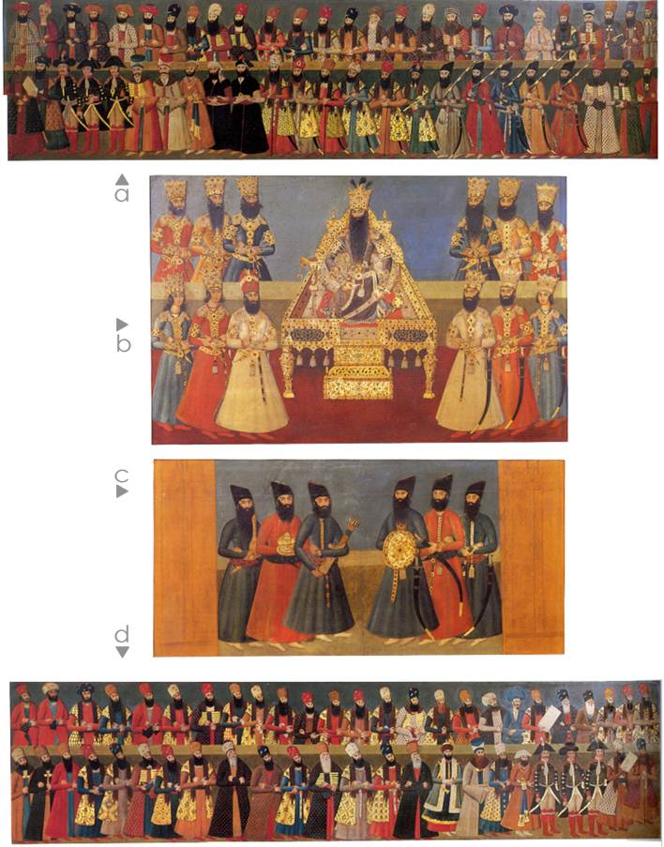
Fig18. These copies of the Nagarestan Palace picture were made from the original painting which has been destroyed. The wall painting from the Negrestan palace in Tehran is dated to the early 19th century, and shows the Festival of Salam-e Nowruzi in the court of Fath Ali Shah. After [2].
Pre and post Islamic traditions as well as the European elements all bear upon it.
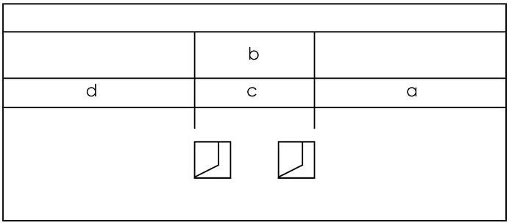
Fig. 18a. This indicative scheme was constructed by the author from surviving photographs of the wall painting of the Negrestan palace in Tehran dated to the early 19th century, showing the Salam-e Nowruzi in Fath Ali Shah’s court.

Note: The original represented an imaginary New Year’s reception at the court of the monarch. The mural was completed in 1812-13, for the reception hall of the palace by a team of artists under the supervision of Abdullah Khan. Because these reduced copies, were produced sometime between completion in 1812-13 and 1834, the year of Fath Ali Shah’ s death, we can accept them as copies of the original work. Parameters for the dating of the copies are given by the date of the palace, the use of English paper watermarked with a date of 1816, and an engraving of 1834 of the mural executed by the English artist Robert Havell [8].
In the picture we see Fath Ali Shah (r. 1797-1834) seated on the peacock throne (Takht-e Tavus), with his sons and retainers about him. His son, Muhammad-Ali Mirza stands on his right, and Abbas Mirza on his left. According to Persian protocol the right side of the Shah has always been the more important. Ceremonially the painter will have placed Muhammad Ali Mirza at the right because he was older than Abbas Mirza. The foreign envoys from England, Russia and France are located in the side panels. Among the foreign personalities are the British envoys John Malcom, Hartford Jones and Gore Ouseley on the left panel, and on the right panel the French general Gardane, depicted here with two colleagues, Mssrs, Jaubert and Jouanin [2].
Comparison between this imperial wall painting and the Achaemenid reliefs at Persepolis, allows us to conclude that Abddullah Khan and his assistants were inspired by Achaemenid royal and artistic concepts . Some of the similarities are;
The main theme which followed Achemenid rock reliefs at Persepolis showing the festival of New Year (Nowruz). At that time representatives of many countries participated in this festival in recognition of the Achaemenid king as the Shahanshah. As in the Achaemenid reliefs, the Negarestan wall painter presents the same event in which the envoys of other countries Ulama and nobles participated. The envoys of France and Great Britain along with ambassadors from the kingdom of Sind, Arabia and the Ottoman Empire, reflected the Persian court’s perception of these envoys as symbolic of the submission of the rulers of the world to the mighty Shahanshah (King of Kings).
Scholars argue that the successors of the Achaemenid’s never forgot the political and imperial splendour of ancient Persia [36], [9], [37]. It is clear that, the intention of Fath Ali Shah in setting up his works beside the Achamenid and Sasanian rock reliefs indicates his aspiration and desire to emulate past glorious. Just as Achaemenid kings believed that kingship is granted by God, Fath Ali Shah was similarly described in the letter, which he sent to the ruler of Afghanistan, claiming that God had granted the crown to him [18], [38].
It was the function of the Negarestan mural decorations to celebrate the power of Fath Ali Shah and his government. A number of small-scale copies commissioned by Fath Ali Shah were made for use as diplomatic gifts [1], although In terms of the impact on the religious situation there was a friendly relationship between Fath Ali Shah and the Ulama [39]. None of the celebrated and influential priests such as Shaikh Kashef-al Qeta, Mirza-ie Qumi, Naraqi, and Kashfi are depicted here. Because the Shi’ah believe that rulership is the gift of God the Prophet and the Innocent Imams, during the absence of the Twelve Shi’ah Imams the Ulama must take their place [40]. Therefore, although Fath Ali Shah was supported by the Ulama, particularly during the war against Russia, many of them did not recognize his spiritual supremacy [19]; Ansari, 1952).
The composition of the Negarestan mural was symmetrical and in this it is similar to numerous Persian pictures. The composition is essentially Persian and this compositional pattern derives from Achaemenid and Sasanid precedents.
The picture is full of symbolism although it is created in a naturalistic style. All the personages are depicted as real persons and each of the 118 figures has been identified. With the objective of realism the figures are depicted life size and in naturalistic style.
Despite the large scale of the original work it was full of decorative detail. These details are less apparent in the watercolour copies.

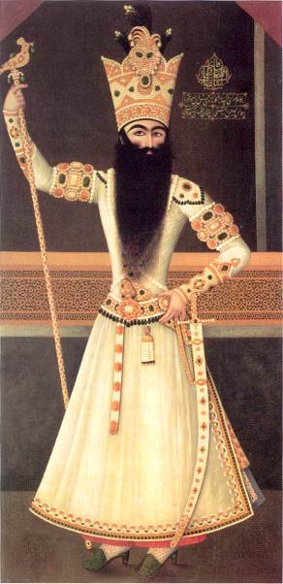
Fig. 19. A Wall painting of Fath Ali Shah, dated 1809-10, oil on canvas singe by Mihr Ali, 235 x 124 cm and now in the Hermitage Museum, St. Petersburg.

Note: this work exemplifies the standards of royal painting in early Qajarid art.
The absence of three-dimensionality should not be construed as an inability to create truly realistic paintings but as a deliberate attempt by artists to create idealized portraits in conformity with Persian taste.
The task of producing an opulent image of Fath Ali Shah was given to Mehr Ali who had painted several portraits of the Shah including this figure one of the finest. The work was inspired by European royal portraits. (figs. 19a&19b)
In accordance with Persian convention, the artist created an idealized portrait of a handsome majestic and noble king.
Broad shoulders and a slim waist project power and elegance. A minimum of modeling adds a touch of realism but maintained above all are late seventeenth century formulae of two-dimensional iconic representation most noticeable in the literal treatment of the boots and arms.

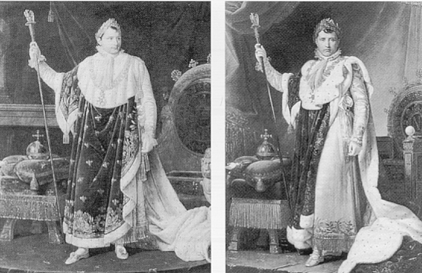
Fig.19a (left). Robert Lefevre, Napoleon in his Robes, 1811, Versailles (detail). After [26].
Fig.19b (right). Francois Gerard, , Napoleon in his Robes, 1805, Louvre Museum (detail). After [26].

9. The Harem
Women of the Harem and noble women are another prominent subject of early Qajar mural painting. In spite of the tradition that murals depicting women are rare, early Qajarid murals showing women are a primary theme. This most probably derived from the increasing power of Qajarid women during the period. Some of them such as Mahd-e Olia (Nasir-ed-Din Shah’s mother) took a crucial part in political affairs. Fath Ali Shah had about one thousand wives and concubines [41]. Basically the decline of religious faith in the Persian court from the late Safavid period onward allowed art to drift into sensuality more than ever before.

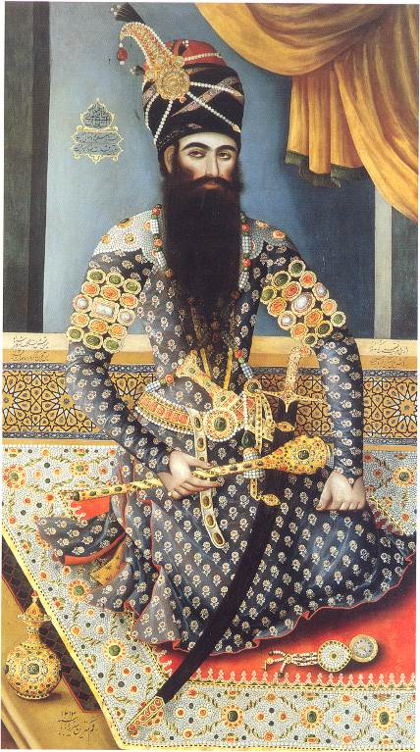
Fig.20. Portrait of Fath Ali Shah, by Mirza Baba (active 1789-1810), Tehran, signed and dated 1798-99. size 200 x 117. Oriental and Indian Office Collections, The British Library, London.

Note: this seems to be the first portrait of Shah to have reached England, following the political function of such portraits during the early Qajarid period. It was presented, to the Court of the Directors of the East India Company in 1806. The work is dated soon after Fath Ali Shah’s accession to the throne in 1797, and shows him wearing a turban rather than the Taj-e Kiyani, the imperial crown which Fath Ali Shah had commissioned and which he wears in most of his later portraits. Mirza Baba was the foremost artist of the early Qajar period, painting with equal facility on different scales and in different media. [7]. In parallel with Mihr Ali, Mirza Baba created the definitive image of Fath Ali Shah and he contributed to the fashioning of the royal image by designing the Marble Throne in Tehran in 1802 [26].

A desire for decoration that would suit the purpose of the building for which the paintings were intended led to the portrayal of girls in various roles such as playing musical instruments, dancing, and sometimes taking refreshment in the form of wine or sweet- meats. The range of subjects also covers more traditional subjects following the trends of miniature painting. Also the more popular scenes from Persian poetry and tales do occur, though they are in a minority [5]. However Qajarid artists changed the spiritual conception of women in traditional painting toward sensuality. They made the concept of a female beloved available in a new mode: as an earthly reality, rather than as a literary fantasy. In such works the bare-breasted woman appears repeatedly. Qajar wall painting mirrored the role of women in the court. Although nude females do appear in Safavid and Zand art this sensual emphasis displayed through the style of dress or association with fetishist objects seems to be a heavily accented theme in Qajar painting. Perhaps it was to avoid social stigma that the Qajar representations of women were rarely signed or dated [38], [8], [4]. The Qajar bare-breasted woman emerged as the eroticisation of the breast reached its culmination, influenced by the Persian male perception of women in Europe. Woman, the beloved, had symbolic significance in Persian traditional art; but now the concept gradually changed to that of a realistic woman with a social role. For instance Leila in the Khamse of Nizami is the iconic female beloved in Persian literature and painting of her symbolized a sacred love. Therefore the relationship between Leila as the beloved and Majnoon as the lover became symbolically the relationship between man and God [42]. The decline of mysticism in Persia and the importation of secularism caused the mystic qualities of women to be particularised in art. In literary representations the breast is never singled out as a particular site of beauty or erotic attention. When the fifteenth century poet Jami, for instance, describes Zulayka’s beautiful body, she is allegorised and coded from head to toe, without emphasis on her breasts. Moreover, similar and at times identical descriptive accounts are given for beautiful male bodies, a point related to the prevalence of homoeroticism in this literature. This poetic practice highlighted what male and female beautiful bodies have in common rather than their points of evident difference [4]. The Madonna and Child was another European theme brought into the Persian repertoire. Even these representations convey the composition’s erotic message with tight-fitting bodice and deep décolletage [1].

10. Conclusion
The early Qajarid murals marked a clear return to tradition; however, at the same time late 18th century European court style appeared in the palaces in Tehran. It was inspired by both Persian traditions and European elements. As a consequence of the ties with the European idiom, combined with the reborn consciousness of native traditions, the early Qajar mural moved into eclecticism with a distinctive Persian character.
The influence of imperial Sassanian and Achaemenid themes also appeared on the carved figural reliefs. Portraits of princes and historical scenes were used to adorn his new palaces and they were often shaped like an arch in order to fit into a space in the same shape on a wall.
The character of the early Qajar murals is largely embodied in the subjects chosen by the royal court. Mural decoration and art were led to serve political affairs in order to legitimise the Qajar dynasty. For this reason Fath Ali Shah distributed several paintings to foreign powers such as Russia, Britain, France and the Austro-Hungarian Empire. The portraits of Fath Ali Shah and his courtiers also were depicted in public places.

References
[1]. Diba, L. (1999) Royal Persian Painting, L. I.B. Tauris Publishers in association with Brooklyn Museum of Art.
[2]. Soudavar (1992) Art of The Persian Courts, New York, Rissoli.
[3]. Curzon (1892), Persia and the Persian Question, 2vol, London, Murray.
[4]. Ekhtiar, M. (1989) From workshop and Bazaar to Academy; Art Training and production in Qajar Iran, in Royal Persian Painting, ed Diba, L., I.B. Tauris Publishers in association with Brooklyn Museum of Art.
[5]. Falk (1972), Qajar Painting, Persian Oil Painting, London, Faber.
[6]. Lerner, J, A. (1991) Rock Relief of Fath Ali Shah In Shiraz. London, Ars Orientalis 21.
[7]. Robinson, B, W. (1964) The Court Painters of Fath Ali Shah, “Erets-Israel.
[8]. Robinson, B, W. (1977) Persian Oil Painting, London, HMSO.
[9]. Meskoob, S. (2002), On QajarPainting; An Illusory Distinction and Orginality, Tavoos, issues 5 & 6.
[10]. Emami, K. (1976) A survey of Persian Painting During 18th and 19th Century, Tehran, Farah
[11]. Anisi, A. (2000) Kahk-e Golestan (The Golestan Palace), Tehran, Tavous Magazine, No.14.
[12]. Seif, H. (1990), Naqqashi-ye Qahve Khane (Coffee House Painting) Tehran, Cultural Heritage Organisation.
[13]. Amanat, A. (1997) Qajar Iran, an article from Royal Persian Painting, ed, Diba, L. Tauris Publishers in association with Brooklyn Museum of Art.
[14]. Zibakalam, S. (2002) Ma chegune ma shudim , ( How did we became us), Tehran, Nayy.
[15]. Madadpour, M. (1994) Tajadod va din zudaie dar hounar-e monavaroulfekri az ebteda ta Qajar (Reform in intellectual culture and art from the beginning to the Qajarid period).
[16]. Turner, J. (1996) Qajar in the, Dictionary of Art, London, Macmilian.
[17]. Ferrier, R. W. (1989) The Art of Persia, New Haven & London, Yale University Press.
[18]. Hairi, A. (1999) Nokhostin royaroi-ye andishe-garan-e iran ba do roye-ye tamaddon-e qarb, (The Early Encounters of Iranian Thinkers with the Two-Faced Civilization of Western Bourgeoisie), Tehran, Amir Kabir
[19]. Hairi, A. (1977) Shi’ism and Constitutionalism in Iran, Leiden.
[20]. Godard, A. (1965), The Art of Iran, (trans from French by Michel Heron), London, George Allen & Unwin.
[21]. Scarcia, G,R. (1989) The Qajar School, Encyclopaedia of World Art Vol Xl, PP.811-19.trans. to Farsi, Y,Agand, Tehran, Mula.
[22]. Behbudi, H. (1990) dar barey-e adabiyyat-e novin-e Iran (On Modern Literature of Iran Before the Constitutional Movement), Tehran; Huzeye Hunari.
[23]. Kasravi, M. (1978) Tarikh-e Enghelab-e Mashrute, ( The History of the Constitutional Revolution), Tehran, Amir Kabir.
[24]. Algar, H. (1969) Religion and the State in Iran, University of Berkley.
[25]. Arianpour, Y. (1961) Az Saba ta Nima (“ From Saba to Nima”), (a history of Persian literature in last 150 years), Tehran, Zavar.
[26]. Raby, J. (1999) Qajar portraits in London, London, Azmuth Edition, in association with the Iran Heritage Foundation.
[27]. Ehsani, MT. (1989) Iranian Bookbinding and Pen Cases, Tehran, Amir Kabir
[28]. Keikavusi, N. (1992) Golgasht dar negarestan (Promenade in the Picture Gallery) An Album of Iranian And European Painting From Suseye Sa’dabad (Museum of Fine Arts), Tehran; Negar Books.
[29]. Sarafraz, A & Firoozmandi B. (1997) The Lessons from Archaeology ( Mede, Achaemenid, Parhtian and Sassanid , Tehran, Marlik
[30]. Adamiat, F. (1980), “Mirza Hussin Khan-e Sipahsalar”, Tehran, Amir Kabir.
[31]. Adamiat, F. (1961) “Fikr-e Azadi Va Muqaddima-yi Nihdat-I Mashrutyat-e Persia” (The conception of liberty and preface of the Constitutional Revolution), Tehran. Kharazmi.
[32]. Herzfeld, E. (1941) Iran in the ancient East, Oxford, Oxford University Press.
[33]. Wilson, J, K. (1988) Hunar-e Iran, (The Art of Iran), trans by Feriyar, A. Tehran, Farhangsara.
[34]. Curtis, J. (1980), Ancient Persia, London, British Museum Publications.
[35]. Zuka, Y. (1976) Naqqashi Iran dar quron-e hijda va nozda, (Persian Miniature In The 18th and 19th centuries), Tehran, Farah.
[36]. Frye, R, N. (1976) The Heritage of Persia , London, Cardinal
[37]. Safa, Z. (1990) Tarikh-e adabiyyat-e Iran (The history of Persian Literature), eight volumes, Tehran, Elmiyye
[38]. Tavakoli - Taraqi, M. (1989) Imagining Western Women: Occidentalism and euro-eroticism, Radical America 24, No3.
[39]. Jafarian, R. (1990) tarikh-e Shi’ah dar Iran (the history of Shi’ah in Iran), Qum, Ansariyan.
[40]. Lambton, A, K,S. (1990) Qajar Persia, London , I.B. Tauris.
[41].Bakhtiyari, A.Gh. (1997) Zamine-ye tamadon-e Iran va farhang (The context of the Persian civilization and culture), Tehran; Pajang.
[42]. Servatian, D. (1997) Payvand-e negargary ba adabyyat, (The association of Persian Miniatures With Persian Literature), an article from seminar of Persian Painting In Iran (1997), The Fine Art Museum, Tehran.
[43]. Hunarfar, L (1965) Chehel Sutun Palace (Isfahan) , Tehran, Magazine of Hunar va Mardum, 121.
[44].Ayatyllahi, H. ( 2000) Hunarhay-e tajassumi ( The Fine Art), an article from the book of simaye farhangi-eye Iran (A View of Persian Culture), Tehran, Eilam.
[45]. Salemi, M. (1999) Qajarid Painting From the Beginning To the End, B.A. thesis, Tehran, Azad university, Unpublished.
[46]. Hatam, (2000) Tarikh-e hunar va memari (The History of Art and Architecture), an article from the book of simaye farhangi-eye Iran (A view of Persian Culture), Tehran, Eilam.
[47] Morier, J. ( 1976 ) Haji Baba of Ispahan, London.

* Mahdi_zandieh@yahoo.com 1 Assistant professor, Department of Architecture, Faculty of Architecture and Urbanism. Imam Khomeini International University (IKIU). Qazvin, Iran. ² Assistant Professor, Department of Art & Architecture, Faculty of Painting, Tarbiat Modares University, Tehran, Iran. ³ MSc. Department of Architecture, Faculty of Architecture and Urbanism. Imam Khomeini International University (IKIU) ? Zoka, Y. (1963) Mirza Abul Hasan Khan-e sani al-Mulk Ghaffari, Tehran, Hunar va Mardum, no.10 & 11. Zoka, Y. (1970) Tarikhche-ye sakhteman-e arg-e saltanati Tehran, (History of the Buildings at the Arg, Tehran.
Diba, L. (1989) Lacquerwork, ed Ferrier, New Haven & London, Yale University Press.
Sharifzadeh, A. (1994) tathir-e qab bar naqqashi-ye Irani ( The Influence of the Western Painting on Persian Painting), Tehran, Mirath Farhangi. Sharifzadeh, A, (1994) sukhani digar dar barehe shahname-ye Davari, (Another interpretation of the Shahname Davari), Tehran, Museha, No. 13 &14.
Najmabadi, A. (1999) Reading For Gender Through Qajar Painting, (Royal Persian Painting, ed. L. Diba, L. I.B. Tauris Publishers in association with Brooklyn Museum of Art.
Because the wall surfaces of Persian buildings are articulated and modeled with niches, panels and framing the shape and size of a painting is determined by the nature of the space for which it is designed, and for this reason many of the pictures have an arched top allowing them to fit precisely into the arch-shaped niche which frequently occurs. This feature allows missing paintings to be identified.
The impact of archaizing on contemporary architecture and art was so strong during the Pahlavi period that it changed the shape of Tehran. See Kiyani, “ Architecture during the reign of Reza Shah Pahlavi” period unpublished (PhD thesis university of Tehran, 1998)
Author of “Persia and the Persian Question” a significant work in terms of British policy in the area.
refer to: Hairi, (1982), Shi’ah and Constitution in Iran, Tehran. Hairi (1977) Shaykh Fazl Allah Nuri ‘s refutaion of the idea of constitutional. Shiekh Murteza Ansari (1952), Almakaseb (jobs).
Ali Quli beg Jabbadar and Muhammad Zaman were the first Persian painters to introduce this type into Persian art.

