Context-oriented Lighting Strategy in Urban Spaces (Using Space Syntax Method)
Case study: Historical Fabric of Isfahan

Abbas Azari, Mehdi Khakzand
Abstract
Lighting plays a key role in night escapes of urban spaces, in a way that it can be effective in giving identity to them. By considering this importance and inexistence of a process for composing urban Lighting strategy made this study to be conducted by the objective of providing process for compilation of context-oriented lighting strategy in urban spaces.
Reaching a suitable solution for Lighting in urban spaces, a process is needed which can encompass all different aspects in the context of lighting. In this way, a process is proposed via that this shortage can be compensated. This process, at first considers basic urban studies including historical, cultural, religious, social, ceremonial and land-use and then the design scenario is propounded and in order to investigate the urban spaces context via space syntax method, the integration parameter is used. Later on, guiding is propounded which can be analyzed by Intelligibility parameter from space syntax method. And also designing alternatives can be analyzed by space syntax method. By studying the organizer structure and its prioritizing, we could achieve the lighting originated from the context. The last part of process is based on observance of the topics related to light pollutions which has a very critical role in lighting. In this study the analytic-descriptive research method with modeling and simulation are applied to achieve a context-oriented lighting process in urban spaces.
The results of this study are showing that the provided process can be applied practically for lighting by considering the urban context. So this study has practical aspects and it can create a suitable strategy for lighting urban design and planning.
Key words: Lighting strategy, context, space syntax

1-Introduction
Among all senses, our visual sense has more important role in urban spaces perception, as the beauty of urban at nights, is based on suitable Lighting. Suitable light at nights causes harmony in urban spaces and would give a special identity to the urban. So light could have an important role. Suitable Lighting could be one of supporting reasons for identity of a place and raise its special character. Achieving a suitable Lighting, we could increase the vibrancy of a place and its relaxing atmosphere and then causes more people there.
Light in addition to its applied uses would have a symbolic point and in many cultures is a holy and important element. In our religion, Islam, light is one of God’ names, because all light and brightness in universe origins from God[1] . And it also has been repeated as a leader in Holly Quran many times and this repetition means its importance. So we could understand light would show realities and causes directing. In another word, it could show the context of urban and directs human mind. If light could not do this, urban would get on anonymity and could not be able to connect with its context at nights and this issue in historical patterns of a urban, with attention on its historical and identical past would be so complicated.
Every space has some characters that lighting plan could support its characters. Using Lighting techniques and understanding its real characters could help to make a suitable nightly designing. Among this knowledge of artificial light characters, spaces ability and understanding of light’s effects, could cause a suitable designing with correct Lighting. Lights could not be known as a mean for lightning, but for a symbol of meaning and senses [2].
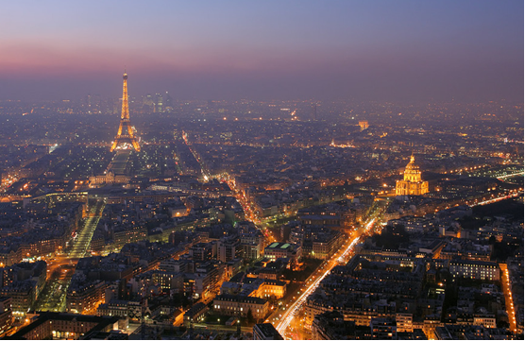
Figure1: Lighting in valuable space of historical urban, Paris, emphasizing on organizer structure
Lighting without attention on context is inefficient and if could not be able to connect with that, it cannot reflect the essence of the city spaces. Lighting would have a harmonic pattern and logic to support identity and help the existence of senses in places. Suitable lighting causes appealing and make happiness in cities, especially if the urban contains some historical building and parts, so this issue would get more worth. For creating vibrant spaces, making an organizer structure and operational relations, would be useful. For Lighting based on identity, security, antiquity, architectural style, structural materials, aesthetics, ideology and its symbolic aspect and other building in its environment, this way would be attention able. So the most important issue is composing context lighting in urban spaces. For this study, based on the importance of Isfahan, its historical texture would be researching. Analytic-descriptive study with modeling and simulation has been used for achieving the context-oriented lighting process in urban spaces.
2- Light, context and organizer structures of urban spaces
Context-oriented is one of the common approaches in urban planning which supposes context as a historical event, which urban elements inside it, would be known, made and progressed. This view at first just noticed about frames, but slowly have noticed about humanity aspects and expanded its social-cultural aspects in society. Context-oriented ones believe that the elements of urban frames are not affected by its own inner characters, but is depend on its environmental systems. For this reason, we could not search just frames of elements and don’t notice about the time and the context which the element is inside it. Analysis in this aspect, is studying buildings or environments in connection with environmental elements and every changing and interruptions are related to these factors[3] .
Knowing the correct urban functions and their organizer structure would correctly help to find a suitable solution for Lighting and the quality of urban spaces would be raised in both visual and operational aspects. As it has been shown in Figure 1, in extensive Lighting plan, Michlen, Belgium, the organizing structure and the connection between operations have been considered. In other words, the spatial values and the its relation about structure of suitable uses of light in urban spaces, in attention of operational connections have been done. So this key point would be important that if we could understand urban structures based on contexts, in fact we have reached on a Lighting strategy.
For assessing of context planning and understanding of organizer structure, there are many ways. One of the suitable ways accepted by the majority of urban planning and architecture scientific society is space syntax. In next section, we would explain this issue and the using ways for composing of Lighting plan strategy.
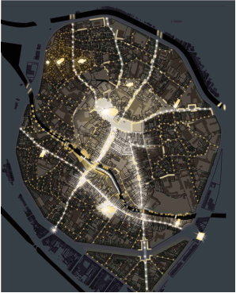
Figure2: Organizer structure with operational urban connections, Lighting master plan, Milchen, Belgium[4]

3- Space Syntax, a way for understanding and analyzing the context-oriented in urban spaces.
Space syntax is a collection of theories and methods which explains the spatial ontology and would name it as one of most important ways for spatial morphology. Spatial Configuration as the main point of spatial analysis is an aspect that has been prepared based on graph theories. In this way, spatial systems not based on common geometric ways also based on spatial topology would be analyzed. Space syntax would analyze the connections between whole urban spaces together and will illustrate results by graphic-mathematics parameters. Mathematical parameters could be used as a model which will predict operation and manner in urban spaces. Graphic data, analysis of space syntax is an important element in urban studies. As the effect of frame’s interruptions in urban fabric would be seen graphically. Spatial Configuration is a way which is successful in prediction of Pedestrian and driver moves and also the level of spatial usage[5] .
Space syntax is a science-based, human-focused approach that investigates relationships between spatial layout and a range of social, economic and environmental phenomena. These phenomena include patterns of movement, awareness and interaction; density, land use and land value; urban growth and societal differentiation; safety and crime distribution [6].
Space syntax was pioneered in the 1970s by Prof Bill Hillier, Prof Julienne Hanson and colleagues at The Bartlett, University College London. Today, space syntax is used and developed in hundreds of universities and educational institutions as well as professional practices worldwide. Built on quantitative analysis and geospatial computer technology, space syntax provides a set of theories and methods for the analysis of spatial configurations of all kinds and at all scales.
Research using the space syntax approach has shown:
- the state of movement patterns
- the state of security patterns in the city
- the state of relations between main and subsidiary urban centers
- revising the state of spatial segregation in cities
- the state of effects of form on culture[6]

This relationship between the structure of the urban grid and movement densities along lines can be called the principle of ‘natural movement’. Natural movement is the proportion of movement on each line that is determined by the structure of the urban grid itself rather than by the presence of specific attractors or magnets. This is not obvious initially, but on reflection does seem natural. In a large and well developed urban grid people move in lines, but start and finish everywhere. We cannot easily conceive of an urban structure as complex as the city in terms of specific generators and attractors, or even origins and destinations, but we do not need to because the city is a structure in which origins and destinations tend to be diffused everywhere, though with obvious biases toward higher density areas and major traffic interchanges. So movement tends to be broadly from everywhere to everywhere else. To the extent that this is the case in most cities, the structure of the grid itself accounts for much of the variation in movement densities [7].

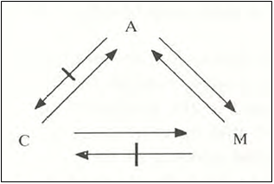
Figure 3: the Figure is showing the logic of natural movement
1) Attraction pole (A) which affect on movement but not on spatial order
2) Movement (M) which affect on attraction pole and is affected by it but does not have any effect on spatial order
3) Spatial order affects on movement and attraction pole but those do not have any effect on it.
Based on these logics, movement in space is more affected by spaces ordering and their relations with each other[8]

Movement is an aspect of vitality, of the experience of density and diversity that characterize urban life. Thus, generating, distributing, modulating or accommodating movement is at the core of urban planning and design[9]. In terms of urban planning and design, the layout of space first generates movement, then movement-seeking land migrates to movement-rich lines, producing multiplier effects on movement which then attract more retail and other uses, and this leads to the adaptation of the local grid to accommodate the greater density and mix of uses. This dynamic process is called the “movement economy”.

The biological concept of a genotype is essentially an informational concept. It describes something like a total informational environment within which the phenotypes exist, in the sense that individual phenotypes are linked into a continuously transmitted information structure governing their form. Through the genotype, the phenotype has transtemporal links with his ancestors and descendents as well as transpatial links with other contemporaneous organisms of the same kind. The genotype is at least partially realized in each individual organism through what might be called a description centre. A description centre guarantees the continuity of the class of organisms in time and their similarity in space. The description centre holds instructions locally on how some initial material is to adapt local energy sources in order to unfold into a phenotype. The description centre does not have to be a particular organ; it may be spread throughout the organism. It is a description centre because it contains a local embodiment of genetic instructions[10] .

The concept of Genotype is about understanding the social structures, the elements relations, ordered actions pattern and spatial relations. phenotype is changeable in different shapes. For Genotype, we could not make some chronic or location limitations because maybe one type of it would be seen in some building in two places[11] . Achieving hidden relations in urban elements and spatial relations understanding, is a complicated issue, but the important point is that in organic cities, which do not have geometric orders, but a special spatial logic is dominated on it that this spatial logic is hidden in it and make identity for city. Based on literature review, lighting in urban spaces with the space syntax, just one researching sample in 2006 by An-Seop Choi and his colleagues in the name of" Application of the space syntax theory to quantitative street lighting design" has been done.
For this, An-Seop Choi and his colleagues have used this process for their study.
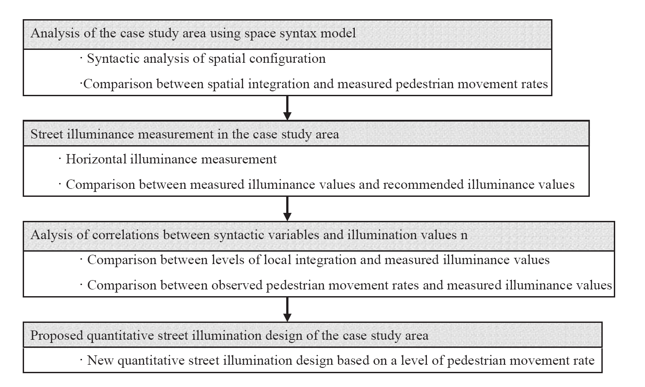
Chart No. 1: the process of Lighting plan study in Seoul- South Korea [12]

As it is mentioned in the second part of research, considering the context has an effective role on urban lighting .space syntax could be used for spatial understanding and its relations with social-spatial logic. So by the integration parameter, space syntax could analyze spatial relations that these analysis would Cause an understanding in context and also spatial organizer structure and logic of space.
In Figure 4 which is showing global integration map in Isfahan, spectrum blue to red, shows the increasing of global integration
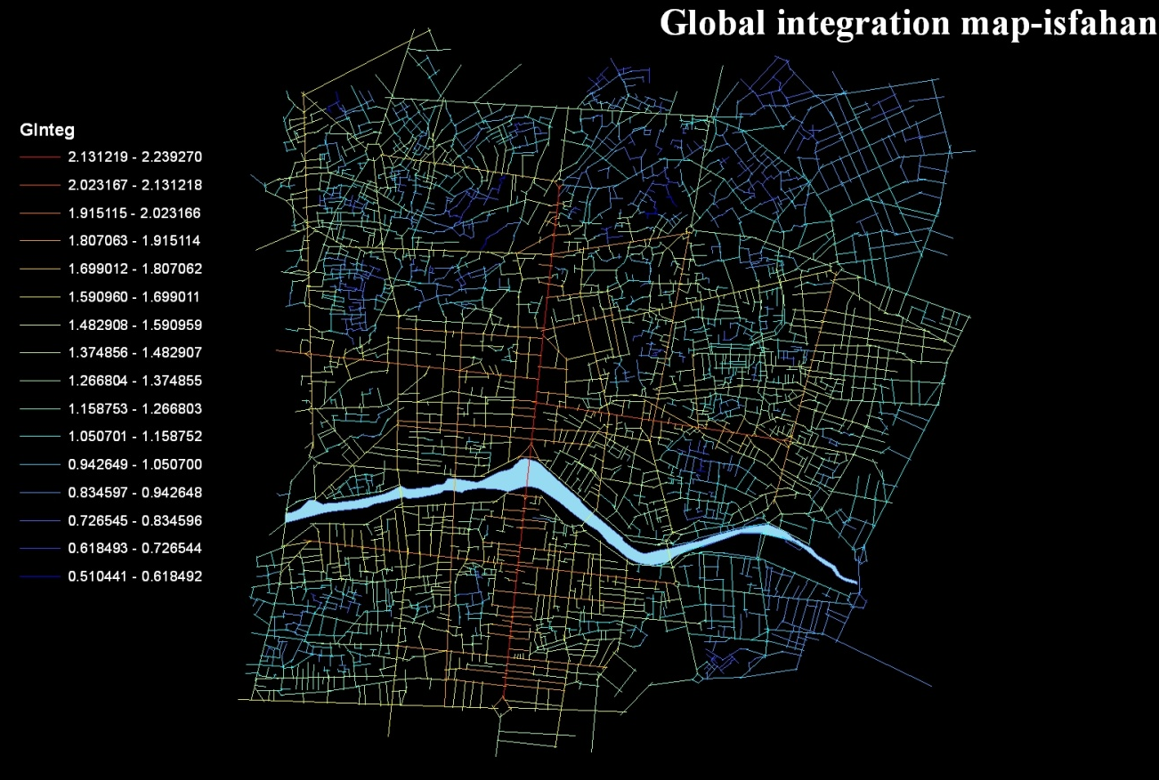
Figure 4 integration map of historical fabric of Isfahan, as it is clear the" Ghahar Bagh" axis has the highest integration value (Source: authors)

The urban space of central part of Isfahan was analyzed after drawing axial lines (the longest lines which provide view and accessing) by Axwoman software (extension software to ArcGIS9.3) and the results show the main structure and hierarchical order of spatial values. As a result, the spatial values resulting in understanding of context in terms of spatial and topologic relations can be extracted.
Correlation between integration and connections which contains the intelligibility parameter, could also analyze the guiding role of lighting. The meaning of urban intelligibility has a direct relation with the urban reconstructing. So the intelligibility of an urban is a relation between local and global spatial urban characters. Understanding an urban by its spaces (like streets) based on the connections between that space with other spaces (local character) and also the quality of integration those spaces (global characters) in whole urban system. In another word, Statistical correlation between connections of axial lines with integration, is a main index which the importance of those axial lines (space) in the whole urban system, would be shown. Intelligibility shows the level of spatial data which could be cached visually by an axial line (space)[5]
In fact, the urban clarity happens when there are conflicts between spatial urban system and social and cultural habitats, resident partnership with visitors [13].
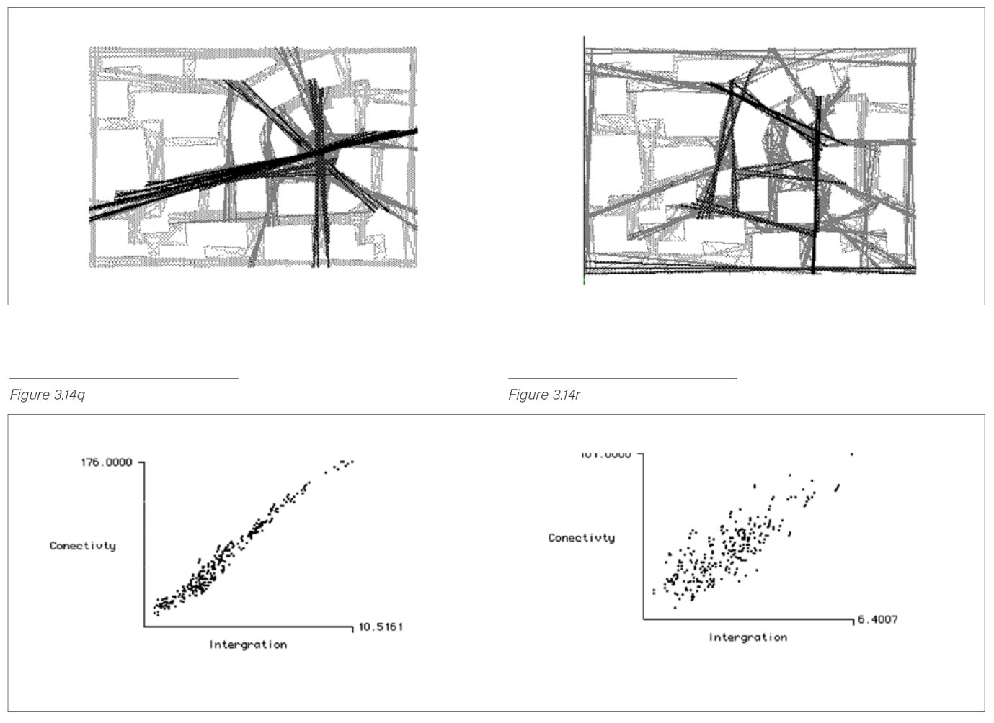
Figure5: this picture explains two different fabrics, as it is obvious in the left fabric, understanding the square position in contrast with whole fabric has more clarity. So the relation of fabric connections and integration has higher R- square in contrast with the right fabric[7]
The results of analysis have shown axis of Chahar Bagh as the main north-south axis and also Amadghah-Sharif Vaghfi axis (East-West) have higher global integration value. In the above Figure it has been shown. Red (higher) to blue (lowest) spectrum shows the value of global integration in urban spaces. Thus, in this way one can identify the organizer structure by integration of urban functions. Therefore high traffic spaces (natural movement theory) and land-use which need this population (movement economic theory) are shown in this structure. Also using numbers of cross roads and local integration, could help composing lighting strategy.
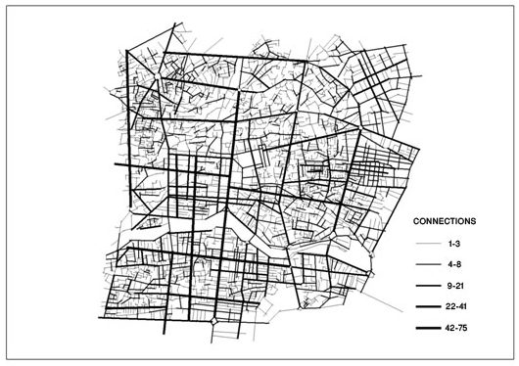
So, by taking into account the existence of organizer structure with urban operation would be recognized by the attention to historical context of Isfahan. This would make a relation between designer and context, based on the space syntax theory. In other hand, based on this logical analysis we could find second analysis about spatial relation with Lighting which would be used to support our plan. In analytical maps, it would be shown by connections, values of global and local integration, which could help designer to know the context of planning and also could affect organizer structure. In Figure 8, organizer structure has been shown by the attention of urban spaces in 3 categories: main, middle and minor, which could be used for composing a strategy for lighting strategy

Figure6: the map for value of intersections’ value (source: authors)
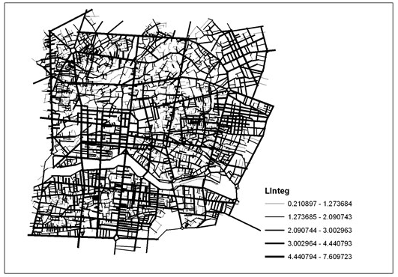
Figure 7: local integration value map (R3) (source: authors)
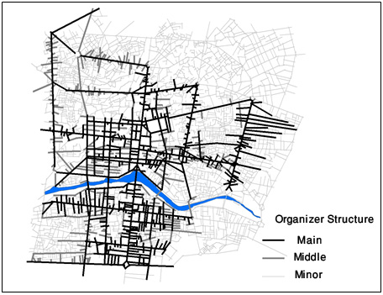
Figure 8: Organizer structure map of the center of Isfahan based on global integration values (source: authors)

4-Light pollution and its Environmental aspects
The main point about urban Lighting which has been named as the red line and necessity of planning is important on its Environmental aspects. For these considerations, the most important one is light pollution. It means using sources of light in unnecessary cases and using inappropriate sources in a place. It was observed by astronomer at first, and during the time, by the attention of researches about its bad effects on environment and health, was studied by other sciences. These days, inappropriate using of light energy and its huge use is one of the reasons for light pollution. For reaching a sustainable development in societies, it’s necessary to manage and control light pollution. In Figure 9, the effects of Light pollution like glare and trespass and so on are shown.

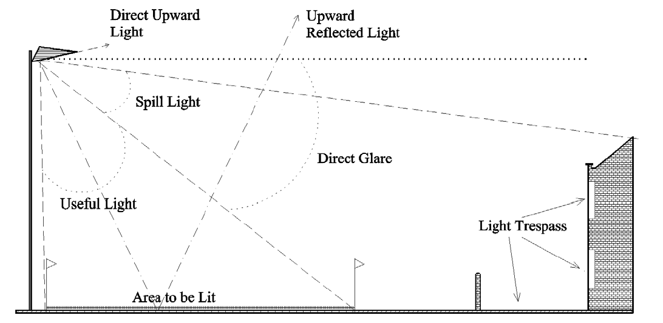

Figure 9: Types of light pollution effect in urban light sources
[14]

One of its important effects is on human health. Human has a naturally inner biological rhythm. Behaviors, operation and emotions would control this rhythm. The daily and nightly changes on sun light would make another system in human body, which make a boarding physiological rhythm on human body. Biological rhythm is active as endogen but circadian rhythm or boarding rhythm has been made by light changing and calibrates biological clock in hypothalamus. In a healthful body, biological rhythm and Circadian rhythm are according to each other. If human behaviors like: sleeping, working, feeding… was not fitting with circadian rhythm, biological activities like harmonic excretion, would be interrupted. The whole creatures even bacteria, have such a clock [15].
As the studies in this section, light pollution is so important in Lighting and is an effective parameter. In Figure 10 which is showing details of lightening master plan in Milchen, Belgium, light pollution has been noticed, intentionally. In this plan light pollution has been explained as a main rule for planning and designer of urban Lighting has to consider about it.
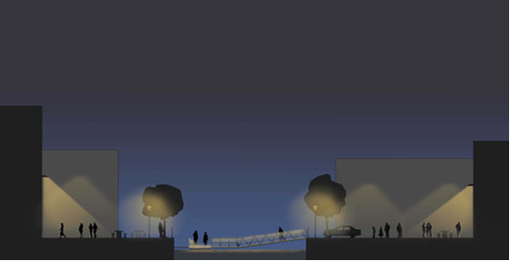
Figure 10: Mechelen (Belgium) Lighting Plan Details, with the Lowest Light Pollution[16]

So for lightning, with the attention of its importance, light pollution would be noticed as a planning filter for representing planning choices. So for planning, we need to study about light pollution. As an example in Lighting of Naghsh-e Jahan square which has been done lately, as article authors visiting, in some cases, light pollution has not been recognized. An example of inattention about light pollution has been shown in Figure 11.
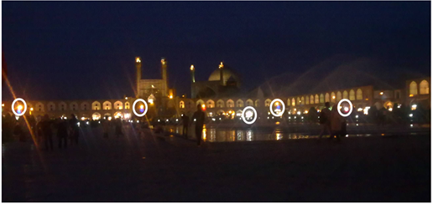
Figure 11: Light pollution in south of Naghshe Jahan[17]

5- Conclusion
One of the main goals of this study is to achieve a comprehensive look to urban lightning, because there is a gap in this subject. Some researchers have studied about as aesthetical view or Environmental and some others as social or cultural view. But in this study, we researched whole aspects in an urban context frame. For such a research we need a method which could explain context-oriented urban space and the complicated spatial relations in an easy way. Space syntax is a suitable frame for assessment of spatial relations and it could be useful in understanding organizer structure of urban spaces and also the effects of planning choices on organizer structure of urban spaces. Based on researches have been done, and miss existing a process for a strategy for urban lightning, a process would be suggested for urban spaces lighting.
In the proposed process, first of all, the basic urban studies such as historical, cultural, regional, social have been reviewed. For this, we used the available data-bases for evaluating different aspects of urban spaces, by taking into account the situation measurement and available evaluations. For context-oriented urban spaces via space syntax we used Integration parameter (local and global). In continues we will have directing which this issue would be analyzed by intelligibility parameter of space syntax method. Also design alternatives would be analyzed by space syntax. By studying the organizer structure and its prioritizing, we could achieve the lighting originated from the context.
The last step is suggestion process based on observance of topics related to light pollution that as it was mentioned in the text of research, it has a very critical role in lighting. This part is like a filter for assessing the strategy. Therefore, in order to compile the lighting strategy, this strategy cannot be effective and efficient without considering the issue of light pollution. So as we said in section 4, light pollution is considered as the red line and the planning requirements which shall be noticed. The main point in this model is that firstly it stands the scenario base and secondly these processes are two-way and fluid.
Totally this study has searched urban Lighting with a structural view. The main point is that the scale of this method is urban so this method would be used in urban Lighting plans. With the attention of historical fabrics and recording them in UNESCO, it is necessary to pay attention to lightning. So this process could be a key for urban Lighting especially in historical textures and a comprehensive view to context, culture, identity, history, topology, and Environment attentions, which makes this method distinct.

Light pollution filter
Urban basic studies
Context
Space Syntax
Guiding
Design Scenario
Global and local Integration+Conecctions
Intelligibility
Priorities of organizing structure
Lighting Strategy

References

[1] Tabatabaei, Seyed Mohammad Hossein (1389) Rasael Tohidi translated by: Dr Ali Shirvani, Park Institute,p65

[2] Tarahan Norpadazan ideh (1388) Study the regulation of cultural heritage monuments lighting, Beautification Organization , Municipality of Tehran,p64
[3] Tavalaee, N (1380) Contextualism in urban planning, Fine Art Magazine No. 10, Tehran University, p35
[4] (www.architonic.com)
[5] Abbaszadegan Mustafa. (1381) Method of space syntax in the Process of Urban Design, Urban Management Journal, No. 9, Tehran,p66 & p69
[6] www.spacesyntax.net
[7] Hillier, B. (2007) Space is The Machine: a Configurational Theory Of Architecture, Cambridge University Press, Cambridge,p 97
[8] Hillier, B.&Pen,A.& Hanson,J.& Grajewski,T&Xu,J.(1993) Natural Movment or,configuration and attraction in urban pedestrian movement,Enviroment and Planning B: Planning and Design,volume 20
[9]Peponis J, Wineman J, Rashid M, Kim S H, Bafna S, 1997 “On the description of shape and spatial configuration inside buildings: convex partitions and their local properties”. To appear in Environment and Planning B
[10] Hillier, B. & Hanson, J. (1984) The Social Logic Of Space, Cambridge University Press, Cambridge ,p 42
[11] Memarian, GH. (1381) Space Syntax, Architecture, Sofee magazine, No. 35, Tehran,p79
[12] An-Seop Choia_, Young-Ook Kima, Eun-Suk Oha, Yong-Shik Kim(2006) Application of the space syntax theory to quantitative street Lighting Design, Building and Environment 41 ,p 355–366
[13] Mir Azimzadeh. (2003) Evolving Urban Culture in Transforming Cities Architectural and urban design in a fluid context,PHD Thesis, Department of Urban Design and Planning,CHALMERS UNIVERSITY OF TECHNOLOGY, Göteborg, Sweden, p465
[14] -Institution of Lighting Engineers (2000)GUIDANCE NOTES FOR THE REDUCTION OF LIGHT POLLUTION, Registered in England No 227499 Registered Charity No 268547 A nominated body of the Engineering Council
[15] Pauley, S.M (2004) Lighting for the Human Cicadian Clock,Medical
Hypotheses:63,588-596.
[16] Susanna Antico Lighting Design ) 2010( Mechelen Lighting Masterplan, Mechelen، Belgium.
[17] Visiting of researchers- summer (2012).

- Msc in Urban and Regional planning, Iran University of Science & Technology, School of Architecture and Environmental Design.
- Assistant Professor in Landscape Architecture, School of Architecture and Environmental Design, Iran University of Science & Technology.

