Title:

Analysis of physical development and function of city entrances in Rasht, Iran

Nooreddin Azimi¹*, Mohammadreza Faroughi² and Mona Tajbakhsh³

¹ Assistant professor, Department of Urban Planning, Faculty of Architecture and Arts
University of Guilan, Km 5 Tehran Road, Rasht, P.O.Box 1841, Iran, Tel: +(98) 131-669-0381 Fax: +(98)131-669-0553, E-mail: Azimi@guilan.ac.ir/ nooreddinazimi@yahoo.com (Corresponding author)

² Mohammadreza Faroughi, Lecturer, Department of Urban Planning, Faculty of Architecture and Arts, University of Guilan, E-mail: Faroughi@guilan.ac.ir

³ Mona Tajbakhsh, PhD. Student, Department of Urban Design, Faculty of Architecture and Urban Planning, Shahid Beheshti University, Tehran, Iran, E-mail: M_Tajbakhsh@sbu.ac.ir,

Analysis of physical development and function of city entrances in Rasht, Iran

Abstract
Organization of a space and its elements is made according to their physical and functional characteristics which create a hierarchy in terms of the placement, use and observation of elements. As a common space, urban entrance is the first place that introduces a city to its visitors and it is imprinted in the memory of people. This study aims to provide a detailed analysis of the physical development and function of entrance axes in the city of Rasht, Iran and find out how they have been developed in congruence with the interior parts of the city. The data employed in this research mainly comes from a field survey and the collected data has been described using content analysis. Main findings indicate that entrance axes in Rasht present a low density pattern, in the form of single story row shops with sporadic low rise buildings and uneven distribution of activities dominated mainly by auto-related services. Because of the lack of design guidelines, most constructed buildings along the entrances neither comply with urban skyline nor with a continuous street edge line portraying a weak exterior outlook and inappropriate city image. Adopting a number of urban planning approaches such as supporting the density increase, encouraging mixed land uses, employing local architectural style in building design could enhance the exterior outlook, increase the land value, expedite investments and eventually improve the economy along the entrance axes.
Keywords: entrance axis, urban periphery, physical development, activity pattern, Rasht

- Introduction
After the 1960s, the political and socioeconomic transformations accelerated urban growth in Iran in such a way that it altered the country from a predominantly rural society to an urbanized nation by mid-1980s. The land reform policy of the early 1960s and following socioeconomic changes (Majd, 1987), is considered as the main important events that triggered first wave of rural urban exodus in Iran. As a result, many workers who previously worked for landowners, lost their jobs due to the transferring lands from landowners to villagers and moved to the cities where industrialization process demanded labor force. The outcome was the growth of informal settlements which emerged especially around the large cities (Majd, 1987). Revolution of 1979 and its ensuing socio-political changes accelerated rural-urban migrations which led to more urban growth and expansion of informal settlements around most cities (Maghsoodi, et. al, 2011). Over the 1970s and 1980s period, with 5.4% annual growth rate at national level, the share of urban population reached to 54% which changed Iran to an urbanized nation. Due to the government’s effective population control measures, the growth rate declined sharply in the following years; however, because of the continuation of rural-urban migrations, urban growth rate is still relatively high. In the past 25 years, urban population was doubled and exceeded 53 million. In contrast, for the first time, rural population experienced a negative growth after the 1996s (Table 1).

Table 1 goes here

The rapid urban population growth in Iran over the past decades resulted in uncontrolled physical expansion causing the emergence of informal settlements around most cities. The informal settlements in the urban fringe unfit with the main part of the city in terms of physical and socioeconomic conditions. Urban entrances are among the places where one can easily observe the unsuitable physical conditions in them. The unsuitable conditions in the entrances can be exemplified in their unfitted landscape, lack of visual harmony, congestion, less public facilities and little attention to the needs of arriving passengers. Through examining the physical development and activity pattern in the main entrances of Rasht, this article attempts to explore the possible ways to deal with the problems in this part of the city so that they could be embedded to the main city, represent city’s identity and improve the quality of urban environment.

2. Research background
Lynch (1960) identified five key elements that make up people's perception of their city. These elements are paths, edges, districts, nodes, and landmarks. Inspired by Kevin Lynch, Norberg-Schulz, in his Mellom himmel og jord - Between Heaven and Earth- has also argued that cities should have defined edges or boarders (Van Nes, 2012). City edge is usually felt by people while passing through urban entrance axes which relate outer parts of cities to their inner parts. Having a visible or tangible city edge or not, urban entrance axes act like thresholds of the city. According to Bridges and Charitos (1997), a threshold is an intermediate space which functions as interface or intersection between the other spatial elements. The nature of this interface may range from a state where one space flows into the other to a case where one space clearly ends and the other begins. They designate a gate from a space and an exit to another space. They are the intersections of the possible routes of an operator within the environment. Thresholds afford views to more than one space and involve decision-making (where to go next); the combination of the actual or potential navigation choices and the greater complexity of the scene, coupled with the decision-making process (Gale, et al., 1990).
From a philosophical point of view and according to Küpers (2011), transitional places and moves in space refer to spheres of an in-between as very basic constituents of liminality. The limen of liminality refers to a threshold or passageway, a state of being between two different existential planes. Crossing this threshold is a transient moment, but requires to actually ‘take place’. Like the bottom part of a doorway that must be crossed when entering a building, traversing the liminal refers to a practical move through transitional times and spaces. As thresholds are situated at an edge calling for a movement, they carry with them a sense of opening up towards and closing away from.
Andresen and Milani (2006), have emphasised on interaction between the natural world and human construction at the City Threshold” where the expanding sub-tropical city meets adjacent open landscapes, it forms a threshold or an in-between-place at times called the ‘peri-urban’. This often-contested threshold, while neither city nor landscape, comprises overlapping and contrasting elements of both. The result is a condition of complexity and ambiguity that enriches opportunities for creative invention- a condition common to threshold places at all scales”.
A recent model for planning built environment as part of the natural environment can help us in resiliently theorizing corridor and axis development concepts as the most important and tangible sections of a city, defining its characteristics and urban qualities. Over the last few decades, the new urbanists have mounted a remarkably successful public relations campaign against traditional zoning practices and the suburban land-use patterns resulting from them (Garnett, 2012).
Transect approach which is formulated by Andrés Duany, who previously put forward the Lexicon of the New Urbanism for designing neighborhoods and towns, is also a planning strategy that might help while seeking for different concepts to organize the elements of the urban environment in city thresholds (Talen, 2002). As nearly every town has some rural-to-urban distinctions, the transect defines a categorization system that organizes all elements of the urban environment on a scale from rural to urban. Arrangement of these elements enhances the visual experience of travelers passing through urban entrance axes and provides urban edge dwellers and passengers with their needs (Steuteville, 2000).
The transect defines a series of zones that transition from sparse rural lands to the dense urban core. Each zone is fractal in that it contains a similar transition from the edge to the centre of the neighbourhood. The design laden code is heavily influenced by architects and requires their participation in its implementation (Van Hemert, 2007, 3). Planners facilitate this system by learning how to allocate spatially, finding the appropriate location and juxtaposition of urban elements along a continuum of human habitats, from urban to rural. This serves to integrate natural and man-made systems in a way that is, in our modern world, conspicuously missing (Talen, 2002).
Connecting people is what corridors and axis are built for, but for too long we have been just using roads to cross distances, and we even lost the meanings that entrance corridors bring to the city. We connect from home to work, or from our neighboring town to our town passing entrance corridors without feeling being welcomed and delighted by an appropriate and visually beautiful transect of the city, but as our knowledge of urban issues is expanding, that logic is also clearly shifting and these days it is understood that roads and corridors must be designed in a way to satisfy a wide range of human needs.
According to Pakzad (2009, 9), the entrance functions as a transition which extends from the outside to the inside and from the public into the private domain. Organization of a space and its elements is made according to their physical and functional characteristics which create a hierarchy in terms of the placement, use and observation of elements. One of the functions of an entrance is connecting the external space to the internal space. Other entrance space functions include changing the direction, stop, expectation, entry, division and determining the directions and paths. Having a hierarchy among these activities, leads to a better function of entrance spaces (Soltanzadeh, 2005).
In general, entrance spaces could be categorized into perceptual and functional characteristics which reflect the formation of the elements of entrance spaces and their physical and functional characteristics (Bahraini, 2003). The perceptual characteristic deals with factors such as inviting, identity, the sense of arrival, ready to view a new space and perceptual communication between the two spaces. The functional characteristics of a space include cases such as establishing the physical connection between the two spaces, providing needed security and monitoring related connections, guidance and control, introducing the city and defining several of its characteristics and its presence among the daily activities of the city (Soltanzadeh, 2006).
Because of the change in transportation systems, today the nature of urban entrance has changed from the past as no longer a specific point separates inside and outside of a city. Since the speed of vehicles and the volume of traffic among the cities have dramatically increased, the old entering points have changed to a kind of buffer zone which allows incoming travelers to adjust road speed to city speed. Entrances stimulate the sense of arrival for the travelers and prepare them to enter the city. It is from this perspective that, we think addressing the case of city entrances in Rasht would help us to understand their functions and problems and seek for the ways to improve the quality of urban environment in a fast growing third world city.

- Historical development and present status of Rasht
Historically, Rasht was a major transport and business centre which connected Iran to Russia and Europe, and was therefore entitled the "Gate of Europe" (Iranica, 2011). The origin of Rasht has been referred to a village between Lahijan and Fouman regions in 10th century where it was as a rest area for passing caravans (HUDGP (2007a; Sutudah, 1962). However, its modern history dates back to the Safavid era in 17th century when Rasht became the provincial capital of the Guilan under Shah Abbas and grew as a major centre for silk trade with numerous textile workshops (Sardar-Afkhami, 1966).
Because of its long time relation to the west, Rasht exposed to international diplomacy and trade contributed to the early development of "European-style" cultural activities, in advance of other Iranian cities (Iranica, 2011). To mention, the first national library of Iran was established in Rasht under the Qajar dynasty (1785 to 1925), a theater was founded in the early years of the twentieth century and Nasim Shomal as the first modern newspaper of Iran after the constitutional revolution (1906-1911) was published in this city (Nowzad, 2000, pp. 15,94). Another sign of Europeanization and uniqueness of Rasht was the very early development of women's associations in this city. During the constitutional revolution, female circles (anjomans) were created in the province (Afary, 1989) and later in the 1930s, an association of literary women was established which worked for the advancement of women through various project initiatives and the publication of a bimonthly magazine (Faḵhraʾi, 1976, pp. 359, 560).
Existence of religious minorities from the past and presence of foreign representatives and businesses, because of the commercial linkage to Russia and Europe, characterized Rasht as a multicultural city (Bromberger, 1988, p 96). Rabino, the early twentieth-century English vice-consul in Rasht, reports that in the late eighteenth century there was a large group of Armenians in Rasht, as well as a considerable number of Russians, many Hindus and Jews were living in the city (Rabino, 1995, P. 548).
For most part of its history, the physical expansion of Rasht was confined between Zarjub and Gowhar-rud rivers and its appearance was distinct from cities of the Iranian plateau. The old city was not surrounded by gated walls and its bazaar was not covered (HUDGP (2007a). Rabino described the bazaar in these words: "Instead of a vaulted roof or dome stretching from one end of the street to the other, there are canopies on both sides to protect from the sun and rain" (Rabino, 1995, p. 74). Rasht remained only lightly populated and its population did not exceed 60,000 until World War I (Iranica, 2011).
Under Reza Shah’s rule (1920-1940), large thoroughfares were built from north to south and from east to west, and post office, City Hall and Hotel Iran buildings were constructed on the main square (Azimi, 2006). Later, under Mohammed Reza Shah and following the land reform policy of 1960S and later establishment of the Islamic Republic (1979), rural migrations began which led to a considerable population increase and physical expansion of the city. New neighborhoods were created, producing a markedly different social geography. Since that time, the rich and fashionable neighborhoods including Golsar in north, Moṭahhari at the center, and Manẓariya in the south, while middle class residents tend to live in Bisotun, Sabza Meydan, Saʿdi, Ḵomeyran-e Zahedan, and Estaḵr. The eastern, southern, and western districts of Kord Maḥalla, Taza-abad, Jamaran, and Hafezabad are mostly home to poor migrants, who settled on the outskirts of the town close to the roads leading to their regions of origin (Iranica, 2012).
Within the city, each old district includes at least one religious building. To the east of the bazaar and the current Moṭahhari avenue, there is a large concentration of religious buildings, including boqʿa-ye ḵahar-e-emam ", and the mosques of Badi-allah and Ṣafi, built under the Safavids. In addition to the Friday Mosque of the bazaar, the bazaar itself includes mosques for each profession (mosque of zargaran, the goldsmiths; mosque of Kasa-forušan, the vessel merchants, edged by a theological school; etc.). To the west of the city lies the shrine of Dana-ye Ali and Baqerabad Mosque of Ḥaj Ṣamad Khan to the north of Bazaar (HUDGP (2007a).
An evidence to the city’s multicultural past, Rasht comprises a few Christian churches and a section of the bazaar called Posht-e kelisa "Behind the church" indicates the remembered presence of an old church. While there is no synagogue in Rasht, the place name Tappa-ye Yahudi, still in use, gives evidence of Jewish settlement. The most outstanding architecture, however, is found in public, rather than religious, monuments and date from the end of the Qajar (19th century) and early Pahlavi period. The town hall and the post office are imposing and elegant buildings of early twentieth-century European style, standing on the main city square, while the pavilion (Emarat-e Kolah-farangi) adorns the southern city park (Park-e shahr). Rasht also contains many upper-class houses with brick walls, verandas and wooden doors, wooden mullion and multicolored glass windows, and roofs covered with semi-cylindrical roof tiles (Iranica, 2011). Among these remarkable houses are the Abrishami house in the Ṣayqalan neighborhood and the Qadiri house in the Sabza Meydan neighborhood (Azimi, 2006).
Under the general socioeconomic conditions of the country, Rasht has experienced a rapid population growth and physical development particularly during the last three decades which transformed it from a medium sized city to a regional metropolitan in the recent years. Between the 1950s and 1970s, population growth in Rasht was moderate; however, after the 1980s, it has been one of the fastest growing large cities in Iran (Table 2).
Table 2 goes here
The rapid population growth of Rasht in recent decades has accompanied by significant physical expansion. While in 1979 Rasht occupied only 1,579 hectares (ha) of land, the city expanded to 8,118 ha in 2006 (HUDOG, 2007a). Like many third world cities, such a rapid growth relinquished a balanced urban development and led to the emergence of various urban problems, such as inadequate infrastructure, lack of basic services, congestion, housing shortage and informal development particularly in the fringe areas (Azimi, 2004). Because of the rapid growth, large amount of agricultural lands around the city especially along entrance roads were consumed. In this study, four main entrances in the city of Rasht with 9.8 km in length are examined in detail.
4. Data and methods
The main data utilized in this study comes from a field surveys conducted in the summer of 2013. A questionnaire was designed to obtain the physical and functional characteristics and of all land lots and buildings constructed on the first layer (row) of four main entrances in the city of Rasht. The main variables included number of lots, type of land use, the size, height, density, exterior outlook, public facilities and quality of environment. All of the land lots along the four entrances which included 707 lots were enumerated. The entrances are: 1) the Tehran Road (Rd) entrance in the south, 2) the Lahijan Rd entrance in the east, the Anzali Rd entrance in the northeast and the Fouman Rd entrance in the west. Their lengths are 2.4 km, 2.1 km, 2.3 km and 3.0 km respectively. Figure 1 shows the location of study area in the city of Rasht.

Figure.1 goes here
We used both quantitative and qualitative methods to describe and explain the characteristics of urban entrance in terms of their physical development, activity patterns and quality of urban environment.
5. Findings
5.1 The physical development of entrance axes
5.1.1 Built and undeveloped land lots
A total of 707 land lots were counted along the four main entrances in Rasht from which 616 (87%) were built lots and 91 (13%) were undeveloped or vacant lots. Most of the activities along the entrances are in the form of small and single story row shops. On average, there are 35 lots per kilometer along the entrances which varies between 28 in Anzali and Fouman Rd entrances to 57 in Lahijan Rd (Table 3). The difference number of land lots shows that Lahijan entrance axis has the densest activities among the other three. Tehran Rd entrance with 39 land lot per km has the average situation.
Table 3 goes here
Some of the vacant or undeveloped lots along the axes are fenced, but some others have been left without any use and maintenance which produce unsuitable image for the entrances.

5.1.2 The lot size
To evaluate the scale of development along the entrances, we calculated the size of land lots and classified them in different classes. The most recently updated map of Rasht was used for this purpose. Based on the range of land lots, they were divided into five categories including very small size (less than 100 m²), small size (100 -249 m²), medium size (250- 499 m²), large size (500-1999 m²) and very large size (over 2000 m²). The distribution of lot size within the entrances axes and among them varies considerably. In general, there are a large number of small lots with lowest area share and, in contrast, a small number of very large lots with highest area share. In aggregate, among the four entrances, 27.3% of the land lots are very small with only 1.1% of area share and very large lots which include 7.4% of the of the total lots, but share 68.9% of the area (Table 4).

Table 4 goes here
Among the entrances, Lahijan Rd with 34% has the highest ratio and the Tehran Rd with 11% has the lowest ratio of the smallest lots size. This implies the dominance of small scale activities on Lahijan Rd entrance. On the other hand, Anzali Rd with 17% and Lahijan Rd with 4% have the biggest and smallest ratio of very large lots respectively. This is also indicated in the average lot size among the entrances with 1806 sqm for Anzali Rd and 806 Sqm for Lahijan Rd. We can argue that the unequal distribution of lot size could imply unequal scale of activities along the entrances axes.
As Table 4 indicates, 68.9% of area share along the entrances axes belong to land lots with over 2000 sqm and about 20% to land lots between 500 and 2000 sqm. With respect to the overall residential density of 157 persons per hectare in Rasht (HUDGP, 2007b, p. 504) and taking account that the size of 80% houses in 2011 census was 100 sqm (SOGP, 2012), we can argue that the density of development in most part of the entrance axes are very low compared to that of the whole city.
5.1.3 Building age
Among 616 buildings surveyed along the main entrances, 15.9% are 10 years old or less, 17.3% between 11 and 20 years old, 40.8% between 20 and 30 years old, and finally 26.1% are over 30 years old. Among the entrances, Tehran Rd entrance has a relatively higher percentage of newly constructed buildings compared to the other three. On the other hand, the Fouman Rd has older buildings than the others (Figure 2).
Figure 2 goes here
Like many other large cities in Iran, after the end of Iran-Iraq war (1980-1988), there have been substantial redevelopments within the city of Rasht which has noticeably transformed urban landscape in many interior districts. As a result, the number of newly constructed buildings and their density have considerably been increased. However, fewer redevelopments are observed along the entrance axes. It is estimated that while on average about two thirds of existing housing units in Rasht have been built in the past 20 years, less than one thirds of the existing buildings along entrances have been built in the same period (SIC, 2012; SOGP, 2009).
One of the main reasons for the higher percentage of buildings with over 20 years old along the entrance roads could be attributed to the general conditions of the country in the early years of the 1979 revolution when urban areas received massive migrants from rural areas which mainly settled in the fringe and along the entering road to the city.
With expanding the redevelopments toward the city edges, more reconstruction is expected to take place along the entrance roads as its evidence can be seen on the Tehran Rd. Also taking into account that most existing buildings along the entrances are single story row shops with over 20 years old, the possibility of their redevelopments in the near future is very high. Therefore, through the implementation of appropriate urban design guidelines, the new development along the entrances could integrate them in the main body of the city.
5.1.4 Building height
Our survey indicated that in terms of building height most buildings along the main entrance roads are relatively lower than that of the city average. In total, among the 616 surveyed buildings, 70% were single-story, 19% two-story, 6.1% three-story, 4.5% four-story and only 0.4% five-story buildings and on average in the four entrances 1.46 stories (Figure 3). Based on 2006 census, the average building height in the whole city was 1.75 floors (HUDGP, 2007b). From the last decade, because of the shortage of land within the city, the majority of buildings are constructed in multi-story form. Based on 2011 census, about 45% of the total residential units in Rasht are considered apartment houses (apartment here means buildings with 3 or more housing units). Our findings show that among the entrance axes, Tehran Rd with an average of 1.77 stories has relatively taller buildings than the other three. As stated the existing buildings along the entrances are mostly single-story; however, the new redevelopment takes place in form of multi-story buildings as we can see in the case of Tehran Rd entrance.
Figure 3 goes here 2012
5.1.5 Building façade
Building façade features the environment image of city (Moughtin, et al, 1995) and plays an important role in urban and environmental design (Utaberta, 2012). It also represents the value of building structure and is considered as representative device for inner and outer of the building (Askari, 2009).
Based on the existing building façades in the entrance axes, we categorized them into seven classes including: stone, cement, brick, store shutter, glass/composite and other materials. Even though the store shutter is not a usual façade type, we considered it here as a class because most single-story buildings along the entrances are row shops with shutter outlook. 47.2% of the facade of buildings/shops are shutter, 17% stone, 12.6% cement, 6.6% glass or composite, 3.5% brick and 2.6% other materials. Approximately 10.6% of the buildings lacked any façade (Table 5).
Table 5 goes here
As Table 5 depicts, store shutter is the dominant façade type in all the entrances. Among them Fouman Rd and Lahijan Rd entrances with 55% and 51% have the highest share while Tehran Rd and Anzali Rd entrances with 38% and 42% have lowest share. More stone and brick facade, most used materials in today constructions, are found in Tehran Rd entrance which implies more redevelopment along this entrance than the other three.
5.1.6 Building materials
In this study, we divided the structural materials into three main categories including 1) iron and concrete structure, 2) brick and iron structure, and 3) cement block. Iron or concrete frame structure is the most durable structure and usually most multi-story buildings are built with this material. In brick and iron structure, walls are typically built with brick and the spanning is made with iron lintels covered with a brick arch which is relatively stable. The cement block structure has been defined as a less stable structure because its main material is comprised of cement blocks covered most frequently with wooden or iron lintels.
According to Figure 4, from 616 buildings along the main entrances, about 69.9% have been built with iron or concrete frame, 15.9% with brick and iron and 14.2% with cement block. Estimated figures for the whole city are about 67.7%, 22 % and 10.3% respectively which relatively are the same SOGB, 2009). Among the entrances, Anzali Rd with close to 80% has the highest share of durable building (Iron/concrete structure); while Fouman Rd entrance with over 20% has the highest share for less durable structures (cement block material).
Figure 4 goes here
5.2 Activity patterns in the urban entrances of Rasht
Our study showed that most of the land lots along entrance axes have more than one activity. We enumerated a total of 1857 activities at ground level along the four main entrances in Rasht (an average of more than three activities per land lot). However, on the upper floors number of activities decreases sharply; 162 at second floor, 60 at third floor and 42 on fourth floor and up. The reason for this sharp decrease is that the majority of built lots are single-story buildings and only less than 30% of them have more than one story buildings. On the upper floors, land uses are mainly residential and in some cases, office use. Based on the existing patterns of land uses, we categorized the activities in 11 classes. Type and distributions of activities within each entrance and among them is depicted in Figure 5.
Figure 5 goes here
As Figure 5 illustrates, in general auto-related activities (including auto services and auto parts) with 39.5% are dominant along the entrance axes; followed by general commercial activities with 24%, public services with 9.7% and manufacturing with 7.4%. Other activities (e.g. education, health, transportation) comprise 7.5% and vacant buildings/shops 11.9%. Except for some difference in the Tehran Rd, most of the activities along the entrances are almost similar to each other.
Among the four entrances, we can see a noticeable difference between the Tehran Rd and the other axes. In Tehran Rd, general commercial use with 37% has the biggest share followed by auto-related activities with 23.7% and public services with 14.8%. In Lahijan Rd, auto-related activities with 52.2% dominate the other uses and general commercial use with 17% and public services with 7% are next important activities in this entrance axis. In Anzali and Fouman roads, auto related activities are in the first place with 42.4% and 37% respectively followed by general commercial land use with 21.4%.
In addition to the sharp decrease in the number of activities on upper floors, activity pattern in them is also different than that of the ground level. While most activities at ground level are auto-related or commercial uses, 72% of the activities on the second floor are related to residential use, 14% office use, 3.7% commercial use, 2.5% public services, 2.5% health use, and the remaining 5% other uses. Activities on the third floor and above were primarily residential use and in some occasions office use.
6. Summary and conclusion
Rasht experienced a rapid population growth especially after the 1979 revolution in Iran which instigated massive rural migration and led to the expansion of informal settlements around the city. The rural migrants primarily began to settle in the urban fringe and mainly around the entering roads. These developments rapidly expanded and in a period of about two decades (1980s-1990s) most areas between entering roads were filled and the city was almost encircled by informal settlements (HUDGP, 2007a).
Since the expansion of informal settlements and development along entrances occurred fast, they lacked to attain adequate urban facilities and their land use patters did not shape in congruence with those of the interior districts.
The urban morphology along the entrances has mainly been shaped in the form of single story row shops with sporadic multi story buildings of between two and five floors. Because of the lack of design guidelines, most constructed buildings along the entrances neither comply with urban skyline nor with a continuous street edge line. While the margin of interior streets usually are covered with full line of trees, except for the case of Tehran Rd entrance, the margin of entrance axes mostly do not have adequate greenery. The output is streets with zigzag edges of buildings with no harmonic skyline, weak greenery and inappropriate landscape.
Another aspect of development along entrance roads is their lower density pattern compared to that of the interior districts in the city. As mentioned before, 70% of the buildings along entrances are single story and another 19% two-story buildings and only a few between three and five story structures. The average area size for land lots along the main entrances is relatively large (over 1300 sqm) with less residential land uses compared with the internal districts. Moreover, 13% of the land lots along the main entrances are undeveloped or vacant spaces without any activity. Considering that the densification policy is pursued in the new city plan, increasing the density along entrance roads could be reemphasized in the future developments.
Despite the general lower building density along the entrances axes, the function of most entrances is auto related activities which drag people from the city for car repair services. In addition, many people use these entrances to commute to work or educational services located in the suburbs which contribute to heavy daily traffic. While adoption of some traffic control measures like prohibiting street parking along the entrances could lessen the existing traffic in the short term, construction of new ring road plan around the city could alleviate the congestions of entrances axes in the long term.
The existence of buildings affected by 19th century Russian architecture, bazaar with its different components, prominent public buildings, distinct neighborhoods and beautiful gardens within the city have generated an identity for Rasht that is rooted in the local culture and historical past. This identity has been imprinted in the memory of people who lived or visited the city. Other aspects of Rasht’s identity can be summarized in the elegant houses with large and wooded yards, big verandahs, sloped roofs covered with semi-cylinder clay and extended eaves, wooden doors and windows with colored glass, especial building style and passages to allow air circulation and deter strangers, neighborhood mosques or other religious sanctuaries and local Mydanches (small squares) for social events.
Characteristics of rapid growth and physical expansion after the revolution of 1979 around Rasht, was mostly unplanned and accompanied by insufficient public services, inadequate infrastructure, low quality housing, lack of identity and inappropriate urban landscape. Developments along urban entrance axes share most of these characteristics
Like other large cities in Iran, since 1990s shortage of urban land in Rasht persuaded local authorities for the adoption of densification policy in the previously built areas. As a result, a wave of redevelopment began and spread in many interior districts. Because of the continuation of rapid population growth in Rasht, redevelopment is advancing outward. Since the majority of existing buildings along the entrances are one or two stories with over 20 years old, they are prone for redevelopment and some have already begun.
Adopting a number of urban planning approaches such as supporting the density increase, encouraging mixed land uses, employing local architectural style in building design could enhance the land value, expedite investments and eventually improve the economy along the entrance axes. Increasing the land value and further redevelopment could push the congestion producing car services out of the entrances and replace them with more clean, higher class and tourist related activities like hotels, restaurants, souvenir shops, banks and social and cultural activities. These measures and placing some cultural figurative symbols in appropriate open spaces could help to the revival of the city’s identity, facilitate the integration of entrance axes to the main city and improve the quality of urban environment.

References
Afary, J. (1989) On the Origins of Feminism in Early Twentieth Century Iran, Journal of Women’s Studies 1/2, pp. 65-87.
Andresen, B., and Milani, L. (2006) Place and occasion at the city threshold. In: R. Kenny (ed), Subtropical Cities Conference Proceedings: Achieving Ecologically Sustainable Urbanism in a Subtropical Built Environment, 27-29 September 2006, Brisbane, Australia, pp. 1-12.
Askari, A, (2009) Public Evaluation of Historical Building Facades in the Vicinity of Dataran Merdaka, Kuala Lampur. Journal of design and built environment Vol. 5, December, pp. 49-59.
Azimi, N. (2006). Restructuring urban morphology, a case study of Rasht, Iran, Quarterly Researches in Geography, University of Tehran, No. 53, pp. 13-25.
Azimi, N. (2004) Recent urban housing change in Iran, a case study of Rasht, Guilan Province, in: Proceedings of the International Conference on Adequate & Affordable Housing for All, June 24-27, 2004, University of Toronto, Toronto, Canada.
Bahraini, H. et al. (2003) Environmental design principles and standards of urban entrance, Journal of Environmental Studies, 29 (31): pp. 13-36.
Bridges, A.H. & Charitos, D. (1997), "On Architectural Design of Virtual Environments", Design Studies, Vol. 18 (2) pp.143-154.
Bromberger, C. (1988) "Comment peut-on être Rashti? Contenus, perceptions et implications du fait ethnique dans le nord de l'Iran," in J.-P. Digard, ed., Le fait ethnique en Iran et en Afghanistan, Paris, pp. 89-108.
Faḵhrāʾi, E., (1976) Gilān dar gozargāh-e zamān, Tehran.
Gale, N., Golledge, R., Pellegrino, J.W. and Doherty, S. (1990) The acquisition and integration of route knowledge in an unfamiliar neighbourhood, Journal of Environmental Psychology, 10, (1) pp. 3-25.
Garnett, N.S., (2012) Redeeming Transect Zoning. Brooklyn Law Review, Notre Dame Legal Studies Research Paper No. 12-83. pp. 571-588.
HUDGP (2007a) Master plan of Rasht, Vol. 1. Housing and Urban Development Organization of Guilan Province, Rasht.
HUDGP (2007b) Master plan of Rasht, Vol. 2. Housing and Urban Development Organization of Guilan Province, Rasht.
Iranica, Encyclopedia, (2011) RASHT i. The City, Accessed at: http://www.iranicaonline.org/
Küpers, W. (2011) Dancing on the limen–embodied and creative inter-place as thresholds of becoming: phenomenological perspectives on liminality and transitional spaces in organisation. Tamara, Journal for Critical Organization Inquiry, Special Issue on Liminality, 9(3–4):pp. 45–59.
Lynch, K. (1960) The Image of the City, Cambridge: MIT Press, Massachusetts.
Maghsoudi Tilaki, M., Mostafa, R., Marzbali, M.H., Abdullah, A and Arrifin, J. (2011) Chanllenges of the informal settlements in developing countries’ cities, a case study of Iran, World Applied Sciences Journal, 12 (2), pp. 160-169.
Majd, M.G. (1987) Land Reform policies in Iran, American Journal of Agricultural Economics, Vol. 69 (No. 4) 198.
Moughtin, C., Oc, T., and Tiesdell, S, (1995) Urban Design: Ornament and Decoration, Great Britain: Butterworth Architecture Press.
MPGP (2007) Statistical Yearbook of Guilan Province, 2006, Management and Plan Organization of Guilan Province, Rasht.
Nowzād, F., (2000) Tāriḵ-e jarāʾed o majallāt-e Gilān az āğāz tā enqelāb-e eslāmi, Tehran.
Pakzad, J. (2009) Theoretical Principles of Urban Design Process, Ministry of Housing and Urban Development, Shahidi Publications, Tehran.
Rabino, H. L., W(1995) V el ayāt-e dār-al-marz-e Irān:Gilān, tr. J. Ḵhommāmizāda, Taati Publication, Rasht.
Sardar-Afkhami- Engineering Consultants (1966) First Master Plan of Rasht, Ministry of Housing and Development, Tehran.
SCI (2007) Detailed Results of the General Census of Iran, Guilan Province, Statistical Centre of Iran, Tehran.
SOGP, 2011) Statistical Year book of Guilan Province, 2010, Management and Plan Organization of Guilan Province, Rasht.
Soltanzadeh, H. (2005) Entrance Spaces in Traditional Iranian Architecture, Daftar Pajoheshhaye Farhanghi, Tehran.
Soltanzadeh, H. (2006) Urban Spaces in Historical Contexts of Iran, Daftar Pajoheshhaye Farhanghi, Tehran.
Statistical Centre of Iran (SCI), (2012) Statistics Yearbook of Country for 2011.
Statistical Office of Guilan Province (SOGP), (2009) Detailed Result of 2006 Census, Shahrestan-e-Rasht, Raht.

Steuteville, R. (2000) Transect applied to regional plans, Better! Cities & Towns, September Issue, p. 1 Accessed in Jan. 2012: http://bettercities.net/article/transect-applied-regional-plans.
Sutudah, M. (1962) Hododol Allam Menal Mashreg val Maghreb, University of Tehran.
Talen, E. (2002) Help for Urban Planning: The Transect Strategy, Journal of Urban Design, Volume 7, Number 3, pp. 293-312.
Utaberta, N., Jalali, A., Johar, S., Surat, M. and Che-Ani, A. I. (2012) Building Facade Study in Lahijan City, Iran: The Impact of Facade's Visual Elements on Historical Image, World Academy of Science, Engineering and Technology Vol. 67, pp. 701-706.
Van Hemert, J. (2007) Sustainable Zoning: A New Imperative, the Sustainable Community Development Code, Rocky Mountain Land Use Institute, February 2007, Draft, accessed at: http://www.law.du.edu/images/uploads/rmlui/rmlui-sustainable-SustainableZoningFramework %206.
Van Nes, A., (2012), Between Heaven & Earth Christian Norberg-Schulz's Contribution to the Phenomenology of Place & Architecture, in Environmental & Architectural Phenomenology Newsletter, Vol. 24.
Table 1 Population distribution in urban and rural area and number of cities in Iran (1956-2011)
Year |  | Urban Population |  |  |  | Rural Population |  |  |  | Country
Year | Number  (1,000) |  | % | Growth rate | Number  (1,000) |  | % | Growth rate | Total  (1,000) |  | Growth rate | No of Cities
1956 | 5,954 |  | 31.4 |  | 13,001 |  | 68.6 |  | 18,955 |  |  | 201
1966 | 9,794 |  | 38 | 5.1 | 15,994 |  | 62 | 2.1 | 25,789 |  | 3.1 | 271
1976 | 15,855 |  | 47 | 4.9 | 17,854 |  | 53 | 1.1 | 33,709 |  | 2.7 | 373
1986 | 26,845 |  | 54.3 | 5.4 | 22,600 |  | 45.7 | 2.4 | 49,445 |  | 3.9 | 496
1996 | 36,818 |  | 61.3 | 3.2 | 23,237 |  | 38.7 | 0.3 | 60,055 |  | 2.0 | 612
2006 | 48,260 |  | 68.6 | 2.7 | 22,131 |  | 31.4 | -0.5 | 70,391 |  | 1.6 | 1,012
2011 | 53,647 |  | 71.4 | 2.1 | 21,503 |  | 28.6 | -0.6 | 75,150 |  | 1.3 | 1,331
Source: (SCI, 2012)

Table 2. Population growth in Rasht 1956-2011
Rasht | Rasht | Growth rate of Rasht | Average Growth rate for cities over 500,000
1956 | 109,491
1966 | 143,557 | 2.75 | 5.15
1976 | 188,957 | 2.79 | 4.96
1986 | 290,036 | 4.41 | 4.61
1996 | 417,748 | 3.72 | 2.42
2006 | 557,366 | 2.93 | 2.01
2011 | 639,951 | 2.80 | 1.66
Source: (SOGP, 2011; MPGP, 2007)

Table 3 Status of land lots in the main entrance axes, Rasht, 2013
Status of land lots | Number of lots |  |  |  | All entrances
Status of land lots | Tehran Rd | Lahijan Rd | Anzali Rd | Fouman Rd | No | (%)
Total number of land lots | 191 | 212 | 133 | 171 | 707 | 100
Built land lots | 168 | 194 | 116 | 138 | 616 | 87.1
(%) | 88.0 | 91.5 | 87.2 | 80.7 | 87.1
Undeveloped (vacant) land lots | 23 | 18 | 17 | 33 | 91
(%) | 12.0 | 8.5 | 12.8 | 19.3 | 12.9 | 12.9
Length of the entrance (km) | 2.4 | 2.1 | 2.3 | 3.0 | 9.8
Ave. number of land lots per km | 39.8 | 50.5 | 28.9 | 28.5 | 36.1

Table 4 Classification of lot size among the main entrances of Rasht, 2013
Land lot classes | Tehran Rd |  | Lahijan Rd |  | Anzali Rd |  | Fouman Rd |  | All entrances
Land lot classes | Lots (%) | Area (%) | Lots (%) | Area (%) | Lots (%) | Area (%) | Lots (%) | Area (%) | Lots (%) | Area (%)
Very small lots (<= 99 m²) | 11.1 | 0.3 | 34 | 2.7 | 31.5 | 0.7 | 28.1 | 1.4 | 27.3 | 1.1
Small lots (100-249 m²) | 27.8 | 3 | 21.6 | 7.7 | 23.3 | 2.2 | 26.3 | 5.3 | 24.4 | 4.2
Medium size lots (250-499 m²) | 31.7 | 6.8 | 15.6 | 10.9 | 6.8 | 1.4 | 21 | 8.2 | 18.8 | 6.3
Large lots (500-1999 m²) | 21.7 | 11.3 | 24.5 | 44.4 | 20.6 | 11.2 | 20.1 | 21.9 | 22.1 | 19.6
Very large lots (=>2000 m²) | 7.7 | 78.6 | 4.5 | 34.2 | 17.8 | 84.4 | 4.4 | 63.1 | 7.4 | 68.9
Total (%) | 100 | 100 | 100 | 100 | 100 | 100 | 100 | 100 | 100 | 100
Total no. of lots | 191 |  | 212 |  | 133 |  | 171 |  | 707
Total area of lots (ha) |  | 30.06 |  | 17.1 |  | 26.37 |  | 19.68 |  | 93.2
Average lot size (m²) |  | 1574 |  | 806 |  | 1806 |  | 1151 |  | 1318

Table 5 Status of building façade in the main entrances of Rasht, 2013
Type of façade | Tehran Rd | Lahijan Rd | Anzali Rd | Fouman Rd | All entrances
 | (%) | (%) | (%) | (%) | (%)
Store-shutter | 38.5 | 51.6 | 42.2 | 55.7 | 47.2
Stone | 26.1 | 14.6 | 12.2 | 13.4 | 17
Brick | 9.4 | 0.5 | 0.8 | 2.7 | 3.5
Glass/composite | 4.6 | 13.9 | 3.4 | 1.4 | 6.6
Cement | 14.7 | 7.4 | 23.2 | 8.6 | 12.6
Other materials | 2.4 | 3.3 | 2.4 | 1.8 | 2.6
Facade-less | 4.3 | 12.5 | 10 | 16.2 | 10.6
Total | 100 | 104 | 94 | 100 | 100

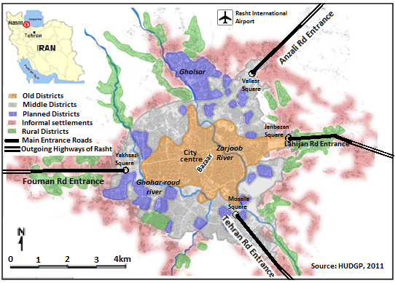
Figure 1 Study area and the location of main entrance axes in Rasht, 2013

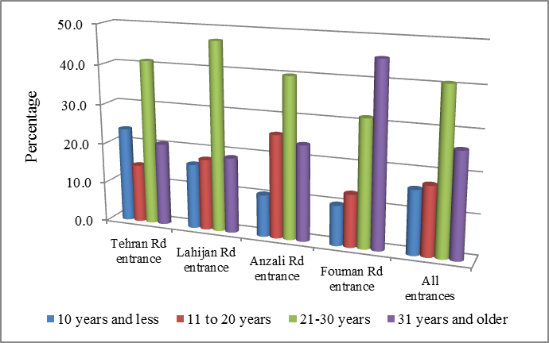
Figure 2 Building age in the main entrance axes, Rasht, 2013

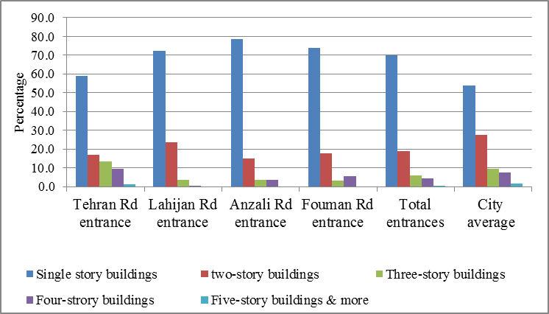
Figure 3 Building height along the main entrance axes compared to the city average, Rasht 2013

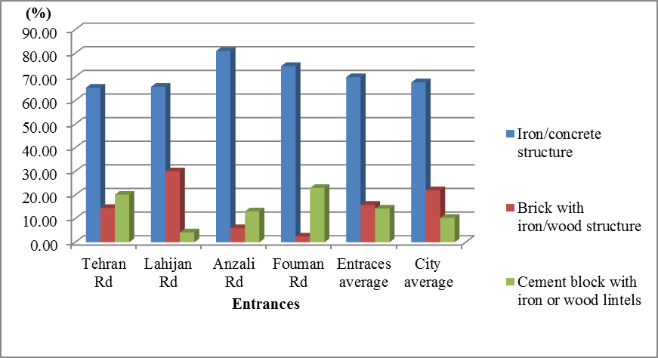
Figure 4 Main building materials along the urban entrances in Rasht, 2013

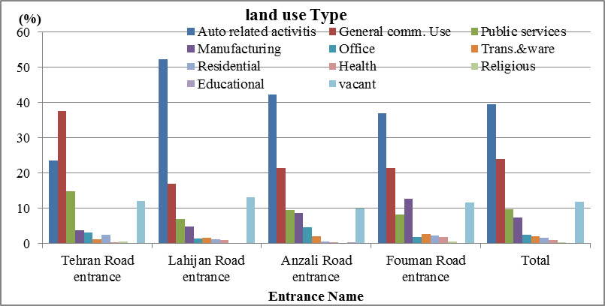
Figure 5 Distribution of activities at ground level among the entrance axes in Rasht, 2013.

