Urban Underground Development;
An Overview of Historical Underground Cities in Iran

Mahdi Montazerolhodjah
Ph.D. Candidate, Department of Art & Architecture, Tarbiat Modares University
Email: mahdiimontazer@yahoo.com
Mohammadreza Pourjafar*
Professor, Department of Art & Architecture, Tarbiat Modares University
Email: pourja_m@modares.ac.ir
Aliakbar Taghvaee
Associate Professor, Department of Art & Architecture, Tarbiat Modares University
Email: taghvaea@modares.ac.ir

*Corresponding author
Phone: 02182883731
Fax: 02182883731
Address: Tarbiat Modares University, Jalal Ale Ahmad Highway, P.O.Box: 14115-111, Tehran, Iran

Urban Underground Development;
An Overview of Historical Underground Cities in Iran

Abstract
With the increasing rate of urbanization problems such as traffic congestion, air pollution, and lack of open and green spaces have been affect the cities and their citizens. This condition remains one of the great challenges of the future. This growth would causes increasing demands for more land use, homes, and work places, more public transport and mass transit systems and modern infrastructure, so new approaches must be found to better utilize space available.
Considered use of underground space creates new for solving these challenges. The urban underground spaces have great untapped potentials. If these potentials managed correctly, would chip in considerably to the urban sustainable development.
Nevertheless seeking of spaces and shelter within the earth is no new idea, man and animal alike have exploited the protective and insulative properties of the soil long before recorded history. During the history communities have existed in areas all over the world including Iran, Turkey, Egypt, Ethiopia, China, North Africa, and the American Southwest, to name a few.
Some of the best examples of man’s symbiotic relationship with nature are Nushabad in Kashan, Sāmen in Malayer and Kariz in Kish Island. These underground cities and Constructions offer many opportunities and lessons for underground development.
This study aims to discuss the ancient settlements of Nushabad, Sāmen and Kariz for their unique and creative underground space use and also explore the potential of developing underground spaces in order to achieving sustainable development . The basic hints of discussion are the physical geography and dominating forms of underground space use.

Keywords: Nushabad, Sāmen, Kariz, Underground Development, Urban Sustainability.

- Introduction
The pressure caused by increase in population is an important factor in the deterioration of the environment, particularly with regard to the over exploitation of natural resources and to the quality of life in urban areas [1].
More than half the population of the world now lives in urban areas and the expectation is that this figure will grow rapidly in the next decades – reaching 70% in 2050 [2]. This facts show the reason of the horizontal expansion and increase in population that have characterized urban growth and development patterns of the last few decades have produced cities that are often inconsistent with the principles of sustainable development [3]. Cities should be able to withstand such large migrations, but even with today’s infrastructure and contemporary population numbers, many cities are on the edge of satisfying their residents’ requirements [4].
The creation of sustainable urban areas with the resilience to survive natural disasters and the effects of climate change through urban resilience-building will be critical for urban planning and engineering in the coming decades. This White Paper will explore these themes and the contribution and impact of underground space use to achieving sustainable urban development and creating resilient cities [2]. The urban underground contains a large intact potential that, if correctly managed and used, would contribute considerably to the urban sustainable development.
As stated in the Finnish report [5]: "Underground construction, based on the principles of sustainable development, aims to minimize environmental hazards, to save energy, to increase the functional diversity of the urban structure, to reduce the need for local transportation, to make services more easily accessible to residents, and to protect the urban landscape and culture".

- Underground Spaces in Urban Development
As noted above, urban growth and development always had been a result of growing urbanization. In the past, cities have grown in two ways;
- They have spread and got wider;
- They become denser with the appearance of high buildings.
But nowadays there is a third option, building down and go to the underground.
Not all cities have the same potential for using their underground space. Obviously, any city is provided with an underground usable space, in the same way as any plot of private land. However, it is well known that there are factors which favor and others which detract from its use, independently of the financing capabilities of the urban community [1].
In many cities underground car parks, shopping centers and cinemas are developed. Typically these are developed over time and somehow the thought of connecting these underground facilities never occurs [6]. This kind of development had enhanced in modern time and after that. In reality, since the advent of modern cities, underground space has always been used, for water and gas distribution, for sewers, for basements and for metro or subway systems. Now, in many cities of the world, this use can no longer be ad hoc, but must be planned and coordinated, even positively encouraged [7].
The urban underground spaces comprise three basic parts. The First is the immediate underground level, the use of which is instantly impressed by the urban requirements and public needs. The second is the deep level, for which the quality for example its competency for underground structures, is the determining factor for defining its activity and use. And the third is the reliefs, which provide us with space with some obvious benefits, because the rocks which make up such regions are of premier quality.

- Benefits of Going Underground
Growth of cities and therefore increasing of demands for more spaces have resulted in cities that have towers and skyscrapers and compact fabrics. However, this way is not a refusal option but we have should not forget the urban qualities such as skyline. Of course another vital object is the resource that lies beneath these buildings. Fortunately underground development is one of the great opportunities that we can use it to resolve this problem at the way of our cities sustainable development.
The potential is to bury unsightly car parks, highways and shopping malls, and direct the surface space that this unlocks to other uses that improve the urban environment [8].
The benefits offered by underground structures are directly based on certain specific qualities of underground space.
The benefits of utilizing underground space can be summarized as follows.
Table1: The benefits of utilizing underground space
Aspects | Benefits
Energy | - Reduction of conduction  - Heat storage capacity  - Stability ground temperatures  - Control on air infiltration  - Reduction of heat gain  - Impact of occupancy patterns on energy related benefits
Space and land use | - Limited visual impact  - Preservation of surface space  - Efficient use of scarce land  - Preservation of natural vegetation/scenery  - Allows for more compact urban structure  - Saves building land from secondary uses (traffic, parking) for recreation, work, housing  - Protection from cold or hot climates  - Protection from surface noise and vibration  - Provide security  - Protection from natural disasters  - Constructing in rock is cost-effective because of the hard bedrock in some places
Landscape and townscape | - helping to protect the natural landscape and saves urban areas  - Taking streets down into tunnels improves the quality of life in city centers  - less visual impact than an equivalent surface structure  - help to hide unattractive technical facilities in sensitive locations
Environment conservation | - Building material durability  - No need of external cladding  - Underground construction does not affect the superficial shape of rocks or the natural conditions of the area  - Environmental stress factors (e.g. noise pollution) can be reduced by underground construction  - Underground construction helps to protect environmental and cultural values
Citizens protect | - Stability and resistance  - food preservation  - protecting from the transmission of airborne noise  - protecting from the nuisances and dangers generated by some facilities  - safety and security advantages
- Underground Space Uses
According to continuous development of urban areas, the official buildings, public transport facilities, commercial areas and the other conventional business and land uses have been densely developed over past decades with very limited land for further developments. But yet, there are many problems such as traffic congestion, air pollution, limited public space and low quality areas.
The use of underground space can offer an excellent opportunity for creation of space, enhancement of connectivity and improvement of the urban environment in the densely developed urban districts. Moreover, underground space can be used to house new facilities or relocate existing surface facilities that are incompatible with the urban setting or not optimizing the use of the above ground space, thereby freeing up valuable surface land for other beneficial uses [9].
Underground utilization pattern varies in different urban contexts, depending on the local culture, geographical situation, social environment, and economic needs [10]. Also Optimization of Urban Underground Space use has to take into accounts social-economic demand and possible supply of geo-space resources [11].
Nowadays planning system could unify the underground spaces and their uses and determine the future use and developments from a unified prospect. This unified approach and the recognition of underground spaces as a main part of development planning has encouraged particular capacity of the underground in urban planning in the world especially in developed countries.
On these basis, the use of underground space in many countries has been growing rapidly in the last two or three decades.
George S. Webster in 1914 gave a list of uses for what he calls "subterranean streets":
- Water pipes, sewers, gas pipes, electrical conduits, steam and hot water pipes, pneumatic tubes, refrigerating pipes and an inconceivable number of other structures of a similar character which will be required in the future;
- Subway galleries for pipes and conduits;
- Vaults under the sidewalks;
- Subway for passengers rail traffic;
- Tunnel crossing the subterranean streets;
- Subterranean freight services, to connect with railroad terminals, business houses and industrial establishments [12].
But today the use of underground spaces in urban areas is more diverse and more widespread. The use of underground spaces could be modeled as given in the table below:

Table 2: Underground Space Uses [6]
Category | Kind of uses
Transport Use | - High pressure transport pipelines and other utility networks  - Tunnels for transport (people and freight)
Production Use | - Subsurface biodiversity  - Foundation for nature, agriculture and city park  - Exploration of natural resources  - Water reservoir and water extraction
Urban Structure Use | - Foundation and structure for roads and buildings  - Car parks, underground station. Cinemas. Offices, shopping centers and housing
Storage Use | - Storage of waste products, dangerous goods  - Decontamination and cleanup of brown field sites,  - Energy storage, thermal energy storage
Archive Use | - Cultural heritage and archaeology  - Geomorphologic and earth science values  - Sub surface biodiversity

- Historical Review
It seems that humans first used underground space as a Shelter. It is logical to conceive early human seeking protection from intense weather or wild animals by residing in caves or underground spaces. The targeted development of underground space most probable were the result from a tendency to extend the space and efficiency of caves for the purposes such as more living space and for establishing territory or even food storage. Also many uses were found for the unique features associated with the underground spaces, as human potency to extend openings and to drilling down new goals that developed by built space.
In 4000 B.C. villagers at the recently unearthed banpo site in china lived in semiunderground pit dwellings with A-frame roof supporting a thin layer of soil and vegetation [13].
The thermal advantages of the earth’s temperature moderation in a continental climate with cold winters and hot summers, together with the ability to provide shelter with a pick and shovel, energy and mechanization consequent in the mass construction of these caves to our day [13].
Urban services, such as drainage and water supply, can be traced back to the ancient Babylonians who constructed water supply tunnels in about 2500 BC and to the Romans who had well developed water and sewerage systems. Wherever civilization flourished people found a use for underground space. In Europe and Asia underground space was developed for storage, housing and defensive purposes [7].
Between second and fifth centuries, Romans adopted a similar approach in Tunisia to overcome the disadvantages of the extremely hot and arid climatic conditions. The outcome was the below-ground atrium dwellings constructed at Bulla Regia. Other examples of the earth-integrated vernacular architecture in the Mediterranean region exist in the Gaudix region of Spain, in Sicily, and on the Isle of Santorini, Greece. Indian cliff dwellings of Mesa Verde, Colorado, subterranean houses of the central Australian desert and mined houses of South Australia set other examples. Among these examples the Cappadocia region in Anatolia is a valley dominated by cave buildings [14].
The established and extensive use of the underground spaces was developed in 17th century by development of gunpowder that caused the enhancement of excavation techniques.
Tunnels were developed to facilitate transport during the Industrial Revolution in Western Europe. Canals and railways were used extensively during the 19th Century and their need for relatively flat grades required tunnels to pass through mountainous areas. As underground excavation techniques became more efficient, and as improved technology enabled tunnels to be built through difficult ground, underground transport systems became more extensive [7].

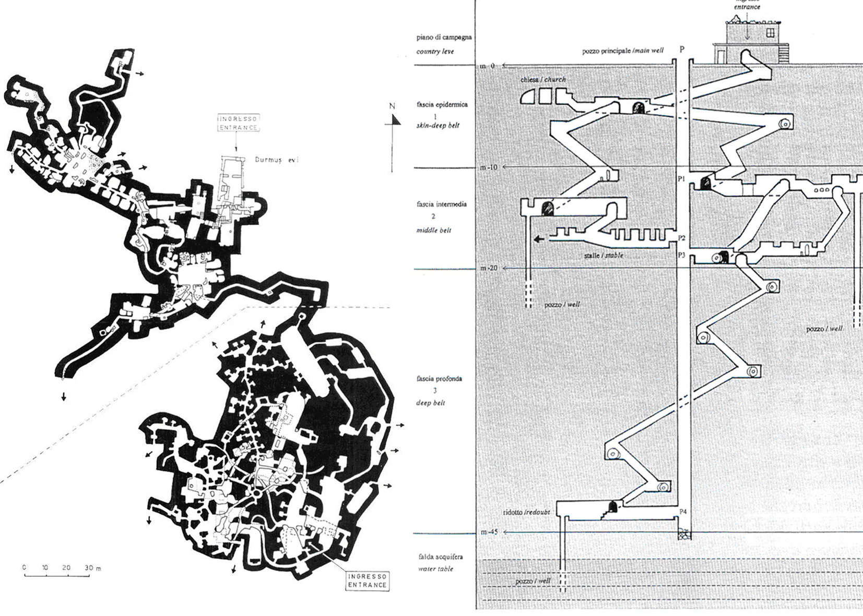
Fig.1: 8th –7th centuries B.C underground city of Derinkuyu, Turkey [15]

The invention of the compressed air rock drill in 1860s by Germans and the invention of dynamite in 1870s in England [16] and the later developments in tunnel techniques authorized the speedy development of the underground transport such as underground tunnels those serving London and Paris and other great cities [17]. The use of compressed air, Dewatering techniques, and the development of the tunnel Fender permitted underground tunnels to pass under Impassable places such as rivers, within rocks and mountains and through bedraggled ground.
Marc Brunel’s Thames Tunnel was the world’s first subaqueous tunnel and spurred an innovation revolution, the 1,300 feet tunnel ran beneath the river bed and Built for pedestrians and carriages in 1843 [18].
Underground construction such as the French Maginot Line was used extensively during World War II by many nations like Germany, United Nations, Japan, and England for more protection and Civilian defense.
The concept of providing for civilian defense through underground facilities has continued to present times. The Norwegians combined the utility of a modern sports arena with the need for strategic defense in the construction of an Olympic ice hockey stadium which can accommodate over 5,000 people for a sporting event or 7,000 in an emergency situation [7].

- Cases of Historical Underground Cities in Iran
  - Location
Kariz: The Kish old qanat has 15 km length that along two branches from Sefeyn district and airport to current location of Kish cultural and touring complex of underground city of Kish becomes three branches.
Nushabad: Nushabad town is around Aran o Bidgol County and is one of five small historical towns that are in Isfahan province.
Samen: hidden town or Samen underground city is in Samen city and is placed in 15 km of Malayer in Hamadan province. Excavating in an underground place in Samen town lead to discover a hidden town that is in a stone bed made of granite and is made hand-dug.

  - Historical aspects
Kariz: Kariz underground city is remainder of Kish main qanat that was made in past. This qanat is over 2500 years old. Also this qanat used to provide the fresh potable water for the island inhabitants.
Kariz town is 16 m below ground and its roof is 8 meters tall and mostly covered with fossil, seashell and coral that according to expert opinion, is 270 to 570 million years old and its parts identified and has an official certificate.
Nushabad: Nushabad town is the capital of Sasanian Empire, Anushirawan and is 1500 years old.
Nushabad underground city is known as “Ouyi”. In story of remainders of Kashan Sialk , when one get to Nushabad, a legend is heard that under the skin of this town history is breathing then Astonishingly, in the early eighties the dream of a town under the ground of Nushabad became true.
Samen: there is no information about exact age of this mysterious city. But according to primary reviews it likely dates back to before the Parthian dynasty. It’s likely that extent of this city at the time of Mithridates I of Parthia (160 to 130 BC) is its greatest and it made to perform for rituals.

  - Physical Characteristics
Kariz: Kish qanat is not comparable to the qanats of other places of Iran In length of qanat branch and in depth of wells, but according to very low slope of island, how to conduct underground waters to ground surface in Kish was very important and shows that in its time they used most advanced methods for digging qanats.
Today qanat complex with change of use has changed to an amazing underground city that has more than 10000 square meters and now it’s called Kariz of Kish.
By developing the construction of Kariz, viewers can easily go from ground surface to qanats and by passing in halls and corridors spend moments in a pleasant place. Temperature in Kariz underground city is 10 to 12 degrees colder than outside weather and this lead tourists and inhabitants of Kish in warm seasons of year to spend hours in city to be safe from heat.

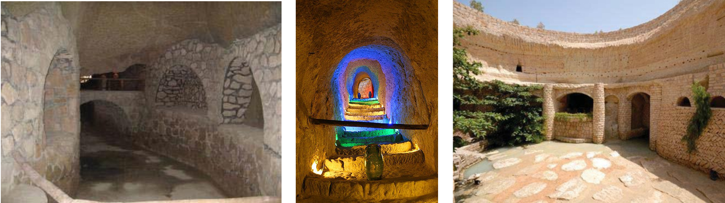
Fig.2: Kariz Underground City

Nushabad: Ouyi underground city in three levels architected and has been dug to 20 meters deep. Entrance of this underground city is a narrow hall, size of one person, when you enter inside the city, the smell of moist soil is felt. This underground town was created in three levels in depth of 4 to 21 meter from the ground surface. Area of this town was much because of connection between Neighborhoods and to protect life and property of people in unsafe situations and has been spread both horizontally and vertically.
The thing that is known as Ouyi underground city is in fact dense structures, complex and broad such as narrow and nested halls and small rooms. Away from main entrance the height of all sections of Ouyi is the normal height of human, between 170 and 180 cm.
This city in different historical periods had military and defensive usage. The ways of entering this complex are hidden in houses or inside adobe palace and in canals of “Payab” that are below houses made to conduct water of qanat and wells that were inside mosques. In old houses kitchens, there were ways to enter to these places that they skillfully covered well with pan.
Along the way of underground city, rooms have been dug for temporary refuge. Each room height is 180 cm. The persons inside Ouyi have done many measures for resting and being safe from enemy so that even in at depth of 18 meter enemies don’t attack them.

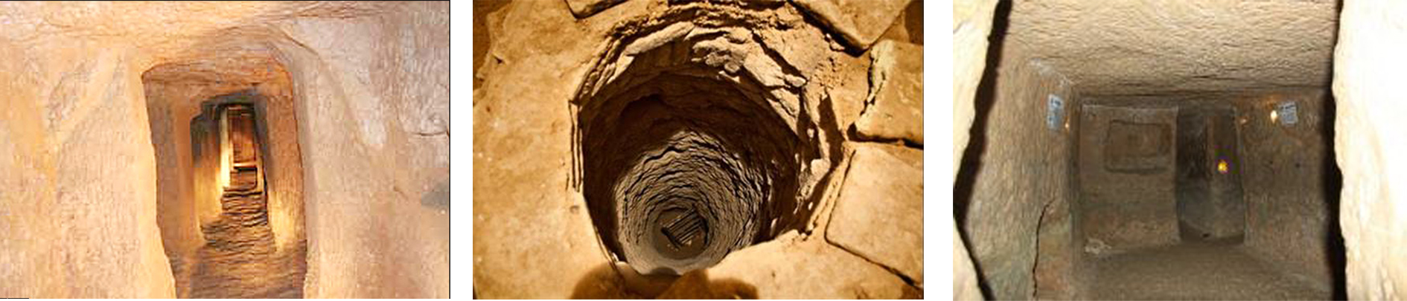
Fig.3: Ouyi Underground City

Samen: the area of this city is estimated over 3 acres that now almost 25 rooms have been discovered. This underground town was discovered in depth of 3 to 6 meter of ground and canals dug inside that during historical periods had been detached and around those, there are multiple rooms too. According to archaeological studies the town consists of nested canals. This place during historical periods had expanded and rooms and hallways of this town have different ages.

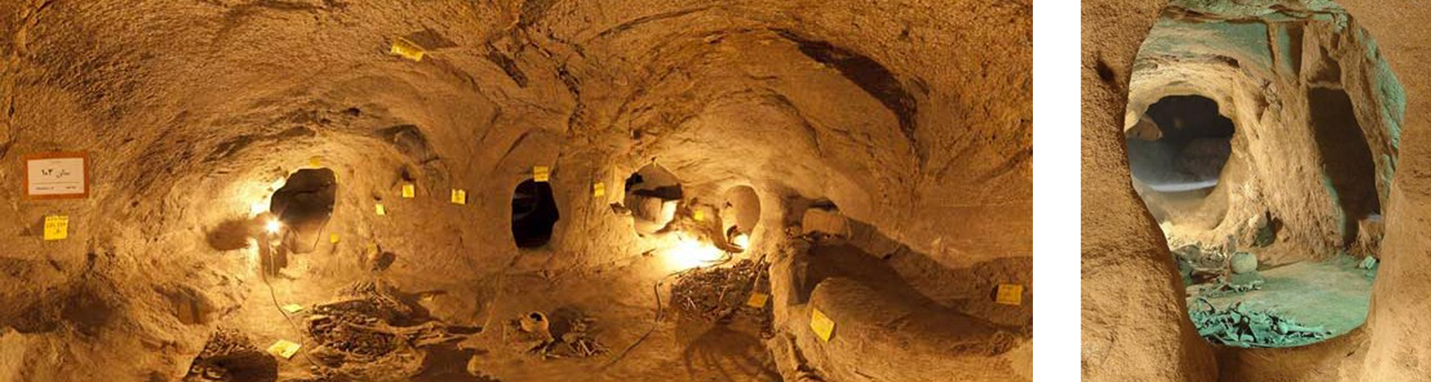
Fig.4: Samen Underground City

  - Functional System
Kariz: Kish qanats with age of more than two thousand years are some of oldest works remained from ancient Iran that now with reconstruction and improvement one of these qanats is provided in form of wide tunnels with unique architecture of a fun and interesting complex is provided for visitors.
Nowadays much effort is done to find new usages, while preserving the historical fabric in Kariz reconstruction project. In recent years much effort is done For reconstruction and to Preserve and restore the historical fabric and in addition to appealing historical and spatial complex, considering new usages like handicraft stalls of Iran and world, classic and modern restaurant, museum, amphitheater and conference hall, art galleries have increased its performance.
Nushabad: the reason behind of the architecture of this ancient complex can be defined in three options; a place for worshipers of Mithraism, a place to protect against high and grueling heat of salt pan or a shelter to protect from attackers that targeted this part of central plateau.
Considering defensive reason and being used as shelter, this type of architecture which is created in earth had a great influence on how the architectural plan proposed.
In times of insecurity and the times of seeking shelter in underground water that inhabitants consumed was provided from qanats and “payab”. In addition to “payab”, the path of Ouyis in some parts was connected to qanat.
Ventilation system of Ouyi underground city was through canals that are made in first floor and into ground surface. Connected wells of floors, in addition being path, caused flow of air in lower floors.
Samen: it is assumed that this city was a hidden town from before Parthian period and later it was used as cemetery.
It is likely that this place was first used to perform special religious ceremony, probably Mithraism based on worshipping “Mitra” god of ancient Iran and the god of sun. Available evidence suggests that religious ceremony was done hidden in underground and probably some the canals of this place was used to bury religious sacrifices or important persons of religions. A survey conducted shows that this city was used in three periods during history.
First period: the reason behind the creation of this city is returns to first period that according to primary surveys the primary core of town is older than some of its canals and rooms around the town. There is a chance that this city was made hidden for performing a ceremony special for Mithraism.
Second period: in this period of history this place is used most. This period returns to Parthian period. Although digging this place is done much before Parthian however, constant use, and somehow their heyday has elapsed in the Parthian period.
Third period: third period is the downfall of this ancient place that seems to be at the same time with reducing the power of Iran Kings. In this period this place was used as a shelter and burial of special dead. This period lasts from the time of Arab invasion of to Iran and “Nahavand” war until First World War even during Qajar era. The case that all archeologists agree on is that this city was unknown in all three periods.

- Discussion
This article studied the traditional underground cities of Nushabad, Sāmen and Kariz for their unique and creative underground space use and also explored the potential of developing underground spaces in order to achieving sustainable development.
Although the cases given here have been chosen from the historical underground cities, the use of underground can also contribute on contemporary development to enhancing the sustainability and compatibility of cities.
The following table compares the results of the 3 historical underground cities.
Table3: The compare of three historical underground city in Iran
City  Features | Kariz | Nushababd | Samen
General features | - with age of more than two thousand years  - over 2500 years old | - the capital of Sasanian Empire  - more than 1500 years old | - it likely dates back to before the Parthian dynasty  - made to perform for rituals
Physical Characteristics | - is provided in form of wide tunnels  - more than 10000 square meters  - Consist of halls and corridors  - 10 to 12 degrees colder than outside | - in depth of 18 meter of ground  - three levels architected  - has been dug to 20 meters deep  - in depth of 4 to 21 meter from the ground surface  - narrow hall entrances  - has dense structures, complex and broad such as narrow and nested halls and small rooms  - the height of all sections is the normal height of human, between 170 and 180 cm  - Each room height is 180 cm | - area of this city is estimated over 3 acres  - almost 25 rooms have been discovered  - in depth of 3 to 6 meter of ground  - consists of nested canals
Functional System | - As a qanat and water supply system  - historical and spatial complex  - considering new usages like handicraft stalls of Iran and world, classic and modern restaurant, museum, amphitheater and conference hall, art galleries | - The reason behind of it can be defined in three options: a place for worshipers of Mithraism, a place to protect against high and grueling heat of salt pan or a shelter to protect from attackers that targeted this part of central plateau.  - Considering defensive reason and being used as shelter  - Ventilation system was through canals that are made in first floor and into ground surface  - Connected wells of floors, in addition being path, caused flow of air in lower floors | - It was a hidden town from before Parthian period and later it was used as cemetery.  - first used to perform special religious ceremony  - some the canals of this place was used to bury religious sacrifices or important persons of religions  - city was used in three periods during history:  - city was made hidden for performing a ceremony special for Mithraism;  - Constant use, and somehow its heyday has elapsed in this period;  - In this period this place was used as a shelter and burial of special dead

In this research, it has been shown how using of underground public spaces in urban planning and design systems can contribute to supporting cities develop in a dynamic and sustainable context. In addition the author has also indicated that it is obligatory that the utilization and use of underground spaces and facilities is the most efficient way to go if we want to achieve sustainable development.
In the field of urban development, studies and evidences show that underground public spaces is an extensive experience especially in developed countries such as Japan, USA, Canada and China, but it is as yet unfamiliar to many cities in developing countries.
Also it was concluded from the case studies that underground development provides opportunities to use attainable urban spaces more efficient, but it requires a long term planning. This could be happen through planning for various uses that underground spaces can accommodate. Some of these uses are transport use, production use, urban structure use, storage use and archive use.
Also if this happens then a lot of benefits could be achieved that are key criteria in getting closer to sustainable development. Some of these criteria include; energy consumption, environment conservation, Landscape and townscape enhancement, citizen's protection and land saving.
In total the authors believe that for more advancement in this specific subject, urban planners and designers need to more theoretical discuss and experimental surveys to develop this special part of cities planning and its different aspects. In fact they feel however that a larger cooperation between planners, designers, architects, engineers and developers is required to fully perception the potential and benefits of this asset.

- Conclusion
This research presented the history, benefits, examples and uses of public underground spaces from a literature review. At the other hand it discussed about the influences of planning underground spaces on urban development that could help to develop a better approach toward sustainable development
Because of the reasons that argued before like as rapid growth of development and increasing in demand for land, awareness about the possibility of using urban underground space and utilizing them for more extensive use can help cities to reach the goal of sustainable development
Although there is a long history of underground spaces being used to accommodate various functions therefore the concept of underground spaces and planning them are not new. Though until now it hasn’t been implemented in many countries, but in most of developed communities this approach is using in order to taking steps towards sustainability.
On this basis, planning for underground spaces in cities should be based on planning goals and existing condition of underground planning and urban development. In addition it should be consistent with geological and morphological condition.
Planning underground space provides new challenges to urban planners and designers but also poses them unique opportunities for achieving sustainable development. Of course this can only be achieved under the conditions of a long term planning.

References
- Godrad, Jean Paul, 2004, Urban Underground Space and benefits of Going Underground, World Tunnel Congress and 30th ITA General Assembly – Singapore.
- ITACUS; International Tunneling and Underground Space Association Committee on Underground Space, 2011, Sustainable Urban Underground Development, Lausanne Switzerland.
- Maire, Pierrick., Blunier, Pascal., Parriaux, Aurèle & Tacher, Laurent. 2006, Underground Planning and Optimisation of the Underground Resources' Combination Looking for Sustainable development in Urban Areas. Infoscience: Scientific Publications of EPFL - École polytechnique fédérale de Lausanne.
- Durmisevic, Sanja, 1999, the future of the underground space, Journal: Cities, Vol. 16, No. 4, pp. 233–245, Elsevier Science Ltd.
- Rönkä, Kimmo; Ritola, Jouko; and Rauhala, Kari. 1998. Underground Space in Land Use Planning. National report published in TunneUing and Underground Space Technology 131), 39-50.
- Knights, M., and Admiraal, H. 2009. The Use of Underground Space in Urban Development. Paper presented at the Workshop' Underground Structures in Hot Climate Conditions', Riyadh, Saudi Arabia, 8-9 December.
- Dobinson, Ken and Bovven, Rod, 1997, Underground Space in the Urban Environment Development and Use, the Warren Centre for Advanced Engineering, the University of Sydney.
- Chow FC, Chapman TJP and St John HD. 2002. Reuse of foundations: planning for the future. Proc. 2nd Int. conf. on soil structure interaction in urban civil engineering, Zurich.
- Wan Chai District Council, 2014, Pilot Study on Underground Space Development in Selected Strategic Urban Districts, Development, Planning and Transport Committee.
- Carmody, J. & Sterling, R. (1993) Underground Space Design, New York, Van Nostrand Reinhold Publishing Company.
- Li, Huan-Qing, 2011. Sustainable 3D urban governance: creating a “deep city” for our modern city, EPFL, Switzerland.
- Webster, George S. (1914). Subterranean Street Planning. In: Annals of the American academy of political and social science, Vol. 51, Housing and Town Planning (Jan., 1914), pp. 200-207. Sage Publications.
- Carmody, A. & Sterling, R. 1985. Earth Sheltered Housing Design. New York: Van Nostrand Rheinhold Company.
- Erdem, A & Erdem, Y. 2005, Underground space use in Ancient Anatolia: the Cappadocia example, In Erdem, Y., & Solak, T. (Ed.) Underground Space Use: Analysis of the Past and Lessons for the Future, Taylor & Francis Group, London.
- Gulyaz, M.E., 1995. Rock Settlements and Underground Cities of Cappadoccia. Dunya Turizm Ltd., Istanbul.
- Dickinson, J. M. 1969, Compressed Air Drilling in the Yorkshire Dales Lead Mines, the Northern Cavern & Mine Research Society Skipton, U. K. PP. 31-33.
- Broere, Wout. 2012. Urban Problems, Underground Solutions. In Y. Zhou, J. Cai, and R. Sterling, editors, ACUUS 2012 Advances in Underground Space Development, pp. 1528-1539.
- Lydon, Rio, 2012. The Eighth Wonder of the World: How might access for vehicles have prevented the economic failure of the Thames Tunnel 1843-1865? Economic History Working Papers from London School of Economics and Political Science, Department of Economic History

