AN EVALUATION OF THE EFFECTIVENESS OF VENTILATED HOLLOW CORE SLAB ON THERMAL COMFORT IN ONE COLLAGE IN LUTON, ENGLAND.

Dr.Mehrvash Kazemi Shishavan*(corresponding author)
Assistant professor of Architecture, Department of Art and Architecture Islamic Azad University Shabestar Branch, Shabestar, Iran
Email: m.kazemi@iaushab.ac.ir
Telephone (Mobile): +989141165748
Fatemeh Sadat Mirakbari
PhD student of Islamic Azad University, Shabestar Branch.Shabestar, Iran.
Email: Fatemeh.mirakbari@gmail.com
Telephone (Mobile): +989121276292
Prof. Furgus. Nicol
Deputy Director of the Low Energy Architecture Research Unit, London Metropolitan University, London, UK.

An evaluation of the effectiveness of Ventilated Hollow Core Slab on Thermal Comfort in one college in Luton, England

Abstract:
To maintain a comfortable and healthy indoor environment in which occupants feel comfortable it is necessary to have stable and suitable temperature and humidity level. Today the main aim of construction is to combine healthy and comfortable indoor environment with the use of natural resources. Thermal mass is one of the profitable strategies to save energy and to increase the thermal comfort. One of the efficient ways, in order to provide adequate thermal mass within the building, is to use Ventilated Hollow Core Concrete Slab (VHCS). The main objective of this paper is to assess how VHCS affects thermal environment within the buildings and thus the thermal comfort of occupants. Various techniques have been used over time and the paper describes the results of summer investigation in a college building located in Luton using VHCS system as an exposed thermal mass. Over two weeks period, temperature data were recorded. Moreover, occupants of the building were surveyed regarding thermal comfort levels. Based on the finding from the review of existing literature in the field and integrated approach outlined in this paper, results indicate that use of VHCS as a thermal mass in university buildings reduces the daily temperature swing and the number of hours with extreme temperatures. Results also show the influence of the system on the thermal comfort level of occupants; however, this influence can be negative or positive depending on physical and psychological factors.
Keywords: Ventilated hollow core slab (VHCS), Thermal mass, Thermal comfort, Energy efficiency

1. Introduction:
Before introducing mechanical ventilation, cooling and artificial lighting in buildings, several methods were used to change the climate within the buildings in the begging of 1900s. Some of the examples of this methods are active use of window ventilation, large room volumes or large room heights, use of thermal mass and frame design of window for maximum use of daylight while minimizing solar gains. During the last few years, several of these techniques have been reintroduced in order to decrease or eliminate the need for mechanical ventilation and cooling. Moreover, comfort requirements, indoor air quality and energy efficiency show an increasing trend. Therefore the previous passive methods need to be improved in modern buildings.
Thermal mass is one physical feature that has significant impacts on the thermal environment within a building, thus the thermal comfort of occupants. In this method building’s surface are used as a thermal energy store. The consequence is a slow heating of the building in summer and the highest inside temperature is reached only during the late hours when the outside air temperature is already low. Active use of the building mass can significantly increase the total energy saving of the building and keeps the thermal environment within the comfortable range. One of these active strategies is to use Ventilated Hollow Core Slab (VHCS). Ventilated hollow core slab is a precast slab of prestressed concrete typically used in the construction of multi-story buildings and has tubular voids extending the full length of the slab. In this technique, ventilation air is passed through the hollow cores of the floor and ceiling slabs, therefore the airflow will increase the convective heat transfer. This system can be used for heating and cooling buildings.
This research mainly focuses on further and higher educational buildings in UK climate. However, the techniques used and the results obtained from this study may be transferable to other countries with similar climates and building codes. Therefore, this study intends to prove that by using the VHCS, thermal performance of the building and consequently the comfort level of the occupants can be enhanced.
2. Literature review:
Thermal comfort is a psychological state where an individual is satisfied with the body’s thermal environment [1, 2]. Personality, culture, and mood, along with other social and individual differences affect a person’s level of thermal comfort. Because of these factors and difficulty in defining thermal comfort, methods of analysis of thermal comfort are complex [1]. Thermal comfort analysis can provide important information for the design of buildings that are thermally efficient. Also, incorrect analysis of thermal comfort in the design of buildings can result in many problems, including the unnecessary installation of air conditioning and heating units, as well as dissatisfaction with the thermal climate of the building. With more knowledge of thermal comfort, buildings can be more effectively and efficiently designed [1].
In the former studies, thermal mass is described as an effective and efficient way of maintaining a stable temperature in order to provide a thermally comfortable environment for occupants. The scientific definition of thermal mass is solid elements that are used in the construction of buildings that can absorb incoming energy from the sun or other sources store it and later release this energy as heat [3]. Through the storage of heat for later release, thermal mass can minimise peaks in temperature, and moderate or relocate these peaks to a time that is later than the temperature peaks of the outside air [4].
Moreover, thermal mass might have a positive influence on thermal comfort. Primarily, because of the reducing temperature swings and sustain and steadier thermal environment provided by utilising high degree of thermal mass [5]. Furthermore, in winter, the air temperature can be lower than the surface temperatures. A lower air temperature will not only reduce the heat loss but also improve the perceived indoor air quality [6]. For instance, during the summer, thermal mass could store heat radiated during the day and gradually release the heat during the night and then can be removed through ventilation when the outdoor temperature is lower. As a result air temperature variations remain within the comfort range for most hours during the day. In winter, due to the same reason, the stored heat is released back into the room during late evening hours, this means heating the surrounding when it is needed and avoiding overheating and discomfort condition during the high solar radiation periods of the day. Therefore, thermal mass effect produces a positive effect on occupant comfort. Additionally, thermal mass influences comfort by radiant exchanges with the skin. As thermal exchanges of the body through radiation represent 62% of the total thermal exchange (convection, conduction, evaporation) [7], the radiant temperature in one specific point in a room that depends on surrounding surfaces temperature and of the position of the point is as important as the indoor air temperature. Even small change in mean radiant temperature has a great effect on the effective temperature sensed from the occupants.
Following concrete has been introduced as a common material to be used as thermal mass [8]. One of the efficient ways, in order to provide adequate thermal mass within the building, is to use Ventilated Hollow Core Concrete Slab (VHCS). VHCS is a pre-stressed concrete plate with a tubular void that is stretched along the full length of the concrete slab (Fig.1). This special feature reduces the weight of the structure and therefore also reduces the cost of the material as less concrete is used to produce such a slab. The hollow core of the slab is used for ventilation purposes and the ventilated air is pushed through the core tubes (Fig.2). High thermal mass of the hollow core structured building allows for building to be cooled down, heated and ventilated. It happens when warmed or cooled fresh air is circulated through the slabs.
The thermal mass of the ceiling and floor slabs and their large surface acts as an energy storage in VHCS system. The temperature inside the slab remains pretty constant during the change of the environmental conditions. When the winter/summer season changes the thermal mass of the building stores heat/cold relatively and thermal comfort is achieved. For example during the summer nights cool air travelling through the slab cools it down and slab become a cool store therefore when the day comes cool air released inside the building and it helps to maintain comfortable thermal conditions and save on energy consumption (Fig.3). During the summer hot days, warm air passes through the thermal mass of the slab and as it passes with the low-velocity rate it cools down. Another function of the thermal mass of the slab is that it absorbs the heat produced by electric appliance and occupants (Fig.4). During the winter, highly insulated building skin stores the heat. Thermal mass absorbs the heat recovered from the extract air and releases it into the room. The exposed ceiling soffit also acts as a low-temperature radiant heating system (Fig.5). Usually, during the night all the heating systems inside the building are switched off and the only source of the heating that allows for thermal comfort to remain is the heat gradually released inside from the building envelope mass.
To make building act efficient and maintain thermal comfort inside it has to compromise some features like having a high thermal mass envelope with a low U-values, windows with a low infiltration rate and floor /roof slabs being exposed to the room. The American Society of Heating, Refrigerating and Air-Conditioning Engineers (ASHRAE) and The International Organization for Standardization (ISO) have both released standards to predict the thermal comfort of individuals over analysis of a range of personal and environmental factors. Both models are the continuation ofresearch undertaken by Fanger. Fangarhas analyzed the thermal comfort of college students in the 1970s [9]. This study leads to the development of a range of thermal comfort standards. Fanger developed an equation for the analysis of thermal comfort, which simplifies the estimation of thermal discomfort as Predicted Mean Vote (PMV) and Predicted Percentage Dissatisfied (PPD) [10]. Nicol and Humphreys (2007) comment that standards based on Fanger’s work are possible to be more prescriptive than standards based on studies in a real setting, which can lead to the unnecessary use of active heating or cooling systems [10]. ASHRAE Standard 55 was created for the Heating Ventilation and Air Conditioning (HVAC) industry in designing and operating ventilation and air conditioning systems. The standard recommends both a winter indoor temperature and a summer indoor temperature and allows for a buffer zone around each of these temperatures. Humphreys criticizes this standard for a variety of reasons: It means that zones of thermal comfort are constant according to both time and location, which is incorrect as thermal comfort temperatures vary greatly according to geographic location and have varied throughout time; and It applies uniform classifications of ‘summer’ and ‘winter’ to all geographic regions, however these seasons are clearly different with changes in latitude, distance from the ocean, and other geographic variations [11].
There are different ways that levels of thermal comfort can be expressed in studies using the adaptive approach. Baker and Standeven[12] express the availability of occupants to adapt to thermal conditions as an adaptive opportunity, that means the opportunity available within a building for occupants to make themselves comfortable. Therefore, higher adaptive opportunity can mean wider ranges of temperatures are possible in an environment for occupants in which they can feel comfortable. To determine a rang in which an individual is comfortable, thermal neutrality and preferred temperatures can be used; when thermal neutrality is a state experienced when an individual feels neither warm nor cool sensations. Similarly, the preferred temperature is the temperature range within which an individual will identify as being comfortable [5]. There is no clear boundary between comfort and discomfort, and no temperature where all people will be comfortable, or have a desire for warmer or cooler temperatures. In lots of buildings, thermal discomfort is possible to effect at some point, and it is recommended that thermal comfort should be defined as a zone rather than a specific temperature [5]. Broad zones for acceptable temperatures were set for offices in the temperate climate of the UK and indicated a range of between 13°C and 30°C, dependent on levels of physical activity (HSE, 1999). Nicolcalculated a comfort temperature based on the running mean of outdoor temperature and determined that thermal discomfort levels were a function of the difference between the internal temperature of the building, and this comfort temperature [5, 10].
3. Methodology:
As the subject focuses on the utilization of Hollow Core Slab as a thermal mass in Further and higher educational buildings, one college has been selected as a case study. The case study has been surveyed over ten days gathering quantitative and qualitative data to allow analysis of the subject in regarding thermal environment.
Qualitative data was obtained through interviewing the occupants at the beginning of the study. The Building Use Studies (BUS) questionnaire collecting information about the background, activities, adaptation behaviour, level of satisfaction with the thermal performance of the building, amongst other variables, has been used and distributed to 20 occupants. Analysis of these data has delivered appropriate information in terms of thermal comfort, which is described in the paper.
In terms of quantitative data, iButtons (temperature data loggers (Fig.6)) have been used. Placing a couple of the iButton in various spaces within the buildings and one of the loggers outside produced valuable information of hourly indoor and outdoor air temperature. Furthermore, by placing the iButtons at the ceiling, the temperature of the hollow core slab has been recorded. Data recorded during ten days in July has been used to produce several graphs, which allowed evaluating the thermal performance of the buildings.
3.1. Analysis considerations :
The accuracy of the iButtons used in the case study has an accuracy of +- 0.5oC.
Thermal Comfort Zone (TCZ) is considered between 22oC and 26oC.
4.General information; LUTON SIXTH FORM COLLEGE
Luton Sixth Form College building sits on the north part of the Luton, Bedfordshire, UK, (Fig. 7). Luton has a temperate marine climate with the average annual precipitation around 27 inches. The average maximum dry bulb temperature is 21.4oC and the average minimum dry bulb temperature is recorded 0.7 oC. Eco tech software is used to produce several pictures giving an overview of the Luton climate. Since there is not whether data of the luton in this software, weather data of the Gatwick which is approximately similar to the Luton climate is used (Fig. 8,9).
In this study, 8 classrooms and 2 offices within the educational blocks of the building with different orientation were studied (south facing and north facing). The rooms selected wisely in order to make the study able to compare the effect of the orientation in the thermal environment within the rooms. Figure (10)shows the plans of the building and position of the selected rooms in each block. Green areas are the educational blocks using VHCS and the red boxes are the placement of the rooms that have been investigated.
To monitor the temperature, iButtons (temperature data loggers) are used. They have an accuracy of +- 0.5oC and record temperatures between -40°C and +85°C. measurements were taken at 30 minutes intervals (throughout the day and night) and ran for two weeks from June 22th 2012 to July 2th 2012. A Blue dot receptor is used to download the temperature recorded by iButtons and transfers the data to the computer(Fig 11). These data have been transferred to the Excel software then, created graphs have been analysed.
To measure the inside air temperature the iButtons were placed in the selected rooms in order to be out of direct sunlight and noticeable air currents. To minimize the interference with the occupants, where possible iButtons were placed out of the vision of the occupants. Moreover, slabs temperatures were recorded by placing the iButtons attached to the ceiling. This allows to compare the slab temperature with the inside air temperature. Placing one iButton outside the building in sheltered position enabled comparison of the inside data and outside to examine the effectiveness of the VHCS on the thermal environment. Figure 12 and figure 13 illustrate the placement of the iButtons in different rooms (Fig. 12, 13).
iButton measuring the slab temperature.
iButton measuring the ambient indoor temperature.
iButton measuring the ambient Outdoor temperature.
Figures (14,15) are the key maps that named each room with the alphabetical symbol. Room A and B are offices and the rest are classrooms.
5.Thermal monitoring‘observation and result:
Graph and table in the following lines present some of the results obtained in the whole research. Graph 1 highlights the inside air temperature of the all spaces by respect to the outside temperature to gives a general overview of the thermal environment within the building. As can be seen from the graph, although the monitored outside air temperature is fluctuating between the ranges of minimum 9oC and maximum 26oC, inside air temperature of the rooms remained pretty constant with the maximum rise of 24oC in the room F and minimum drop of 19 in the room H. The highest and lowest outside air temperature is occurred in June 28th and July 1st, respectively (Graph1).
Over the recorded period, during the first week the slab temperature in the room F is higher than the room I, as a result the indoor temperature of the room F is warmer. However, since 29th the slabs temperatures for both rooms has reached to the same level and remained fairly constant in the next following days. During this last three days indoor temperature for room I is slightly higher than the room F. This might be either because of the accuracy of the equipment (+- 0.5 oC) or due to the height of the obstructions in front of the both rooms. There is a block with one floor height obstructing the room I, while the obstruction for the room F has two-floor height (Fig.16). The latter may obstruct more solar gains; hence the temperature of the room is lower. The temperatures remain fairly constant as a result of the high thermal mass of the space (Graph2).
Table (1) illustrates the results of the monitored temperature in rooms F and I. Results show that compare to the outside temperature, the indoor-recorded temperatures are relatively stable. The average temperatures inside the rooms are similar.Both rooms are remained approximately 50 percent of the times within the thermally comfortable temperature.The ambient temperature inside the room I is more varying than the room F with amplitude of 5oC.Average slabs temperatures are very similar and changing over the time within the small range.
The results of the recorded temperature in rooms A and B in the building are presented in table (2). Comparing the indoor and outdoor temperatures, it would reveals that indoor temperatures are considerably stable though the temperature outside the building is very fluctuating. The average indoor temperature is similar in the rooms A and the room B. Also, the recorded temperatures are in the same range. The temperature variation during the weekdays is mainly due to the internal gains. Both rooms are more than 70 percent of the time within the TCZ. The average slabs temperatures are very similar also changing over the times within the small range around 2oC. The average slab temperatures of these rooms are higher than another rooms that have been measured. It can be assume that when the slab temperature is higher, the indoor temperature is more in the comfort zone.
General results of the comparison of the classroom C and classroom H is shown in the table (3). The recorded temperature shows the outside temperature fluctuates widely and just 6 percent of the times remain within the TCZ. However the indoor temperatures are considerably stable. The average inside temperature of the room C that is located in the first floor is half degree higher than rom H, but taking to account the accuracy of the equipment, 0.5oC is not relevant in the measurement. Room C and H are 25 percent of times within the TCZ (22oC to 26oC) and for the rest of the times the rooms are over cooling. Slab temperature for both rooms most of the time remains at the same value.
Graph (3) displays the thermal performance of the classroom C and H during two days of the recorded data in June 24th and 25th, though the outdoor temperature is fluctuating, the indoor temperatures are fairly constant. In this period the difference between indoor temperature and Slab temperature is approximately 2 Co. Additionally this graph shows the earlier drop of the indoor temperature in the room C that is located in the first floor. This maybe caused of having more external surfaces than the room H. This drop in the indoor temperature that is about 1.5 Co was happened at 23:30 PM for the room C while for the room H the temperature dropped at 7AM in the next day morning. This phenomenon illustrates the greater time lag for the room H that has been produced by the thermal mass.
6.Thermal Comfort Investigation:
To investigate the comfort level of the occupants created by the building, numbers of the occupants have been interviewed in the first step and their general idea about the overall comfort regarding the temperature has been recorded. Furthermore, 20 of the Building Use Studies (BUS) questionnaire have been distributed amongst the occupants. Though this is a very small sample to evaluate the performance of a building but there were some reasons, which made the survey restricted. As this study is conducted during the summer brick, numbers of staff exist in the building were reduced also it was not allowed to speak with the students. Additionally, because of the utilization of the VHCS only in the four educational blocks, practically there were 4 office rooms available to be surveyed.
The occupants have been questioned about their general feeling regarding the thermal environment within their rooms. The overall outcome of the personal interviews was: the occupants were not generally satisfied with the thermal condition of the building and perceived the building during the summer very cold. Most of the participants complain about the drafts produced by the supply air diffuser on the ceiling.
Furthermore BUS questionnaire has been used to investigate thermal comfort level of the occupants of the Luton building (Appendix1). This questionnaire contains ranges of the quantitative and qualitative data. Survey data gathered from the BUS questionnaires are typed into pre-formatted Excel data files. This file has been send to the BUS Company to be analyzed.From those who have answered the questionnaire 85% are over thirty years old. Moreover 55% of the participants are male.Asking the occupants about the quality of the air and temperature during the summer and winter, results are as follow:
The occupants described the air in the summer considerably dry and draughty but acceptably fresh. The occupants also perceive it the temperature during the summer varying reasonably and it is noticeably cold. The participants rated the overall air quality in the building unsatisfactory. They found the thermal condition of the building generally uncomfortable (Fig.17).
Also, The occupant perception about the indoor climate of their working area during the winter period shows that they found the air within the building draughty also they reported highly variation in temperature. The results show most of the time they feel cold. The air also is considered neither dry nor humid and reasonably stuffy. In overall both air and temperature are not satisfactory and amongst hundred buildings assessed by the BUS methodology, this collage perform relatively poor in terms of the thermal environment during the winter (Fig.18).
Responds show 78 percent of the occupants change their behavior by adding more cloths on. When they have been asked about their level of control over heating, cooling and ventilation, the answers was completely negative (Fig.19).
Analyzing the overall comfort illustrates the occupants found the building environment generally comfortable. Taking to account all the results, this means though the occupants may feel unsatisfied in some extent, still think this building is better than the other buildings. It can be seen the building is in the normal range compare to hundred building and around 70 per cent is rated comfortable (Fig.20).
6.1.Reasons and possible solutions:
As the VHCS is a centrally controlled system working with the defined set point, it is not unusual for the occupants to think they don’t have enough control over their thermal environment. Referring to (Humphreys, 1995b) the thermal discomfort arises from the lack of availability to control the environment [11]. On the other hand the diffusers in the ceiling are supplying the air from the top to the rooms, this makes the people feel draught. Because the air is moving cross them though the temperature is around 21 – 22 degrees, the occupants perceive the temperature cooler than the actual temperature.
There are several possible solutions to increase the comfort level of the occupants. During the summer the challenge is people are entering the building from the hot outdoor temperature to the VHCS area which is in the cooling mode where the set point for the slabs is 21oC, therefore they will perceive the temperature quite cold and when the body get used to the temperature it would reveal that it is not that much cold.As the British Council Offices is estimated the thermal comfort temperature between the range of the 22oC to 26oC for the mechanical ventilated building this can be conclude that, potentially by rising the set point temperature 2oC or 3oC the inside temperature can stay for a longer period within the thermal comfort environment and reduce the effect of the seasonally outside temperature. Another option is using different type of diffusers to distribute the air to the different direction so prevents the drought by blowing the air to the corners rather than down. Also it is possible to change the location of the diffusers, for example in the Thomas Pain building the AHU is pumping the air through the slabs and diffuses it inside from the walls.
From the all mentioned above, building and occupants should interact properly to provide the maximum comfort. Though the VHCS can remain the environment within the comfort limits, the building should allow occupants to control their environment. And this is normal if the occupants don’t find the indoor condition satisfactory they feel they don’t have that much control over it.
7.Conclousion:
Based on the findings from all the previous research and the results of the investigation throughout one building, the following results can be highlighted as the final conclusions.
Utilizing the VHCS in the building could reduce the peak temperature during the day and the temperature fluctuation. The VHCS also has a great influence on the reduction of the total hours with the excessive temperatures and capability of the building to handle the diurnal heat loads from the internal gains and solar gains.
The effectiveness of the VHCS is influenced by several parameters mainly including the amount of thermal mass and ventilation strategy. It is also important to take to account a great role of the climate, set-point temperature, occupancy pattern and ventilation airflow rates, where the results of the collage confirm the high potential of the VHCS to be set for the higher temperature thereby results in the higher thermal satisfaction of the occupants and lower energy demand.
It is also investigated that the VHCS could provide the thermally comfortable environment within the building by remaining the inside temperature stable. However the occupant’s perceptions regarding the comfort is largely effected by the physical and psychological parameters. Giving the occupant the opportunity to have control over their environment is one of the most important key elements.

8.References:
[1] de Dear, R. J. (1998). Developing an Adaptive Model of Thermal Comfort and Preference.ASHRAE Transaction, 104-145.
[2] D.O. Rijksen, C. A. (2010). Reducing peak requirements for cooling by using thermally activated building. Energy and Buildings, 42, 298-304.
[3] Givoni, B. (1991). Characteristics, design implications, and applicability of passive solar heating systems for buildings (Vol. 47). Solar energy.
[4] BALARAS, C. A. (1996). The role of thermal mass on the cooling load of buildings, An overview of computational methods. Energy and Buildings, 24, 1-10.
[5] Nicol, F. &. (2005). Maximum temperatures in buildings to avoid heat discomfort. Retrieved March15,2012 from: http://www.inive.org/members_area/medias/pdf/Inive%5Cpalenc%5C2005%5CNicol.pdf.
[6] Fang L., W. D. (2004). Impact of indoor air temperature and humidity in an office on perceived air quality, SBS symptoms and performance. Indoor Air , 14.
[7] Bruce Haglund, K. R. (n.d.).THERMAL MASS IN PASSIVE SOLAR AND ENERGY-CONSERVING BUILDINGS.From http://arch.ced.berkeley.edu/vitalsigns/res/downloads/rp/thermal_mass/mass-sml.pdf.
[8] J.A. Clarke. (2001). Energy Simulation in Building Design.Oxford, UK: Butterworth- Heinemann.
[9] Fanger, P. O. (1972). Thermal Comfort: Analysis and Applications in Environmental Engineering. Columbus: McGraw-Hill Book Company.
[10] Nicole, F. &. (2007). Maximum temperatures in European office buildings to avoid heat discomfort.Solar Energy, 81 (3), 295-304.
[11] Humphreys, M. (1995b). Thermal Comfort Temperatures and the Habits of Hobbits. In Nichol F., Humphreys, M., Sykes, O. &Roaf, S. (Eds.) Standards for Thermal Comfort: Indoor Air Temperature Standards for the 21st Century.
[12] Baker, N. &. (1995). A behavioural approach to thermal comfort assessment in naturally ventilated buildings. In K. S. Stean (Ed.), Environmental Diversity and Architecture.

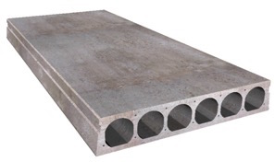

Figure1: Hollow Core Concrete Slab (https://oldcastleprecast.com).

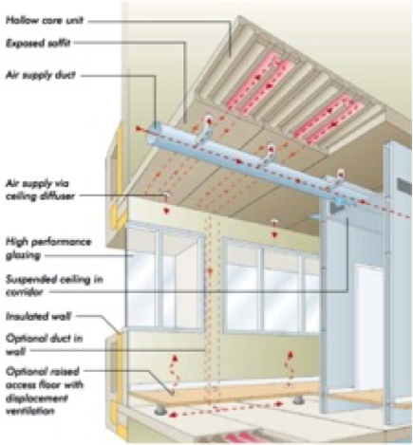

Figure 2: The Ventilated Hollow Core Slab (VHCS) System (http://mesbuildingsolutions.co.uk).

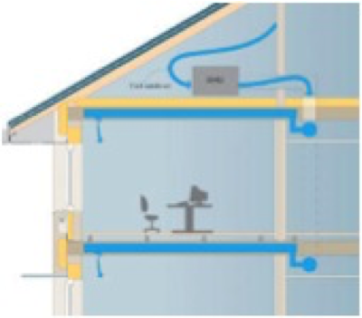

Figure 3: VHCS system during the summer night, (https://www.termodeck.com).

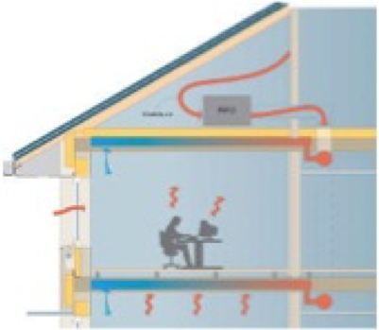
Figure 4: VHCS system during the summer day, (https://www.termodeck.com).

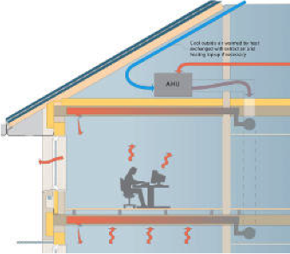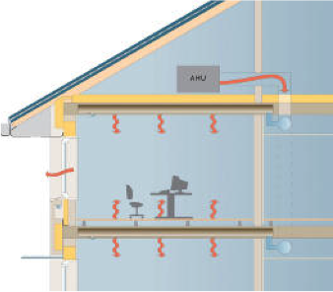
Figure 5: VHCS system during the day and night in winter, (https://www.termodeck.com).

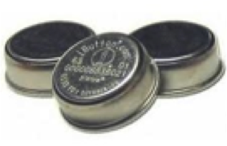

Figure 6:iButtons (https://www.embeddeddatasystems.com)

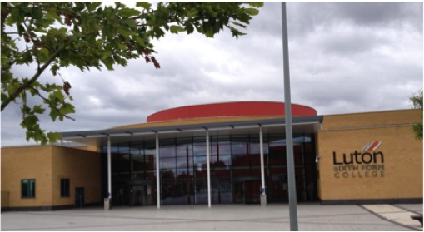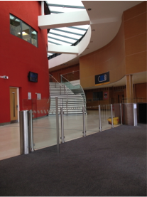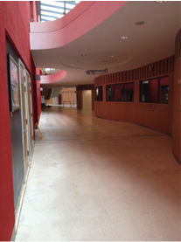

Figure 7:Luton Sixth Form Collage; source: Authors

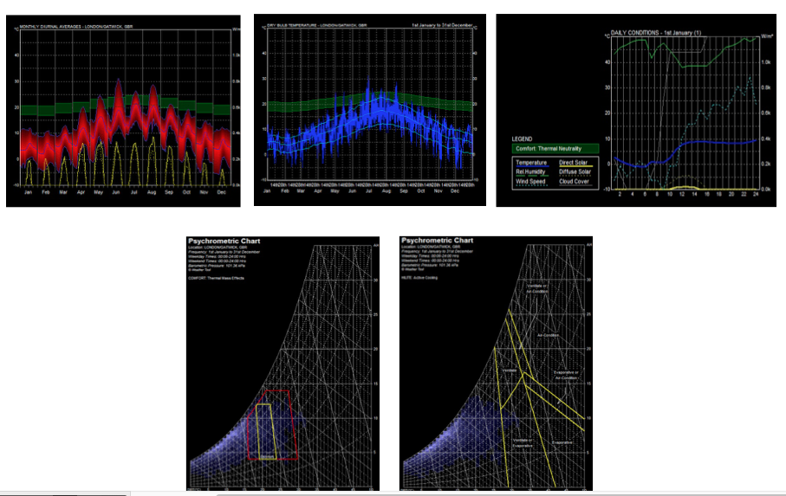

Figure 8: General Climate Analysis- Eco tech software; source: Authorss.
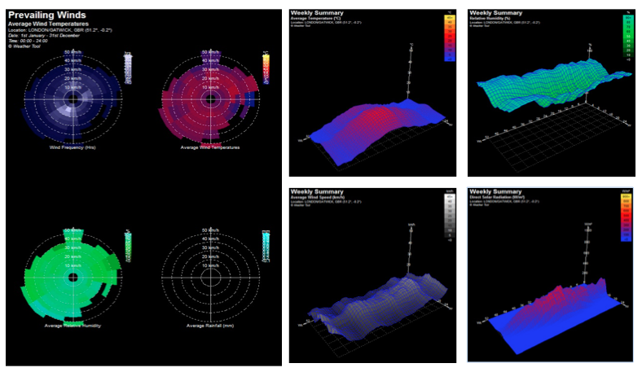
Figure 9: General Climate Analysis- Eco tech software; source: Authors.
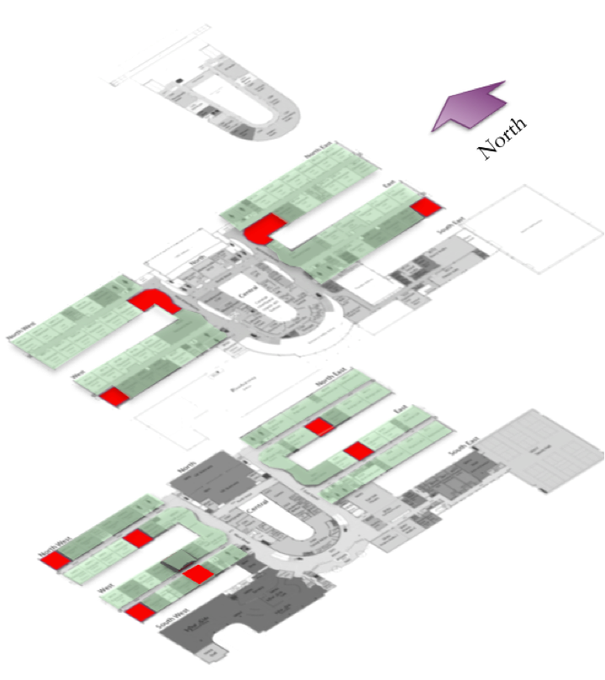

Figure 10: General plans of the Luton Sixth Form Collage; source: Authors.

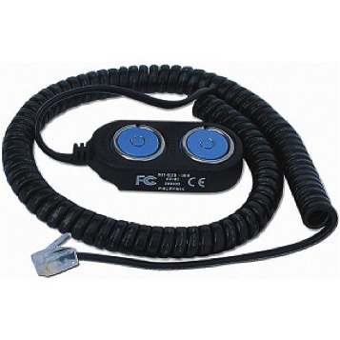

Figure 11: Blue dote receptor

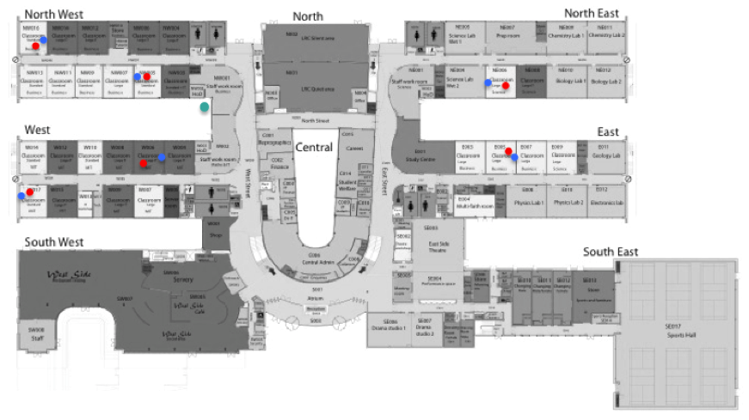

Figure 12: Ground floor plan, placement of the iButtons; Source: Authors.

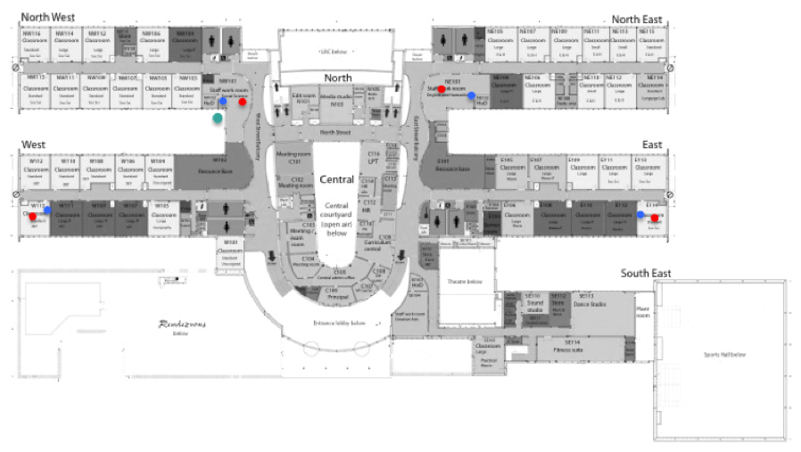

Figure 13: First floor plan, placement of the iButtons. Source: Authors.

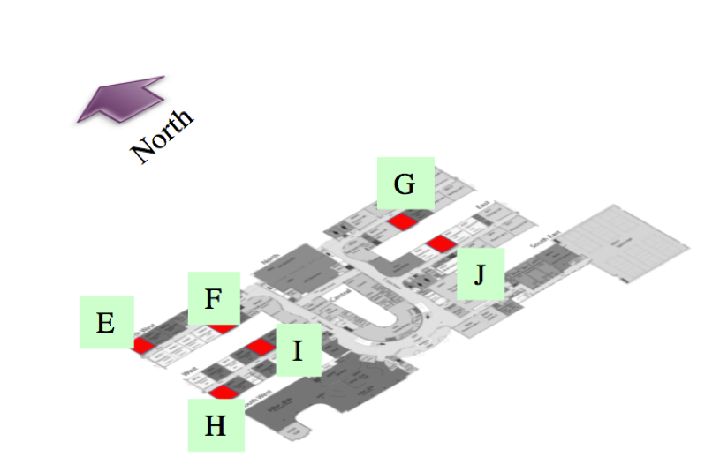

Figure14: key map of the building, showing the monitored room in the ground floor; Source: Authors.

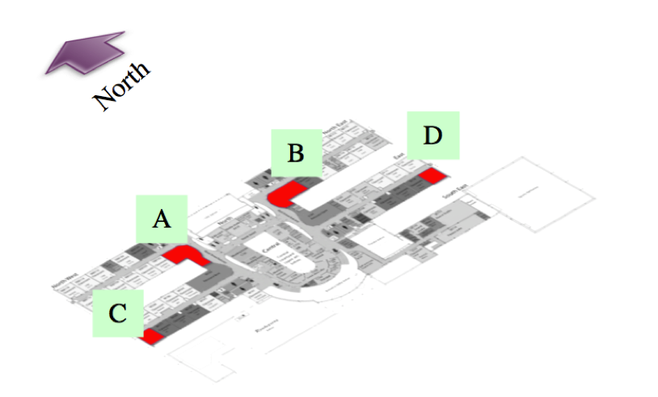

Figure 15: key map of the building, showing the monitored room in the first floor; Source: Authors.

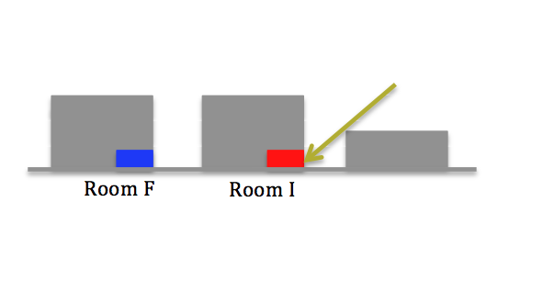
Figure 16: Schematic sections of the room F and room I; Source: Authors.

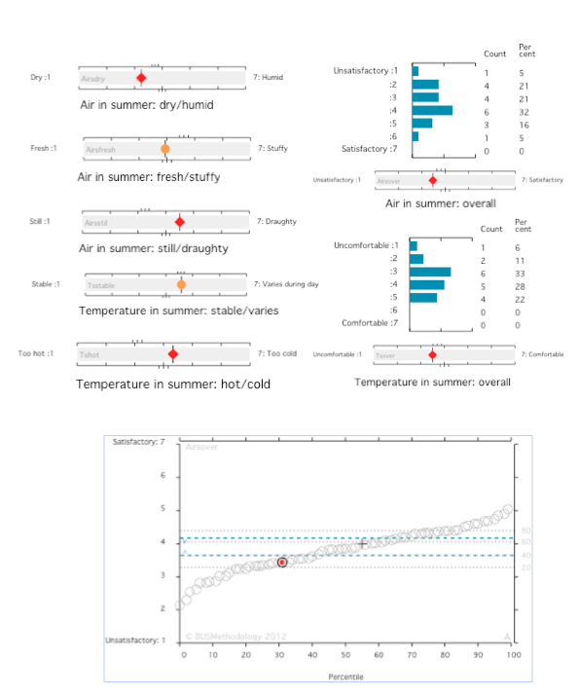
Figure17: perceived overall air conditions in summer; Source: Authors.
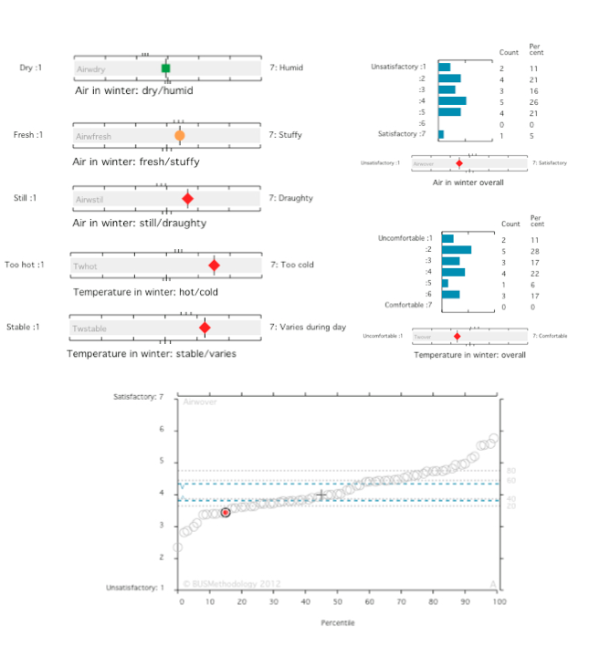
Figure18:perceived overall air-conditions in winter;Source: Authors.

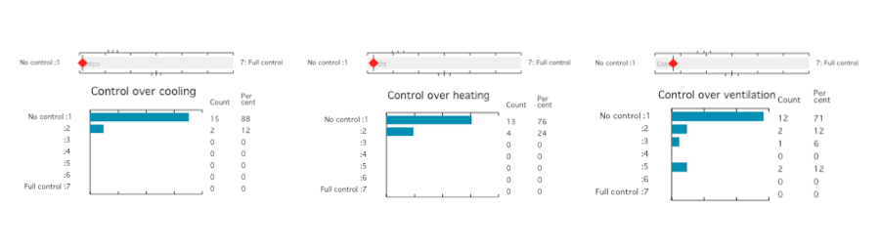

Figure 19: Control of the occupants over the Cooling, Heating and Ventilation; Source: Authors.

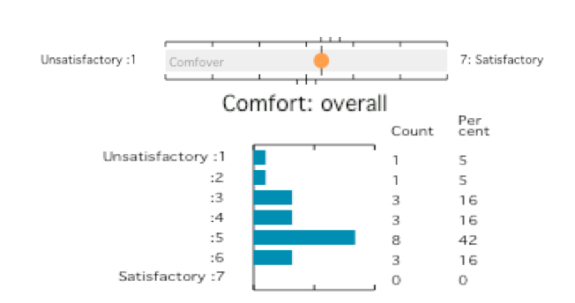

Figure 20: Perceived overall comfort in the building;Source: Authors.

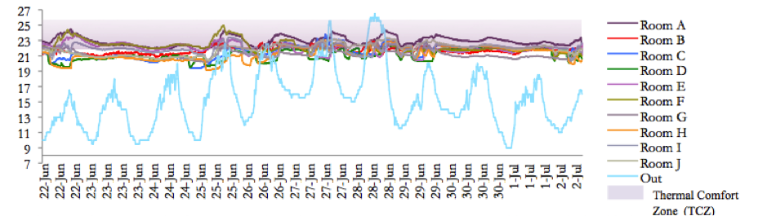

Graph 1: General result of the recorded ambient temperatures during the June 22th to July 2th 2012 (Luton Sixth Form Collage);Source: Authors.

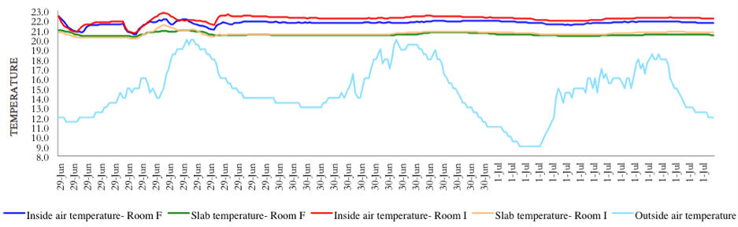

Graph 2: Comparative temperature results room F and room I during 29th, 30th Juneand1th July 2012(Luton Sixth Form Collage);Source: Authors.

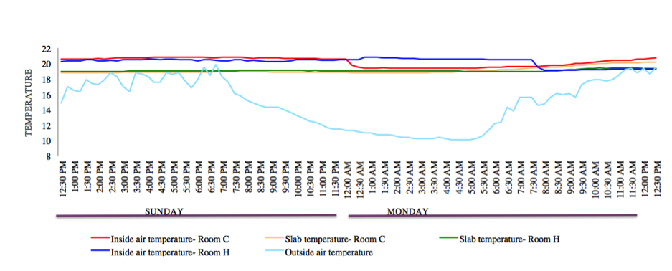

Graph 3: Comparative temperature results room C and room H during 24th and 26th June 2012 (Luton Sixth Form Collage);Source: Authors.

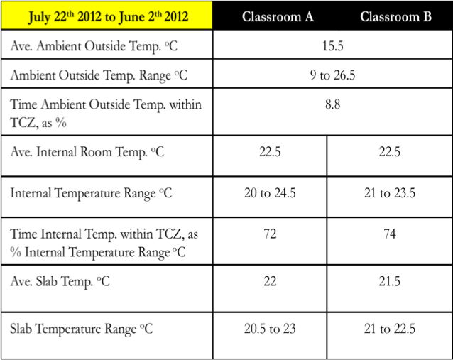
Table 1: General results of the comparing classroom F and classroom I;Source: Authors.
Table 2: General results of the comparing classroom A and classroom B; Source: Authors.
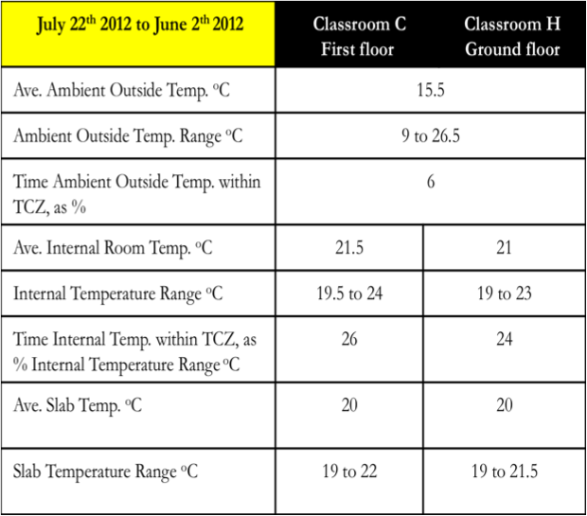
Table 3: General results of the comparing classroom C and classroom H; Source: Authors.

Appendix1:BUS questionnaire.

