Regeneration-led gentrification; a comparative study of Atabak and Khani-Abad neighborhoods in Tehran

Authors:
- Mohammad Massoud- corresponding author
Associate Professor at Isfahan Art University
- Bahador Zamani
Assistant Professor at Isfahan Art University
- Hosein Ebrahim Rezagah
PhD Candidate at Isfahan Art University
Regeneration-led gentrification; a comparative study of Atabak and Khani-Abad neighborhoods in Tehran
Abstract
The concept of "gentrification" is becoming an important and widespread phenomenon in most of the world's cities, both developed and developing. Consequently, many people have forcibly left their places or have lived at a higher cost. Therefore this phenomenon has become one of the most controversial issues of urban studies in recent years and can be analyzed as an influential and underlying factor in the evolution of urban economics and cultural changes. Social groups and movements resistance against the negative outcomes -especially homelessness caused by this phenomenon- has highlighted its unpleasant aspects. In Iran, and particularly in Tehran, less attention has been paid to the occurrence of this phenomenon and its outcomes. In some experiences, urban regeneration projects, by resolving the physical problems of neighborhoods and the major obstacles that led to their poor quality, raise demands for housing. This process causes an increase in the prices of units, which is finally followed by displacement of old residents. In such cases, urban regeneration actions accelerate and intensify the phenomenon of gentrification within the worn-out neighborhoods of the city.
The main objective of this research is to investigate the effects of urban regeneration policies on the occurrence gentrification as well as long-term impacts of this phenomenon on the social and economic structure of worn-out urban neighborhoods. In order to achieve these goals, the case study approach is used with statistical data analysis of the last ten years. Hence, the trend of changes in the number of “building permits” and “land prices” in the ten-year period of 2006-2016 is investigated in both neighborhoods. The results show that signs of occurrence of the phenomenon are more pronounced in the neighborhood where more and stronger regeneration interventions and physical changes can be observed.
Key words: Gentrification, causes, outcomes, regeneration, Displacement

Introduction:
Gentrification is a newfound concept first emerged in the 60's in the fields of social sciences, urban development and urban economics. This implies the forced displacement of the working class and low-income residents of old neighborhoods due to the presence of middle and upper classes. Despite the passing of almost half a century since the initial introduction of the Gentrification to the academic and professional societies in Europe and the United States, it is still unrevealed in Iran and has a rough path ahead to become a professional concern. Although the above concept was first introduced in European and American cities, the occurrence of this phenomenon can be observed in large cities of Iran. Many cities in Iran, including Tehran and Isfahan, contain physically worn-out areas. Because of physical problems, these areas are mainly secure locations for those classes who, for various reasons, do not have the tendency or power to switch to areas with fewer difficulties. In these areas, along with undeniable social problems, due to the long residence ages or common characteristics (culture, ethnicity, and social class), intra-neighborhood relations and in general, social capitals are bold and strong. Other prominent features of these areas are the proximity to commercial and administrative centers and, in general, to the city's work and activity centers. There are middle and upper classes in these cities who -for various reasons, such as time and cost saving- are interested in living close to the work and activity centers; residential areas at the margin of activity areas are of great desirability for these people. Some of the most important reasons for the decreased attraction of these areas as the target of immigration for middle classes are physical problems and weak public services and facilities. Improving the physical condition of these areas will lead to an increase in demand for housing, by middle and upper classes and results in rising land prices. The added value of the estates, the increase in the entry of upper economic classes and the loss of previous social cohesion, will gradually cause the low-income groups to lose their ability and desire for living in the neighborhood and move to other areas of the city which are more relevant to their economic condition. In this way, the old area will lose the previous coherent relations and social capitals that have gained over time (Ebrahim Rezagah, 2012: 24).
Gentrification as a concept that has received numerous and various opinions over the past half century (documented from 1964 onwards) is a multi-dimensional topic that has many pros and cons. diversity of its outcomes has led to the emergence of a range of perspectives either rejecting and considering it as undesirable or accepting and considering it as desirable.
The introduction of this concept as a concern in Iran's academic and professional associations, firstly, requires understanding the subject, the causes of its formation, and the outcomes of its occurrence. Therefore, the present article seeks to investigate its occurrence in Tehran's neighborhoods, by processing its concept, its causes, and opinions of the relevant scholars and thinkers. First, we address the recognition of the concept of gentrification from the viewpoint of various theorists; its occurrence stages, positive and negative consequences and subsequent consequences, and then we examine signs of its occurrence and consequences in Khani-Abad and Atabak neighborhoods located in Tehran, districts 12 and 15, respectively.
Theoretical Foundations
Gentrification is a process in which higher-income residents of the city’s inner neighborhoods replace low-income families. One of the first notes to use the term "Gentrification” is Manchester's literary and philosophical writings written in 1888. According to historians, there has also been Gentrification in ancient Rome. Where large villas, in the third century, were replacing small business units (Parkins and Smith, 1998: 197).
Ruth Glass was one of the first to use the term in the 60's to describe the process of displacement of the working class in London. In her 1964 studies, Glass introduced a gentrification as an aspect of the change in which the working class living in London's neighborhoods, like Hampstead and Chelsea, was replaced by middle classes. According to her, gentrification is associated with improving physical condition, changing ownership structure from rent to own and raising prices (Wyly, 2010: 2).
Gentrification, as one of the most complex urban behaviors, has led many researchers to analysis, and debate in various fields of economic, political, sociological, and geographic areas (Hamnett, 2009: 477), And implies the replacement of lower classes by the middle classes in urban areas. This is more common in the central and older neighborhoods of the cities, which, over time, have gathered the lower strata of society. The newcomer middle class has sought to reduce costs and bring revenue sources closer to the neighborhoods. On the other hand, the main inhabitants of these neighborhoods are always looking at these newcomers as aggressive people, who are not, in fact, a member of their community.
The encyclopedia of the city has defined the term "the process of renovation and promotion of neighborhoods which is associated with the influx of upper and middle classes to the inner neighborhoods of the city and the displacement of the poorer inhabitants" (Caves, 2005: 25).
Some researchers point out that the occurrence of this phenomenon is the rehabilitation of the working class or abandoned homes, through housing for middle-class residents or the process of moving higher-income residents into disadvantaged neighborhoods that suffer from lack of investment and attention, (Levy et al., 2006: 11 quoted from Atkinson, 2002; Wyly and Hammel, 1999). The phenomenon of "gentrification" is also defined as the rebuilding of urban centers by middle and upper classes, a concept that not only affects residential sectors, but also other commercial and administrative sectors of these centers (Smith, 1996quoted by Levy et al., 2006: 11). In this view, "gentrification is defined as a set of activities to improve housing and the residential environment; A shift in the composition of neighboring units and the replacement of low-income groups by middle and high income, In the central parts of cities "(Button, 1985: 125).
If the occurrence of gentrification in the geographical, physical and economic fields is looked on as an opportunity, in order to invest in the improvement of space and construction in a region that has already faced the problem of exhaustion and decline, the positive aspect is more obvious. On the other hand, if this phenomenon is considered as the loss of the place of living of low-income groups by higher-income people, its negative aspects are visible (Marcuse, 1999: 790).
Gentrification is a controversial and multi-faceted phenomenon; the process of this phenomenon decreases and overcomes issues that are unanimous in their unfavorability. It seems that the occurrence of this phenomenon has helped the old neighborhoods from poverty, erosion, crime, and addiction, and many other acute problems. This phenomenon entails huge amounts of capital (human capital of newcomer middle class, new services, and rising land prices) and encourages urban management to provide modern public services for the neighborhood. Of course, former low-income residents who are forced to leave due to higher rents and house prices are not using these new services and investments (Wyly, 2010: 3).
Regeneration-led gentrification
After studying the phenomenon in the city of Bilbao, Vicario and Martinez conclude that one of the effects of urban regeneration policies proposed to restore the structure of urban centers can be the occurrence of gentrification in the inefficient and deprived neighborhoods of the city. In their opinion, the Bilbao experience highlights the importance of local government in creating potential neighborhoods subject to the phenomenon of gentrification (2005: 155).
According to Roberts, regeneration is a process that leads to the creation of new urban spaces by preserving the main spatial (physical and activity) characteristics; a comprehensive and integrated view of a set of measures that will solve urban problems (Roberts, 2000 quoted in Bahraini et al. 2013: 20).
Existing literature on the effects of urban regeneration on urban areas is divided into two groups; the first group considers these effects positive because of the replacement of the poor people by the middle classes. The second category of these effects is negative for social reasons. The first category seeks to stimulate economic growth in the urban areas and encourage prosperous people to settle in the modernized worn-out areas; this is done through the improvement of the physical environment. The group argues that the benefits of economic growth will gradually shift from the restored environment to the lower classes, which are the traditional inhabitants of the deteriorated regions. On the other hand, the second group argued that opportunities and resources should be directly available to deprived people (Atkinson and Bridge, 2005).
Referring to the positive effects of urban regeneration and sustainability, while avoiding the class nature of related processes and neutralizing the negative image of the occurrence of gentrification (Lees 2008: 2452), politicians try to hide the effects of displacement of inhabitants and social homogeneity of neighborhoods. On the contrary, they rely on the benefits of Organizing neighborhoods and diversity in the focus of poverty (Maloutas, 2011).
Since Ruth Glass's time, there has been a lot of effort to elaborate the process of occurrence of gentrification that attempted to explain the causes, context, process, participants and its implications. In sum, two trends in thinking about the occurrence of this phenomenon can be identified: "economic structuralism", a Marxist view led by Neil Smith, and the idea of "Individual independence", a human vision led by David Ley.
According to Smith, capital is only returned to the selected parts of the city for the benefit of the rent gap. He portrays the gentrification, different things for different people; a process that will improve the housing and retail economy in neighborhoods through private sector investment (2004: 47). Richard Florida, in his book “cities and the creative class”, also introduces the exacerbation of gentrification, in direct connection with the increase of wealth (2002: 15).
The rent gap is the difference between potential land rents and fixed rents in the actual housing market. Potential rent is the amount of rent that can occur if there is the best and highest use of land, and fixed rent of the housing market is the amount of rent that has been designated for the current user, under existing conditions and with the consent of the property owner, (Wong, 1988: 64). In other words, the rent gap is the difference between the current rent in a deteriorated and depreciated area and potential rent if the same area is improved (Cowan, 2005).
Smith's economic view, with emphasis on capital and resources, poses many questions without answering. Various characteristics of demand are not taken into consideration and the choice of specific regions of the city, if there are many other areas with similar characteristics, is not covered. The identity of new people, the process by which these people choose a place and the role of environmental factors are other things that the economic perspective has failed to respond.
Freeman stipulates that education is likely to be better than income to introduce the newcomers. Because young professionals, are often pioneers of gentrification. The humanitarian perspective covers the weaknesses of the economic perspective, but it does not retain in the economic aspect of this phenomenon (Freeman, 2005: 24).
The combination of these two approaches in the new perspectives has led to the emergence of two sets of theories, each of which forms the basis of earlier thinking, theories of the supply side (economic view) and theories of the demand side (Human Perspective). Although both theories have contributed to the explanation of the existing artifact and natural structure, their major difference is that who or what causes the process of gentrification. Now it can be argued that these definitions and concepts complement each other (Wyly, 2010: 4).
Philip Clay's four-step model emphasizes the process of changing the neighborhood. He found that private investment in the late 1970s took place in all major cities of the United States, especially old neighborhoods that were occupied by the working class. Places that for some reason had not been of interest to investors. He describes the various sequences of the phenomenon of gentrification, based on his studies in American cities (Clay, 1996 quoted by lees at el. 2007: 30):
In the first stage (leading actors), individuals in small groups, regardless of the potential risk, enter a declining neighborhood and rectify their own facilities at a personal expense. In the second stage, the number of people and their visibility, increase and renewal at the level of the blocks expand. Still, capital has not come up much, and since vacant homes are scarce, displacement of former inhabitants begins. In the third stage, the process becomes more conscious than before, and goes beyond the limited number of first stage newcomers; the new residents consider housing as a capital asset. At the last stage, the rise in house prices and rental rate is institutionalized and displacement of the old owners, not just tenants, begins. In addition, with the escalation of this stage, the newcomer middle class (pioneer perpetrators) is also subject to displacement.
Results and effects
If gentrification is identified as the strategy of some middle-class groups to increase spatial capital, it can have a significant effect on the "displaced" population. A population that, in addition to losing their neighborhood (and consequently social capital), has lost its place capital due to the occurrence of gentrification.
It can be argued that gentrification is like a double-edged sword; it can provide many desires for space, revive it, and, at the same time, have devastating effects on small indigenous communities and businesses. As the rent gap theory predicts, one of the most obvious effects of the phenomenon is the change in the basic infrastructure of the neighborhood. Areas exposed to the phenomenon are generally worn out and old, however, such neighborhoods have capacities that are potentially very attractive for the arrival of middle-class immigrants.
Table 1: Positive and Negative Consequences of gentrification
Positive outcomes | Negative consequences
Increased incentives for owners to improve their construction status | The displacement of the lower classes of the neighborhood following a rise in prices
Reduce crimes | Psychological and mental consequences of displacement
Stabilization and improvement of the physical condition of the worn-out areas | The anger and distrust of the social strata of the community towards both local and national governance
Increased property value | Reducing affordable housing
Increasing the purchasing power of local retail consumers | Unsustainable and speculative increasing in prices
Reduce the rate of vacancy and lack of use of the building | Homelessness
Increased local revenues | Increased collusion between investors and local rulers
Encouraging and increasing the likelihood of continued development in neighborhood | Commercial / Industrial gentrification
Reduce pressure on local infrastructure and services | Increased costs due to changes in local services
Suburban dispersal decline | Relocation and increasing demand for housing in marginalized neighborhoods
Increased social mix | The loss of social diversity (from heterogeneous communities to wealthy ghettos)
Restitution of assets (with or without local support) | Losing the old population and being occupied by new groups
References: Loretta Lees, Tom Slater, and Elvin Wyly, 2008: 5
The most important social consequence of gentrification is the displacement of the poor and working class of the city's central neighborhoods. Since people have gathered in urban centers, for a variety of reasons, groups of citizens have been forced to leave their place of residence. According to experts, displacement occurs when residents are forced to leave their homes due to circumstances that affect their settlements or their immediate surroundings. These causes, which go beyond the control of the inhabitants, make it impossible, risky or out of their financial standing. Gentrification is considered one of the most fundamental causes of displacement (Hutchison, 2010: 224-225).
In this process, low-income groups are forced to leave when they are no longer able to afford rent and tax increases because of new developments or the occurrence of gentrification. This type of displacement is also known as unwanted displacement (Newman and Wyly, 2006: 1).
Lees et al. (2008), Slater (2011), Smith (1996, 2009), Wyly (2010), and Atkinson (2000, 2002), without referring to "regeneration", concluded that through eliminating the physical inefficiency of neighborhoods, physical interventions along with the arrival of capital, create demand for housing in the neighborhood, through a wider range of families. An increase in demand, and consequently land prices and rentals, causes the displacement of a lower class that previously had chosen the neighborhood because of low prices. Based on the results of these studies, the intensity and size of interventions have a direct correlation with the rate of progression of gentrification in worn-out areas. In the following, the extent of the progress of gentrification in the inefficient neighborhoods of Tehran, which was the basis for systematic interventions, namely, regeneration measures, and the relationship between the plurality and severity of measures and regeneration policies with the onset of gentrification, are examined.
Methodology
In this research, regeneration project, as factors aimed at solving the problems of many deteriorated neighborhoods are independent variable and the occurrence of gentrification as an event that results in hidden capacities in some neighborhoods, Reveals the dependent variable. This research seeks to identify the effects of adopting policies and the implementation of regeneration projects in worn-out areas on the severity of the occurrence of gentrification.
In order to know the characteristics of case studies and collecting the required information, using the questionnaire and photography technique, information is obtained and the method of collecting required statistics and information is in the form of library, documentary and field.
Regarding the formulation of the problem and the methodology of the research, it is necessary to examine the intervening and influencing policies on the occurrence or non-occurrence of the gentrification, using the case study method. This approach is based on two axes, "analysis of the content of policies and Plans "and" analysis of the implications of policies and plans". Affected areas, at different stages of the process of review, from non-occurrence to relative occurrence, are chosen in order to assess the extent of the positive and Negative effects of policies. Hence, in the first step, the city of Tehran has been selected as a major subject of the research. In the second step, according to the Phenomenon, the inner city of Tehran have been identified as residential areas that comprise the deteriorated neighborhoods of the city. Finally, in the third step, the target areas have been selected at two levels of occurrence, from the preliminary stages to relative occurrence. The effective indicators are severe inefficiency, the existence of policies and plans for regeneration, the high proportion of rental to owner-occupied properties and the gap between the growth of land prices And rentals in comparison with the average growth throughout Tehran.
Accordingly, considering the statistical data and recreational plans prepared for the inefficient neighborhoods of the city, the study area in relation to the preliminary stages of the occurrence of gentrification, is Khani-Abad district, and the study area in connection with the occurrence of the phenomenon of gentrification, is Atabak neighborhood.
Case study
In order to understand the process of occurrence of gentrification, an overview of the regeneration measures in these neighborhoods, the manner of occurrence of physical changes in a 10-year period (2006 to 2016) was investigated and price changes as the most significant signs of the occurrence of gentrification (Smith, 1996 ) was studied.
I-Khani-Abad neighborhood
Khani-Abad, one of the old neighborhoods of Tehran, is located in the second wall of Tehran region (Naseri Fence) and on the southwest side of the 12th district of Tehran. The resident population has declined over the last two decades, and its population growth rate (around 1.3%) is indicative of a stagnation in housing performance. According to statistics, about 85 percent of the residents of the neighborhood are immigrants. In the last half century, they have immigrated to the area from the northwest cities of the country (Diargah engineering consultants, 2009). One of the most important problems in the neighborhood is the small size of the housing lots, as 84% of them have an area of less than 100 square meters. This factor, along with the problem of the inability of car access to plots, has led to the Construction stagnation, in spite of the encouraging policies of approved regeneration documents (the allocation of low-interest loans for renovation, the forgiveness of renovation and reconstruction fees, and other incentive measures). In total, nearly 3% of existing buildings are new and on the other hand, more than 85% of buildings are over 40 years old. The same factors have caused the housing investors not to be eager to renovate in the neighborhood (Alipour and Biabani Moghadam, 2011).
Apart from the rules and regulations of the comprehensive (approved in 2007) and detailed plans (approved in 2012) of Tehran, that generally include all the worn-out areas of the city, Khani-Abad is affected by two documents; first, urban landscape regeneration of Khani-Abad (Diargah engineering consultants, 2009) and second, Takhty neighborhood development (Takhty neighborhood reconstruction office, 2014).
Table 2: Local government regeneration measures in Khani-Abad neighborhood
the title of the document | Preparation year | Supplier institution | Level | Output
Tehran City Master Plan | 2007 | Establishment organization of detailed plans of the city of Tehran | Tehran and its regions | - Access hierarchy  - Zoning  - Topical and thematic projects
Development pattern of the 12th district of Tehran | 2003 | Establishment organization of detailed plans of the city of Tehran | 12th District of Tehran | - The proposed spatial organization
Detailed plan of the 12th district of Tehran | 2012 | Establishment organization of detailed plans of the city of Tehran | 12th District of Tehran | - Network Sequence and street widths  - zoning  - Topical and thematic development catalytic projects  - Regeneration policies for worn-out neighborhoods
Khani-Abad neighborhood urban landscape design | 2009 | Tehran Municipality Renovation Organization | Khani Abad neighborhood | - The proposed spatial organization of the neighborhood  - Proposed landuse  - Regeneration policies  - Spatial design
Takhty neighborhood development document | 2014 | Office of Takhti neighborhood regeneration | Takhty neighborhood | - Development catalytic projects
Reference: Researchers
In particular, the urban landscape design of Khani-Abad neighborhood focuses on the of the neighborhood renovation regardless of its financial resources, as well as the participation of investors, and has taken into account the "Land Readjusment approach" (Figure 1). On the other hand, the Takhty neighborhood development document, which was prepared by the office of renovation services in Takhty, has focused on the implementation of several individual parking projects as catalytic projects at the neighborhood level. A field study of the status of the neighborhood (2017) in comparison with the proposals of the documents above, suggests slight changes within it, after eight years since the approval of the urban landscape design and three years since the development of the neighborhood document. Regardless of the mechanism of implementation and monitoring of these schemes, the limited amount of changes in the neighborhood suggests the effect of these documents on the inflow of capital into the neighborhood and the change of its physical infrastructure.

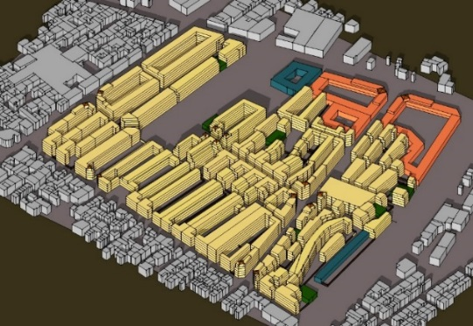
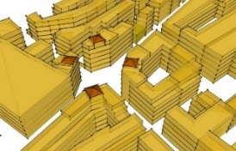
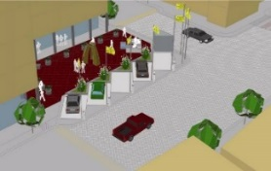
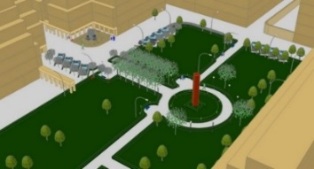
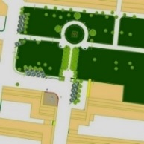
Figure 1: Khani-Abad neighborhood urban landscape design
Reference: Diargah engineering consultants, 2009

The low tendency to invest in the neighborhood (the 3% share of the newly constructed building relative to the total residential units) and the lack of attractiveness of the neighborhood as a destination for immigration (especially for the middle class) indicate that the current situation is not conducive to the occurrence of gentrification. However, obviously, it can be seen from aggregation of residential units and the much higher price of new residential units than the average of the neighborhood and surrounding district. The comparative study of the number of construction licenses issued during the period from 2006 to 2016 in Tehran, 12th District and Khani Abad neighborhood of declare the lower demand for investors in the neighborhood compared to the region and the city.

Chart 1: Changes in the number of construction permits in Khani abad, District 12 and Tehran
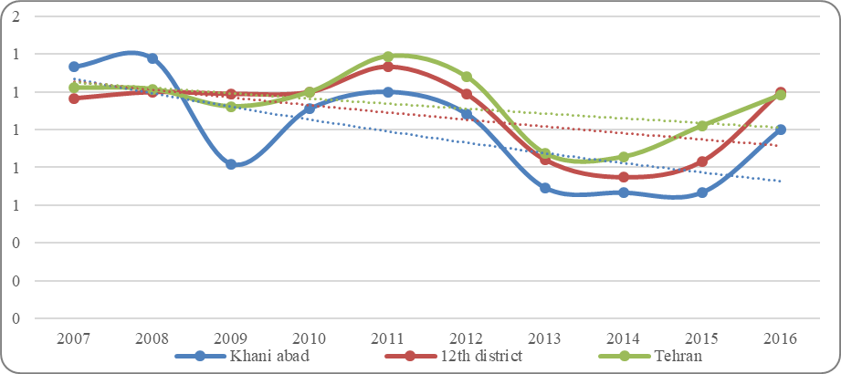
Reference: Iranian Center for Statistics, Field Study

On the other hand, the study of land price changes during this 10-year period (2006-2016) indicates lower changes in this neighborhood compared to Tehran and the 12th region. Chart 2 shows that the neighborhood has survived the land price increase process in Tehran, and during the last decade the pace of land prices has fallen as compared to the 12th district. The low return on investment in the neighborhood justifies the lack of renovation and restructuring by the private sector.

Chart 2: Price changes per square meter of residential property in Khani Abad, 12th District and Tehran
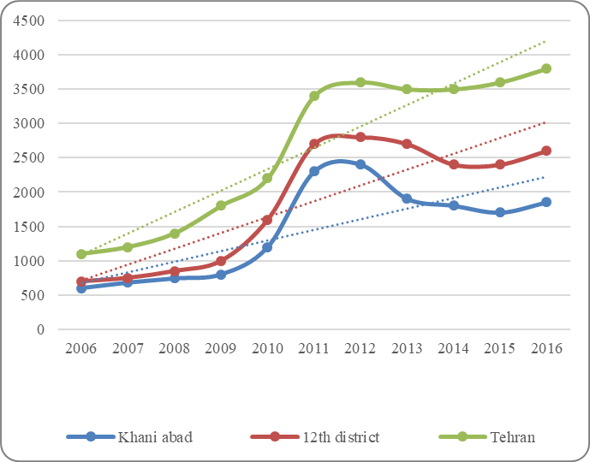
Reference: Iranian Center for Statistics, Field Study

II. Atabak Neighborhood
The Atabak neighborhood, near Imam zadeh Malek Khatoon, is located in the 15th district of Tehran. This neighborhood is limited to the streets of mallaieri (north), Derakhshanno (south), Imam Ali highway (west), and Khob-Bakht (east). Apart from the general regeneration rules, and comprehensive (2007) and detailed plan (2012), since 2000, this neighborhood has been the subject of many regeneration actions (ownership plan of the eastern lands of Shahid Khob-Bakht (2003), the plan of the Imam Ali highway, (2005), urban landscape design of Imam Ali district (2006)).
The intervention of the Tehran municipality in the Atabak neighborhood started in 2001. Based on the "Continuation of the East Highway" project, in this year, the municipality took ownership of the parts on the fringes of the Khob-Bakht St. During the years 2001 to 2002, about 165 plots were purchased according to the plan. In 2003, the consultant of the detailed plan of the region proposed a redirection of the highway from the Khob-Bakht St to the current route. The main justification for this proposal was the use of highway capacity to rebuild the rusty texture of the area. After the approval of the plan in 2003, the modernization organization as the executive took ownership of the project through attracting financial resources. In 2005, the design was undergoing major changes. The first urban landscape project prepared by Tehran's modernization organization is the Khob-Bakht neighborhood plan (Haj Ali Akbari, 2011).

Table 3: Urban governance regeneration measures in the Atabak neighborhood
the title of the document | Preparation year | Supplier institution | Level | Output
Tehran City Master Plan | 2007 | Establishment organization of detailed plans of the city of Tehran | Tehran and its regions | - Access hierarchy  - Zoning  - Topical and thematic projects
Development pattern of the 15th district of Tehran | 2003 | Establishment organization of detailed plans of the city of Tehran | 15th District of Tehran | - The proposed spatial organization
Detailed plan of the 15th district of Tehran | 2012 | Establishment organization of detailed plans of the city of Tehran | 15th District of Tehran | - Network Sequence and street widths  - zoning  - Topical and thematic development catalytic projects  - Regeneration policies for worn-out neighborhoods
Eats of Khob-Bakht St land acquisition plan | 2003 | Municipality of the 15th district of Tehran | Atabak neighborhood | - Owning parts located within the Khob-Bakht St
West of Imam Ali HW land acquisition plan | 2005 | Tehran municipality | 15th District of Tehran | - Owning parts located within the Imam Ali Highway
Imam Ali region's Special Renovation Project | 2005 | Renovation Organization of Tehran Municipality | Neighborhoods of Imam Ali district | - Proposed spatial organization and land use of the neighborhoods of Imam Ali district
urban landscape design of Khob-Bakht neighborhood | 2006 | Renovation Organization of Tehran Municipality | Atabak neighborhood | - The proposed spatial organization of the neighborhood  - Proposed landuse  - Regeneration policies  - Spatial design
Reference: Researchers
The Urban Landscape Project of the Khob-Bakht neighborhood (2006) shows that the population of the neighborhood has shrunk from 12,000 to 6,400 during the renovation process. Therefore, the displacement of residents of the neighborhood, although slowly began and gradually became a compulsory state. In this project, it has been attempted to create the necessary ground for the development of roads and the creation of services and open spaces in urban areas by reducing the occupancy level of residential use. According to the plan, the number of residential and commercial units in the neighborhood, which was close to 1,500 before the commencement of the rehabilitation process, will be converted to 180 newly built residential blocks (quoted in Haj Ali Akbari et al., 2008).
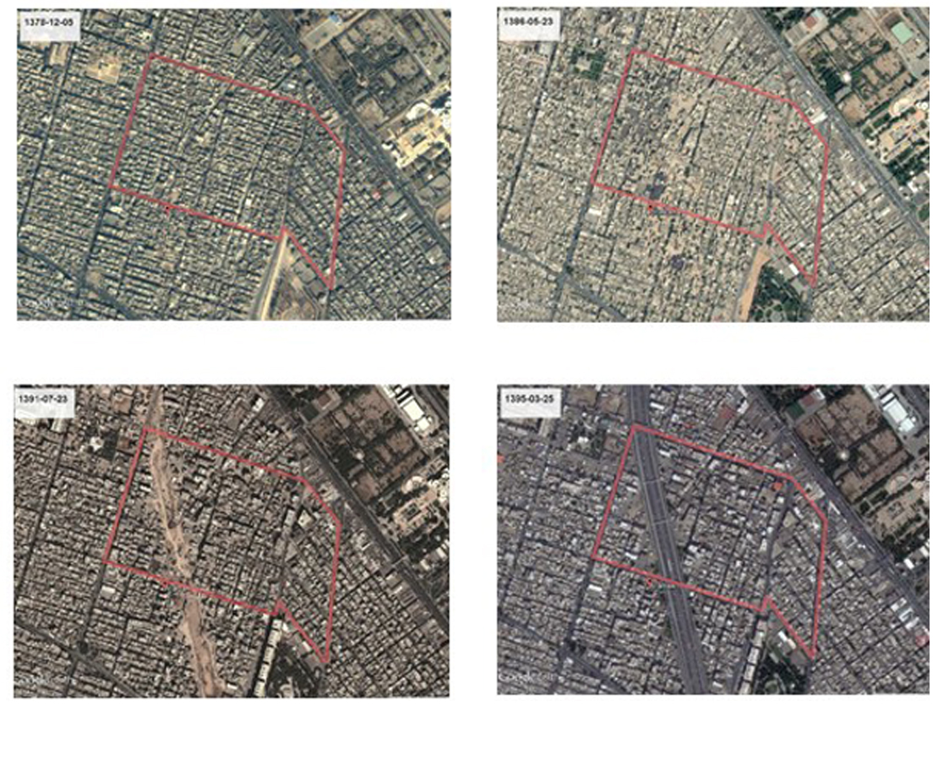
1999-Neighborhood density and extreme small plots - The absence of signs of initiation of interventions
2007 - Ownership and destruction of small plots within the neighborhood by the encouragement of the local governance
2012 - Destruction and fragmentation of neighborhood tissue by Imam Ali Highway
2016 - Completion of housing construction projects as well as Imam Ali Highway
Figure 2: Atabak changes during the years 1999 to 2016
Reference: Google earth satellite picture

The existence of ruined buildings or vacant land that is the result of the demolition of buildings has led to the formation of insecure hangouts in the neighborhood, which has created a suitable field for the emergence of addiction and lewdness. Despite the interest of residents in fleeing the neighborhood and the immigration of many to other neighborhoods, the interesting point is the tendency of investors and applicants to this neighborhood. The study of the number of construction licenses issued in the period from 2006 to 2016 indicates the relative growth of the number of them in the years 2009 to 2013 as well as the year 2016. According to the area of the Atabak neighborhood (14 hectares), from 2006 to 2016, 3.8 hectares of houses are built newly with a maximum age of 10 years. (27% of the total area of the neighborhood). From 2006 to 2011, 140 pieces were constructed or renovated. The focus was on construction in the eastern part, and the total construction during these years was 20,500 square meters. From 2011 to 2016, 65 pieces were constructed and renovated, and the focus of construction in these 5 years was in the central and eastern parts of the neighborhood; most of the mentioned aggregation projects were emerged during these 5 years. The total construction during this period is 17,200 square meters. The examination of the issued construction permits, taking into account the conditions governing the regional and national economy, and in other words, a comparative study, indicates that their growth rate is much higher than that of the 15th district and the entire city of Tehran has it. So that the growth rate of construction licenses in the year 2010 was exceeded Tehran and in the year 2011 exceeded the 15th district. This indicates the greater willingness of investors to attend the neighborhood, and hence higher returns on investment.

Chart 3: Changes in the number of construction permits in atabak, 15th District and Tehran
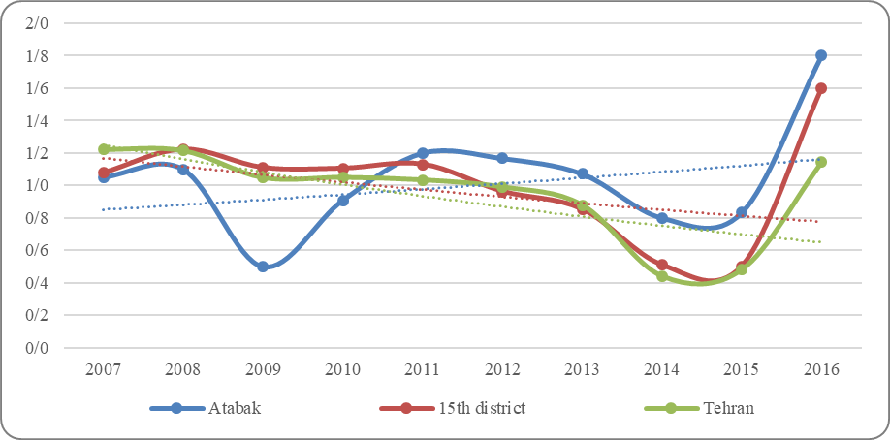
Reference: Iranian Center for Statistics, Field Study
Comparison of land price changes in Atabak, 15th district and Tehran city shows that the average price of land since 2009 simultaneously with the intensification of physical changes in the neighborhood has exceeded 15th zone and since 2011, the total city of Tehran. This justifies the interest of investors in this neighborhood and the higher profitability of construction.
Chart 4: Price changes per square meter of residential property in Atabak, 15th District and Tehran
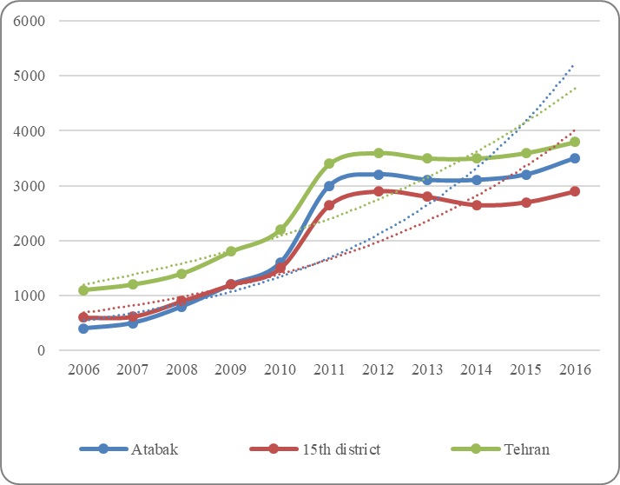
Reference: Iranian Center for Statistics, Field Study
In this research, two neighborhoods from central regions of Tehran were investigated with two different situations in terms of urban regeneration and urban concentration. First, Khani-Abad district in the 12th and 2nd districts of Atabak district in the 15th district of Tehran. Both of these neighborhoods are considered as deteriorated neighborhoods in Tehran according to the upstream documents such as master and detailed plans. But, in the previous decade, Atabak neighborhood was chosen as the leading district for implementing urban regeneration policies. In addition to common "urban landscape" projects that were prepared for most of the worn-out neighborhoods, including Khani-Abad, Atabak has been the subject of many regeneration projects such as the possession of residential plots to aggregate them, the construction of residential projects with public subsidies and the construction of the Imam Ali highway as one of the south-to-north linkage structures.
A comparative study of two case studies suggests that in both neighborhoods signs of the occurrence of gentrification can be observed, with the difference that the signs and the rate of progress is more obvious in Atabak neighborhood. The comparison between the growths in the number of construction permits issued in the two neighborhoods makes clear that although between 2006 and 2011 the rate of increase or decrease of building permits both follows a similar logic and is close to each other. But between 2011 and 2015, there is a significant increase in the number of construction licenses issued in Atabak neighborhood. This growth has reached its peak in the year 2016.
The comparison between the land price changes in the two neighborhoods in question indicates that the price of land is close in both areas, till 2008. Between 2008 and 2011, despite the close proximity of land prices in both neighborhoods, there is a further increase in Atabak neighborhood. But from 2011, the distance between the two neighborhoods increased every year and peaked in 2016 (more than 15 million IR.RLS per square meter of residential land).
Conclusion
In recent years, the process of regeneration of the worn-out neighborhoods of Iran's cities, despite the high desirability of its subject, did not take the economic and social consequences of the various aspects into account and damaged the social structure of the native inhabitants of these neighborhoods. Examples of this kind of interference can be found in neighborhoods of desert cities that are gradually losing genuine populations and even earlier uses.
This paper, with the aim of recognizing the various dimensions of gentrification, has tried to introduce the importance of paying attention to this phenomenon in the field of urban, social and economic sciences as a research and professional concern. Ultimately, the quality of its occurrence and consequences has been investigated in Khani-Abad and Atabak, two neighborhoods of Tehran.
Based on the findings of this study, in general, the origins of the phenomenon of gentrification can be sought in the region's excessive recession and the creation of a gap in the value of land and rents between the neighborhood and other parts of the city. Therefore, the gap between value and rent can be cited as the reason for the occurrence of this phenomenon, and the neighborhoods that have met this gap have been considered to be the likely basis of its occurrence. On the other hand, the implementation of regeneration projects by addressing the physical dilemmas of these worn-out neighborhoods will act as catalyst projects for the occurrence of the phenomenon and will contribute to the occurrence of the phenomenon with all its positive and negative consequences.
The comparison of Atabak and Khani-Abad as neighborhoods that both have been prone to occurrence of gentrification, based on factors such as location and the gap between land prices and rents, indicates that, in the neighborhood with more obvious and objective regeneration activities over the past decade (Atabak), private sector investment, as well as land price growth, are more severe. Evidence suggests that the gentrification of this neighborhood is faster and more widespread than the neighborhood where regeneration measures are more limited (Khani-Abad).
If the goal of urban regeneration is the development of justice and equality, and if the processes of renewal, revival and rehabilitation seek to support those who live in neighborhoods, then the Private and public sector investors and decision makers should also consider the negative outcomes of their investments and actions, and seek to resolve them.
References:
- Atkinson, R. (2000) Measuring Gentrification and Displacement in Greater London, Urban Studies, 37, 1, pp. 149-165.
- Atkinson, R. (2002) Does gentrification help or harm irban neighborhoods? An assessment of the evidence-base in the context of new urban agenda. Bristol: ESRC Centre for Neighborhood Research.
- Atkinson, R. and Bridge, G. (2005) Introduction. In R. Atkinson & G. Bridge, Gentrification in a Global Context: The New Urban Colonialism. London: Routledge.
- Blasius, J., (2004) Gentrification und die Verdrängung der Wohnbevölkerung in Kecskes, R., Wagner, M. and Wolf, C., (Eds.) Angewandte Soziologie. 1st ed. Wiesbaden: Springer Science + Business Media, pp. 21-44.
- Beauregard, R. (2010) the Chaos and Complexity of Gentrification. In L. Lees, T.Slater & E. K. Wyly (Eds.), the gentrification reader (pp. 617 p.). London; New York: Routledge.
- Caves, Roger w.(2005) Encyclopedia of the City, New York, Routledge
- Clark, E., (1992) on gaps in gentrification theory in Housing Studies (Journal), Vol.7, No. 1, pp. 16-26.
- Duany, Andres (2001) Three Cheers for “Gentrification”, The American Enterprise 12, no. 3
- Ebrahim Rezagah, Hossein (2011) Capital-led urban design; toward protection and promotion of capitals in deteriorated areas, Master's degree in Urban Design, Faculty of Architecture and Urban Planning, Shahid Beheshti University
- Florida, R. (2002) The Rise of the Creative Class: And How It's Transforming Work, Leisure, Community and Everyday Life. New York: Basic Books.
- Freeman, Lance (2005) Displacement or succession? Residential mobility in gentrifying neighborhoods. Urban Affairs Review 40 (4): 463-491.
- Haji Ali Akbari, Kaveh (2011) Review of the two-year experiences of facilitating the renovation of the city of Tehran in the local renewal offices, Modernization Internet magazine, the second year, No. 13, July
- Haji Ali Akbari, Kaveh et al. (2008) Participatory modernization - Case study of Khob-Bakht neighborhood, The first conference on the renovation and revitalization of urban worn-out fabrics, Mashhad
- Hutchison, Ray (2010) Encyclopedia of Urban Studies, Los Angeles, Sage Publications
- Hamnett, C.(1991) The Blind Men and the Elephant: The Explanation of Gentrification in Transactions of the Institute of British Geographers, New Series, Vol. 16, No. 2, pp. 173-189
- Freeman, Lance (2005) Displacement or succession? Residential mobility in gentrifying neighborhoods. Urban Affairs Review 40 (4): 463-491.
- Jerzyk, M. (2009) Gentrification’s third way: An analysis of housing policy and gentrification in providence. Harvard Law and Policy Review, 3, 413–430.
- Lees, L. (1994) Gentrification in London and New York: An Atlantic Gap? in Housing Studies (Journal), Vol. 9, pp. 199-217.
- Lees, L. (2008) Gentrification and Social Mixing: Towards an Inclusive Urban Renaissance? In Urban Studies (Journal), Vol. 45, No. 12, pp. 2449-2470.
- Lopez-Morales, E. (2011) Gentrification by Ground Rent Dispossession: the Shadows Cast by Large Scale Urban Renewal in Santiago de Chile. International Journal of Urban and Regional Research, 35(2), 1-28.
- Lind, H. and Hellström, A. (2003) Gentrification - an overview of the literature. Report No. 17, Stockholm: Housing Project at the Division of Building and Real Estate Economics. Working Paper No. 38.
- Ley, David (1996) Artists, Aestheticisation and the Field of Gentrification, Urban Studies November 2003 40: 2527-2544
- Levy , Diane K. et al, (2006) In the face of gentrification: Case Studies of Local Efforts to Mitigate Displacement, Washington, DC, The Urban Institute Metropolitan Housing and Communities Policy Center
- Lees, L., T. Slater and E. Wyly (2008) Gentrification. Routledge, London.
- Lees, Loretta, Slater, Tom, and Wyly, Elvin (2010) the Gentrification Reader. New York: Routledge. Lees at el، 2006
- Landry, C. (2008) the Creative City. A toolkit for urban innovators. 2nd ed. London: Earthscan in association with the International Institute for Environment and Development.
- Marcuse P, (1999) Comment on Elvin K.Wyly and Daniel J. Hammel's `Islands of decay in seas of renewal: housing policy and the resurgence of gentrification' Housing Policy Debate 10 789 – 797
- Maloutas, T., (2011) Contextual Diversity in Gentrification Research in Critical Sociology (Journal), Vol. 38, No. 1, pp. 33-48.
- Newman, K. and Wyly, E. (2006) The right to stay put, revisited: gentrification and resistance in New York City, Urban Studies 43(1): 23-57
- Okada, Shuhei (2014) Transformation of spaces and places in inner cities: the case of gentrification in Brixton since the riot in 1981, Ph.D. dissertation, Royal Holloway, University of London
- Slater, Tom (2005) Gentrification and the Displacement Question, Presentation in Toronto Neighborhoods CURA
- Slater, Tom (2006) The Eviction of Critical Perspectives from Gentrification Research in International Journal of Urban and Regional Research, Vol. 30, No. 4, pp. 737-757.
- Slater, Tom (2011) Gentrification of the City, The New BlaCkwell Companion to the City, Wiley-Blackwell, 571-585Smith، 1982
- Smith, Neil (1987) Gentrification and the Rent Gap in Annals of the Association of American Geographers (Journal), Vol. 77, No. 3, pp. 462-478.
- Smith, Neil (1996) the new urban frontier. Gentrification and the revanchist city. London: Routledge.
- Smith, Neil (2009) Revanchist Planet, Gentrification of the City, George, Allen and Unwin, London.
- Striedieck, Mirja (2012) Causes, developments and consequences of gentrification processes, A case study of the urban district of Hamburg-St. Pauli, Master Thesis, Blekinge Tekniska Högskola
- Wyly, Evelin (2010) Gentrification, Geography 350

- This Document is based on the PhD thesis by Hosein Ebrahim Rezagah, under supervision of Dr. Mohammad Massoud and Dr. Bahador Zamani
- Massoud53@yahoo.com
- B.zamani1975@yahoo.com
- Hosein_rezagah@yahoo.com

