Housing visual quality in urban pattern; Application of isovist method in old fabric of Bushehr city
M. Alalhesabi, S. B. Hosseini, F. Nassabi*
M. Alalhesabi, Professor in Department of Urban Studies, Iran University of Science & Technology, Tehran, Iran, Email: Alalhesabi@iust.ac.ir
S. B. Hosseini, Professor in Department of Architecture, Tehran, Iran, Email: hosseini@yahoo.de
F. Nassabi, PhD student at the same Department, Tehran, Iran, Email: f_nasabi@yahoo.com

Abstract
Visibility is an important factor of environmental and urban quality. The objective of this paper was to find whether there is relationship between urban form and visual quality. The case study was a neighborhood public space in spatial configuration located in Bushehr city that is surrounded by urban development and sea. Compact urban space, squares, long and narrow streets shape this fabric. Isovist tool has been used to evaluate visibility and a grid analysis and two paths inside the fabric with different urban form have been analyzed using Syntax2D software. The results show that paths with different urban form have various visual qualities.
Keywords:
Urban form, Residential space, Bushehr city, Visual quality, Isovist.
Introduction
A lot of aspects influence neighborhood quality and visual aspect is one of them. Isovist that is the points visible from a vantage point is used to analyze visual quality in the environment. Isovist indexes studied in this research are area, perimeter, drift, occlusivity, compactness and circularity. The neighborhood in old fabric of Bushehr city has been studied and its visual quality has been analyzed. The aim of this study was to find whether the visual quality of housing and urban open space in the neighborhoods is influenced by urban form and its objective was to find the relationship between open space form of the neighborhood unique fabric, its organic pathways, a linear main access which divides this fabric in to two parts and visibility.
Literature Review
Researchers have worked on different tools to quantify the visual quality of the environment. Thiel was one of them, who suggested a sequence notation of the built environment in which the details of the perception that he thought of it as a biological function, would be recorded in a path [18]. This is a time scale linear record which its visible values were drawn from Lynch’s “image-able elements” [15]. Another technique to develop visibility analysis was introduced by Benedikt as he figured that the analysis made by Thiel lacked a tool working on architecture space and form at the same time as they are visually presented. Benedikt introduced isovist to architectural analysis looking for a more accurate way of thinking to the space. He described ‘isovist’ as “the set of all points visible from a given vantage point in space”[4].
*Corresponding Author.
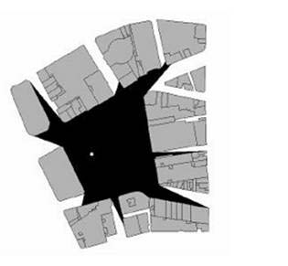
Fig.1. Defining isovists through visibility graphs: (a) the isovist polygon generated from viewpoint defined by the open circle at’O’[3].
Benedikt’s measures of the properties of isovists are area; perimeter, occlusivity and he calculated the properties of point isovists at a grid of locations in the open space of a configuration to create isovist fields”Fig.1”. Considering archetypes, he suggested that common elements of isovist fields can be presented to define spaces like ‘corridor’ or ‘colonnade’.Tandy introduced the concept of isovists into spatial analysis[16] but it was Benedikt who worked on isovists as a way to analyze architectural space. Gibson was the creator of idea of perceptual quality of isovist fields. He introduced the concept of ‘optic flow’ in landscape [11]. To measure the visibility according to urban form attributes, Gibson suggested the 'ambient optic array' of urban visibility based on the direct perception of viewers. The ambient optic array is measured spatially based on the collective amount of geometric Cartesian space occupied by the ambient optic array, which is reflected from physical surfaces that are visually perceivable from a particular vantage point [12]. Benedikt and Burnham showed the effect of isovist attributes in how perception of space, they also proved that ‘spaciousness’ perception had relationship with complexity of the isovist [5]. Braaksma and Cook worked on Visibility graph based on isovists in space [1]. Hillier and Hanson studied graph analysis of built environment and visibility relationship of space[13]. They used isovist and space syntax techniques to deconstruct some architects’ houses and how they have created space. Batty analyzed isovists at different scales of building and urban space [3]. He showed an algorithm creating a set of isovists picking the largest to smaller ones holding the whole environment. Turner and Doxa used isovist to study way finding [19] and[8]; while Batty et al. and Turner et al. (1999) worked on the relationship of visibility graph analysis and people movement [2] and [20].
Received Jan. 27, 2010
Revised May 25, 2010
Accepted Sep. 1, 2010
Research method
In this study open space visibility of neighborhood in old fabric of Bushehr city and their isovist properties have been analyzed in a correlational research to find whether there is relationship between urban open space form and visibility. Geometric measures of Benedikt: area, perimeter, occlusivity, circularity and compactness are the indices of analysis [4] and drift index has also been analyzed. Drift index studies isovists longest possible line of sight. Occlusivity is the proportion of the perimeter on the solid boundary of the environment, while Compactness shows how close the isovists are to a convex space. Circularity as Davis showed is the spikiness of the isovists and the ratio of the square of the perimeter to area [6]. Different computer programs like Depthmap, Spatialist and Syntax2D can be used to analyze isovist. Syntax2d that ” is an open source spatial analysis program by the Taubman College of Architecture and Urban Planning at the University of Michigan” has been used in this study [7]. Isovists were drawn on a plan representing major boundaries. In order to find this, a grid analysis and two paths in the neighborhood fabric have been studied. The paths chosen on the study are different in form. One organically shaped that circulates the neighborhood while the other is linear in form and separates the neighborhood in two parts. The neighborhood fabric comprises a mixture of incremental and planned development “ Fig. 2”. One of the characteristics of this morphology is its composition as a set of rather long and narrow streets with number of squares different in shape.
Case study: old fabric of Bushehr city
Bushehr is a city on the southwestern coast of Iran, on the Persian Gulf [21]. The traditional fabric of Bushehr is compact which leads to the formation of an attractive cityscape and makes Bushehr as one of the most specified cities in Iran [14]. As Sabatsani noted, despite its warm and humid climate that causes the need of open space in buildings for ventilation “Fig. 3”, the city seems compact [16].
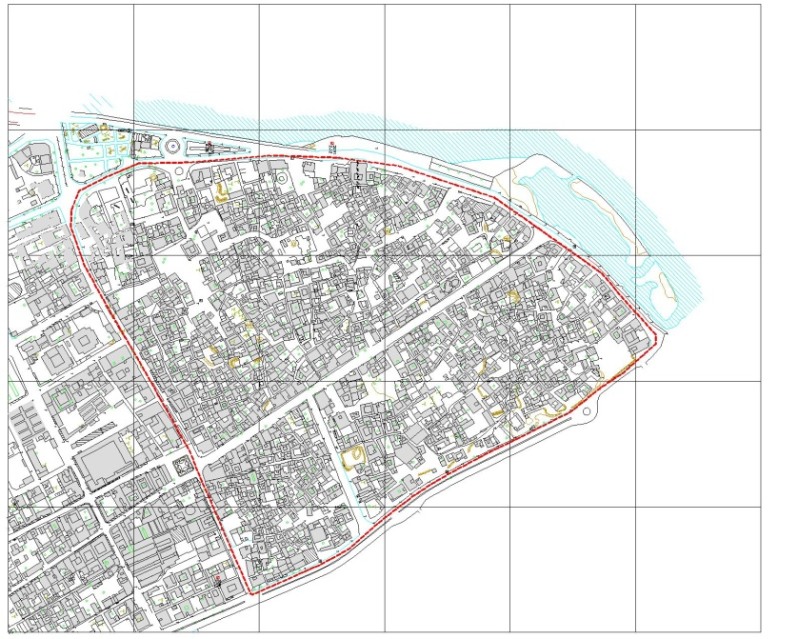
Fig.2. Map of the area of the study- Old Fabric neighborhood of Bushehr City
In old neighborhood of this city, urban fabric is very compact and streets are narrow. Proportion of walls height to street width is approximately ten to one due to its commercial role and land worth. High buildings of approximately fifteen meters along these narrow streets create permanent shadow and have a great role in decrease of environment temperature [10].
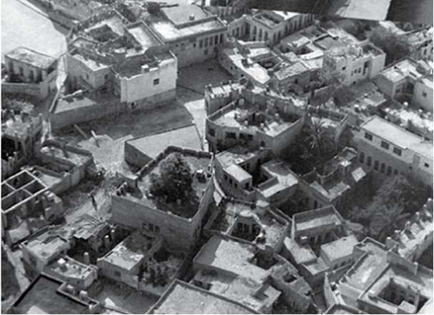
Fig.3.Compact and dense urban fabric of Bushehr with isolated urban blocks[9]
To use cool breeze of the sea inside the urban fabric, open spaces are shaped around houses that are the effective elements in division of fabric to smaller possible blocks. Buildings look outwards to have the least shared walls in neighborhoods using maximum air draught that has shaped isolated blocks composed of one to some dwelling units. Access networks are shaped in a hierarchy influenced by environmental temperature, humidity, wind direction, land natural condition and social-economical character. Mass and space of this fabric leads to different air pressure in spaces and facilitate air draught. The neighborhood of this study is located at the northern part of the city in a site of about 40 hectares, surrounded by Persian Gulf, Lian Avenue and Taleghani Boulevard. The old fabric of the site is shaped of dwelling blocks, local squares and narrow streets.
Visibility Analysis of Case study
According to literature review, isovist is a way of analyzing visual quality. Isovist indices of the neighborhood open spaces of the study area are analyzed, using syntax2D software. The geometry graphs of isovist indices and two paths in the neighborhood are shown in figures 4-9. Correlations between these indices are shown in table 1. At first, the isovist is shaped for the all nodes specified on an evenly spaced grid of 0.2m, including publicly visible and accessible areas.
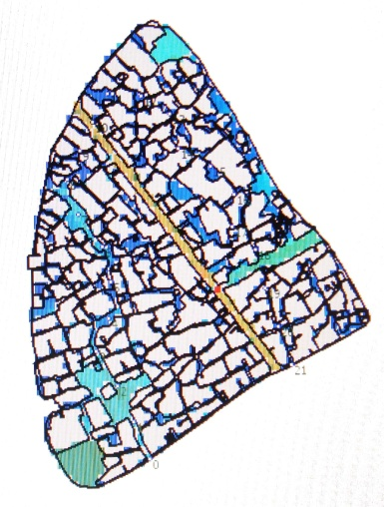  [a]  [b] | 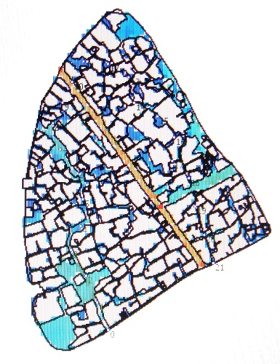  [c] | 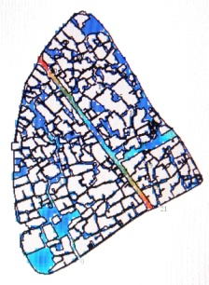
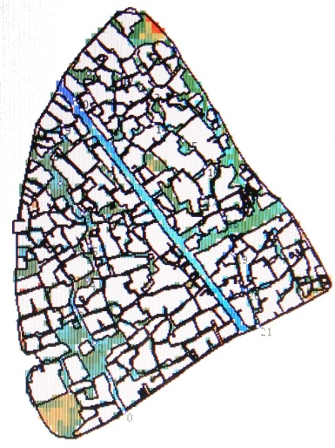  [d]  [e] | 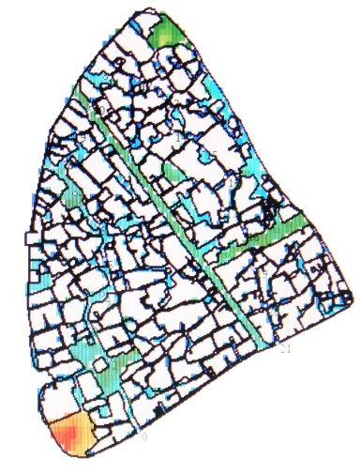 | 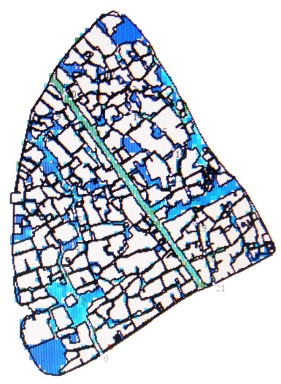  [f]
Fig.4. Isovist graph analysis of housing in old fabric of Bushehr city based on a grid of 3692 cells; [a] area, [b] perimeter, [c] drift, [d] occlusivity, [e] compactness and [f] circularity.
The spaces in the constellation of streets and squares in the neighborhood chosen in Bushehr city is represented by 3692 grid cells. The isovist fields and their frequency distribution are mapped in figure 4 from which it is clear that streets dominate the space. A planar isovist is produced for each grid point to create a network of all direct connections between nodes and from that, a visibility graph, analyzed to reach patterns of visual properties [19].
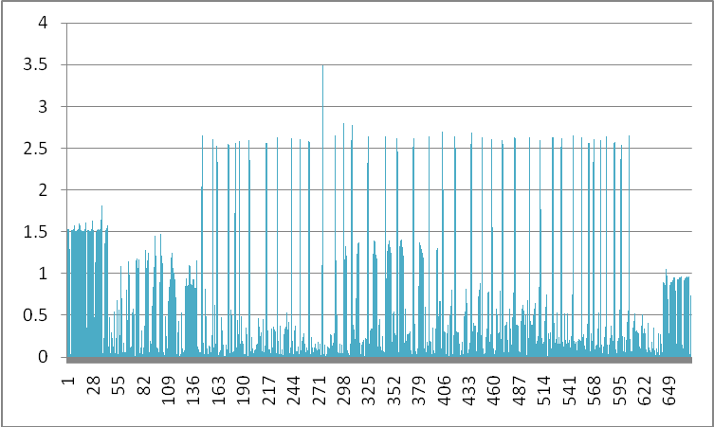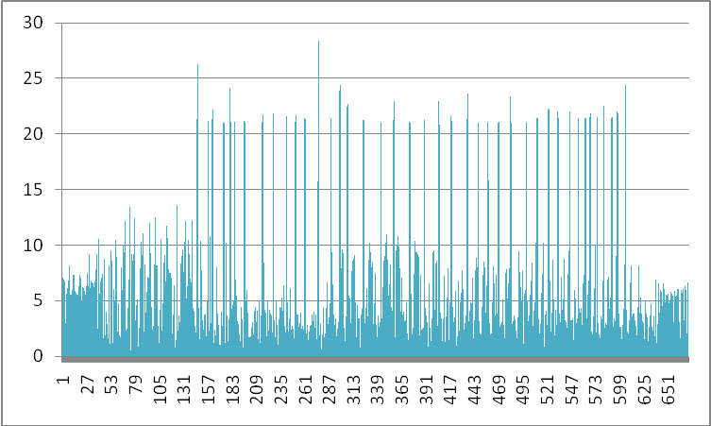
[a]
[a]
[b]
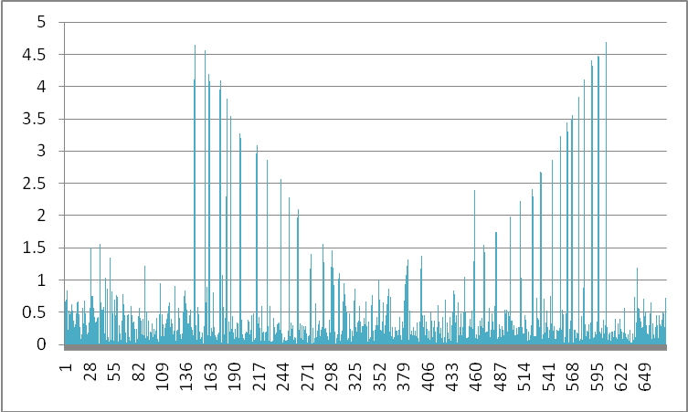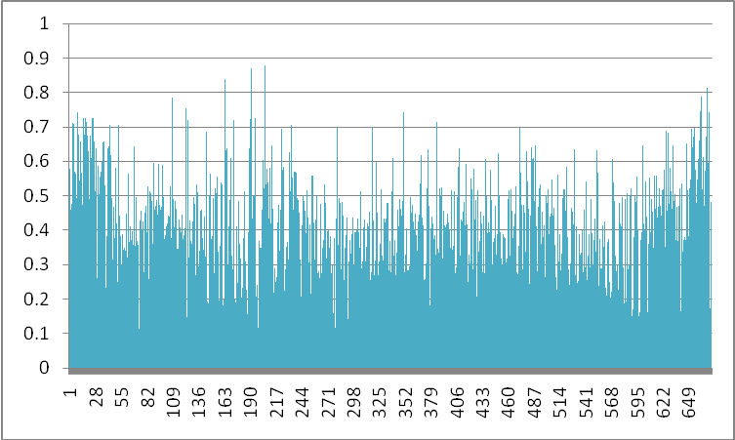
[d]
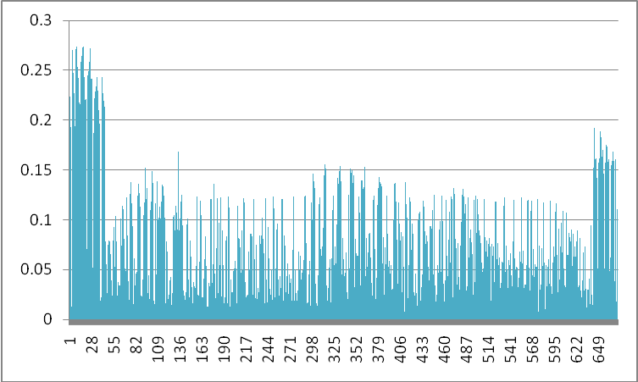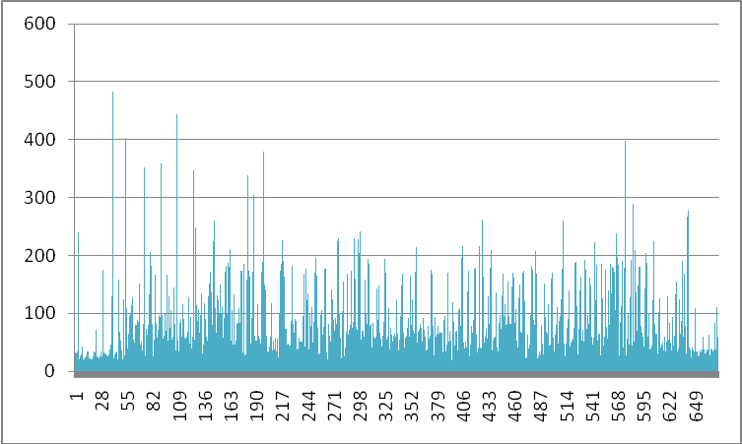
[e]
[f]

Fig.5. Frequency distribution of isovists comprising each isovist field based on a grid of 3692 cells; [a] area, [b] perimeter, [c] drift, [d] occlusivity, [e] compactness and [f] circularity.

The plans show the grid isovist index of the neighborhood spaces. The coloring shows from red for the most integrated (and shallowest from all other nodes on average) through to blue for the least integrated (deepest on average). The analysis shows that area index is highly correlated with perimeter at 0.92 and the area and compactness maps are correlated with each other in the same manner as drift and area.
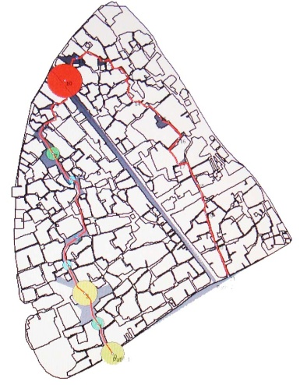  [a] | 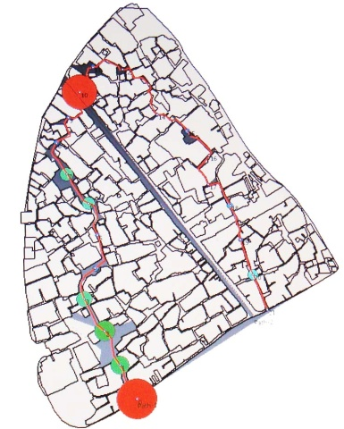  [b]  [c] | 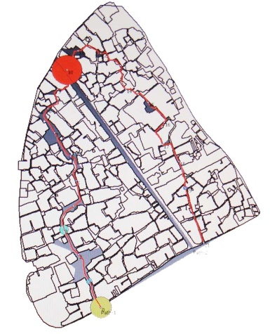
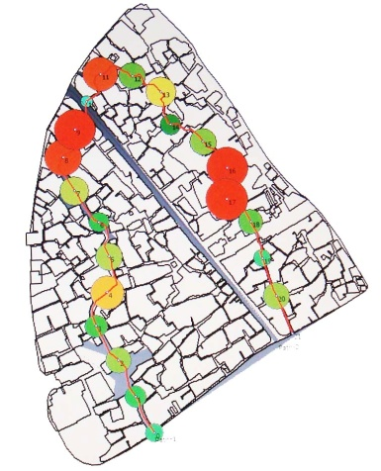  [d] | 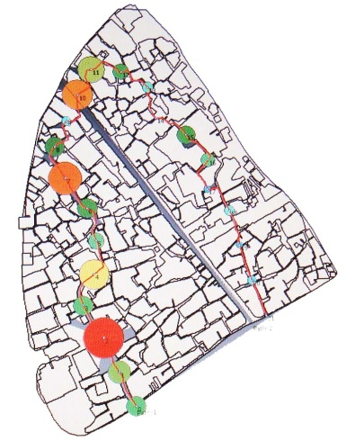  [e]  [f] | 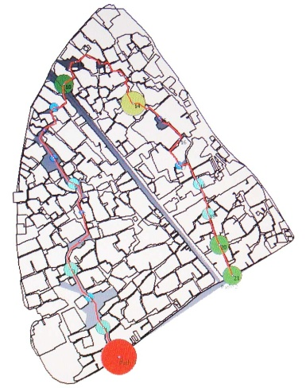
Fig.6. Isovist analysis of path 1 based on 502 nodes; [a] area, [b] perimeter, [c] drift, [d] occlusivity, [e] compactness and [f] circularity.

An interesting path through the neighborhood is shown in figure 6. Starting western down of the neighborhood, it travels along the fabric from streets and squares and reaches the eastern end of the neighborhood. The profiles of six isovist indexes of the path circulating the neighborhood in old fabric of Bushehr city based on 502 nodes are shown in this figure while figure 7 shows the six line graphs of frequency distribution of isovists comprising each isovist fields. In terms of area index, the graph is downwards and the point which the path crosses Enghelab avenue has the highest frequency of this index. On the other hand, the squares of the neighborhood open space have the highest distribution of this index. Turning to perimeter index, the graph shows the same pattern. While the path reaches the main access street, dramatic increase in perimeter index is revealed. Area index of the path is correlated very strongly with drift and perimeter. And these profiles in figures 6(a) and 6(c) shows clearly the changes in space encountered as the path node changes from streets to squares it shows domination of narrow streets in which long way can be seen, except when entering the main access road where the long linear vision increases actual distance seen. In fact there are some positions where the viewer can see large areas, thus providing a feeling of spaciousness. This is also shown from the perimeter index which increases at major junctions.
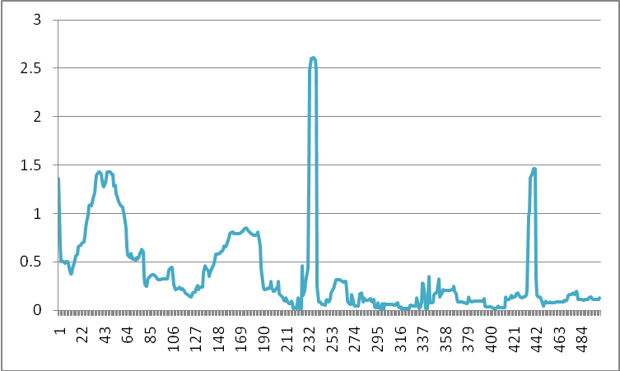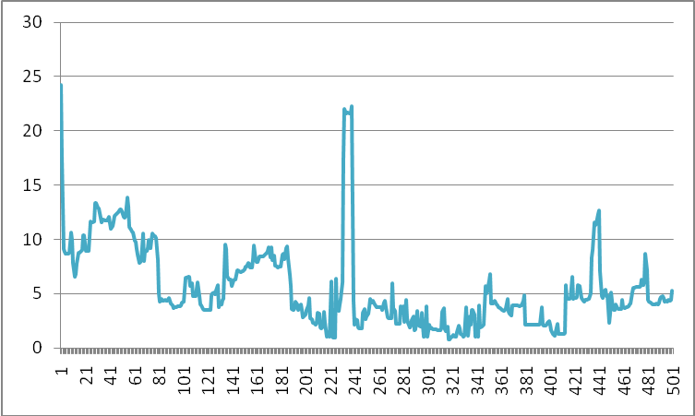
[a]
[b]
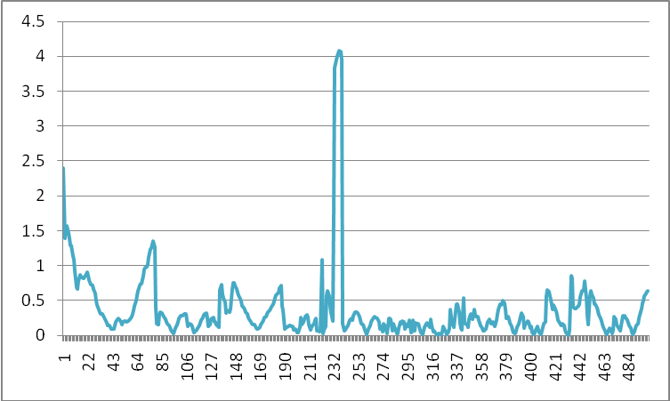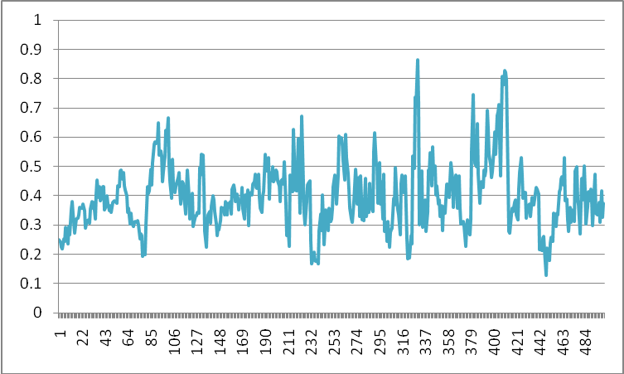
[c]
[d]
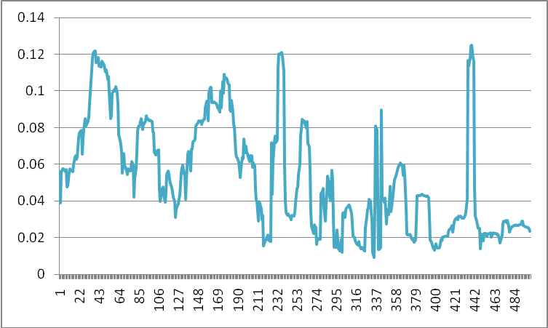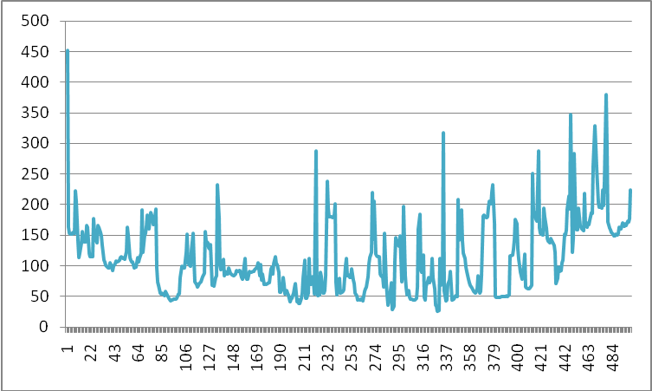
[e]
[f]
Fig.7. Frequency distribution of isovists comprising each isovist field of path 1 based on 502 nodes; [a] area, [b] perimeter, [c] drift, [d] occlusivity, [e] compactness and [f] circularity.
Compactness index which shows how enclosed the viewer feels to the environment, is affected by the area seen shows variation, while the occlusivity or circularity of spaces which define the path is much fluctuated in that these indices are influenced by the details in space. A comparison of the path with the six isovist fields indicates that a variety of spatial experiences in the urban base are captured from long views in narrow streets to complex views in squares. Path 2 drawn along Enghelab Avenue, divides the fabric in two parts. Figure 8 shows the six isovist indexes of the path and their frequency distribution are drawn in figure 9. The study shows that area, perimeter, occlusivity and circularity indexes have the highest correlations while compactness and circularity are the less correlated indices. Area, perimeter, compactness and circularity indices lack variety during the path. On the other hand drift index gets less at the center of the path and higher value at the ends, which shows a space of environmentally tedious.

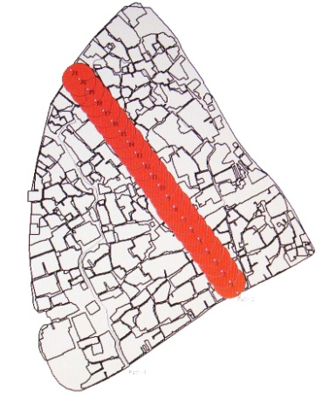  [a]  [b] | 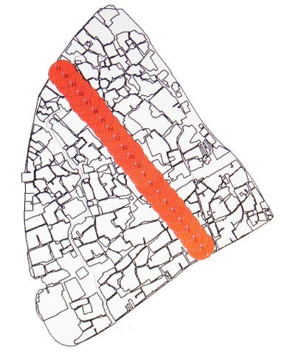  [c] | 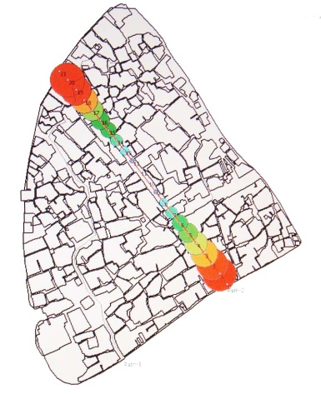
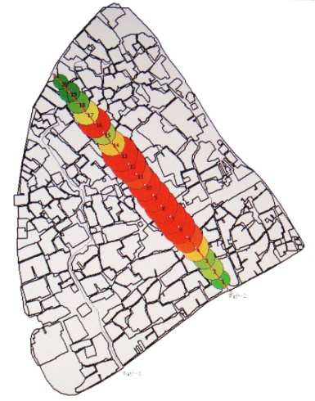  [d]  [e] | 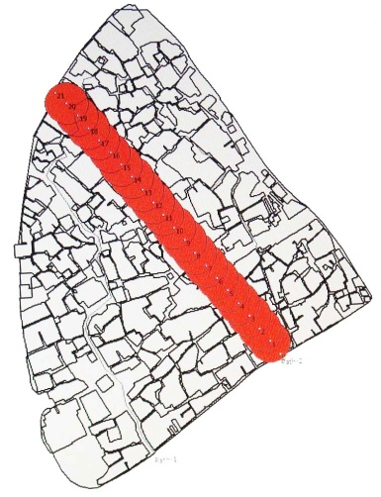  [f] | 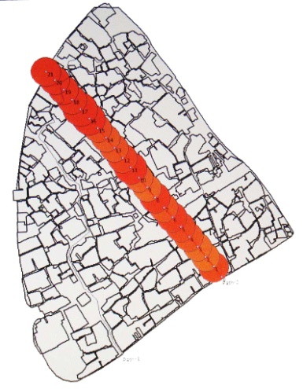
Fig.8. Isovist analysis of path 2 based on 502 nodes; [a] area, [b] perimeter, [c] drift, [d] occlusivity, [e] compactness and [f] circularity.

The analysis of isovist fields in these two paths shows interesting results. The compactness index is dominated by reaching Enghelab avenue that its central vantage point is the most compact of anywhere in the area. The squares which are indentations in the neighborhood open space are more compact than the narrow streets which dominate the entire morphology.
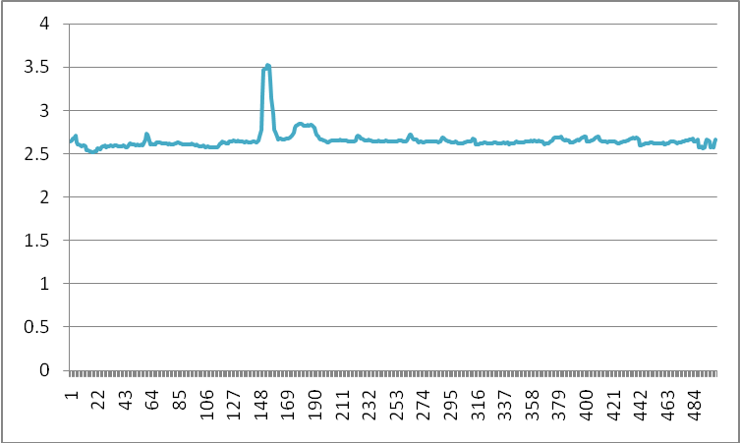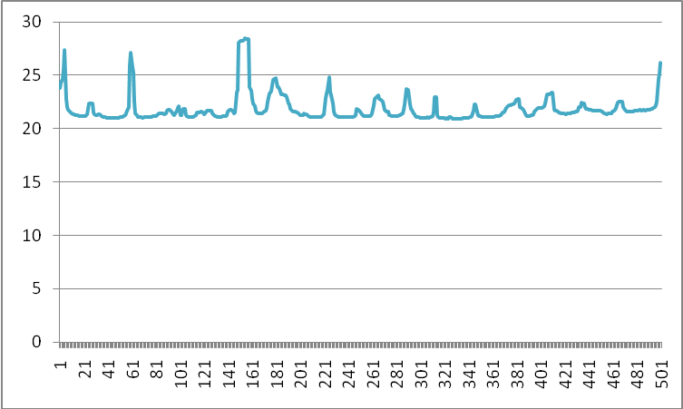
[a]
[b]
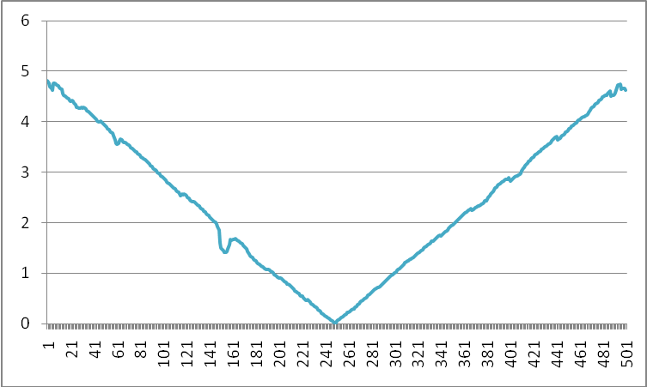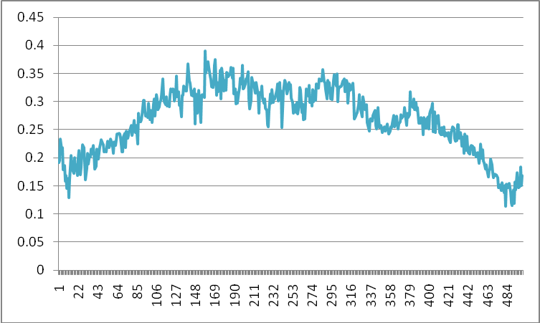
[c]
[d]
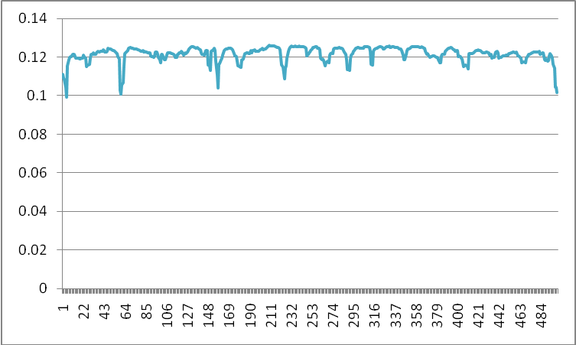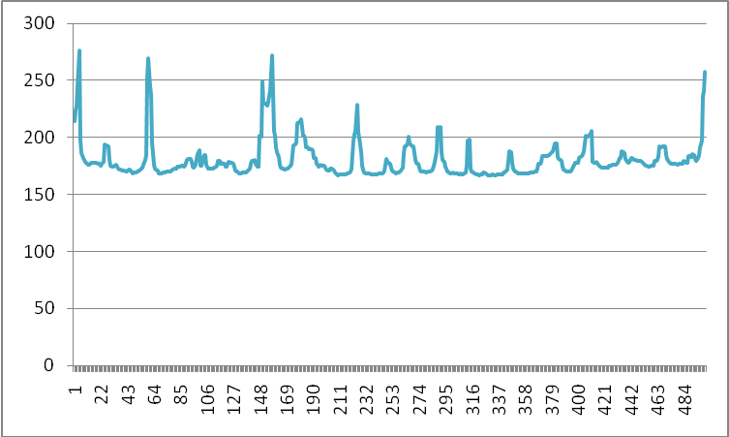
[e]
[f]
Fig.9. Frequency distribution of isovists comprising each isovist field of path 2 based on 502 nodes; [a] area, [b] perimeter, [c] drift, [d] occlusivity, [e] compactness and [f] circularity.
The area index shows up these patterns quite clearly. As shown in table 1, correlation between isovist indices reveals that the correlation between area, perimeter, drift and compactness are the highest. When the paths are examined, the compactness index of path 1, being higher in squares shows a variety of values while in path 2 it reflects a few numbers of compact objects present in the scene.
Showing the domination of long streets, the compactness index is the lowest index of all the others isovist fields of the study. The squares and some junctions have the highest compactness while the main parts of long streets have the least. The circularity field shows that areas on the edges of streets have higher circularity than the center lines, this being a result of the organic form of the neighborhood plan.
Tab.1. Correlations among the paths isovist measures
“ Path” isovist 502 Nodes |  | Path 1 inside old urban fabric which is organically shaped
 |  | area | perimeter | drift | occlusivity | compactness | circularity
Path 2 along the main vehicular access dividing the fabric in two parts | area |  | 0.93 | 0.8 | -0.55 | 0.7 | 0.45
 | perimeter | 0.58 |  | 0.87 | -0.63 | 0.49 | 0.69
 | drift | -0.48 | -0.08 |  | -0.6 | 0.27 | 0.62
 | occlusivity | 0.44 | 0.13 | -0.83 |  | -0.15 | -0.62
 | compactness | -0.11 | -0.87 | -0.2 | 0.09 |  | -0.18
 | circularity | 0.38 | 0.97 | 0.04 | 0.03 | -0.96
Conclusion
This study shows that isovist tool is applicable in analyzing visual quality in urban fabric. In this research two forms of urban open space has been analyzed to evaluate visibility using Syntax2D. Six isovist measures in grid and two paths one with organic and another with linear form have been studied. Also correlations between these measures in two paths have been compared with each other. Studies and analysis show that area and perimeter indices have the highest correlation. In organic path these two indices have highest value reaching Enghelab Avenue that divides this fabric in two parts and also these measures are higher in local squares than long and narrow streets. On the other hand these indices remain unchanged in linear path. Drift index that studies the longest possible line of sight rises dramatically reaching Enghelab Avenue while it almost stabilizes inside the organic path. Turning to linear path, this index is the highest at the ends and the lowest in the middle of the path. Occlusivity index that is the proportion of the perimeter on the solid boundary of the environment Shows fluctuation in organic path unlike linear path. While Compactness index that shows how close the observer feels himself to the environment shows notable variations in organic path having a steady graph in linear path. Circularity index that is the square of the perimeter to area as is influenced by detailes in space shows significant changes in organic path while it is nearly stablised in linear path. To conclude it can be siad that urban form has relationship with its visibility; meaning that the organic path creates a variety of isovist indexes unlike linear path that divides the neighborhood fabric in two parts. Furthermore, the analysis shows that squares which are the place of social interactions are more compact than the streets of the neighborhood as they define non physical geometries and variety in the spatial experiences is achieved moving within them. Finally the study shows that the form of neighborhood open space plays an important role in its visual quality and the quality of housing.

References
- Braaksma, J.P. & Cook, W. J. “Human Orientation in Transportation Terminals”, Transportation Engineering Journal, TE2, 106, 1980, pp. 189-203
- Batty, M. & Jiang, B., “Multi-agent simulation: new approaches to exploring space-time dynamics within GIS”, WP 10, center for Advanced Spatial Analysis, University College London, London, 1999. Available from: http://www.casa.ucl.ac.uk/multi_agent.pdf [Accessed 23 June 2010].
- Batty, M. “Exploring isovist fields: space and shape in architectural and urban morphology”, Environment and Planning B: Planning and Design, No. 28, 2001, PP. 123-150.
- Benedikt, M. L. “To take hold of space: isovist and isovist fields”, Environment and Planning B: Planning and Design, No. 6, 1979, pp. 47-65.
- Benedikt, M. L. & Burnham, C. A., “Perceiving architectural space: from otic rays to isovists”, Persistence and Change Eds, W H Warren, R E Shaw, Lawrance Erlbaum, Hillsdale, NJ, 1985, pp. 103-114.
- Davis, L. S. & Benedikt, M. L. “Computational models of space: isovists and isovist fields”, Computer Graphics and Image Processing 11(3), 1979, pp. 49-72.
- Dong, T., Hanratty, M., Torres, A. & Xu, L. Syntax2d Vocabulary Analysis, Michigan, Taubman College of Architecture & Urban Planning University of Michigan, 2008.
- Doxa, M., “Morphologies of Co-Presence in interior Public Space in Places of Performance: The Royal Festival Hall and The royal National Theatre of London”, J. Peponis, J. Wineman and S. Bafna (Eds.) Proceeding 3rd International Space Syntax Symposium, Georgia Institute of technology, Atlanta, 2001.
- Ghazbanpur, J., New life-Old form. New life-Old form, ministry of Housing and Urbanism, Tehran,1992
- Ghobadian, V. Climatic Analysis of the Traditional Iranian Buildings, Tehran University Publications, Tehran, 1994.
- Gibson, J. J., The ecological Approach to Visual Perception, Houghton Mifflin, Boston, MA, 1979.
- Gibson, J.J., The Ecological Approach to Visual Perception, Lawrence Erlbaum Associates Inc, New Jersey, 1986.
- Hillier, B. & Hanson, J., The social logic of space, Cambridge University press, Cambridge, 1984.
- Hossein, B., Urban Planning Process, Tehran University Publication, Tehran, 1999.
- Lynch, K., The image of the City, MIT Press, Cambridge, 1960.
- Sabatsani, N., “Bushehr as an energic city” Journal of Applied Science, 7, 2007, pp. 3262-3267.
- Tandy, C.R. V. “The isovist method of landscape survey”, in Symposium: Methods of Landscape Analysis (Ed) HC Murray Landscape Research Group, London, 1967, pp. 9-10.
- Thiel, P., “A sequence experience notation for architectural and urban space” Town Planning Review 32, 1961, pp. 33-52.
- Turner, M., Doxa, D. & Penn A., “From Isovist to Visibility Graphs: A Methodology for the Analysis of Architectural Space”, Environment and Planning B: Planning and Design 28. Pion Publication, Britain, 2001, P.P. 103-121.
- Turner, A. & Penn, A. (1999) “Making isovists syntactic: isovist integration analysis”, The 2nd International Symposium on Space Syntax, Universidad de Brasilia, Brazil, 1999.
- Wikipedia, 2010. Bushehr. Available from: http://en.wikipedia.org/wiki/Bushehr [Accessed 23 June 2010].

