**Understanding Iranian Inter-Regional Migration Network: Applying the Gravity Model on a provincial scale**

Maedeh Hedayatifard

Assistant Professor, Urban and Regional Planning, Allameh Tabataba’I University, Tehran, Iran

[Maedeh.Hedayatifard@atu.ac.ir](mailto:Maedeh.Hedayatifard@atu.ac.ir)

**Abstract**

This study examines the historical trends and dynamics of inter-regional migration in Iran between 1996 and 2011, focusing on the economic and spatial factors influencing migration flows between origin and destination regions. The analysis applies network analysis and multivariable regression to 961 inter-regional migration pairs. The findings reveal, first, that economically powerful regions such as Tehran, Isfahan, and Khorasan attract the highest levels of migration due to their diverse economic opportunities, infrastructure, and urban amenities. However, wealth alone does not determine migration activity. For example, regions like Khuzestan and Bushehr, despite their high GDP per capita, experience lower migration rates due to limited employment opportunities in capital-intensive sectors like oil and gas and a lack of economic diversification. Second, the analysis highlights that migration decreases with geographic distance but increases toward major urban centers like Tehran, reflecting the pull of agglomeration economies and access to services, which attract migrants from farther regions. Tehran's sustained position as a primary destination underscores its pivotal role in Iran's economic and social framework. The transition from smaller to larger migration flows, particularly in the 50,000–100,000 range and higher, reflects increasing urbanization and intensified migration trends driven by population growth, regional inequalities, and the concentration of opportunities in major cities. Third, between 1996 and 2011, non-productive sectors such as real estate and trade in origin regions pushed migration, while productive sectors like agriculture and fisheries retained populations. Conversely, financial intermediation and energy-related activities in destination regions attracted migrants. The findings also show that while regional wealth reduces out-migration, saturation effects in developed regions, such as high living costs and job market constraints, limit their attractiveness. These findings emphasize the importance of balanced regional development and the role of infrastructure and economic opportunities in shaping migration trends.

**Keywords**: Migration, Regional economic activities, Gravity Model, Regional Migration Network, Iran

# **Introduction**

Migration is influenced by a complex interplay of economic, social, political, and environmental factors.

Economic opportunities, such as employment prospects and higher wages, are among the most significant drivers of migration, particularly from rural to urban areas or across regions (Harris & Todaro, 1970) (Greenwood, 1997) (Pekkala, 2003). Social factors, including access to better education and healthcare, also play a critical role in shaping migration patterns (Bansak et al., 2020) (Urbański, 2022). Political instability, conflict, and persecution often force individuals to migrate in search of safety and stability (Simpson, 2022) (Bansak et al., 2020). Additionally, environmental changes, such as natural disasters and climate change, have increasingly contributed to migration, particularly in vulnerable regions (Duijndam et al., 2022) (Nabong et al., 2023) (Beine & Parsons, 2015). In 2020, more than 30 million new people became displaced as a result of weather-related disasters (IDMC, 2021). These factors often interact, creating push and pull dynamics that influence migration decisions and patterns globally.

Spatial features including distance and regional infrastructure also play a crucial role in shaping inter-regional migration patterns. Distance often acts as a barrier to migration, as greater distances typically involve higher costs, both financial and social, which can deter individuals from relocating (Hosseini et al., 2017) (Rahmani & Hasanzadeh, 2011) (Kaveh Pirouz & Farrash, 2017) (Zanjani, 2001). However, advancements in transportation and communication technologies have reduced the impact of distance in recent years, enabling more long-distance migrations (Düvell & Preiss, 2022) (Czaika & Reinprecht, 2022). Regional features, such as economic opportunities, infrastructure, and quality of life, serve as significant pull factors, attracting migrants to regions with better employment prospects, education, and healthcare services (Czaika & Reinprecht, 2022) (Simpson, 2022). Conversely, regions with limited resources or poor living conditions often experience out-migration. Additionally, cultural and linguistic similarities between regions can facilitate migration by reducing adaptation challenges for migrants (Czaika & Reinprecht, 2022). These spatial and regional dynamics highlight the importance of both physical and socio-economic factors in influencing migration flows.

These factors are particularly relevant in understanding inter- and intra-regional migration patterns. Among these, economic factors have often been studied within the framework of neoclassical migration theories, such as Lee’s push-pull model of migration, considering factors such as market size, social welfare, unemployment rates, and wage level. However, the network approach to migration, and considering the relationship between the economic factors of origin and destination regions and their contributions into migration decisions has received comparatively less attention in research and studies.

In Iran, during the period 1986–1996, approximately 8.5 million intra- and inter-provincial migrations occurred in Iran, of which 34.8 percent were inter-provincial migrations. This figure increased to about 12 million during the period 1996–2006, with the share of inter-regional migration rising to 42 percent. Between 2006 and 2011, there were approximately 4 million intra- and inter-regional migrations, and the share of inter-regional migration further increased to around 45 percent. This upward trend in inter-regional migration highlights the growing importance of the distribution of human resources and understanding the economic origin-destination factors across different parts of the country. This study attempts to understand the historical trend of inter-region migration network in Iran and to examine the dynamics of this network through the lens of spatial distance and origin-destination economic factors. The key questions are: How and why has inter-regional migration in Iran changed over the period from 1996 to 2011? and what economic characteristics of origin and destination regions influence inter-regional migration?

The paper is structured as follows: the first section provides a literature review on regional migration, drawing on key concepts and factors. The second section outlines the analytical methods and techniques employed in the study, including network analysis and regression modeling. The third section presents an analysis of the inter-region migration network in Iran, and its evolution over time (1996-2011), and the determinants of migration flows. Finally, the concluding section discusses the implications of the findings for regional policy-making and offers recommendations for addressing migration-related challenges.

# **Literature Review**

The motivations behind migration have been analyzed and theorized for decades, with studies identifying key factors driving migration, such as economic, political, social, cultural, demographic, and environmental influences. Migration theories provide a foundational understanding of the mechanisms driving inter-regional migration, with a particular emphasis on economic factors. Ravenstein's theory of migration (Grigg, 1977) highlights key principles such as the effects of distance, communication networks, spatial differences, and the central role of economic motivations in migration decisions. Building on this, Lee's migration model (1966) underscores the importance of origin and destination factors, including regional wages and unemployment rates, in shaping migration flows. Higher real wages in a region tend to attract greater in-migration, while elevated unemployment rates discourage it (Gerber, 2006) (Lewis & Peri, 2015). These economic drivers are further explained by job-search theory, which frames migration as an optimal decision-making process. According to this theory, individuals search for employment until they receive a job offer with a wage that meets or exceeds their reservation wage, the minimum acceptable wage they are willing to accept (McCann, 2001). This highlights the labor market's role as a mechanism for absorbing and adjusting to microeconomic shocks, with unemployment, labor force participation, and migration reflecting its response to external forces. For instance, a decline in labor demand can reduce wages, prompting labor migration, which may, in turn, create opportunities for the origin region by attracting new firms, investments, and institutions (Brandsma et al., 2014) (Park & Hewings, 2009).

While traditional migration theories focus on economic factors such as wages and unemployment, more recent studies have expanded the scope to include non-economic factors influencing inter-regional mobility. While Greenwood (1997) highlights the importance of GDP per capita, unemployment rates, and urbanization ratios as key economic criteria for migration analysis (Greenwood, 1997), non-economic factors such as climate conditions (Butros et al., 2021), culture and social behaviors (Hirschle & Kleiner, 2014) and affordable housing (Gerber, 2006) (d’Albis et al., 2019) also play significant roles. These factors are particularly relevant in attracting the creative class, whose presence can enhance a region's economic performance (Gerber, 2006) (Hirschle & Kleiner, 2014). Human capital theory further explains migration as a means of maximizing returns on human capital investment, with individuals moving to regions where they can achieve higher economic and social gains. (Faggian & McCann, 2009). Migration, therefore, plays a critical role in redistributing human capital, fostering knowledge spillovers, and driving regional innovation and economic growth (Faggian & McCann, 2009) (McCann, 2001) (Farahmand & Ghasemian, 2019).

The economic configuration of regions is also a key determinant of migration patterns, as it shapes the opportunities and constraints faced by individuals. One prominent approach in regional development is the growth pole theory, introduced by François Perroux (1955). This theory remains highly relevant in understanding how specialized industries drive regional development and migration. Growth poles are regions where industries or sectors with high growth potential are concentrated, creating agglomeration economies that attract labor, capital, and innovation (Parr, 1999) (Scott & Storper, 2003). Recent studies emphasize that economic specialization, rather than diversification, is often the foundation of growth poles, as specialized industries generate backward and forward linkages that stimulate regional and national economic growth (Hedayatifard, 2023) (Hedayatifard & Rozenblat, 2019) (Iammarino & McCann, 2013) (Rodríguez-Pose & Wilkie, 2017). For example, Silicon Valley in the United States thrives as a global growth pole due to its specialization in technology and innovation, while Shenzhen in China has emerged as a hub for electronics and manufacturing, attracting both domestic and international migrants (Florida, 2017). These specialized regions not only drive economic growth but also shape migration patterns and regional inequalities, as resources and opportunities become concentrated in specific areas (Rodríguez-Pose, 2018) (Crescenzi & Iammarino, 2018).

Migration theories and regional development approaches highlight the dynamic interplay between economic, social, and spatial factors in shaping inter-regional migration patterns and their impact on regional economies. This study aims to further explore how origin-destination economic configurations influence inter-regional migration network and contribute to broader patterns of economic growth (Figure1).

Population

Distance

Regional Economic Feature

Economic Value-added

Market Size

Wealth of the region

Inter-Regional Migration

Scale of Migration

Frequency of Migration

Long-Distance Migration

Inter-Regional Migration Network

Origin

Destination

1996

2006

2011

Figure 1- Research Analytical Framework for Interplay of Inter-Region Migration and Regional Economic Features

# **Methodology**

Ravenstein's focus on the role of distance has made the gravity model one of the most enduring tools for understanding migration patterns. Lowry's 1966 study on migration further emphasized the importance of employment opportunities as a key determinant of labor force migration. Expanding on this, Rogers (1968) proposed that a matrix formulation of intra-regional population growth and distribution provides a concise empirical framework for analyzing the spatial relationship between population and employment (Rogers, 1968). Building on these foundational theory, methodological approaches to analyzing aggregate migration flows have often relied on gravity models, regression models for gross and net migration, accounting frameworks, and Markov models of population change (Clark, 2020). This research, inspired by the work of Rozenblat (2015) on understanding networks by gravity model (Rozenblat, 2015), adopts this model, incorporating both distance and the economic characteristics of origin and destination regions to analyze migration network in Iran during 1996-2011. The quantitative methodological approach of this research also applies multivariable regression to analyze the 31 regions interflows of migration in 1996-2011. The analysis is structured around three key steps:

*Step One: Examination of the structural characteristics of the inter-regional migration network*

The network consists of nodes and edges, with the directed migration network representing regions as nodes and migration flows as edges. This step focuses on identifying the most strategic and significant regions for in-migration and out-migration flows. To achieve this, the in-degree and out-degree indices (Wasserman, 1994) are calculated for each region across two time periods: 1996–2006 and 2006–2011.

*in degree index: The number of edges entering to the node of i*

*out-degree index: the number of edges going out from the node i*

*Step two: Examining the role of economic factors in the inter-regional migration network*

Based on Lee's theory regarding the relational and relative nature of migration, this study focuses on spatial interactions using the gravity model, which aligns with Waldo Tobler's First Law of Geography (1970): "everything is related to everything else, but near things are more related than distant things." The original formula has been adapted with specific indices for each independent variable to analyze migration flows between regions, taking into account the size and characteristics of regional economies. This model is widely applied in international economics to explain trade flows between countries (Rozenblat, 2015).

the migration from region I to region j

و : the mass of regions I and j

: is the multiplier parameter of migrants from origin region i

: is the multiplier parameter of migrants to destination j

: the distance between region I and j

is the negative multiplier parameter of the distance (Friction of distance).

Given the significance of economic sectors in influencing the volume of inter-regional migration, independent variables such as the value added by major economic activity groups, in-migration, population, market size (GDP), societal wealth (GDP per capita) for both origin and destination regions, as well as the geographical distance between the centers of each region, are calculated. The model is then modified by applying logarithmic transformations to both sides of the equation.

# Using multiple linear regression on the inter-regional migration matrix, the model evaluates the impact of economic activities on migration during the periods 1996–2006 and 2006–2011. The analysis was conducted on 961 regional migration pairs.

# *Step three: Analysis of Attractive Flows*

# To identify migration flows that are either more or less attractive than expected, a residual analysis is performed. This involves examining the differences between the observed migration flows and the values predicted by the model.

# **Results**

## *Inter-regional Migration Network between 1996-2011*

By recognizing migration as a networked phenomenon influenced by origin-destination factors, the gravity model can effectively analyze the economic characteristics of two population centers and the distance between them as a repelling force. An examination of migration patterns between two regions, considering the geographic distance index, has shown that, as expected, the volume of migration from 1996 to 2011 decreased with increasing geographic distance. The highest volume of migration occurred at distances of less than 200 kilometers. While this trend gradually declines as distance increases, it rises again at distances of 400–600 kilometers and 1000–1200 kilometers, indicating the presence of migration-attracting poles and the dominance of the agglomeration economies of these centers over diseconomies of scale (Figure 2).

Figure 2-The trend of inter-regional migration based on the geographical distance

Source: Findings of the research

Findings also have shown that the number of migrations decreases as the size of the migrating population increases. In other words, large-scale migrations occur far less frequently, which highlights the centrality of the Tehran region in attracting migrant populations. Additionally, from 1996 to 2011, the trend of inter-regional migration gradually shifted from smaller-scale migrations to larger-scale migrations. For instance, in 1996, the number of migrations involving fewer than 50,000 people was more than double the corresponding figure in 2006 and 2011. The highest volume of migration for all three timelines was observed in the population range of 50,000–100,000 people. This trend indicates an intensification of inter-regional migration flows, particularly for migrations involving more than 200,000 people (Figure 3).

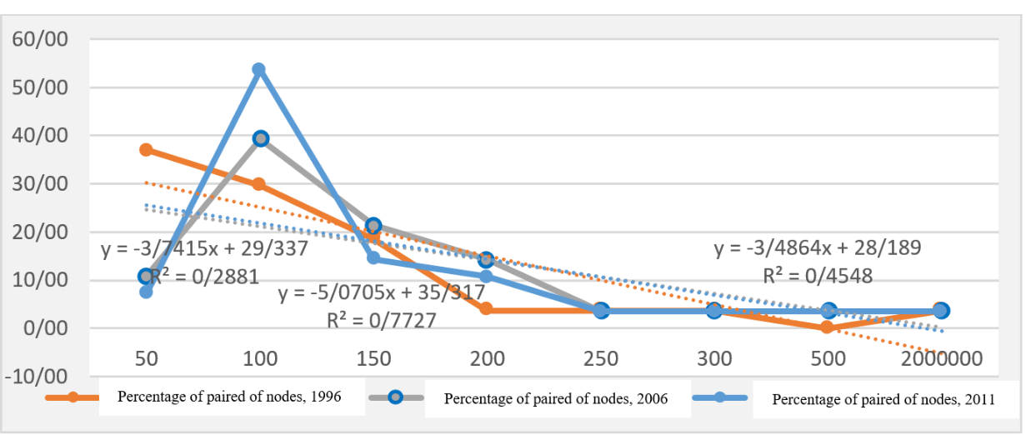

Figure 3: The frequency of pairs of regions based on amount of migration

Source: Findings of the research

Between 1996 and 2006, the provinces of Tehran, East Azerbaijan, and Khorasan (Figure 4), and between 2006 and 2011, the provinces of Tehran, Khorasan, Khuzestan, Isfahan, and Fars, respectively, had the highest levels of attraction in inter-regional migration (Figure 5). Considering both external and internal centrality, Tehran, East Azerbaijan, Khorasan, and Isfahan experienced the highest net immigration rates during the 1996–2006 period, while Tehran, Isfahan, Khuzestan, and Markazi recorded the highest net immigration rates during the 2006–2011 period (Figure 6). This structure reflects an increase in inter-regional linkages, accompanied by the emergence of new, rapidly growing regions during this timeframe. Similarly, between 1996 and 2006, Tehran also had the highest emigration rate, followed by West Azerbaijan, East Azerbaijan, Khorasan, and Isfahan, respectively, with a significant difference. In 2006-2011, this trend evolved, with Tehran maintaining its position in terms of external centrality or emigration rate, while Khuzestan and Khorasan ranked second and third, respectively. When considering income or GDP, which represents market size and regional economic productivity, as well as the regional wealth index (GDP per capita) and its relationship with immigration and emigration rates, the analysis revealed that regions with greater economic power, such as Tehran, Isfahan, Khorasan, and Khuzestan, also experienced the highest levels of inter-regional migration. In other words, regions with higher wealth tend to have stronger inter-regional linkages. However, the findings indicate that there is no strong correlation between regional wealth and inter-regional migration rates. For instance, despite having the highest levels of wealth (GDP per capita), the provinces of Kohgiluyeh and Boyer-Ahmad, Khuzestan, and Bushehr are not ranked among the top provinces in terms of centrality.

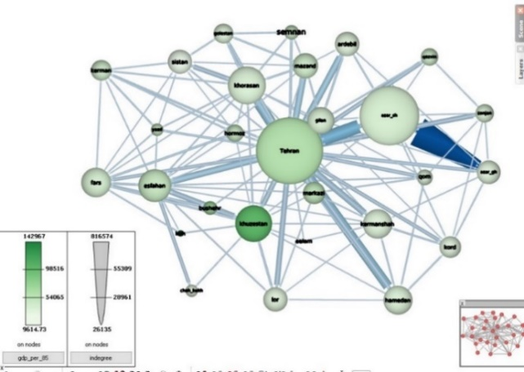

Figure 4- in-degree Centrality in migration flows and GDP per capita of regions (1996-2006)

Source: Findings of the research

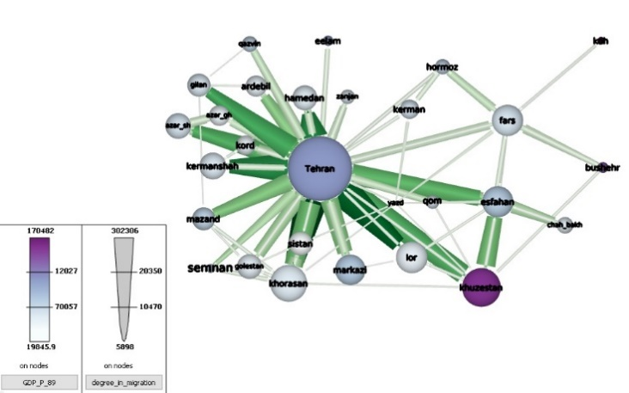

Figure 5-in degree Centrality in migration flows and GDP per capita of regions (2006-2011)

Source: Findings of the research

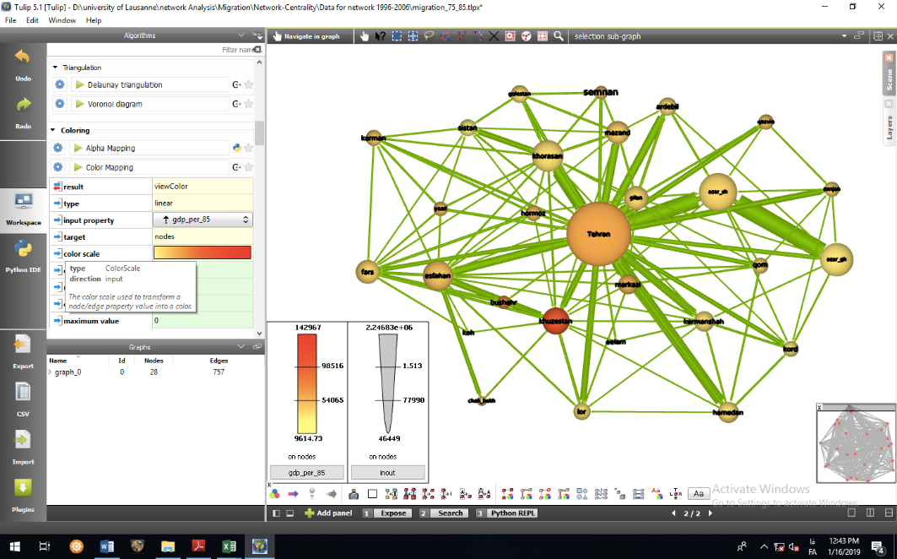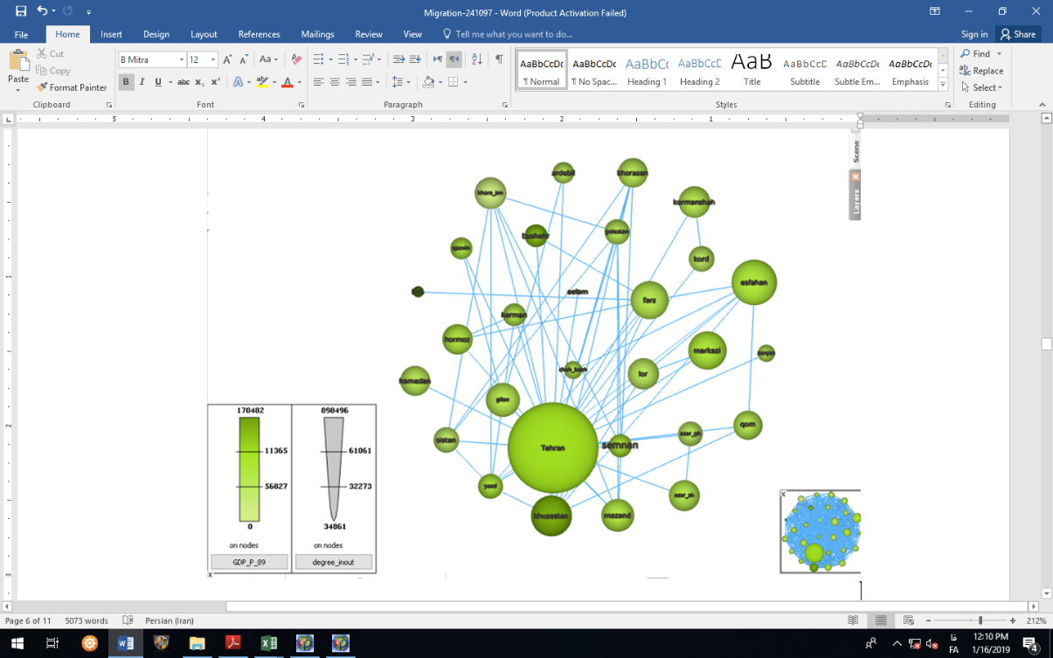

Figure 6- In-out degree or net migration (Size) of regions and GDP per capita (Color);

left 2006-2011, right: 1996-2006- *\*Edges are migration of over 5000 people*

*Source: Findings of the research based on formal statistics of Iran, Regional accounts, Iranian Central Bank 1996-2011*

## *The Interface of Economic Activities and The Inter-Regional Migration Pattern*

With the increasing trend of inter-regional migration flows, the gravity model has been employed to precisely examine the role of economic factors. Origin-destination migrations are considered as inter-regional linkages, while factors such as intra-regional migrations, market power and production, wealth of the region, population size, distance between regions, and the value added of activities in Agriculture, Fisheries, Mining, Industry, Energy, Construction, Wholesale and Retail Trade, Hospitality, Warehousing, Financial Intermediation, Real Estate, Services, Education, and Social Services for each origin and destination region have been taken into account. To enhance the efficiency of the analysis, a logarithmic scale has been applied to the aforementioned indicators.

Table1: Economic factors in inter-region migration in Iran (1996-2006) and (2006-2011)

|  |  |  |  |  |  |  |
| --- | --- | --- | --- | --- | --- | --- |
| 2006-2011 | | | 1996-2006 | | | Economic activities |
| Pr(>|t|) | Std. Error | Partial R2 | Pr(>|t|) | Std. Error | Partial R2 |
| 0.038492 | 0.126594 | -0.262479 | - | - | - | intra_O |
| 0.667587 | 0.173674 | 0.074617 | - | - | - | intra_D |
| 0.653732 | 3.303907 | -1.482699 | 0.00203 | 1.414182 | -4.379498 | Intercept |
| 0.506720 | 0.268567 | 0.178406 | 0.21232 | 0.287006 | 0.358273 | GDP_D |
| 0.256689 | 0.332345 | -0.377263 | 0.02390 | 0.287014 | -0.649657 | GDP_D |
| 0.794892 | 0.611855 | 0.159119 | 0.27064 | 0.248757 | 0.274236 | GDP_Per capita_D |
| 0.544357 | 0.535510 | -0.324801 | 0.02880 | 0.248755 | -0.544928 | GDP_Per capita_O |
| 0.860152 | 1.014920 | -0.178873 | 0.43517 | 0.596927 | 0.466084 | Population_D |
| 0.802728 | 1.080296 | -0.269977 | 0.35308 | 0.597006 | 0.554756 | Population_O |
| 0.000701 | 0.039511 | 0.134496 | 0.01376 | 0.039219 | 0.096848 | distance |
| 0.217403 | 0.158462 | -0.195629 | 0.26975 | 0.127573 | -0.140904 | Va_Agriculture_D |
| 0.002517 | 0.125910 | -0.381751 | 0.01768 | 0.127579 | -0.303339 | Va_Agriculture_O |
| 0.406132 | 0.086539 | -0.071932 | 0.02772 | 0.060475 | 0.133391 | Va_Fisheries_D |
| 0.924033 | 0.067272 | 0.006417 | 0.03415 | 0.060477 | -0.128353 | Va_Fisheries_O |
| 0.702399 | 0.065088 | 0.024879 | 0.10683 | 0.043796 | 0.070714 | va_Mining_D |
| 0.511167 | 0.077946 | 0.051238 | 0.24758 | 0.043791 | 0.050674 | va_Mining_O |
| 0.512111 | 0.211886 | -0.138972 | 0.16561 | 0.158783 | 0.220366 | Va_Industrial_D |
| 0.904139 | 0.168894 | -0.020348 | 0.43714 | 0.158772 | -0.123440 | Va_Industrial_O |
| 0.001132 | 0.119633 | 0.391028 | 0.15778 | 0.086158 | -0.121833 | Va_Energy_D |
| 0.609720 | 0.129205 | -0.065985 | 0.15312 | 0.086180 | 0.123248 | Va_Energy_O |
| 0.448122 | 0.669389 | -0.508043 | 0.24010 | 0.290631 | 0.341694 | Va_Construction_D |
| 0.098060 | 0.399288 | -0.661416 | 0.23752 | 0.290635 | -0.343583 | Va_Construction_O |
| 0.964102 | 0.513919 | 0.023138 | 0.08045 | 0.187649 | 0.328494 | Va_Trade_D |
| 0.006853 | 0.184984 | 0.501628 | 0.03229 | 0.187676 | 0.402561 | Va_Trade_O |
| 0.787676 | 0.231995 | 0.062507 | 0.12562 | 0.161216 | 0.247208 | Va_Hotel_D |
| 0.717536 | 0.193510 | -0.070031 | 0.74272 | 0.161215 | -0.052939 | Va_Hotel_O |
| 0.731187 | 0.291166 | 0.100068 | 0.39427 | 0.187821 | -0.160099 | Va_Investment_D |
| 0.215877 | 0.213539 | 0.264502 | 0.10271 | 0.187820 | 0.306882 | Va_Investment_O |
| 0.237383 | 0.534545 | 0.632121 | 0.02232 | 0.245896 | 0.563051 | Va_intermediation_D |
| 0.089264 | 0.210053 | -0.357425 | 0.22824 | 0.245938 | -0.296584 | Va_intermediation_O |
| 0.439775 | 0.617932 | 0.477664 | 0.07080 | 0.274255 | 0.496254 | Va_Real Estate_D |
| 0.041918 | 0.228696 | 0.466077 | 0.97311 | 0.274224 | -0.009248 | Va_Real Estate_O |
| 0.082396 | 0.336279 | 0.584919 | 0.64355 | 0.263466 | 0.121969 | Va_Service_D |
| 0.160617 | 0.360336 | 0.506074 | 0.04977 | 0.263522 | 0.517875 | Va_Service_O |
| 0.126368 | 1.189897 | -1.820969 | 0.07929 | 0.651898 | -1.145580 | Va_Education_D |
| 0.357699 | 0.678266 | 0.624242 | 0.59719 | 0.651876 | -0.344631 | Va_Education_O |
| 0.350982 | 1.146478 | 1.070001 | 0.80318 | 0.453967 | -0.113185 | Va_Social work_D |
| 0.523053 | 0.290065 | 0.185340 | 0.83503 | 0.453930 | 0.094568 | Va_Social Work_O |
| Residual standard error: 0.4417 on 718 degrees of freedom  Multiple R-squared: 0.5872, Adjusted R-squared: 0.566  F-statistic: 27.61 on 37 and 718 DF, p-value: < 2.2e-16 | | | Residual standard error: 0.4399 on 720 degrees of freedom  Multiple R-squared: 0.5995, Adjusted R-squared: 0.58, F-statistic: 30.79 on 35 and 720 DF, p-value: < 2.2e-16 | | | *O= Origin  *D= Destination  *V= Value added |

In the inter-regional migration model for the period 1996–2006, contrary to the common assumption that inter-regional migration increases with the economic strength of the destination, an inverse relationship was observed between these two indicators. On the other hand, as expected, inter-regional migration decreases with an increase in the local wealth of the origin region, or in other words, the GDP per capita at the origin. This inverse relationship is also significant in the context of various economic activities. For instance, inter-regional migration decreases as the value added of the agricultural and fisheries sectors in the origin region increases. Thus, in provinces rich in agricultural and fishing activities, there is less inclination for the outflow of human resources. Conversely, an increase in the value added of service activities and wholesale and retail trade in the origin region, as well as an increase in the value added of financial intermediation activities (such as banking) in the destination region, leads to higher inter-regional migration. Therefore, the expansion of service activities and the decline of productive activities such as agriculture and fisheries in the origin region, along with the growth of financial intermediation activities in the destination, contribute to an increase in inter-regional migration.

However, during the period 2006–2011, the inter-regional migration model operates independently of indicators such as market size and regional wealth. In this model, an increase in intra-regional migration and the value added of the fisheries sector reduces the tendency for inter-regional migration. Meanwhile, economic activities such as real estate and wholesale and retail trade in the origin region led to an increase in inter-regional migration. Additionally, the growth of value-added activities in the energy sector at the destination also influences population mobility (Table 1).

These results indicate that the development of land- and resource-based activities, such as fisheries and agriculture, reduces the outflow of population from a region. On the other hand, the expansion of non-productive activities, such as services, real estate, and wholesale and retail trade, increases migration out of the region to other areas. Assuming the validity of the human capital theory in the context of inter-regional labor migration, educated and skilled human resources constitute a larger share of the migrant population. Consequently, with the increasing trend of employment in non-productive activities, particularly in the real estate sector, the level of human capital in the origin region declines. In the long term, this leads to a reduction in agglomeration economies, innovation, and the emergence of new jobs.

## *The Evolution of Population-Attracting Areas Based on Migration’s Economic Model*

To analyze the attractiveness of regions in terms of exceeding expected levels of immigration and emigration, residual analysis was employed. The error resulting from the difference between observed and predicted inter-regional migration rates can indicate the degree of adherence to or deviation from the human mobility interactions outlined in the proposed model. Specifically, if the standardized residuals are positive, they indicate greater-than-expected attractiveness of a region in attracting migrants. Conversely, negative residuals suggest higher-than-expected emigration from a region. The distance from zero in the residual analysis determines the extent of deviation from the expected level.

The outputs of the migration network analysis using the gravity model for the period 1996–2006 reveal that population flows (origin-destination) such as East Azerbaijan–West Azerbaijan, Isfahan–Chaharmahal and Bakhtiari, Tehran–East Azerbaijan, West Azerbaijan–East Azerbaijan, Khorasan–Sistan and Baluchestan, and Kohgiluyeh and Boyer-Ahmad–Fars exceeded expected levels during this decade, increasing the internal centrality of these destinations. These pairs are central to the analysis because they identify the regions where migration patterns deviate from the model's predictions. Findings showed that there may be two scenarios behind the emergence of these population flows. The first scenario is that the two regions have similar market sizes, and the population and labor linkages lead to internal synergy. An examination of GDP growth rates for each of these flows shows that the bidirectional linkage between East and West Azerbaijan, with relatively equal growth rates of 22.2% and 22.4%, respectively, as well as Isfahan and Chaharmahal and Bakhtiari, with growth rates of 24.2% and 25%, respectively, align with the first scenario. The second scenario arises from a significant difference in market size between the origin and destination regions. In contrast, all other flows, except for the destination of Kohgiluyeh and Boyer-Ahmad, align with the second scenario. On the other hand, Chaharmahal and Bakhtiari, as a destination for population flows from Isfahan, Hamedan, and Kurdistan, has experienced a greater-than-expected decline in attracting human resources. An analysis of the relatively high GDP growth rate for this region indicates that its development trajectory has not been sufficient to meet population and settlement needs.

Continuing with the analysis of population flows, regions that attracted migration flows beyond the expected levels predicted by the economic model during the 2006–2011 period include the following destination- origin pairs: East Azerbaijan–West Azerbaijan, Isfahan–Chaharmahal and Bakhtiari, Tehran–Ardabil, Tehran–Ilam, Tehran–Semnan, Tehran–Kermanshah, Tehran–Lorestan, Tehran–Hamedan, Khorasan–Sistan and Baluchestan, Fars–Kohgiluyeh and Boyer-Ahmad, Qazvin–Zanjan, Kurdistan–Kohgiluyeh and Boyer-Ahmad, Kermanshah–Ilam, Golestan–Semnan, and Golestan–Sistan and Baluchestan. These pairs are central to understanding the regions with significant migration activity, so they are highlighted as a primary takeaway. In the economic model for inter-regional population flows, the main factors driving these flows emphasize the destination more than the origin. Economic activities such as wholesale trade and real estate in the origin regions positively influence migration flows, while agricultural activities negatively impact them. At the destination, activities related to infrastructure positively influence population mobility.

Conversely, migration flows that experienced a greater-than-expected decline in attracting population include the following origin- destination pairs: East Azerbaijan–Kohgiluyeh and Boyer-Ahmad, Ardabil–Chaharmahal and Bakhtiari, Bushehr–Qazvin, Chaharmahal and Bakhtiari–East Azerbaijan, Chaharmahal and Bakhtiari–West Azerbaijan, Chaharmahal and Bakhtiari–Ardabil, Kohgiluyeh and Boyer-Ahmad–East Azerbaijan, Kohgiluyeh and Boyer-Ahmad–West Azerbaijan, Kohgiluyeh and Boyer-Ahmad–Tehran, Kohgiluyeh and Boyer-Ahmad–Zanjan, Kohgiluyeh and Boyer-Ahmad–Qazvin, Kohgiluyeh and Boyer-Ahmad–Golestan, and Kohgiluyeh and Boyer-Ahmad–Gilan. The findings indicate that unexpected migration flows during the 2006–2011 period predominantly occurred over long distances, whereas in the previous period, neighboring flows were more prominent. In other words, there is an increasing trend toward polarization in inter-regional migration flows during this period.

Based on the inter-regional migration flow model, which incorporates origin-destination economic factors and residual analysis, it has been concluded that three regions—Tehran, Khorasan, and East Azerbaijan—consistently attracted higher-than-expected migration flows during both study periods, 1996–2006 and 2006–2011 (Figure 7).

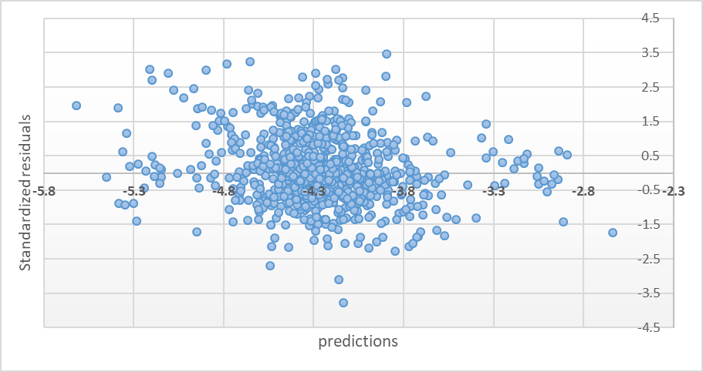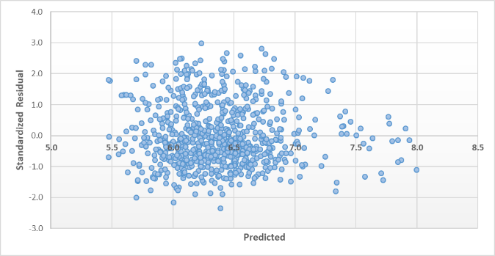

Figure 7: analysis of residuals and attractive migration flows right hand: 1996-2006 and left hand: 2006-2011

Source: Findings of the Research

# **Discussion and Conclusion**

From 1986-to 1996, there were approximately 8.5 million intra-and inter-provincial migrations, of which 34.8 percent were inter-provincial migrations. This figure reached about 12 million in 1996-2006, and the share of inter-regional migration increased to 42%. From 2006-to 2011, there were about 4 million intra-and inter-regional migrations, and the share of inter-regional migration increased to about 45 percent. This increasing trend of inter-regional migration indicates the importance of the distribution of human resources and economic origin-destination factors in different parts of the country.

The analysis showed that economically powerful regions, such as Tehran, Isfahan, Khorasan, and Khuzestan, experience the highest levels of inter-regional migration, indicating stronger inter-regional linkages in wealthier areas. However, there is no strong correlation between regional wealth (GDP per capita) and migration rates, as provinces like Kohgiluyeh and Boyer-Ahmad, Khuzestan, and Bushehr, despite their high wealth levels, are not among the most central provinces in terms of migration activity. The findings can be explained by several factors. Economically powerful regions like Tehran, Isfahan, and Khorasan may experience high levels of inter-regional migration due to their centrality, diverse economic opportunities, larger populations, and better infrastructure, making them attractive destinations. In contrast, provinces like Kohgiluyeh and Boyer-Ahmad, Khuzestan, and Bushehr, despite their high GDP per capita, have wealth concentrated in specific sectors like oil, gas, or agriculture, which are capital-intensive but generate limited employment opportunities. Additionally, these provinces may lack the population size, economic diversity, connectivity, or social and cultural pull factors (e.g., urban amenities or educational institutions) that drive migration. Historical migration patterns and networks also may play a role, as regions like Tehran have long-established linkages, while geographically isolated or less accessible provinces may not. Thus, wealth alone does not determine migration activity, as other structural and social factors significantly influence migration flows.

Also, the decrease in migration volume with increasing geographic distance reflects the natural tendency for people to move shorter distances due to lower costs and familiarity. However, the rise in migration at distances of 400–600 kilometers and 1000–1200 kilometers suggests the influence of major migration-attracting poles, such as Tehran, where agglomeration economies, better job opportunities, and access to services draw migrants from farther regions. Tehran’s continued dominance as a key destination highlights its central role in the country’s economic and social landscape. The shift from smaller-scale to larger-scale migration flows, particularly in the 50,000–100,000 range and beyond, indicates growing urbanization and the intensification of migration trends, driven by population growth, regional disparities, and the concentration of opportunities in urban centers. These patterns reflect the increasing pull of major cities and the structural changes in migration dynamics over time.

The analysis of inter-regional migration from 1996–2006 reveals that, contrary to expectations, migration decreased with the economic strength of the destination, challenging the assumption that stronger economies attract more migrants. However, as anticipated, migration declined with higher local wealth (GDP per capita) in the origin region, as wealthier areas experienced less out-migration. Regions with strong agricultural and fisheries sectors also saw lower migration rates, as these activities reduced the outflow of human resources. In contrast, migration increased when the origin region had higher value-added in service activities and wholesale and retail trade, while financial intermediation activities, such as banking, in the destination significantly attracted migrants. Overall, the decline of productive sectors like agriculture and fisheries in origin regions, coupled with the growth of service and financial activities in destination regions, contributed to higher inter-regional migration flows.

During the period 2006–2011, inter-regional migration was found to operate independently of indicators such as market size and regional wealth. Instead, increased intra-regional migration and the value added of the fisheries sector reduced the tendency for inter-regional migration, while economic activities like real estate and wholesale and retail trade in the origin region encouraged it. The increase in intra-regional migration during 2006–2011 may suggest that shorter-distance moves became more prevalent, possibly due to improved local infrastructure, urbanization, or regional disparities within provinces, reducing the need for long-distance inter-regional migration. Additionally, growth in energy sector activities at the destination influenced population mobility.

These findings (1996-2011) suggest that the development of land- and resource-based activities, such as fisheries and agriculture, reduces population outflows, whereas the expansion of non-productive activities, such as services, real estate, and trade, drives migration to other regions. Furthermore, under the framework of human capital theory, educated and skilled individuals make up a significant portion of migrants, meaning that the rise of non-productive activities, particularly in the real estate sector, depletes the human capital of origin regions. Over time, this decline in human capital diminishes agglomeration economies, stifles innovation, and hampers the creation of new jobs in these regions.

The inverse relationship between migration and the economic strength of destination regions may reflect saturation effects, where highly developed regions face constraints such as high living costs, housing shortages, or job market saturation, reducing their attractiveness to migrants despite their economic power. Wealthier origin regions with higher GDP per capita tend to experience less out-migration because residents have better access to local opportunities, reducing the need to migrate. This is particularly true for regions with strong land- and resource-based sectors, such as agriculture and fisheries, which provide stable livelihoods and discourage population outflows. As origin regions increasingly focus on non-productive activities like services, trade, and real estate, migration rates rise because these sectors may not provide sustainable or long-term employment, pushing people to seek better opportunities elsewhere. Conversely, the growth of financial intermediation and energy-related activities in destination regions attracts migrants by offering higher-paying or more stable jobs. The findings highlight the contrasting effects of productive and non-productive sectors. Regions with strong fisheries and agriculture retain populations due to the stability these sectors provide, while non-productive sectors, such as real estate and trade, fail to anchor populations, driving migration. Additionally, the growth of energy-related activities in destination regions likely reflects the resource-driven pull of industrial hubs.

Findings showed that in 1996-2006 migration flows between regions were influenced by two main scenarios: regions with similar market sizes experience bidirectional linkages that foster internal synergy, as seen in East and West Azerbaijan (GDP growth rates of 22.2% and 22.4%) and Isfahan and Chaharmahal and Bakhtiari (24.2% and 25%). In contrast, most other flows, except for Kohgiluyeh and Boyer-Ahmad as a destination, were driven by significant disparities in market size between the origin and destination regions. This demonstrates that both market size similarity and disparity are key factors shaping regional migration patterns. Chaharmahal and Bakhtiari has seen a greater-than-expected decline in attracting migrants from Isfahan, Hamedan, and Kurdistan, despite its relatively high GDP growth rate, indicating that its development has not adequately addressed population and settlement needs.

The migration patterns observed during 2006–2011 can be explained by the strong pull factors in key destinations like East Azerbaijan, Isfahan, Tehran, and Khorasan, which attracted migration beyond what the economic model predicted. These regions likely offered better infrastructure, urban amenities, and economic opportunities, making them more appealing to migrants. The findings highlight that migration flows are more influenced by conditions at the destination, such as infrastructure development and job availability, than by the economic conditions of the origin. Additionally, while wholesale trade and real estate activities in origin regions push people to migrate due to limited long-term stability, agricultural activities discourage migration probably by providing steady livelihoods.

To address the increasing inter-regional migration and its implications, policymakers should focus on enhancing infrastructure and urban amenities in less central regions to reduce migration pressures on major hubs like Tehran and Isfahan. While productive and land-based activities in the northern provinces of the country are increasingly threatened by various factors such as the growing trend of agricultural land conversion, climatic factors, and others, the findings of this study recommend that policymakers strengthen these productive sectors to better manage inter-regional migration. Additionally, managing the saturation effects in economically powerful regions through housing, cost of living, and job market interventions, can help achieve more balanced regional development.

# **References**

Bansak, C., Simpson, N., & Zavodny, M. (2020). *The economics of immigration*. Routledge.

Beine, M., & Parsons, C. (2015). Climatic factors as determinants of international migration. *The Scandinavian Journal of Economics*, *117*(2), 723-767.

Brandsma, A., Kancs, d. A., & Persyn, D. (2014). Modelling migration and regional labour markets: An application of the new economic geography model RHOMOLO. *Journal of Economic Integration*, 372-406.

Butros, D., Gyberg, V. B., & Kaijser, A. (2021). Solidarity versus security: Exploring perspectives on climate induced migration in UN and EU policy. *Environmental Communication*, *15*(6), 842-856.

Clark, W. A. (2020). Human migration.

Crescenzi, R., & Iammarino, S. (2018). Global investments and regional development trajectories: the missing links. In *Transitions in regional economic development* (pp. 171-203). Routledge.

Czaika, M., & Reinprecht, C. (2022). Migration drivers: Why do people migrate. *Introduction to migration studies: An interactive guide to the literatures on migration and diversity*, 49-82.

d’Albis, H., Boubtane, E., & Coulibaly, D. (2019). International migration and regional housing markets: Evidence from France. *International Regional Science Review*, *42*(2), 147-180.

Duijndam, S. J., Botzen, W. J., Hagedoorn, L. C., & Aerts, J. C. (2022). Anticipating sea‐level rise and human migration: A review of empirical evidence and avenues for future research. *Wiley Interdisciplinary Reviews: Climate Change*, *13*(1), e747.

Düvell, F., & Preiss, C. (2022). Migration infrastructures: How do people migrate. *Introduction to migration studies: An interactive guide to the literature on migration and diversity*, 83-98.

Faggian, A., & McCann, P. (2009). Human capital, graduate migration and innovation in British regions. *Cambridge Journal of Economics*, *33*(2), 317-333.

Farahmand, S., & Ghasemian, N. (2019). Spatial Analysis Of The Impact Of Migration On Regional Growth In Iran (2006-16). *Regional Science Inquiry*, *11*(3), 9-20.

Florida, R. (2017). *The new urban crisis: How our cities are increasing inequality, deepening segregation, and failing the middle class-and what we can do about it*. Hachette UK.

Gerber, T. P. (2006). Regional economic performance and net migration rates in Russia, 1993–2002. *International migration review*, *40*(3), 661-697.

Greenwood, M. J. (1997). Internal migration in developed countries. *Handbook of population and family economics*, *1*, 647-720.

Grigg, D. B. (1977). EG Ravenstein and the “laws of migration”. *Journal of Historical geography*, *3*(1), 41-54.

Harris, J. R., & Todaro, M. P. (1970). Migration, unemployment and development: a two-sector analysis. *The American economic review*, *60*(1), 126-142.

Hedayatifard, M. (2023). The Role of “Related Variety” in Regional Economic Development of Iran: Employment Growth or Economic Productivity? *Iranian Economic Review*.

Hedayatifard, M., & Rozenblat, C. (2019). The Relationship between Economic Tightness and Regional Resilience (Case Study: Counties in Kerman Province). *Quarterly Journals of Urban and Regional Development Planning*, *4*(8), 111-144.

Hirschle, J., & Kleiner, T.-M. (2014). Regional cultures attracting interregional migrants. *Urban Studies*, *51*(16), 3348-3364.

Hosseini, G., Moshfegh, M., & Zare'Mehrjard, R. I. (2017). Describing and analyzing the interprovincial migrations through Iran, and its determinants, during 2006-2010. *Spatial Planning*, *6*(4), 19-44.

Iammarino, S., & McCann, P. (2013). *Multinationals and economic geography: Location, technology and innovation*. Edward Elgar Publishing.

IDMC. (2021). Global report on internal displacement 2021. Internal Displacement Monitoring Centre. <https://www.internal-displacement.org/global-report/grid2021/>

Kaveh Pirouz, Z., & Farrash, N. (2017). Migration Flows and their determinants in West Azarbaijan

Lewis, E., & Peri, G. (2015). Immigration and the Economy of Cities and Regions. In *Handbook of regional and urban economics* (Vol. 5, pp. 625-685). Elsevier.

McCann, P. (2001). *Urban and regional economics* (Vol. 15). Oxford University Press Oxford.

Nabong, E. C., Hocking, L., Opdyke, A., & Walters, J. P. (2023). Decision‐making factor interactions influencing climate migration: A systems‐based systematic review. *Wiley Interdisciplinary Reviews: Climate Change*, *14*(4), e828.

Park, S., & Hewings, G. J. (2009). Immigration, aging, and the regional economy. *Cityscape*, 59-80.

Parr, J. B. (1999). Growth-pole strategies in regional economic planning: a retrospective view: Part 2. Implementation and outcome. *Urban Studies*, *36*(8), 1247-1268.

Pekkala, S. (2003). Migration flows in Finland: Regional differences in migration determinants and migrant types. *International Regional Science Review*, *26*(4), 466-482.

Rahmani, T., & Hasanzadeh, E. (2011). Migration, economic growth and regional convergence in Iran.

Rodríguez-Pose, A. (2018). The revenge of the places that don’t matter (and what to do about it). *Cambridge journal of regions, economy and society*, *11*(1), 189-209.

Rodríguez-Pose, A., & Wilkie, C. (2017). Institutions and the entrepreneurial discovery process for smart specialization. *Governing smart specialisation*, 34-48.

Rogers, A. (1968). *Matrix analysis of interregional population growth and distribution*. Univ of California Press.

Rozenblat, C. (2015). Inter-cities' multinational firm networks and gravitation model (international forum). *Annals of the Association of Economic Geographers*, *61*(3), 219-237.

Scott, A., & Storper, M. (2003). Regions, globalization, development. *Regional studies*, *37*(6-7), 579-593.

Simpson, N. B. (2022). Demographic and economic determinants of migration. *IZA World of Labor*.

Urbański, M. (2022). Comparing push and pull factors affecting migration. *Economies*, *10*(1), 21.

Wasserman, S. (1994). Social network analysis: Methods and applications. *The Press Syndicate of the University of Cambridge*.

Zanjani. (2001). *Migration*. The organization for Researching and Composing University Textbooks in the Islamic Sciences and the Humanities (SAMT).