Evaluation of Social Sustainability in Urban Neighbourhoods (Case study : Karaj)

Mojtaba Rafieian1 , Mahsa Mirzakhalili2,*

1 Department of Urban planning ,University of Tarbiat Modarres ,Iran  
[rafiei_m@modares.ac.ir](mailto:rafiei_m@modares.ac.ir) ,021-82883743  
2 Art University of Isfahan , Iran   
[khmahsam@gmail.com](mailto:khmahsam@gmail.com) , 09124801675

Evaluation of Social Sustainability in Urban Neighbourhoods (Case study : Karaj)

Abstract

Karaj with a population around 2 million ‘s is the fourth populated city in the country. Its proximity to the Metropolis of Tehran, rapid population growth , constructing and development of lots of suburban townships around it , this question is asked that whether the development of this city from the social needs aspect has been in proportion with sustainable development? The main objective of this research is to evaluate social sustainability at some neighborhoods in Karaj. Considering the fact that urban neighborhoods , as the smallest units of cities have a high importance in cities and their sustainability are a positive step toward sustainable development as well as social cohesion of city. We selected some neighborhoods as statistic population . Assessment of the related variables made through determining a collection of indicators. The collected data via specialist questionnaires analyzed using SPSS software. The reason for which Kendall’s test was selected to study the meaningfulness relationship of the research variables and the concept of social sustainability is the largeness and qualitative feature of the N volume. The result of the research is the proving meaningfulness of the relationship between the defined variables and the notion of social sustainability except social participation. Level of social Sustainability in the neighborhoods are not the same and there is high gap between them (about 2.6).In addition education indicator has the highest level of sustainability between the neighborhoods (0.024). Access to the recreational facilities indicated the highest level of difference between sustainable and unsustainable neighborhoods(74%).

Keywords: Social sustainability , Urban Neighbourhoods, Sustainable Development , Participation , Happiness and Quality of life

# Introduction

The concept of sustainable development was formed under the influence of Brundtland’s

Report and considered as an essential need in the decade 1970 [29]. Sustainable development refers to a development which could response the actual needs without endangering the capacity of the future generations in supplying their needs [26][28]. The notion of social sustainability emerged as one of the chief pillars of the sustainable development [16] .Social sustainability is one of the significant variables of sustainable development which emphasizes on social ,economical and environmental positive outputs and reduce biophysical results in urban environment and also the promotion of life quality [15].

Of course in the first ,economical and environmental notions were in the interior of sustainable development concept ; however , social issues has opened its way in the researches concerning sustainability [8].Therefore, social sustainability has discussed less in relation to other dimensions in the sustainable development issues and has weak theoretical bases [16].

The problems such as poverty, social restrictions, unemployment and inequality are related to social sustainability [13][22] and in a more fundamental thought, this concept is a bridge between social conditions (such as poverty) and destruction and ruin of the environment [2] and its most important variables including happiness and quality of life, health and security ,participation and equality.

Andrea Colantonio [9],one of the theorists of the social sustainability explaining this concept . He studies sustainability attitudes and evaluates its methods and variables. In his research He examined social sustainability theories transformed towards the policies and strategies such as habitable City, citizenship participation and social capital .Moreover, Mackenzie [19] presents social sustainability variables . He emphasizes on equality in profiting from key services such as health, education and housing.In addition, Galal Ahmed[14] in a research titled “urban social sustainability in Emirates local units” in 2012,evaluated the social sustainability dimensions in public local units in Al Ain .He attained a clear perception on social sustainability in designing urban neighborhoods in Al Ain through a mult- dimensions analysis and eventually ,presented several principles’ designing in urban neighborhoods. The objective of this essay is to evaluate the level of social sustainability in certain neighborhoods of Karaj city with defining the relevant variables and indicators. Rapid growth of population ,increase of immigration rate in this city urban neighborhoods’ infrastructures have challenged the sustainability of most urban neighborhoods from the perspective of sustainable development. Therefore, it has been necessary to evaluate social sustainability in urban neighborhoods as the most important urban effective unit.

**2 social sustainability :the most important dimension of sustainable development**

Sustainable development is based on three different dimensions of sustainability ; social and economical dimensions and ecological or environmental sustainability. These dimensions are recognized as basic elements of sustainable development[20][2] .

Social sustainability dimension has taken as the basis of sustainable­ development­ ­into more consideration in recent years. This concept along with the notion of sustainable development has an important role in discussions ,researches and planning [16].

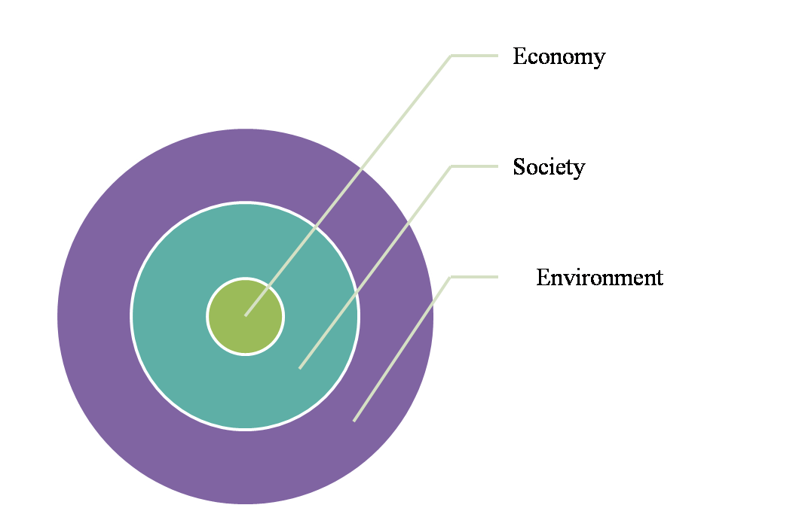

Figure 1:Concentric circles model of sustainability[1]

Sustainable development dimensions are defined in a vertical structure[5].Therefore, sustainable development is not just based on environment policies and is not achieved without solving social and economical problems . Namely , Ray [24] recognizes the responsibility of sustainable development as decrease of unemployment, poverty and lack of job [24].In the process of sustainable development , the role of social sustainability has a significant importance in realization of objectives .Therefore, in strategic goals of sustainable development , the concepts such as empowerment , rise of power, liberty of choice, development of participation, promotion of life quality ,basic capacity provision ,Social security , social accountability and welfare had been emphasized largely; so, social dimensions in relation with other economical and ecological dimensions strengthening the sustainable development and form its rhythmic totality. The social sustainability is a normal and analytical concept and seeks the long term relationship between nature and society . The relationship being capable to providing future generations needs [17] .

Table 1: Definition of social sustainability

* A strong definition of social sustainability must rest on the basic values of equity and democracy, the latter meant as the effective appropriation of all human rights – political, civil, economic, social and cultural – by all people [25]
* [Sustainability] aims to determine the minimal social requirements for long-term development (sometimes called critical social capital) and to identify the challenges to the very functioning of society in the long run [4]
* Development (and/or growth) that is compatible with harmonious evolution of civil society, fostering an environment conducive to the compatible cohabitation of culturally and socially diverse groups while at the same time encouraging social integration, with improvements in the quality of life for all segments of the population [23]
* “Social sustainability refers to maintenance and improvement of well-being of current and future generations ” [7]

One of the most comprehensive definitions of social sustainability with emphasis on urban environments is the one presented by [23], in which the stress has laid on economical (development) and social ( urban society, cultural density and social cohesion) [10].In urban areas , social sustainability is one of the pre-conditions of sustainability in city. Level of urban sustainability could indicates the quality of life in the cities . Urban neighborhoods are the most important and effective units in the urban decision-making . Due to this fact ,the study and recognition of the neighborhoods and the straits and difficulties of their development are issues that discussed in the culture of urban planning recently. Urban neighborhoods is definable as a set of varied uses which supply the need of citizens [12] . Therefore, the study of each of the variables of social sustainability in neighborhoods level , could influence in all city. The newly established concept of social sustainability and weak points in its theoretical bases has caused that many of authorities present different definitions in relation with the sustainability variables .Based on this case, a set of variables has been collected in the table No.2.

Table 2: variables of social sustainability in different sources

|  |  |
| --- | --- |
| **variables of social sustainability** | Source |
| Safety nets/ Ability to withstand and resist pressures/ livelihood /Equality | **Chambers [8]** |
| Equality /Democracy /Human Rights / Job/ Equal access to services and community resources / Social polarization / Equal income distribution | **Sachs [25]** |
| Basic Needs / Needs of future generations /Participation /Social Capital/ Equality | **Baines and Morgan[3]** |
| Local Participation /Sense of place /Local Sustainability / Safe /Social Nets | **Bramley et al[6]** |
| Equality /Diversity /Communication /Quality of life / Democracy | **Barron and Gauntlett[1]** |
| Social integration/Identity and sense of place /Participation and Accessibility / Health / Social Capital / Happiness and Quality of Life | **Colantonio & Dixon [10]** |

***1.2 Social******sustainability******components***

Social sustainability components are placed in three central groups. The first group of the components is happiness and quality of life. This group of components is related to revenue of households, poverty, income distribution, unemployment, education and conditions of life and health and security. The second category of the components relates to the equality of facilities for all categories of society and the third group includes social cohesion [18].

The components of this research are determined based on Colantonio and Dixon ‘s classification[11], in which the stress is upon more conceptual dimensions. In order to analyze every related component , a set of indicators are defined . The relevant data collected and have been analyzed in several phases(This research has chosen some of the neighborhoods of Karaj as a statistical population ).

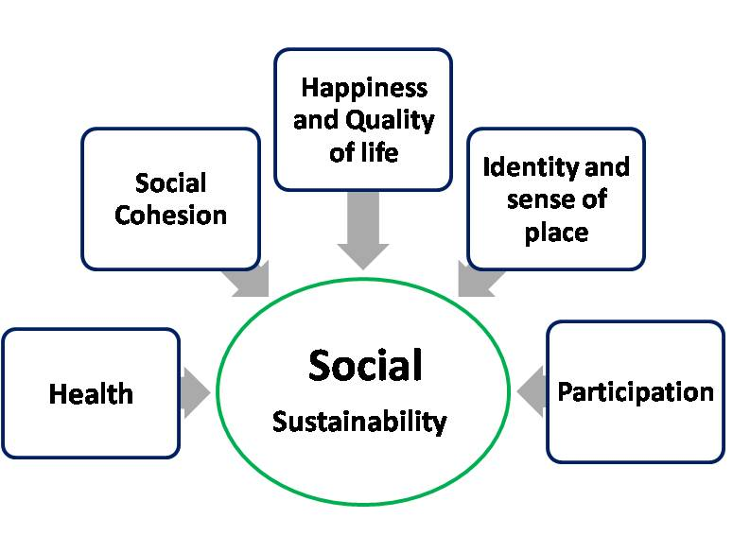

**Effective**

**Component**

**Effectiveness**

**Component**

Figure2:Conceptual model

Karaj in province of Albourz - located in North West of Tehran province- is one of the biggest city of Iran ,which welcomes so many immigrants from other provinces. In such a way that its annual population growth is 14/1 % which is a high percentage in comparison with other big cities of the country.

Map 1: Position of Statistical Population

E:\document- mahsa\Paper B\Ax11\Situiation of Karaj .tif

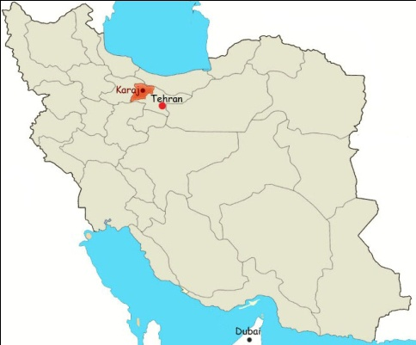

Iran

**3 Materials and Methods**

In this research statistical population has been in Karaj neighborhoods; and sample volume in all quarter has been selected based on Morgan’s Table and summarized upon the following formula :

**n=**

The main tools of collecting data in this research is questionnaire ; in which some indicators are determined and used for assessment all of the components of the research(Table No.3) .

Table 3: Variables and Indictors of research

|  |  |
| --- | --- |
| **Indictors** | **Components of Sustainability** |
| Employment (objective) / Job Satisfaction (Subjective) / Salary Satisfaction/ Infrastructure Services(Phone , gas, water ,net) / Education Services(objective) / Consent of Instructional Services(Subjective) / Leisure Facilities / Trends to Education/ Per Capita Education/ Green Urban Spaces/Effects of Weather / Security at Night /Security at Day/ Access to Media /Pollution Environmental | Happiness and Quality of life |
| Diversity and Ethnic / Local Communication/ Level of Education | Social Cohesion |
| Duration of Stay /Stability at Residence / Level of Participation | Identity and Sense of Place |
| Perspective of participation (subjective) /Participation in Elections (Objective) /NGOs | Social Participation |
| Health Services / Per Capita Health | Health |

In order to attest the validity of the questions ,it has been profited from experts’ views .It has selected a a sample of 30 questionnaires for evaluating the reliability of the questions. Due to the fact , Cronbach’s Alpha of all of the components(dimensions) of the research was assessed using SPSS software and the stability of the questionnaires is also attested(Table No.4.)

Table 4 : Cronbach’s Alpha of each dimensions of Questionnaire

|  |  |
| --- | --- |
| **Cronbach’s Alpha** | **Dimensions** |
| 0.8234 | Happiness and Quality of life |
| 0.8567 | Social cohesion |
| 0.7759 | Identity and Sense of place |
| 0.8389 | Participation |
| 0.7059 | Health |

The selected neighborhoods (Azimyeh , Hessarak region- the neighborhoods of North Hessark and South Hessarak –JahanShahr, RajaeiShahr) are determined by numbers one to five . In order to study the significant relations of the components and the concept of sustainability considering the terms of the research ,Kendall ‘s tau-b Test was selected. Moreover, the study of difference or cohesion of sustainability level in the related statistical population has been done using with Kruskal wallis’s Test ;so , in case of rejecting **H0** hypothesis the neighborhoods’ ranking in relation to the sustainability notion has already been done.

**4 Findings and Results**

Studying qualitative indicators like duration of residence and also the rate of employment has indicated that the selected neighborhoods have a high level of employment in average and the percentage of unemployment is very low .But, the duration of habitation has not been stable between(less than one year, one to five years ,over five years) in every neighborhoods.

Table 5 : Some Neighborhood’s Information

|  |  |  |  |
| --- | --- | --- | --- |
| **Neighborhood** | **Number of Neighborhood** | **Occupation** (Employed :E )  (Student :S) (Unemployed :U) | **Duration of stay** (Less than 1 year: L )  (Between 1-5 years : B )  (More than 5 years : M) |
| Azimiyeh | 1 | E :81.4%,S :13.6% , U :5.1% | L : 33.1 % , B : 38.1 % , M :28.8 % |
| South Hessarak | 2 | E :82.4% , S :12.2% , U :4.0 % | L : 41.9 % , B : 37.8 % , M :20.3 % |
| North Hessarak | 3 | E :60.9%, S :23.0% , U:16.3% | L : 42.5 % , B : 25.3 % , M :32.2 % |
| JahanShahr | 4 | E:73.0%, S :17.6% , U :9.5% | L : 23.0 % , B : 52.7 % , M :24.3 % |
| Rajai Shahr | 5 | E :59.8%, S :26.4% , U:13.8% | L : 39.1 % , B : 25.3 % , M :35.6 % |

The percentage of unemployed persons compared to the two others options has a less per cent. It should be noted that housewives(that they satisfied their situation) have been assessed and evaluated in employee’s group. In general, the employment of all neighborhoods is in an appropriate situation. The other indicators include the rate of job satisfaction and also the relevant income that have been studied in the other cases and in the form of happiness and quality of life component . Each of the components of happiness and quality of life, social mixing and cohesion, sense of place and identity, social participation and health have been analyzed separately through selected indicators and via benefiting from Likert ‘s spectrum . The relationship significance test of every component with social sustainability concept has been presented in the form of Table No.6 for each of the neighborhoods.

Table 6 : Kendall’s tau-b Test

|  |  |  |  |  |  |  |  |
| --- | --- | --- | --- | --- | --- | --- | --- |
| **Neighborhood number** | **Social sustainability** | **Kendall’s tau-b**  **Test** | **Happiness and Quality of life** | **Social Cohesion** | **participation** | **Identity and sense of place** | **Health** |
| 1 | Correlation Coefficient | 0.648 | 0.194 | -0.21 | 0.348 | 0.227 |
| Sig(2-tailed) | 0.000 | 0.011 | 0.789 | 0.000 | 0.001 |
| 2 | Correlation Coefficient | 0.249 | -0.077 | 0.25 | 0.448 | 0.201 |
| Sig(2-tailed) | 0.000 | 0.04 | 0.012 | 0.000 | 0.036 |
| 3 | Correlation Coefficient | 0.488 | -0.014 | 0.194 | 0.351 | -0.136 |
| Sig(2-tailed) | 0.000 | 0.000 | 0.031 | 0.000 | 0.01 |
| 4 | Correlation Coefficient | 0.559 | 0.629 | -0.219 | 0.250 | 0.39 |
| Sig(2-tailed) | 0.000 | 0.000 | 0.134 | 0.017 | 0.000 |
| 5 | Correlation Coefficient | 0.778 | -0.786 | 0.506 | 0.350 | 0.116 |
| Sig(2-tailed) | 0.000 | 0.000 | 0.000 | 0.000 | 0.02 |

H0 Test relating to all of social sustainability components except for social participation component in all of the selected neighborhoods has been rejected.(p-value‹0.05); this means that there is a meaningful relation (direct/indirect) between social sustainability and all of the defined components. The rejection of H0 hypothesis according to the existing views that is based on the relation of each concept with social sustainability and the emphasis on the necessity of existence of all component in formation of social sustainability [6][21][27]. As Table No.4 shows ,social sustainability and participation in neighborhoods Nos. one and four don’t have the significant relationship (p-value› 0). In addition, social sustainability in neighborhoods Nos. two, three and five shows an indirect and significant relationship with social cohesion component; this means that the changes of these two components are not moving in the same direction. There are also an reverse relationship between the two components of sustainability and health. In other cases, there is a direct and meaningful relation between social sustainability component and other components; in order to attain a comprehensive analysis in relation to the above cases ,it is necessary to determine the standard and level of social sustainability in all neighborhoods. Every component was assessed by defining a set of homogenous indicators (table No.3). In a micro scale and via studying the relation of indicators of social sustainability , the educational indicators including the rate of tendency for growth and education expressing in average has been the most significant relationship in the neighborhoods (sig-2 tailed:0.042). The rate of access to the infrastructure (0.036) and health (0.002) services are placed in the following ranks.

Social participation component with indicators like individual perception towards participation(Subjective) , the rate of participation in elections(Objective)and activity of NGOs has been the weakest component which was studied. Namely computing the percentage of cumulative frequency related to the component ,the level and standard of participation in all of the neighborhoods studied has been laid in the very low group(about 36% of the total average of all of the neighborhoods).Figure No.3 has displayed the rate of participation in every quarter.

C:\Documents and Settings\khalili\Desktop\Picture2.tif

Figure 3 : social participation

Based on the achieved result ,in the statistical population studied , there is not a high tendency for participation in social activities ,moreover, participation in practical level is also very low; in all neighborhoods; averagely, around 5% of respondents have chosen very high option (in every indicator of participation).

***1.4 Neighborhoods Sustainability levels***

The significance of relationship between every component and social sustainability does not show equality or inequality of social sustainability level in Karaj’s selected neighborhoods. Therefore the difference or the equality of sustainability level has been assessed using Kruskal- wallis ‘s Test (Table No.7).

This Test is a non-parametric one that puts under the test the sample groups of an identical or a joint statistical society.

Table 7: Kruskal- wallis ‘s Test

|  |  |  |  |  |
| --- | --- | --- | --- | --- |
| **Test statistic** | | **Mean rank** | **N** | **Neighborhood Number** |
| 337.44 | 118 | 1 |
| Variable : social sustainability | | 136.04 | 74 | 2 |
| 292.624 | Chi-square | 137.86 | 87 | 3 |
| 4 | Df | 330.23 | 74 | 4 |
| 0.000 | Asymp-sig | 123.03 | 87 | 5 |

In this table , the statistic quantity of Chi-square(Df quantity) equals to 4 degree of freedom and the significance level of p-value Test is equal to Zero. Consequently, H0 Test has been rejected and the sustainability level in the related neighborhoods is different. Therefore, with providing the average point for social sustainability and the formation of (sustainable spectrum(3.8-5.1) ,mi –sustainable(2.4-3.7) and unsustainable spectrums (1-2.3)) [1]

All of the neighborhoods have been classified and the level of their social sustainability in each of the related indicators and components has been studied. The difference in social sustainability level based on determined indicators has caused that every quarter would be placed in a different rank of sustainability; in a manner that the gap between the neighborhoods is 2.6 , which indicates high difference between the neighborhoods in the social sustainability level. Moreover, in many of the indicators studied ,there is a considerable difference between different neighborhoods due to profit from the said indicators. Azimiyeh and JahanShahr, two sustainable neighborhoods with sustainability level 4.66 and 4.55 respectively, both located in northern part of Karaj . These neighborhoods with high access to educational ,welfare ,recreational and health services that the majority of residents are close to each other from social and economical aspects; and the residence of people with ethnical differences does not considered as barrier for social and local relationships and has not caused social problems. Unsustainable neighborhoods (South Hessarak:2.09;North Hessarak: 2.12; Rajaeishahr:1.94) ,residence of many low-income classes and the immigrants ,who are in lower levels(social and economical). one of the most important existing challenges in these neighborhoods is the lack of social security. Because of High ethnical diversity and following it , rise of anonymous levels ,there would be a high levels of crimes in some neighborhoods(Hessarak Region including North and South Hessarak) , is one of the centers of providing and distributing of narcotics and crimes throughout the province and the country[30]). Another problems is the lack of health and treatment facilities in the said neighborhoods that does not respond to the needs of the increasing and low earning population. Most residents of these regions are from working and vulnerable strata who have immigrated to this city from western provinces in few years ago. In these neighborhoods, the indicators of the quality of life encounter many problems which have not lead to the happiness and contentment of the native residents ,but have caused people to exit from the residential space of these group of neighborhoods. In these conditions ,local un sustainability has decreased the degree of identity and sense of place in a large scale between the residents. The diminution of this indicator causes that accountability of native people towards the plans under execution or the next plans and projects of the neighborhoods or on other words, the effort for increasing and generalizing the indicator of quality of life would decrease. Table No.8 has studied the rate of difference in some of the qualitative indicators in sustainable and unsustainable neighborhoods. The least difference is 8% related to the indicator of access to educational services and most difference relates to access to recreational facilities (74%) in the neighborhoods; in such a way that the rate of access of the neighborhoods in last indicator has been achieved a negative per cent.

Table 8 : The average of some indicators in   
Sustainable and Un Sustainable Neighborhoods

|  |  |  |  |
| --- | --- | --- | --- |
| **Indicators** | **Sustainable Neighborhoods** | **Un Sustainable**  **Neighborhoods** | **Gap** |
| Access to educational services | 86% | 78% | **8** |
| Access to Health services | 82% | 36% | **46** |
| Access to Infrastructure services | 80% | 70% | **10** |
| Recreational facilities | 73% | -1% | **74** |

Social sustainability in a city or a quarter is conditioned upon existence of happiness and quality of life, providing health and security, tendency for social participation. But, the achieved results in the research indicate that in the neighborhoods that the components have sustainability and are in a appropriate situation ,there are low levels of social participation. We can consequent that conditions and terms ruled on the city and lack of confidence and clarity between residents and civil managers affect to the decision and happiness of civilization.

Social sustainability is a multi-level concept that a lot of factors in its realization ;in addition to the defined components and indicators ,the factors like cultural and political conditions and government could also affect it. For instance ,cultural and political conditions could influence the rate of happiness and quality of life and participation and individual ‘s point of view towards his/her social and job future.

**5 Conclusions and Discussion**

Intellectual and cognitive developments in planning ,on one part, and social changes and evolutions ,on the other part , have caused that the notion of sustainability particularly in social dimensions due to its expansion and importance would be transformed to the discussion of the day at the local levels. Therefore, local sustainability could be considered as pre-condition of the sustainable development of the city and region. Population’s growth in Karaj (because of immigration in general) has caused to form many different urban neighborhoods in this city . Sustainable neighborhoods ,located at calm places ,with features as appropriate facilities of life, availability of services and so on ,whereas marginal unsustainable neighborhoods where most of their residents include slum-dwellers and inconformity between population’s growth and ecological and service needs, urban inappropriate programming ,lack of identify and sense of place , also some problems and issues relative to cultural and ethnical mixture and incoherence have been led to the un sustainability of the neighborhoods .In a manner that despite adjacency of some neighborhoods, the sustainability gap between sustainable and unsustainable neighborhoods has been 2.6.

So that some indicators like access to recreational facilities in neighborhoods ,there is a high difference (74% difference). The made evaluations have shown that in spite of the attestation of significance relationships of the selected components and the concept of social sustainability ,the participation of residents don’t follow this rule. This means that even in sustainable neighborhoods despite the dependency and happiness of the residents, the rate of participation has been at a low level and the residents don’t have a positive view resulted from confidence to the performance of civil managers. On other words, there is a kind of homogenization in this component between urban neighborhoods.

Considering the strategic situation of the city and its proximity with a big city like Tehran, it is necessary for urban planners to take into more consideration the issue of homogenization of Karaj’s urban neighborhoods in relation to social sustainability components and to make an effort in order to increase sustainability level in neighborhoods ,as one of the most effective and influential urban units in broader decision-making .

Based on the definition, quarter is the smallest urban unit that in case of reformation and advancement towards sustainable development in neighborhoods ,the sustainability of development in the city is achievable in that .

Correct Planning , attention to urban neighborhoods not only as an administrative area but also as an important part of the city with economical, social and cultural features ,more activity of local council assistants in order to attract participation and local confidence , attention to strengths and weakness points , opportunities and menaces at micro(local) level, paying more and more attention by Karaj civil in charges and managers to the urban neighborhoods in particular unsustainable ones , are all the suggestions that could lead to the growth and development of social sustainability components at the neighborhoods so as with establishing homogenization and resolution of the gaps between the neighborhoods ,social sustainability in Karaj city would be attained.

# References

[1] Barron, L. & Gauntlett, E.: 2002, Model of social sustainability, Housing and sustainable communities’ indicatorsproject, Stage 1 report, Perth, Murdoch University: Western Australia.

[2] Basiage, A.D.:1999 ,Economic, social and environmental sustainability in development theory and urban planning practice, Vol. 19 ,The Environmentalist.

[3] Bianes, J & Morgan , B. : 2004,Sustainability Appraisal : A Social Perspective “In Sustainability Appraisal . A Review of International Experience And Practice ,Dalal-Clayton B And Sadler , B ,(Eds), International Institute for Environment and Development , First Draft of Work in Progress; London.

[4] Biart, M.: 2002,Social sustainability as part of the social agenda of the European community, in Ritt, T. (Ed.): *Soziale Nachhaltigkeit: Von der Umweltpolitik zur Nachhaltigkeit ?*Arbeiterkammer Wien, Informationen zur Umweltpolitik 149, Wien, 5–10.

[5] Birkmann, J.: 2000, Nachhaltige Raumentwicklung Imdreidimensionalen Nebel. Hamm, in: UVP- Gesellschaft: UVP- Report 3/2000.UVP- Verlag,.

[6] Bramley ,G., Dempsey, N. ,Power ,S.& Brown, C,:2006,What is Social Sustainability and How do our Exciting Urban Forms Perform in Nurturing it ? Paper Presented at the “Sustainable Communities and Green Futures ”Conference ,Bartlett school of Planning ,University College London: London.

[7] Chan, E., & Lee, G.K.L.: 2008,Critical factors for improving social sustainability of urban renewal projects, Vol. 85,Social Indicators Research.

[8] Chambers, R, :1992,Rural Appraisal :Rapid, Relaxed and Participatory ,IDS Discussion Paper 311, 69-84,.

[9] Colantonio, A,: 2008,Social Sustainability : Linking Research to policy and Practice, Oxford Institute for Sustainable Development (OISD):Oxford Brookes University .

[10] Colantonio, A., & Dixon, T. : 2009,Measuring Socially Sustainable Urban Regeneration in Europe. Oxford Books University: Oxford.

[11] Colantonio, A., & Dixon, T.: 2011,Urban Regeneration & Social Sustainability: best practice from European cities, Blackwell Publishing: London.

[12] Cowan, R,: 2005,The Dictionary of Urbanism, Street Wise Press: London.

[13] Ekins, P. et al.: 2008,The four-capital method of sustainable development evaluation**,** European Environment,Vol. 18.

[14]Galal A.K ,: 2012,Urban social sustainability : a study of the Emirati local communities in Al Ain, Urbanism, 5(1)

[15]Hendrickson, D., Lindberg ,C., Connelly ,S., & Roseland, M. ,: 2011,Pushing the envelope :Market Mechanisms for Sustainable Community Development .Urbanism , 4 ( 2 ),153-164.

[16] Koglin , T .:2009Sustainable development in general and urban context .Development of Technology and society .Bulletin: Lund University.

[17] Litting ,B. , & Grieler,E,: 2005, Social Sustainability :a catchword between Political Pragmatism and social theory ,Sustainable Development, vol.8.(1-2) .

[18]Löffler, W. : 2004 Was hat Nachhaltigkeit mit sozialer Gerechtigkeit zu tun? Philosophische Sondierungen im Umkreis zweier Leitbilder’, in Littig, B. (Ed.): *Religion und Nachhaltigkeit.Multidisziplinäre Zugänge und Sichtweisen,* LIT, Münster, 41–70.

[19] McKenzie, S.,:2004,Social sustainability: Towards some definitions. Hawke Research Institute: Working Paper Series. Magill, Hawke Research Institute.

[20] Munier, N.,: 2005,Introductionto Sustainability – Road to a Better Future. Springer: Dordrecht,.

[21]Omann I. & Spangenberg J.H.,:2002,Assessing Social Sustainability. The Social Dimension of Sustainability in a Socio-Economic Scenario, paper presented at the 7th Biennial Conference of the International Society for Ecological Economics“ in Sousse (Tunisia), 6-9 March 2002.

[22]Partridge, E.,: 2005,Social sustainability: a useful theoretical framework?.Conference Paper, Australasian Political Science Association Annual Conference*.*

[23]Polese, M. & Stren, R,. (Eds.),:2000,The Social Sustainability of Cities: Diversity and the. Management of Change. University of Toronto Press: Toronto.

[24]Ray ,S,. : 1993,Sustainable Development through the Development of the non-fram sector “Zmagazine .

[25]Sachs, I. , :1999,Social sustainability and whole development: exploring the dimensions of sustainable development. In: B. Egon and J. Thomas, Editors, *Sustainability and the social sciences: a cross-disciplinary approach to integrating environmental considerations into theoretical reorientation*, Zed Books, London .

[26]Smith, C. , & Rees, G.,: 1988,Economic Development .2nd edition . Basingstoke: Macmillan.

[27]Thin N., Lockhart C., & Yaron G., : 2002,Conceptualising Socially Sustainable Development, A paper prepared for DFID and the World Bank, DFID, mimeo.

[28]Tosun , C.,: 2001,Challenges of Sustainable Tourism Development in Developing worth: the case study of Turkey , Tourism Management vol.22.

[29]World Commission on Environment and Development: 1987,Our common future, Oxford University Press: New York.

[30]www.mehrekaraj.com

1. Using T-Test concerning the average and the standard deviation of the social sustainability concept in samples studied