**“Integrity" in the conservation and development of urban heritage**

**Leila Moghimi*[1], Pirouz Hanachi[2], Somayeh Fadaei Nezhad Bahramjerdi[3]**

**Abstract:**

One of the effective strategies for achieving sustainability and creating interaction between the “conservation and development of urban heritage” is to maintain “integrity” in historic cities. The definition of integrity, in relation to the definition of the special values of urban heritage, is important. Reviewing international conservation documents and conventions, as well as relevant theoretical perspectives, indicates that the evolution of the concept of integrity has been the result of both sources, with an emphasis on the principle of conservation and the conservation of heritage significances. It then becomes associated with the concept of “authenticity” in convey of significance, and ultimately aligns with the concept of sustainability and sustainable development in "conserving significance " and "transferring significance." The present study aims to explain and recognize the relationship between the concept of integrity and the sustainable conservation and development of urban heritage. Therefore, the approach of this research is fundamental, and the dominant strategy is content analysis, in order to provide a conceptual framework that, on the one hand, focuses on the concept of integrity and the conservation and convey of heritage significances over time, and on the other hand, ensures the secure and convey of significances to future generations through the concept of sustainability. Therefore, the concepts of "convey significance “and “conservation significance" are vital and essential in the process of sustainable conservation and development of urban heritage.

Keywords: Urban heritage, conservation and development, integrity, sustainability.

1. **Introduction:**

Heritage faces various threats, ranging from human actions to natural calamities, which can be interconnected. Inadequate planning and development projects, armed conflicts, climate change, disasters caused by natural hazards like earthquakes, and other hazards can have harmful impacts on the integrity of cultural and natural heritage. It is surprising that the concept of integrity, particularly in the context of cultural heritage, has not received much attention, even in the World Heritage system, which is the primary platform for disseminating heritage discourses, policies, and practices. This is unexpected because although the term "integrity" is not explicitly mentioned in the 1972 UNESCO World Heritage Convention, the concern for the loss of integrity is evident from the outset through words such as "decay," "deterioration," "damage," "destruction," and "disappearance" caused by "dangers"(UNESCO 1972). At the initial preparatory meeting organized by UNESCO in 1976, the International Council on Monuments and Sites (ICOMOS) suggested "unity and integrity of quality" for cultural properties to be nominated for inscription on the World Heritage List (UNESCO 1976). They also agreed that the World Heritage Committee should have the authority to remove properties from the List if they have been destroyed or have lost their integrity. The International Union for Conservation of Nature and Natural Resources (IUCN) also proposed the concept of integrity, emphasizing the need for natural sites to be of sufficient size to contain all or most of the key elements related to significance and continuity(Cameron and Rössler 2016). In 1977, the proposal of ICOMOS was replaced with "authenticity," which was later combined with integrity. The combination of these two notions was discussed at the World Heritage Global Strategy Natural and Cultural Heritage Expert Meeting in 1998. Although experts agreed that the "test of authenticity" could be replaced by "conditions of integrity," the two notions were not merged until 2005(UNESCO 2005). Despite the lack of a dedicated text for integrity in the Operational Guidelines, cultural properties were nominated and inscribed on the World Heritage List without a clear understanding of this concept. Today, both integrity and authenticity continue to be under-theorized and sometimes confused, even in recent ICOMOS evaluations.

This article takes a closer look at integrity in order to foster informed and constructive discussions about its relationship with urban heritage conservation, development, and sustainability. It presents a model that emphasizes the importance of "conserve and convey significance of urban heritage" as a shared concept between integrity and sustainability in the future. The importance of future-thinking is becoming increasingly recognized in both heritage studies and the professional heritage sector, as evidenced by recent literature (Holtorf 2020). Scholars argue that we need to balance the focus on the past with accountability to the future and plan better for a future that is constantly changing (Holtorf 2020). This requires moving away from the traditional view of heritage, which preserves material remains of the past with fixed value in perpetuity, and towards a new view that serves society in times of climate change or other threats and embraces loss, alternative forms of knowledge, and uncertain futures(Harvey and Perry 2015).The World Heritage Convention, which calls for transmitting the unique and irreplaceable heritage to future generations, is based on the traditional view of heritage (UNESCO 1972). The Operational Guidelines suggest that Outstanding Universal Value (OUV) is fixed, timeless, and automatically beneficial (UNESCO 2019). However, the World Heritage system has rarely considered the possibility of a different significance of heritage in the future, or the possibility of different benefits of heritage in the future (Rudolff and Buckley 2015).While the future cannot be predicted with certainty, it is possible to prepare and plan for it by exploring different future scenarios and making thoughtful decisions. Therefore, the author argues for picking up the notion of integrity in global heritage discourses because its dynamic nature can enable a future-oriented approach to cultural heritage. This can help to consider different future scenarios and responses to loss and achieve sustainable development goals, such as climate action, while reconciling conservation with the needs of an evolving world. Appreciating the dynamic nature of integrity can help to put the new view of heritage into practice and align the implementation of the Convention with global agendas, such as the UN 2030 Agenda.

1. **conservation and development of urban heritage**

Urban heritage is not limited to unique buildings or historical monuments, nor is it simply defined as a collection of built-up areas. Urban heritage exists in the physical characteristics of buildings, public spaces, and urban morphology. It is shaped by the experiences of users and forms the heritage of future generations (Orbasli 2000). Sitte advocated for an aesthetic approach to the historic city, which he believed had a greater aesthetic value than modern urban districts. He also viewed the city as a historical continuum that needed to be analyzed morphologically and typologically to fully understand its subsequent developments(Sitte and Wieczorek 1981). Sitte's ideas laid the foundation for both urban heritage conservation and modern town planning, and had a significant impact on urban construction planning in Germany and abroad (Collins, Sitte et al. 2006). According to sources, Giovannoni was the first author to formally define the concept of 'urban heritage' in his seminal book, Vecchie città ed edilizia nuova (Giovannoni 1931, Choay* 2009). Giovannoni viewed the "old" city as the product of historical layering and believed that the conservation of urban integrity over time required not only the conservation of monumental buildings, but also their surrounding environment.

**2-1-** **Conservation and development of urban heritage in the current century**

In the 1960s, a conventional and aesthetical approach was taken to heritage conservation, but by the 1970s, this had shifted to a social and economic conservation model. In the 1980s, there was a focus on preserving heritage significances in a context of change, and by the 1990s, a landscape approach was adopted for sustainable urban heritage conservation and management. During this time, the definition of urban heritage expanded, moving beyond monuments to encompass entire landscapes and intangible attributes. Understanding this evolution is crucial for developing a contemporary international approach that can effectively address the challenges facing historic urban environments in the 21st century. Throughout the 20th century, historic urban environments gained recognition for their cultural value and importance in modern life. They have become iconic symbols of global cultural tourism and expressions of cultural identity and memory. However, competition for land use in urban areas can be intense, especially for historic inner cities, which have become a focus of urban development and regeneration efforts around the world. This has created tensions over land use, gentrification, and real estate pressures, resulting in conflicts between stakeholders with differing interests in the recognition of urban heritage significances. These conflicts often pit heritage conservation against economic development, making historic urban environments places where conflicts of interest among different social actors are particularly intense. As a result, city managers, developers, and decision-makers often view heritage protection as a barrier to development ((Warren 1998, Turner, Pereira et al. 2012, Carley and Smith 2013)).

According to recent research, conflicts between heritage conservation and development have been ranked as one of the greatest concerns among practitioners and researchers from both the fields of conservation and urban management (TheGettyConservationInstitute 2010, Veldpaus, Pereira Roders et al. 2013, Khalaf 2015). Despite an apparent paradox between the needs of heritage conservation and those of urban and socio-economic development, a new perspective has emerged in recent years that reconciles the notions of conservation and development and promotes them as complementary factors (Rypkema 2005, Bandarin, Hosagrahar et al. 2011, Pereira Roders, Van Oers et al. 2014). Urban heritage preservation is often seen as an ally of development in urban contexts, with some scholars arguing that they are "two faces of the same coin" (Bandarin, Hosagrahar et al. 2011, Pereira Roders and Veldpaus 2013). Moreover, cultural heritage is currently being viewed as a driver and source for sustainable urban development by some scholars as well as international organizations such as UNESCO, United Nations, and ICOMOS (Van Oers, Opportunities et al. 2006, Landorf 2009, Nations 2011, Felicori 2014, ICOMOS 2014, Nations 2014, Duxbury, Hosagrahar et al. 2016).While urban heritage serves as a testament to the past, it also plays a critical role as a "key resource in enhancing the livability of urban areas, and fosters economic development and social cohesion in a changing global environment," emphasizing the need for its cvation(UNESCO 2011b).

The conventional approach to heritage conservation views heritage as static and unchanging, leading to an attitude of "prevention of change"(Araoz 2008) or "intolerance to change"(Veldpaus and Roders 2014) when it comes to preservation efforts. unfortunately, this approach often fails to recognize the dynamic nature of urban environments and neglects the preservation of intangible aspects of heritage (Araoz 2013), resulting in the fragmentation and decay of urban values and meanings (Zancheti, Loretto et al. 2015). Urban conservation processes that prioritize the maintenance of historic integrity and authenticity without considering urban dynamics of change have contributed to this problem (Whitehand, Gu et al. 2007). In the 21st century, the Budapest Statement and Declaration emphasized sustainable development in urban heritage conservation, promoting a balance between conservation, sustainability, and development while involving local communities in WH property management (UNESCO 2002). The concept of sustainable development was included in the WH Convention's Operational Guidelines in 2005(UNESCO 2005d). At the beginning of the 21st century, the WH Centre recognized the need to revise conservation policies to meet contemporary challenges affecting historic urban environments. In response, an international conference on "World Heritage and Contemporary Architecture" was held in Vienna in 2005, resulting in the Vienna Memorandum on World Heritage and Contemporary Architecture. This document introduced the 'working definition' of 'Historic Urban Landscape,' emphasizing the importance of social and ecological values associated with heritage. The Memorandum recognized the evolutionary component of urban landscapes and the need for new approaches to and methodologies for urban conservation and development (UNESCO 2005d). However, it focused primarily on contemporary structural interventions in historic urban environments, limiting the scope of the problem of urban development. The conference resulted in a request to adopt a new recommendation on the subject of historic urban landscapes, which gave rise to the Historic Urban Landscape approach and its related UNESCO Recommendation. In brief, one year after the Vienna Memorandum, UNESCO created a working group on historic urban landscapes in collaboration with its advisory bodies to revise existing documentations and evaluate the relevance of adopting a new recommendation dedicated to the HUL. After extensive experts' discussions, the HUL Recommendation was presented in 2010 and officially adopted at the 36th General Conference of UNESCO in November 2011. The HUL approach was conceived to minimize the existing gap "between the ideal world of the charters and the practical realities" and to guide urban management through the integration of different policies and practices, disciplines, urban sectors, and actors involved in the management of historic urban environments. The implementation of the HUL Recommendation should be adapted to the specificity of local contexts, and national and local governments should define an appropriate and tailored strategy case by case. There are six critical steps for the implementation of the HUL Recommendation: comprehensive surveys and mapping, participatory planning and stakeholder consultations, vulnerability assessment, integration of urban heritage significances into a wider framework of city development, prioritization of policies and actions, and establishment of appropriate partnerships and local management frameworks(UNESCO 2011b). The HUL Recommendation is an international effort to bridge the gap between urban heritage conservation and development. It has been formalized into a specific international recommendation that emphasizes the importance of integrating urban heritage conservation strategies into the broader framework of sustainable development (UNESCO, 2011b: Art. 5). This approach represents a significant turning point in the field of urban heritage conservation (Van Oers, Pereira Roders et al. 2014). The Valletta Principles for the Safeguarding and Management of Historic cities, Towns and Urban Areas, adopted by the 17th ICOMOS General Assembly in 2011, emphasize the need to update existing doctrinal documents related to urban heritage conservation. The document defines historic towns and urban areas as a combination of tangible and intangible elements, including architectural elements, landscapes, archaeological remains, cultural practices, traditions, memories, and cultural references. It emphasizes the importance of managing change to ensure adequate safeguarding of urban heritage while allowing for coherent development and harmonious adaptation to contemporary life. The Principles stress the importance of good governance, involvement of a variety of local stakeholders, and planning as a participatory process, involving all relevant stakeholders. The document recognizes the strict interconnection between natural and cultural elements of urban heritage and encourages collaboration between private and public actors to ensure the sustainable development of urban heritage(ICOMOS 2011b). The UN has emphasized the importance of sustainable urban development and management in various declarations and agendas, including the Declaration on Cities and Other Human Settlements in the New Millennium in 2001 and the 2030 Agenda for Sustainable Development in 2015. These documents stress the need for integrated and participatory approaches to urban environmental planning and management, which address social, economic, and environmental issues(UNESCO 2015b). In 2016, the Quito Declaration on Sustainable Cities and Human Settlements for all, also known as the New Urban Agenda, was adopted(UnitedNations 2016). It reaffirms the global commitment to sustainable urban development and emphasizes the importance of national and local governments, civil society, and other stakeholders in implementing inclusive and effective urban policies. The New Urban Agenda also stresses the importance of integrating urban heritage conservation and management into urban planning and development strategies. The 20th General Assembly of States Parties to the World Heritage Convention adopted a Policy Document for the Integration of Sustainable Development into the Processes of the Convention in November 2015(UNESCO 2015b). This policy aimed to align UNESCO policies with the UN sustainable development agenda and to ensure that cultural and natural heritage properties contribute to sustainable development. The policy emphasizes the importance of integrating conservation and management frameworks with larger regional planning frameworks and engaging stakeholders, including indigenous peoples and local communities. It also adopts a human rights-based approach(UNESCO 1945) and reinforces the connection between cultural heritage, cultural diversity, and human rights. The adoption of this policy has led to the development of a new 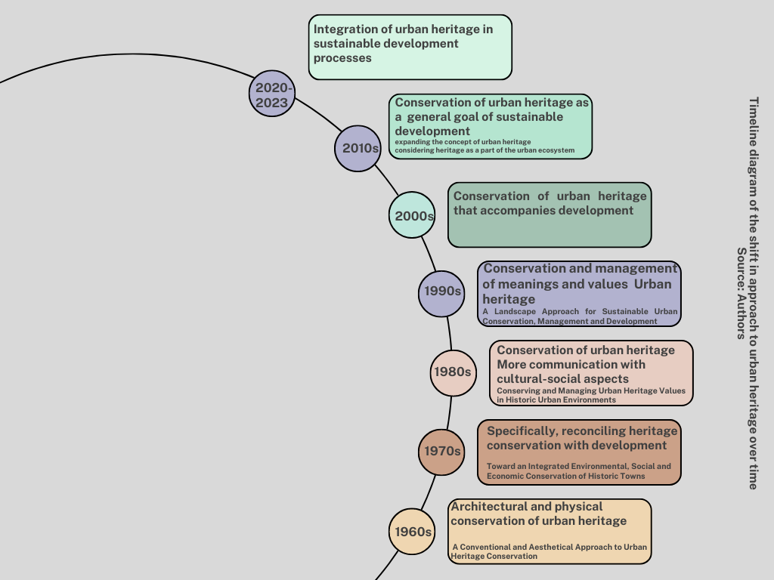paradigm for urban heritage conservation and management that incorporates a sustainable development perspective(UNESCO 2015b). The Hoi An Declaration on Urban Heritage Conservation and Development in Asia, updated in 2017, reflects this new paradigm and explicitly references key international documents on sustainable development(ICOMOS 2017, UNESCO 2017). In 2018, UNESCO pursued the goal of integrating urban heritage conservation into the 2030 Agenda for Sustainable Development (UNESCO 2018), while in 2019, it encouraged member states to actively address issues related to urban heritage conservation and fully utilize the principles and tools developed for implementing the 2011 UNESCO Recommendation on the Historic Urban Landscape (UNESCO 2019). The need for incorporating a sustainable development perspective into the World Heritage Convention processes, balancing global heritage conservation with sustainable development, utilizing innovative and adaptable solutions for aligning global heritage conservation with pervasive and sustainable development needs, and integrating the conservation of Outstanding Universal Value (OUV) of World Heritage properties with sustainable development needs were among the emphasized issues in recent years (ibid.). In recent years, "integrating urban heritage into sustainable development processes and urban planning" has been an important principle for international organizations to protect heritage within the framework of sustainable urban development and reintegrate sustainable development perspectives into the World Heritage Convention processes (WH-SDP) (UNESCO 2021). A human rights-based and democratic approach to aligning heritage with sustainable development has also been a significant principle highlighted by ICOMOS in 2020 (ICOMOS 2020).

1. **Integrity is a key concept in urban heritage.**

The Oxford Dictionary defines "integrity" as a two-part meaning: “the quality of being honest and having strong moral principles” and “the state of being whole and not divided” (Oxford 2023). The following will examine the definition and concept of integrity from the perspective of theorists and relevant documents.

**-1-3 Revisiting and exploring the concept of integrity from the perspective of theorists**

The "conservation principle" of distinguishing between old and new architecture was derived from Ruskin's "principle of honesty" (Ruskin 1890, Khalaf 2016a), therefore, integrity is understood as honesty. According to Herbert Stovel (2008), integrity is a qualifying condition for heritage properties. He associates integrity with the completeness and intactness of the property, proposing that it should be viewed as the object's ability to convey its significance, which is more a matter of communication than a physical reality (Stovel 2007) .Another definition of integrity, as proposed by the International Union for Conservation of Nature and Natural Resources (IUCN), which emphasizes the importance of natural sites having adequate size to preserve most, if not all, of the essential elements related to significance and continuity(Rössler 2008). The HUL approach prioritizes the conservation of the integrity and continuity of urban heritage attributes over the protection of their authenticity(Bandarin and Van Oers 2012, Khalaf 2020), therefore, the definition of integrity is highly significant in relation to the specific definition of urban heritage values. In literary theory, integrity is redefined as a criterion for measuring the status of conserving heritage properties(Zancheti, Loretto et al. 2015), then, integrity is defined as honesty (Kalman 2014) and refers to the continuity in interpreting the concept of the city (Zancheti, Loretto et al. 2015), which includes the continuity of cultural significance, encompassing both tangible and intangible elements (Wang, Huang et al. 2015).The evolving theory of conservation incorporates the concept of integrity within a dynamic context, where changes to the material or physical attributes of urban heritage do not necessarily have a negative impact on the continuity of its cultural significance. Heritage cannot be defined as a mere object, site, building, or any other physical entity. Although these things may hold significance, they alone cannot represent heritage.

|  |  |  |  |
| --- | --- | --- | --- |
| **A theoretical overview of the concept of integrity in heritage** | **Key component** | **Date** | **Theorists** |
| Integrity means honesty, Ruskin's "principle of honesty," the “principle of conservation” , the distinction between old and new architecture | honesty/ conservation | 1890 | Ruskin, Khalaf 2016 a |
| Integrity is a qualifying condition for heritage properties. He associates integrity with the completeness and intactness of the property | - condition for heritage properties  -the ompleteness and intactness of the property | 2007 | Herbert Stovel |
| emphasizes the importance of natural sites having adequate size to preserve most, if not all, of the essential elements related to significance and continuity | significance and continuity | 2008 | Rossler |
| the conservation of the integrity and continuity of urban heritage attributes over the protection of their authenticity | continuity of urban heritage properties | 2012 | Bandarin and van ders |
| integrity is redefined as a criterion for measuring the status of conserving heritage properties | conserving heritage properties | 2013 | Zancheti |
| integrity is defined as honesty | honesty | 2014 | Kalman |
| -integrity refers to the continuity in interpreting the concept of the city  - Variations in conservation theory tend to place the idea of ​​integrity in a dynamic context where the continuity of cultural significance is not necessarily affected by specific changes in material/physical characteristics. | continuity and dynamism | 2015 | Zancheti |
| includes the continuity of cultural significance, encompassing both tangible and intangible elements | tangible and intangible elements | 2015 | Sam Huang & Kyoungjin Kim ‏ |
| Heritage is an evolving and dynamic process, in which elements and values may or may not remain the same, depending on the current necessities. This is a crucial point to consider, as it suggests that the attributes stated in the Operational Guidelines should be associated with continuity | Continuity and adaptive change | 2020 | Khalaf |
| Integrity may be understood as the ability of an asset to convey and maintain its significance, thereby rendering the concept of authenticity redundant | convey and maintain its significance | 2021 | Khalaf |
| Integrity can be understood as the ability of a property to both convey and secure/sustain its significance, rendering authenticity redundant | convey and secure/sustain its significance | 2021 | Khalaf |
| Treating World Heritage properties as evolving processes that embrace continuity and compatible change can help achieve SDGs. Sustainable Development Policy, known as the Policy for the Integration of a Sustainable Development Perspective into the Processes of the World Heritage Convention | -Dynamic nature  -Future-oriented approach to cultural heritage | 2021 | Khalaf |
| The integrity result is the key reference for evaluating and monitoring the conservation status of an asset over time | continuity | 2021 | Khalaf  Taken from UNESCO 2019 |
| Authenticity and integrity should include change as a constant factor, and for the management of historical cities, a third factor - sustainability - should be added.  To establish the authenticity and integrity of a historical city in social activities and cultural characteristics formed in historical environments; This connection takes place through the coherence between physical, social and cultural contexts. ​ | Change and sustainability  Social activities and cultural characteristics | 2022 | Jigyasu & Imon. |

The physical aspect of heritage is not the complete picture. Heritage is, in fact, a cultural process that involves change rather than cultural stagnancy. This process entails the rewriting and redefinition of values to meet the present needs(Smith 2006). Therefore, heritage is an evolving and dynamic process, in which elements and values may or may not remain the same, depending on the current necessities. This is a crucial point to consider, as it suggests that the attributes stated in the Operational Guidelines should be associated with continuity (and change), rather than authenticity, if we embrace the idea of heritage as a process(Khalaf 2021). It is important to note that the World Heritage concept of authenticity originated from the American notion of integrity recommended by Connally in 1976 and defined as "the ability of a property to convey its 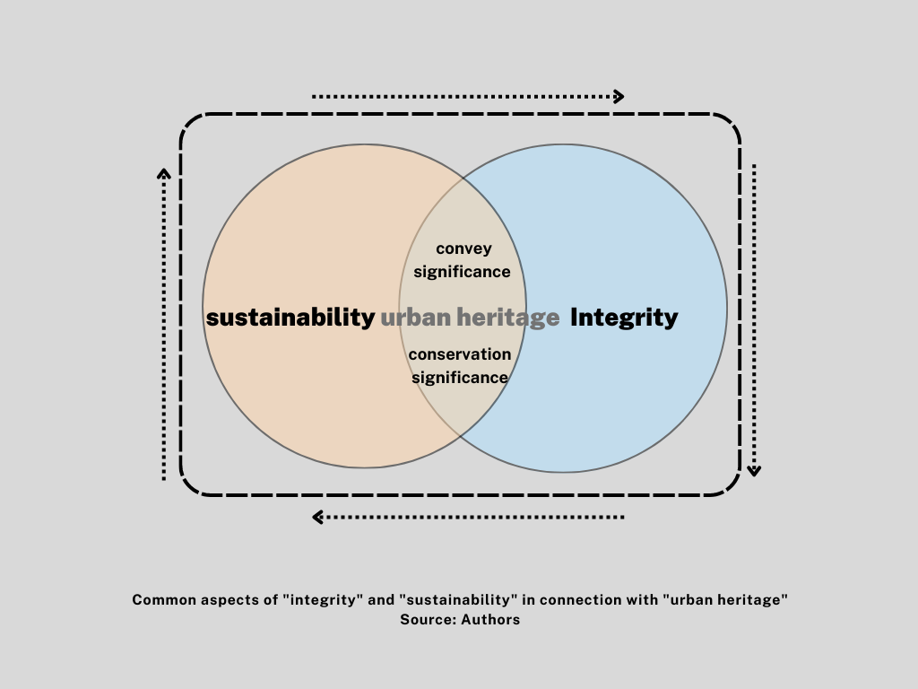significance" according to Herb Stovel(UNESCO 1976). When integrity was added as a requirement in the Operational Guidelines in 2005 for the nomination of cultural properties for inscription on the World Heritage List, Stovel suggested that "authenticity may be understood as the ability of a property to convey its significance over time, and integrity understood as the ability of a property to secure or sustain its significance over time"(Stovel 2008).

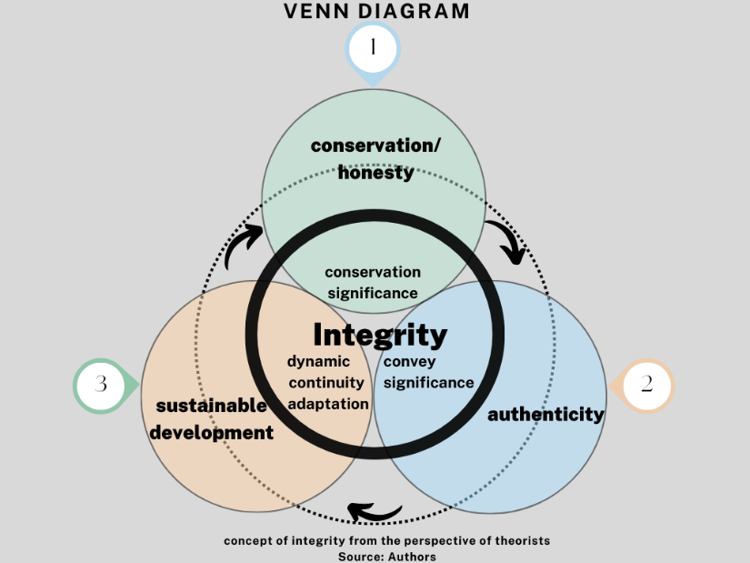This suggests that the initial American definition of integrity became the definition of authenticity, while integrity was given a new definition. However, it can be argued that if a property is able to secure or sustain its significance, it is logically able to convey it in the first place. Therefore, integrity can be understood as the ability of a property to both convey and secure/sustain its significance, rendering authenticity redundant(Khalaf 2021). In fact, the word "convey" appears in paragraphs 88(b) and 89 about integrity in the Operational Guidelines(UNESCO 2019). Although Stovel defended authenticity, other experts questioned its validity. Michel Parent, ICOMOS Vice President and Rapporteur of the World Heritage Committee in 1979, had already noted that authenticity judgments are relative because various factors can influence the interpretation of authenticity(Parent 1979). Additionally, Léon Pressouyre, ICOMOS advisor in the 1980s, objected to the use of the term "authenticity" in a meeting of experts, criticizing the World Heritage Committee's inconsistent interpretation of what he called a "European criterion of authenticity"(Cameron 2019). These criticisms show that not all experts agreed with Stovel that authenticity is a key factor for the successful implementation of the Convention, due to its inconsistent interpretation. “Integrity” can be understood as the ability of a property to both convey and secure/sustain its significance through continuity and compatibility(Khalaf 2021), and can be considered dynamic(Zancheti, Loretto et al. 2015). Treating World Heritage properties as evolving processes that embrace continuity and compatible change can therefore help achieve SDGs. Sustainable Development Policy, known as the Policy for the Integration of a Sustainable Development Perspective into the Processes of the World Heritage Convention (UNESCO 2015b).

Therefore, on the one hand, 'integrity' helps to convey and conserve a property's significance, and on the other hand, the concept of sustainability and sustainable development is responsible for ensuring the identification, conservation, presentation, and conveyance of cultural and natural heritage to future generations (UNESCO 1972). As a result, it seems that the concepts of 'integrity' and 'sustainability' in relation to heritage share common and aligned aspects of 'conveying and conserving significance'.

**3-2- Revisiting and exploring the concept of integrity from the perspective of international conventions**

Integrity is a key concept for documenting heritage property (UNESCO 1976) and assessing their conservation status (Zancheti, Loretto et al. 2015). Integrity refers to the health and completeness of a heritage resource (UNESCO 2005, UNESCO 2009), as this definition emphasizes the tangible and visible aspects, integrity often means "the absence of changes from the original state and/or valuable subsequent configurations" (Kalman 2014). A heritage resource can be considered to have integrity when the values attributed to it are not disturbed or endangered (UNESCO 2009). The Washington Charter defines integrity as related to the conservation of the historical and natural properties of a city and all its tangible and intangible aspects (ICOMOS 1987). In the late 1990s, the Nara Conference on the Preservation and Sustainability of Historic Cities stated that integrity covers human activities related to the physical habitat that are related to the coherence of the historic region, integrating its elements and including the overlapping of historic cities. The recognition of the relationship between social and economic development, community welfare, and the conservation of historical and natural properties needs to be revised. Local park services defined integrity in 1995 as the ability to convey the significance of a place. According to this definition, integrity must be based on an understanding of the physical characteristics of a location and the way they relate to the relevant value. The San Antonio Statement used evaluation of changes to measure integrity (ICOMOS 1996). Subsequently, the assessment of development and changes was emphasized alongside the concept of integrity (UNESCO 2005d), the importance of integrity for balancing conservation and development approaches in the Vienna Conference (ibid, 2005), the importance of integrity in new developments (ICOMOS 2008), and the control of development effects (Jerusalem 2006) to develop strategies and policies related to the conservation of urban heritage (UNESCO 2011b). The Valletta Principles introduce the integrity of historic urban areas as equivalent to the coherence of all their tangible and intangible elements (ICOMOS 2011b), with particular emphasis on intangible elements and characteristics beyond visual and physical aspects as part of the conditions of heritage integrity (UNESCO 2012). The concept of " convey of significance" and emphasis on heritage integrity and its dynamic, continuous, and compatible concepts (UNESCO 2019) and integrity for the conservation, promotion, and convey of heritage features over time (UNESCO 2021) are highlighted in UNESCO's operational guidelines in 2019.

|  |  |  |  |
| --- | --- | --- | --- |
| **General description of the issue related to urban integration** | **Key component** | **Date** | **Declaration / Manifesto** |
| A key criterion for documenting heritage property | documenting heritage property | 1976 | UNESCO |
| The Washington Charter defines integrity as related to the conservation of the historical and natural properties of a city and all its tangible and intangible aspects | Integration of historical city with natural and built environment | 1987 | ICOMOS |
| the Nara Conference on the Preservation and Sustainability of Historic Cities stated that integrity covers human activities related to the physical habitat that are related to the coherence of the historic region, integrating its elements and including the overlapping of historic cities.  Understanding the relationship between socio-economic development, community health and historical and natural features should be improved. | Human activities, integration of components, relationship between socio-economic development, community welfare and preservation of historical and natural features | 1994 | ICOMOS (The Nara Document on Authenticity) |
| The San Antonio Statement used evaluation of changes to measure integrity | Evaluation of changes | 1996 | ICOMOS(The Declaration of San Antonio) |
| Integration is defined as a criterion for the integrity and preservation of natural and cultural heritage. It includes all the necessary elements and components to demonstrate outstanding universal value (referring to the untouchable elements). It sufficiently expresses the features and processes that convey outstanding universal value (referring to the general elements). It also indicates to what extent it has been damaged due to development or negligence. | -Integrity and preservation of natural and cultural heritage  -All the necessary elements and components to demonstrate outstanding universal value, and the extent of damage caused by development and change | 2005 | UNESCO |
| The importance of integrity for balancing conservation and development approaches | Balancing conservation and development approaches | 2005 | Vienna Memorandum on World Heritage and Contemporary Architecture |
| Integration should be considered in new developments | new developments | 2006 | The International Declaration of Jerusalem |
| The importance of the concept of "integrity" to determine and develop strategies and policies to control the effects of development | Controlling the effects of development | 2008 | ICOMOS(Quebec Declaration) |
| The importance of integrity in the conservation of urban heritage | conservation of urban heritage | 2011 | UNESCO |
| The principles of Walta focus on the integration of historic urban areas: historic cities express their nature and coherence through all tangible and intangible elements. These elements include urban patterns, appearance, materials, colors, as well as the various functions that a city or urban area has acquired over time; cultural traditions, traditional techniques, sense of place, and anything that helps define the identity of a place. A historic city has all of the above elements, which in most cases will be in various layers. ​ | The coherence of all tangible and intangible elements | 2011 | ICOMOS |
| The terms of cultural heritage integrity should be extended beyond visual aspects and physical texture to include intangible elements | intangible elements | 2012 | ICOMOS |
| Integrity is a measure of wholeness and intactness that neglect and the effects of bad development should be considered | wholeness and intactness | 2015 | UNESCO |
| Integration has been defined as 'wholeness and untouchedness in operational guidelines | wholeness and untouchedness | 2019 | UNESCO |
| The word 'convey' appears important in paragraphs 88b and 89 regarding integrity in operational guidelines | Convey property | 2019 | UNESCO |
| The concept of sustainability is the obligation to ensure the identification, conservation, presentation, and convey of cultural and natural heritage to future generations (UNESCO, 1972: Article 4) The policy of integrating sustainable development perspectives into the processes of the World Heritage Convention (World Heritage and Sustainable Development Policy) (UNESCO, 2019, 2) | Sustainability and convey of importance | 2019&1972 | UNESCO |
| When the concepts of continuity and compatibility are implemented and related to OUV, integrity, conservation, and management, they can become operational, which has previously been and is currently a requirement in operational guidelines | continuity and compatibility | 2019 | UNESCO |
| Managing cultural heritage becomes a process through which the authenticity and integrity of features are preserved or enhanced over time: Dynamic relationships and functions in cultural landscapes, historic cities, or other living features that are essential to their distinct character must also be preserved | -conservation or enhancement of features over time (continuity and compatibility)  - dynamic relationships and properties | 2021 | UNESCO |

From a total review of the relevant documents and also considering the opinions of experts, the concept of integrity is first blended with the tangible features of conservation and honesty, and then combined with the concept of authenticity (conservation of physical value). After that, the evaluation of development and changes is used alongside the concept of integrity, and finally, these concepts of conservation (honesty), authenticity, and development are emphasized again from the beginning and in order, but this time taking into account both tangible and intangible features as the identifier of the concept of integrity.

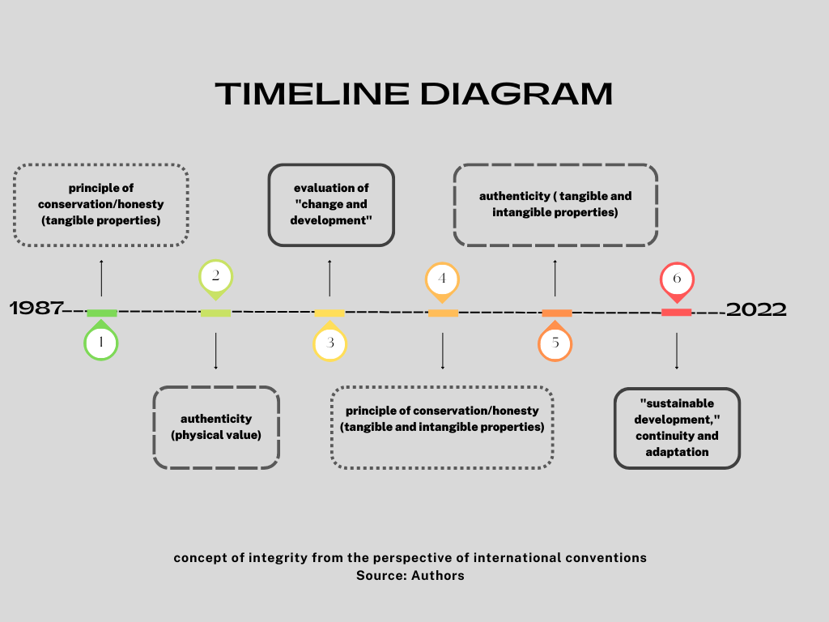

**4-Conclusion:**

The concept of the integrity of urban heritage has evolved over time based on relevant documents, In the first period (1987-2011), this concept was explained through three concepts: "conservation" of tangible properties, the concept of "authenticity" (tangible properties), and finally the evaluation of "change and development", In the second period (2011-2022), the same concepts were revisited, but with consideration for intangible aspects. The concepts of the second period included "conservation" of tangible and intangible properties, "authenticity" (conservation and convey of tangible and intangible properties), and finally, with "sustainable development," continuity and adaptation (continuation of cultural importance) were emphasized (Figure 3). The concept of the integrity of urban heritage from the perspective of theorists also starts with the principle of conservation (principle of honesty), then combines with the concept of “authenticity” and ultimately aligns with the concept of “sustainable development”. The concept of conservation and development of urban heritage has also begun over time from physical and tangible conservation, then highlighting authenticity and value conservation and encompassing tangible and intangible dimensions. In recent years, with the recognition of heritage as a process, its integration into sustainable development processes has been emphasized. Integrity helps to maintain and convey the importance of heritage features over time, while sustainability is responsible for ensuring the identification, conservation, presentation, and convey of heritage to future generations. Therefore, it appears that the concepts of integrity and sustainability are related to urban heritage and have common and consistent aspects of "convey significance “and “ conservation significance". Integrity emphasizes continuity and adaptation in changing the urban fabric, and it is a key concept in the conservation of urban heritage. Hence, the significance of the integrity status in preserving a broad interpretation of the past, present, and future urban fabric and reinterpreting the values of heritage depends on it.

Araoz, G. (2013). "Conservation philosophy and its development: Changing understandings of authenticity and significance." **6**(2): 144-154.

Araoz, G. F. J. A. b. (2008). "World-heritage historic urban landscapes: Defining and protecting authenticity." **39**(2/3): 33-37.

Bandarin, F., et al. (2011). "Why development needs culture." **1**(1): 15-25.

Bandarin, F. and R. Van Oers (2012). The historic urban landscape: managing heritage in an urban century, John Wiley & Sons.

Cameron, C. (2019). "Herb Stovel and authenticity in World Heritage conservation practice." Conversaciones Con Herb Stovel **8**: 95-106.

Cameron, C. and M. Rössler (2016). Many voices, one vision: The early years of the World Heritage Convention, Routledge.

Carley, M. and H. Smith (2013). Urban development and civil society: The role of communities in sustainable cities, Routledge.

Choay*, F. J. E. (2009). "Le patrimoine en questions." (11): 194-222.

Collins, G. R., et al. (2006). Camillo Sitte: the birth of modern city planning, Courier Corporation.

Duxbury, N., et al. (2016). Why must culture be at the heart of sustainable urban development?, United cities and local governments (UCLG).

Felicori, M. J. U. A. P. L. C. N. V. P. L. S. U. B. I. M. (2014). "La cultura sinonimo di sviluppo urbano." 165-172.

Giovannoni, G. J. V. M. (1931). "Vecchie città ed edilizia nuova." **48**(995): 57.

Harvey, D. C. and J. Perry (2015). Heritage and climate change: The future is not the past. The Future of Heritage as Climates Change, Routledge**:** 23-42.

Holtorf, C. J. I. J. o. C. P. (2020). "Conservation and Heritage as Creative Processes of future-making." **27**(2): 277-290.

ICOMOS (1987). "First Brazilian Seminar about the Preservation and Revitalization of Historic Centres . [Online]. Itaipava: ICOMOS. Available from: <http://www.icomos.org/en/charters-and-texts/179-articles-enfrancais/ressources/charters-and-standards/194-first-brazilian-seminar-aboutthe-preservation-and-revitalization-of-historic-centers-itaipava> [Accessed

06/03/2016]. ."

ICOMOS (1996). ""The Declaration of San Antonio. <https://www.icomos.org/en/resources/charters-and-texts/179-articles-en-francais/ressources/charters-and-standards/188-the-declaration-of-san-antonio>."."

ICOMOS (2008). ". Quebec Declaration on the Preservation of the Spirit of Place. [Online]. Available from: <http://whc.unesco.org/uploads/activities/documents/activity-646-> 2.pdf [Accessed 22/06/2017]. ."

ICOMOS (2011b). "The Valletta Principles for the Safeguarding and Management of Historic Cities, Towns and Urban Areas. Adopted by the 17th ICOMOS General Assembly on 28 November 2011. Paris: ICOMOS. ."

ICOMOS (2017). "ICOMOS Action Plan:Cultural Heritage and Localizing the UNSustainable Development Goals (SDGs),[Online]. Available from: <https://www.icomos.org/images/DOCUMENTS/Secretariat/2017/ICOMOS_Action_Plan_Cult_Heritage_and_Localizing_SDGs_20170721.pdf>."

ICOMOS (2020). "Resolution 20GA/19 - People-Centred Approaches to Cultural Heritage.Report of the Resolutions Committee to the 20th ICOMOS General Assembly GA2020/12 –

6, 18-19.".

ICOMOS, F. (2014). The Florence declaration on heritage and landscape as human values. 18th General Assembly and Scientific Symposium.

Jerusalem, D. o. (2006). ""Declaration of Jerusalem,: Jerusalem Statement on the Workshop "New approaches to urban conservation", 4-6th June 2006 (2006). Available from: <http://whc.unesco.org/document/115810>."."

Kalman, H. (2014). "Heritage Planning: Principles and Process. London: Routledge."

Khalaf, R. W. (2016a). "Distinguishing new architecture from old." The Historic Environment: Policy & Practice **7**(4): 321-339.

Khalaf, R. W. J. A.-I. I. J. o. A. R. (2015). "The reconciliation of heritage conservation and development: the success of criteria in guiding the design and assessment of contemporary interventions in historic places." **9**(1): 77.

Khalaf, R. W. J. H. (2020). "The implementation of the UNESCO World Heritage Convention: Continuity and compatibility as qualifying conditions of integrity." **3**(2): 384-401.

Khalaf, R. W. J. H. (2021). "World Heritage on the move: Abandoning the assessment of authenticity to meet the challenges of the twenty-first century." **4**(1): 371-386.

Landorf, C. J. I. J. o. H. S. (2009). "A framework for sustainable heritage management: A study of UK industrial heritage sites." **15**(6): 494-510.

Nations, U. (2011). "2nd UN Resolution on Culture and Development. [Online]. Adopted by the 66th Session of the UN General Assembly. Available from: <http://www.unesco.org/new/fileadmin/MULTIMEDIA/HQ/CLT/pdf/6_> UNGA_Resolution_A_RES_66_208_EN.pdf [Accessed 18/03/2016]. ."

Nations, U. (2014). "4th UN Resolution on Culture and Development. [Online]. Adopted by the 69th Session of the UN General Assembly. Available from: <https://en.unesco.org/sites/default/files/0-unga_resolution_a_res_69_230_en.pdf> [Accessed 18/03/2016].".

Orbasli, A. (2000). Tourists in historic towns: Urban conservation and heritage management, Taylor & Francis.

Oxford (2023). "Oxford Learner’s Dictionaries, “Integrity,” [online]."

Parent, M. (1979). Comparative Study of Nominations and Criteria for World Cultural Heritage, Principles and Criteria for Inclusion of Properties on the World Heritage List, CC-79/CONF. 003/11.

Pereira Roders, A., et al. (2014). "Wedding cultural heritage and sustainable development: three years after." **4**(1): 2-15.

Pereira Roders, A. and L. J. C. d. o. z. n. d. t. v. v. b. g. e. Veldpaus (2013). "Tolerance for change in the built environment: what are the limits?": 17-22.

Rössler, M. J. A. b. (2008). "Applying authenticity to cultural landscapes." **39**(2-3).

Rudolff, B. and K. J. A. c. t. h. s. Buckley (2015). "World Heritage: alternative futures." 522-540.

Ruskin, J. (1890). "The Seven Lamps of Architecture. Sunnyside, WA: George Allen.".

Rypkema, D. D. J. G. U. D. (2005). "Globalization, Urban Heritage and the 21st Century Economy." **1**(1): 1-8.

Sitte, C. and D. Wieczorek (1981). L'arte di costruire le città. L'urbanistica secondo i suoi fondamenti artistici, Editoriale Jaca Book.

Smith, L. (2006). Uses of heritage, Routledge.

Stovel, H. (2007). "Effective use of authenticity and integrity as world heritage qualifying conditions." City & time **2**(3): 21-36.

Stovel, H. (2008). "Origins and influence of the Nara document on authenticity." APT bulletin **39**(2/3): 9-17.

TheGettyConservationInstitute (2010). "Historic urban environmentconservation challenges and priorities for action Meeting Reoport. [Online].Los Angeles: The Getty Conservation Institute. Availablefrom: <http://www.getty.edu/conservation/publications_resources/pdf_publications/historic_urban_environment.html> [Accessed 21/06/2017].".

Turner, M., et al. (2012). "Revealing the Level of Tension between Cultural Heritage and Development in World Heritage Cities (Oszacowanie zakresu konfliktów występujących pomiędzy ochroną dziedzictwa kulturowego a rozwojem w miastach z Listy Światowego Dziedzictwa)." **7**(2): 23-31.

UNESCO (1945). "UNESCO (1945). UNESCO Constitution. [Online]. Paris: UNESCO. Available

from: <http://www.unesco.org/education/pdf/UNESCO_E.PDF> [Accessed

23/11/2017].".

UNESCO (1972). "Convention Concerning the Protection of the World Cultural and Natural Heritage. [Online]. 17th Session of the General Conference,Paris. Paris: UNESCO. Available from: <http://whc.unesco.org/en/conventiontext/> [Accessed 06/03/2016]. ."

UNESCO (1976). "Recommendation Concerning the Safeguarding and Contemporary Role of Historic Areas. [Online]. 19th Session of the General Conference, Nairobi. Paris: UNESCO. Available from: <http://portal.unesco.org/en/ev.phpURL_ID=13133&URL_DO=DO_TOPIC&URL_SECTION=201.html> [Accessed 06/03/2016]. ."

UNESCO (2002). "Budapest Declaration on World Heritage. [Online]. 26th Session of World Heritage Committee, Budapest. Paris: UNESCO. Available from: [http://whc.unesco.org/en/decisions/1217/[Accessed](http://whc.unesco.org/en/decisions/1217/%5bAccessed) 15/11/2015]. ."

UNESCO (2005). "Declaration on the Conservation of Historic Urban Landscapes (Decision 29 COM 5D). [Online]. 15th General Assembly of States Parties to the Convention Concerning the Protection of the World Cultural and Natural Heritage, Paris, 10-11 October 2005. Paris: UNESCO. Available from: <http://whc.unesco.org/uploads/activities/documents/activity48-1.pdf> [Accessed 11/01/2016].".

UNESCO (2005d). "Vienna Memorandum on World Heritage and Contemporary Architecture - Managing the Historic Urban Landscape. [Online]. Paris:UNESCO. Available from: <http://whc.unesco.org/archive/2005/whc05-15gainf7e.pdf> [Accessed 22/06/2017]. ."

UNESCO (2009). " "33rd session of the World Heritage Committee Sevilla, Spain 22-30 June 2009."."

UNESCO (2011b). "Recommendation on the Historic Urban Landscape. [Online]. Paris: UNESCO. Available from: <http://portal.unesco.org/en/ev.phpURL_ID=48857&URL_DO=DO_TOPIC&URL_SECTION=201.html> [Accessed 22/10/2015].".

UNESCO (2011b). "Recommendation on the Historic Urban Landscape. [Online].Paris: UNESCO. Available from: <http://portal.unesco.org/en/ev.phpURL_ID=48857&URL_DO=DO_TOPIC&URL_SECTION=201.html> [Accessed 22/10/2015]. ."

UNESCO (2012). " World Heritage Centre. Report of the International Expert Meeting on Integrity for Cultural Heritage. Al Ain,United Arab Emirates, 12-14 March 2012. Paris: UNESCO World Heritage Centre, 2012. [online]. Accessed April2, 2021. <https://whc.unesco.org/uploads/events/documents/event-833-8.pdf>."

UNESCO (2017). "CONVENTION CONCERNING THE PROTECTION OF THE WORLD CULTURAL AND NATURAL HERITAGE [Online]. Paris: UNESCO. Available from: <https://whc.unesco.org/document/157750>."

UNESCO (2018). "WORLD HERITAGE COMMITTEE Forty-second session Manama, Bahrain 24 June – 4 July 2018: Available from:<https://whc.unesco.org/archive/2018/whc18-42com-18-en.pdf>."

UNESCO (2019). " World Heritage Centre. “Operational Guidelines for the Implementation of the World Heritage

Convention.” WHC.19/01. ."

UNESCO (2019). "WORLD HERITAGE COMMITTEE Forty-third session Baku, Republic of Azerbaijan 30 June – 10 July 2019. Available from: <https://whc.unesco.org/archive/2019/whc19-43com-18-en.pdf>."

UNESCO (2021). "WORLD HERITAGE COMMITTEE Extended forty-fourth session Fuzhou (China) / Online meeting, Available from: <https://whc.unesco.org/archive/2021/whc-21-44com-18-en.pdf>

16 - 31July 2021 ".

UNESCO, W. (2015b). Policy document for the integration of a sustainable development perspective into the processes of the world heritage convention. Paris: General Assembly of States Parties to the World Heritage Convention at Its 20th Session.

UnitedNations (2016). "New Urban Agenda. Quito Declaration on Sustainable Cities and Human Settlements for All. [Online]. United Nations Conference on Housing and Sustainable Urban Development (Habitat III) Quito, 17–20 October 2016. Available from: <https://habitat3.org/the-new-urbanagenda> [Accessed 30/11/2016]. ."

Van Oers, R., et al. (2014). "Aligning agendas for sustainable development in the post 2015 world." **4**(2): 122-132.

Van Oers, R. J. C. b. I., et al. (2006). "Preventing the goose with the golden eggs from catching bird flu–UNESCO’s efforts in safeguarding the historic urban landscape." **2**.

Veldpaus, L., et al. (2013). "Urban heritage: putting the past into the future." **4**(1): 3-18.

Veldpaus, L. and A. P. J. C. o. t. Roders (2014). "Learning from a legacy: Venice to Valletta." **4**(2): 244-263.

Wang, Y., et al. (2015). "Toward a framework integrating authenticity and integrity in heritage tourism." **23**(10): 1468-1481.

Warren, J. J. C. N. B. i. H. S. (1998). "The historic context: principles and philosophies." 8-17.

Whitehand, J., et al. (2007). "Conserving urban landscape heritage: A geographical approach." **2**(5): 6948-6953.

Zancheti, S. M., et al. (2015). "Dynamic integrity: a concept to historic urban landscape." **5**(1): 82-94.

1. Phd student, University of Tehran, This paper is derived from the doctoral dissertation of the first author, titled "conservation and Development of Urban Heritage."
2. Professor, University of Tehran, Department of Architecture

   Associate Professor, University of Tehran, Department of Architecture
3.