**The Influence of Tall Buildings on Wind flow and Pollutant Dispersion in Urban Areas**

**Shima nouri 1, Mehrdad Karimimoshaver 2**\***, Banu Özkazanç 3**

*1 Department of Architecture, Faculty of Art and Architecture, Bu-Ali Sina University, Hamedan, Iran (r.khalvandi@art.basu.ac.ir)*

*2 Department of Architecture, Faculty of Art and Architecture, Bu-Ali Sina University, Hamedan, Iran (mkmoshaver@basu.ac.ir)*

*3 Department of Architecture, Faculty of Fine Arts, Design and Architecture, Istinye University, Istanbul, Turkey(banu.ozkazanc@istinye.edu.tr)*

**ABSTRACT**

Air pollution in many cities is influenced by wind speed and direction, which in turn are affected by urban morphology. Air quality is closely related to urban fabric, which refers to the physical layout and design of urban areas. Factors such as building density, green spaces, transportation infrastructure, land use, and the shape and size of buildings significantly influence air quality. These features affect the concentration of pollutants in the environment by shaping wind flow and local dispersion patterns. This study examines how the height of buildings influences air pollution. In recent years, the strong tendency towards the construction of tall buildings has had adverse effects on cities. The rise in tall buildings, along with their impact on wind flows and the spread of pollutants, presents a significant challenge for urban planners. Today, the risks of air pollution are increasing, and therefore methods of monitoring how pollutants are released are of particular importance. This study evaluates the impact of tall buildings on pollutant dispersion and aims to provide a program tailored to the data obtained to control and improve the current situation. This research was conducted on two groups of buildings in the southwestern part of Tehran (District 18) using computational fluid dynamics (CFD) simulation and geographic information systems (GIS). The results of the study show that as the wind speed in a path increases, the concentration of pollutants decreases. Additionally, increasing the height of a building in a single state increases the wind speed on two sides and decreases the wind speed on the other two sides. In general, based on the assumption of pollutant dilution with increasing wind speed, building height plays an effective role in pollution dispersion.

*Keywords*: Pollutant concentration, pollutant dispersion, building height, wind flow, Tehran

**INTRODUCTION[1]**

In recent years, the rapid construction of tall buildings has raised concerns about their adverse impacts on urban environments. Urban ventilation is significantly influenced by wind speed and direction, which in turn are affected by urban morphology (Ramponi et al., 2015; Aristodemou et al., 2020; Lim et al., 2022; li et al., 2023; Ming et al., 2017; Sev, 2005; Shirzadi & Tominaga, 2023 ; Poon, 2005; Burnett, 2005; Ayres, 2005). The urban fabric, encompassing building geometry and morphology, vegetation cover, and building shape and size, plays a crucial role in air quality (Aristodemo et al., 2020). These features influence pollutant concentrations by shaping wind flow and local dispersion patterns (Carpentieri & Robins, 2015). According to the World Health Organization (WHO), air pollution accounts for an estimated 4.2 million premature deaths globally each year (Aristodemou et al., 2020). Studies have established a link between respiratory and cardiovascular diseases and airborne particulate matter, with fine particles less than 0.1 micrometers in diameter being a primary health concern even at low concentrations (Ruuskanen et al., 2001).

Cancer is another global health concern, with over 110 to 140 deaths per million people annually in Europe attributed to cancer. In Iran, cancer accounts for 15% of all annual deaths (Seifi et al., 2019). Over the past seven decades, extensive research has investigated the impact of urban fabric on pollutant dispersion, employing both experimental (measurement) and computational (simulation) approaches (Carpentier & Robins, 2015). Prior to the advent of measurement and simulation techniques, limited information was available on the relationship between pollutant dispersion and tall buildings. It was generally acknowledged that urbanization can impede natural ventilation, as buildings obstruct breezes originating from natural features such as oceans, seas, lakes, forests, farms, and mountains (AL-Kodmany, 2018).

Recently, methods such as computational fluid dynamics (CFD), which rely on software simulations, as well as experimental and semi-experimental techniques that gather meteorological data over designated timeframes, including wind tunnel tests, have been used to investigate urban airflow and the dispersion of pollutants (Hang et al., 2012). Each of these methods may be more advantageous than the others depending on the context. The choice of methods should consider limitations such as calculation time, measurement accuracy, and project budget. For instance, while wind tunnel and field studies are effective in predicting column dilutions, they are primarily hindered by time and financial constraints (Chavez et al., 2011). Similarly, although employing a network-based method like multi-zone models may enhance calculation speed compared to CFD methodes, it can compromise calculation accuracy (Wang and Chen, 2015). Challenges associated with experimental methods include replicating experiments under identical conditions (Lateb et al, 2015), while wind tunnel limitations include the inability to conduct multiple experiments at different locations and provide a comprehensive picture of the flow field (Ramponi et al., 2015).

One of the earliest studies that combined experimental (wind tunnel) and numerical data to investigate the impact of tall buildings on air pollution dispersion was conducted by Carpentier and Robins (2015). They examined two groups of buildings with different heights and found that height was the main factor in shaping the different flow patterns.

Aristodemou et al. (2018) conducted a study to evaluate air quality in an urban area and identify "dead zones" (areas with minimal airflow) that are influenced by the height of buildings in the surrounding area. Tasiko et al. (2009) demonstrated an inverse relationship between wind speed and air pollution due to the dilution of gases in the ambient air. In contrast, Kubilay et al. (2017) found that there is generally no clear relationship between air exchange rate and overall pollutant exchange rate.

Dilution or dispersion is defined as the reduction in the ratio of pollutant concentration near the source to the concentration measured at another point (Chavez et al., 2011). Ramponi et al. (2015) stated that air quality in an area can be improved by wind flow as wind can dilute and remove pollutants.

Evaluation of the impact of urban morphology, including building height and density, on pollutant dispersion shows that the urban fabric plays a significant role in the dispersion of a pollutant because these factors are related to the amount of wind entering the area and consequently the pollutant concentration at pedestrian level (Yuan et al., 2014).

Experimental studies conducted by Makhelouf (2012) in the La Défense district of Paris demonstrate that the impact of height on pollution distribution encompasses the concept of space between buildings. Building height alone does not have a significant impact on the phenomenon of pollutant dispersion; the most important factor is the arrangement or morphology of the area.

Eeftens et al. (2013) found that on average, in the long term, traffic-related pollution is trapped by surrounding buildings and generally accumulates in areas where the urban fabric prevents wind flow and reduces vertical air exchange.

Yang et al. (2019) investigated the results of their studies in two parts related to building density and height, and the different results for both groups emphasize the need for a comprehensive analysis that includes two essential parameters: average height and building density.

Recently, most studies concerning changes in wind flow patterns in Tehran have been conducted using environmental data and CFD simulations that focus on a single high-rise building. This research, which employs CFD simulations, is positioned close to two weather stations in District 18 of Tehran, as it is more responsive to key meteorological data. In contrast to earlier studies, it investigates a cluster of interconnected buildings instead of just one, to explore the impact of building height on urban pollution dispersion.

Despite the studies conducted to date, there is still a lack of direct understanding of how pollutants disperse in a real-world setting in interaction with tall buildings. Further parametric studies are needed in this regard. In this context, the main question of this research is in what way does the variation in the height of buildings within a group affects the dispersion of air pollutants in an urban area of Tehran. This research is conducted with the aim of Understanding the importance of urban planning, which involves the careful arrangement of structures and deliberate decisions regarding building heights to reduce the concentration and spread of pollutants. This approach can lead to cleaner urban air, ultimately benefiting both the ecosystem and the well-being of city residents.

**MATERIAL AND METHODS**

The methodology of this research is based on Computational Fluid Dynamics (CFD) simulation and GIS-based field data with a spatiotemporal average.

According to the Tehran City Statistical Yearbook of 2019, and the number of days of unhealthy air, PM2.5 suspended particles which have the highest impact factor, were selected as the representative pollutant in the study area (Tehran City Statistical Yearbook, 2019). Real-time weather information for the 22 districts of Tehran was obtained from the Tehran Municipality Air Quality Control Company's weather stations (URL 1). There are three specific winds in Tehran: the north wind, the east wind, and the west wind, which represents the general wind directions (dominant wind). The average wind speed has been measured between 10 and 29 km/h at various times and on different days. According to information from the Tehran City Monitoring System, May and June in the first half of 2019 had the highest unhealthy and very unhealthy pollution indices. Additionally, quality statistics from 2019 to 2021 indicate that the greatest fluctuations in urban air quality, in terms of PM2.5 particle concentration, occurred in Tehran between February and May. Therefore, to draw more accurate conclusions, the data reviewed has been selected to include the months with the highest air quality differences during the first five months of the year. (Tehran City Statistical Yearbook, 2019-2021). Two sites were selected in District 18 (Figure 1), both located next to one of the two weather stations. The first site is located in the Qaem area (Real-time AQI , 2020, Ghaem) and the second site is located in the ShadAbad area of Tehran (Real-time AQI , 2020, ShadAbad).

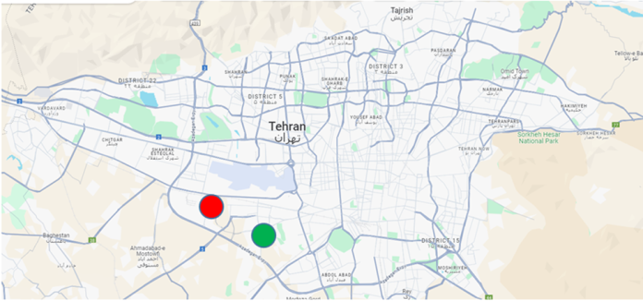

Figure 1. Location of the tested area, District 18 of Tehran (Green color: Location of the first site, Ghaem area, and red color: the second site, ShadAbad in Tehran)

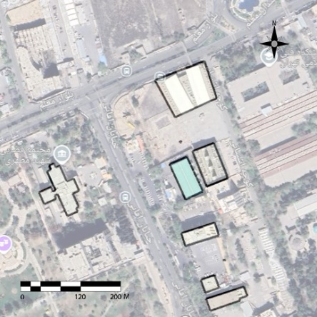

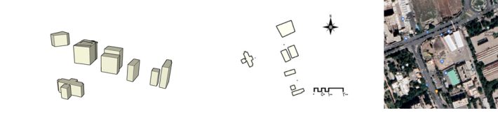

Figure 2.The site and form of the selected buildings in Ghaem area, Tehran (the first site)

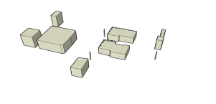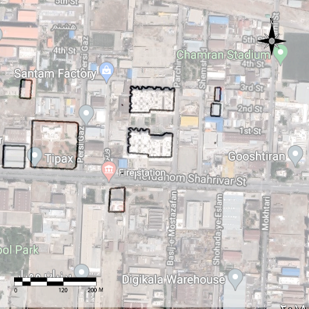

Figure 3.The site and form of the selected buildings in ShadAbad area, Tehran (the second site)

The research methodology is divided into three main phases. Initially, daily pollution indices are obtained from the Tehran city database for the first five months of 2021 using the Geographic Information System (GIS). Subsequently, a pollution distribution map is created for these areas through the interpolation method and ArcGIS software. This statistical technique estimates unknown data based on known values, allowing for the determination of pollutant concentration at any specific location. The map prioritizes the most accurate relevant data, focusing on areas closest to known points, such as meteorological stations.

In the second phase, both building groups are evaluated using wind speed simulations based on Computational Fluid Dynamics (CFD) in Autodesk software. The wind speed data at various heights is then compared with the pollution concentration map. To validate the comparison between pollutant levels and wind speed, several random points are selected from both the pollution dispersion map and the simulated map. A numerical average is calculated for these points, and the results are compared across all three datasets in each area. Once a consistent trend is observed among the results from all three groups, the next phase proceeds with a more detailed comparison of randomly selected points from both maps.

The final phase involves adjusting the height of one building in each group is changed in 15 steps of 3 meters each time and reanalyzing the wind speed. The data on wind speed variations around each building is categorized into four sections for analysis. Ultimately, the study examines the correlation between pollutant concentration and altitude. For this research, Tehran's meteorological data indicated an average wind speed of 20 m/s and a prevailing wind direction from west to east, which were used in the initial simulations. To reduce errors related to variable weather conditions,the wind speed was varied randomly between 15 and 25 m/s, with a 15-degree adjustment north and south during the simulation. After confirming the results, a sensitivity analysis was conducted. Other site features, aside from the buildings, were excluded from this modeling to emphasize broader trends. Despite the high accuracy of the comparative results across multiple points, it is important to note that the wind speed values obtained from the simulated maps are not actual measurements.

**RESULTS**

In examining the relationship between pollution concentration and dispersion, the study compared the mean values from both the pollutant dispersion map and the CFD-based simulated maps across areas influenced by wind direction. These areas included the region behind the building (downwind area), the enclosed space between two buildings, and the area in front of the building. Figure 4 illustrates the pollutant concentration distribution map generated by the GIS system for the first five months of the year. Figures 5 and 6 depict the simulated wind speed at a height of 2 meters above ground level.

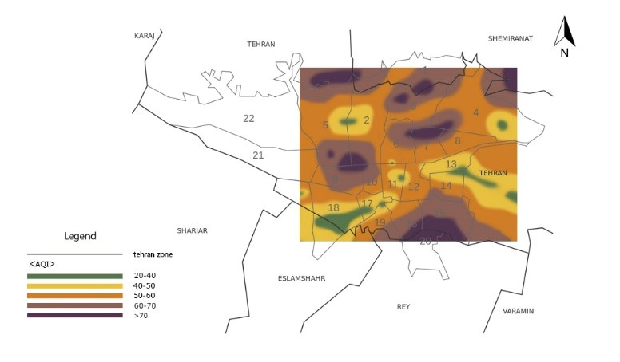

Figure 4. PM2.5 particle dispersion map in the months of January to May in 2021

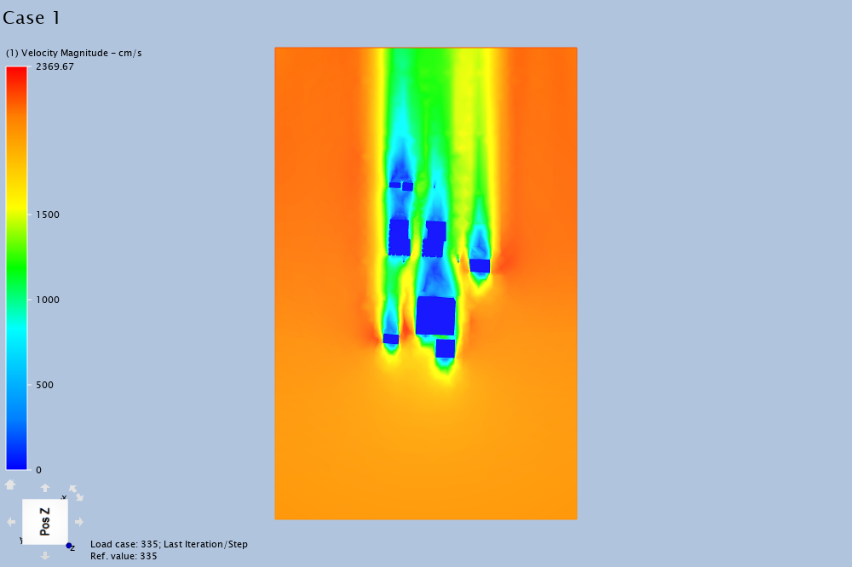

Figure 5. Simulation of wind speed at the second site, ShadAbad, Tehran

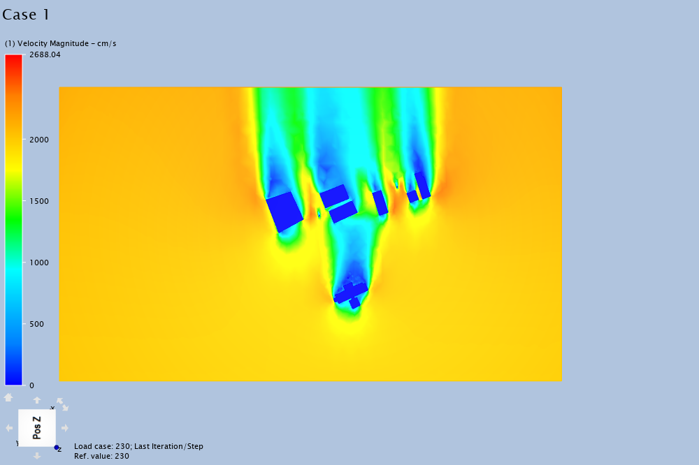

Figure 6. Simulation of wind speed at the first site, Ghaem, Tehran

The comparisons revealed that as the wind enters the site, the wind speed behind an obstacle (the building) initially decreases due to the obstacle's presence and then gradually increases, while there is a decrease in pollutant concentration in that area. In the enclosed space between the two buildings, the wind speed increases in the direction of the wind and then decreases after passing through this area. Throughout this section, pollutant concentration consistently decreases. In front of the building, where conditions are more complex than in other areas, the wind speed first decreases slightly, then increases, and decreases again. The pollutant concentration in this area decreases initially and then increases. Notably, in the open space at the end of the site, where there are no surrounding obstacles, the wind speed shows an increasing trend while pollutant concentration tends to decrease. Overall, as wind speed increases in the prevailing wind direction, there is a reduction in dispersion or pollutant concentration. In areas where air currents are confined, pollutant concentration remains stable or gradually increases. The results also indicated that in areas where a building obstructs the wind, acting as a reflective surface, the wind flow is redirected, resulting in increased pollutant concentration in those areas. The results comparing PM2.5 dispersion and wind speed are presented in Tables 1 and 2.

**Table 1**. Comparison of pollutant dispersion and wind speed in Ghaem area, Tehran (wind speed and PM2.5 dispersion are calculated based on the average of five measurements)

|  |  |  |  |  |  |  |  |  |  |  |
| --- | --- | --- | --- | --- | --- | --- | --- | --- | --- | --- |
|  | | *The region behind the building*  *(Assumed origin: rear side of the building)* | | *The area in front of the building*  *(Assumed origin: front side of the building)* | | *The enclosed space between two buildings*  *(Assumed origin: frontmost side of the buildings)* | | *The open space at the end of the site*  *(Assumed origin: endmost side of the buildings in the area)* | |  |
| *Horizontal distance of selected points from the assumed origin (m)* | | *PM2.5 dispersion*  *(AQI)* | *Wind speed*  *( m/s)* | *PM2.5 dispersion*  *(AQI)* | *Wind speed*  *( m/s)* | *PM2.5 dispersion*  *(AQI)* | *Wind speed*  *( m/s)* | *PM2.5 dispersion*  *(AQI)* | *Wind speed*  *( m/s)* |  |
| *5* | | *36.69* | *270* | *34.21* | *1046* | *36.25* | *716* | *33.27* | *562* |  |
| *10* | | *36.21* | *214* | *33.99* | *1027* | *36.14* | *796* | *33.1* | *574* |  |
| *15* | | *35.58* | *180* | *32.85* | *998* | *35.98* | *806* | *32.88* | *601* |  |
| *20* | | *34.41* | *185* | *31.56* | *819* | *35.66* | *819* | *32.45* | *658* |  |
| *25* | *31.54* | *224* | *30.98* | *920* | *35.72* | *865* | *31.96* | *659* |  |
| *30* | *30.33* | *325* | *31.22* | *1022* | *35.62* | *912* | *31.67* | *682* |  |
| *35* | *29.23* | *360* | *32.27* | *1046* | *34.89* | *963* | *31.22* | *690* |  |
| *40* | *28.52* | *510* | *32.68* | *1020* | *34.21* | *974* | *30.74* | *724* |  |
| *45* | *27.35* | *521* | *32.98* | *998* | *33.77* | *985* | *30.7* | *756* |  |
| *40* | *27.31* | *580* | *33.51* | *953* | *33.32* | *1007* | *29.54* | *789* |  |
| *55* | *25.81* | *599* | *33.84* | *922* | *32.68* | *1019* | *29.11* | *816* |  |
| *60* | *24.52* | *602* | *34.23* | *887* | *32.24* | *1035* | *28.65* | *857* |  |

**Table 2**. Comparison of pollutant dispersion and wind speed in ShadAbad, Tehran (wind speed and PM2.5 dispersion are calculated based on the average of five measurements)

|  |  |  |  |  |  |  |  |  |  |  |
| --- | --- | --- | --- | --- | --- | --- | --- | --- | --- | --- |
|  | | *The region behind the building*  *(Assumed origin: rear side of the building)* | | *The area in front of the building*  *(Assumed origin: front side of the building)* | | *The enclosed space between two buildings*  *(Assumed origin: frontmost side of the buildings)* | | *The open space at the end of the site*  *(Assumed origin: endmost side of the buildings in the area)* | |  |
| *Horizontal distance of selected points from the assumed origin (m)* | | *PM2.5 dispersion*  *(AQI)* | *Wind speed*  *( m/s)* | *PM2.5 dispersion*  *(AQI)* | *Wind speed*  *( m/s)* | *PM2.5 dispersion*  *(AQI)* | *Wind speed*  *( m/s)* | *PM2.5 dispersion*  *(AQI)* | *Wind speed*  *( m/s)* |  |
| *5* | | *53.35* | *188* | *47.3* | *873* | *58.48* | *963* | *39.6* | *853* |  |
| *10* | | *52.88* | *176* | *46.99* | *841* | *54.86* | *987* | *39.45* | *874* |  |
| *15* | | *52.41* | *154* | *46.41* | *786* | *54.35* | *1026* | *38.76* | *925* |  |
| *20* | | *51.36* | *184* | *46.22* | *820* | *54.01* | *1047* | *38.52* | *968* |  |
| *25* | *51.24* | *202* | *45.68* | *888* | *53.25* | *1087* | *38.14* | *985* |  |
| *30* | *51.14* | *236* | *44.2* | *924* | *53.31* | *1112* | *37.84* | *1045* |  |
| *35* | *50.68* | *257* | *44.35* | *976* | *53.17* | *1169* | *37.53* | *1057* |  |
| *40* | *49.66* | *288* | *45.38* | *1024* | *52.68* | *1247* | *36.21* | *1088* |  |
| *45* | *49.65* | *365* | *45.48* | *1047* | *52.69* | *1254* | *35.24* | *1124* |  |
| *40* | *49.43* | *389* | *45.66* | *1021* | *52.54* | *1354* | *34.27* | *1135* |  |
| *55* | *48.52* | *425* | *45.93* | *991* | *51.24* | *1387* | *32.87* | *1245* |  |
| *60* | *47.32* | *450* | *46.54* | *952* | *50.41* | *1436* | *32.01* | *1285* |  |

In the second part of the study, the impact of building height on each of the four main facades of the building was examined for both building groups.

The results indicate that, on a scale of tens of meters, increasing the height of each individual (non-grouped) building increases the wind speed on two faces perpendicular to the wind direction (C and D: side faces of the building) and decreases the speed on the other two faces, which include a stagnant section (A: direction opposite to the wind direction) and a section that prevents the flow from passing (B: in the direction of the wind). Also, decreasing the height of each building in the single case decreases the speed on the two faces perpendicular to the wind and increases the speed on the other two fronts. The results of wind speed measurements at variable heights are shown in Tables 3 and 4.

Table 3. Wind speed in areas A to D in the area of the building with variable height in the first site, Ghaem, Tehran.

|  |  |  |  |  |  |  |
| --- | --- | --- | --- | --- | --- | --- |
| *Height Speed range A*  *(M) (m/s)* | | *Speed rang B (m/s)* | *Speed range C*  *(m/s)* | | *Speed range D*  *(m/s)* | |
| *15* | *1401* | *223* | | *906* | *890* | |
| *18* | *1036* | *216* | | *918* | | *902* |
| *21* | *1031* | *209* | | *929* | | *914* |
| *24* | *1025* | *199* | | *940* | | *924* |
| *27* | *1021* | *193* | | *952* | | *936* |
| *30* | *1016* | *187* | | *970* | | *948* |
| *33* | *1011* | *181* | | *981* | | *959* |
| *36* | *1006* | *174* | | *­­992* | | *971* |
| *39* | *1001* | *168* | | *1004* | | *983* |
| *42* | *995* | *216* | | *1016* | | *994* |
| *45* | *990* | *156* | | *1026* | | *1005* |
| *48* | *984* | *148* | | *1035* | | *1015* |
| *51* | *973* | *142* | | *1045* | | *1026* |
| *54* | *966* | *139* | | *1056* | | *1034* |
| *57* | *809* | *105* | | *962* | | *1669* |
| *60* | *800* | *96* | | *974* | | *1681* |

Table 4. Wind speed in areas A to D in the area of the building with variable height in the second site, ShadAbad, Tehran.

|  |  |  |  |  |  |  |
| --- | --- | --- | --- | --- | --- | --- |
| *Height Speed range A*  *(M) (m/s)* | | *Speed rang B (m/s)* | *Speed range C*  *(m/s)* | | *Speed range D*  *(m/s)* | |
| *15* | *912* | *209* | | *812* | *1532* | |
| *18* | *905* | *203* | | *820* | | *1542* |
| *21* | *899* | *197* | | *830* | | *1552* |
| *24* | *891* | *192* | | *841* | | *1563* |
| *27* | *885* | *186* | | *850* | | *1572* |
| *30* | *879* | *177* | | *858* | | *1584* |
| *33* | *873* | *171* | | *867* | | *1595* |
| *36* | *864* | *163* | | *881* | | *1606* |
| *39* | *856* | *155* | | *891* | | *1600* |
| *42* | *847* | *148* | | *904* | | *1614* |
| *45* | *840* | *138* | | *916* | | *1624* |
| *48* | *832* | *129* | | *928* | | *1633* |
| *51* | *825* | *122* | | *938* | | *1645* |
| *54* | *817* | *114* | | *951* | | *1656* |
| *57* | *809* | *105* | | *962* | | *1669* |
| *60* | *800* | *96* | | *974* | | *1681* |

**DISCUSSION**

The analysis of wind flow and air pollutant dispersion in urban environments, particularly in relation to the rapid increase in tall buildings, reveals significant insights. The presence of obstacles, such as buildings, affects wind speed and pollutant concentration in various ways. Overall, the findings suggest that as wind speed increases in the prevailing direction, there is a corresponding reduction in pollutant dispersion. Conversely, in areas where air currents are restricted, pollutant concentration remains stable or may even rise. The findings also suggest that taller individual buildings enhance wind speed on their side faces (C and D) while reducing it on the front (A) and back (B) faces. Conversely, shorter buildings lead to decreased wind speed on the sides and increased speed on the front and back.

This study aligns with previous research, confirming that the layout of a city, including building design and vegetation, significantly influences wind patterns, which in turn affects urban ventilation and pollutant dispersion. Firstly, it establishes that both trees and tall buildings significantly affect wind direction, corroborating previous research by Carpentieri and Robbins (2015). Secondly, the study reveals that tall buildings contribute to increased pollutant concentration due to alterations in wind speed and direction, a phenomenon supported by Chouz et al. (2014) and Kuzaoza et al. (2012). Lastly, it highlights the relationship between building height and pollutant dispersion, noting that when wind speeds exceed 2 m/s, pollutant dispersion rates increase, as observed by Kim et al. (2015).

By considering building height, this study enhances the understanding of how urban design impacts air quality, highlighting the need for careful planning to mitigate the adverse effects of tall buildings on urban environments. However, the study acknowledges limitations, such as potential inaccuracies due to software constraints and the impact of varying measurement periods, which can introduce unexpected variables like traffic fluctuations and seasonal changes.

Notably, the observed trends in pollutant dispersion relative to building height reveal inconsistencies at specific heights, indicating that individual urban conditions can disrupt expected patterns. This underscores the necessity for innovative urban design strategies that account for these variables, ultimately aiming to enhance pollutant dispersion and improve air quality. The findings suggest that strategic urban planning, which takes into account the height and placement of buildings, can significantly mitigate pollutant concentration. Ultimately, this research advocates for a holistic approach to urban design that prioritises air quality.

Future research should aim to address the limitations identified in this study, such as the software constraints and the variability of external factors, to further refine our understanding of urban environmental dynamics.

**CONCLUSION**

The study investigates how the height of tall buildings influences wind flow and pollutant dispersion. It confirms a correlation between pollutant concentration and wind speed, supporting the hypothesis that simulated conditions reflect reality. However, this relationship varies with experimental conditions, as real-world scenarios are often more complex, although the simulation shows minimal error. As shown in Tables 1 and 2, pollutant concentration has a significant relationship with wind speed. In general, if there is no obstacle to trap the wind flow, an increase in wind speed in an area will result in a decrease in pollutant concentration. Additionally, as shown in Tables 3 and 4, the impact of building height on pollutant concentration varies depending on the specific height range. Therefore, building height alone cannot be considered a definitive determinant of air pollution levels in a given area. In some cases, it may lead to increased pollutant concentrations, while in others, it may have the opposite effect. This highlights the importance of carefully considering the relative positions of buildings and implementing sound urban planning principles.

Despite these promising results and the potential of CFD simulations to inform pollution control strategies, there are concerns regarding the validity of these methods due to their inability to fully account for the chaotic nature of airflow.

Nevertheless, the continuous development of CFD and other simulation techniques holds great promise for improving the accuracy and reliability of these methods. Future studies are expected to be conducted on a larger scale with greater detail, leading to more definitive insights into the relationship between urban form and air pollution.

**REFERENCES**

1. AL-Kodmany K. (2018). *The Sustainability of Tall Building Developments: A Conceptual Framework*,Buildings,7,8
2. Aristodemou E. , Boganegra L., Mottet L. , Pavlidis D. , Constantinou A., Pain C., Robins A., ApSimon H. (2018*). How tall buildings affect turbulent air flows and dispersion of pollution within a neighbourhood*, Environmental Pollution ,233 , 782-796
3. Aristodemou E., Mottet L., Constantinou A., Pain C. (2020). *Turbulent Flows and Pollution Dispersion around Tall Buildings Using Adaptive Large Eddy Simulation (LES)*, Buildings, 10, 127
4. Aristodemou, E., Mottet, L., Constantinou, A., & Pain, C. (2020). Turbulent Flows and Pollution Dispersion around Tall Buildings Using Adaptive Large Eddy Simulation (LES). Buildings, 10(7), 127. https://doi.org/10.3390/buildings10070127
5. Ayres, P. (2005). FUTURE DIRECTIONS FOR THE DEVELOPMENT OF TALL BUILDINGS. Tall Buildings. https://doi.org/10.1142/9789812701480_0003
6. Burnett, J. (2005). TALL BUILDINGS: MEASURES OF GREEN AND SUSTAINABLE! Tall Buildings. https://doi.org/10.1142/9789812701480_0143
7. Carpentieri M., Robins Alan G. (2015). *Influence of urban morphology on air flow over building arrays*, Wind Eng. Ind. Aerodyn,145,61-74
8. Chavez M., Hajra B., Stathopoulos T., Bahloul A. (2011). *Near-field pollutant dispersion in the built environment by CFD and wind tunnel simulations*, J. Wind Eng. Ind. Aerodyn, 99 , 330–339
9. Eeftens M., Beekhuizen J., Beelen R. , Wang M. , Vermeulen R., Brunekreef B. , Huss A. , Hoek G. (2013). *Quantifying urban street configuration for improvements in air pollution models*, Atmospheric Environment, 72 , 1-9
10. Hang J., Li Y., Buccolieri R., Sandberg M., Sabatino S.,(2012). *On the contribution of mean flow and turbulence to city breathability: The case of long streets with tall buildings*, Science of the Total Environment, 416 , 362–373
11. Kim Kyung H., Lee Seung-B. , Woo D., Bae Gwi-N.,(2015*). Influence of wind direction and speed on the transport of particle-bound PAHs in a roadway environment*, Atmospheric Pollution Research ,6 ,1024-1034
12. Kubilay A., Neophytou M. K.-A., Matsentides S., Loizou M., Carmeliet J. (2017). *The pollutant removal capacity of an urban street canyon and its link to the breathability and exchange velocity*, Procedia Engineering ,180 , 443 – 451
13. Lateb M., Meroney R.N., Yataghene M., Fellouah H., Saleh F., Boufadel M.C. (2015). *On the use of numerical modelling for near-field pollutant dispersion in urban environments - A review*, Environmental Pollution ,x,1-13
14. Li, Y., Li, R., Guo, D., Wang, D., Pan, Y., Zhang, J., & Yao, R. (2023). Numerical Investigation of the Impact of Tall Buildings on Pollutant Dispersion during Stable Stratification. Atmosphere, 15(1), 16. https://doi.org/10.3390/atmos15010016
15. Lim, H. D., Hertwig, D., Grylls, T., Gough, H., Reeuwijk, M. van, Grimmond, S., & Vanderwel, C. (2022). Pollutant dispersion by tall buildings: laboratory experiments and Large-Eddy Simulation. Experiments in Fluids, 63(6). https://doi.org/10.1007/s00348-022-03439-0
16. Makhelouf A. (2012). *Impact assessment of the construction of tall buildings in a big town on the urban climate and the air pollution*, Journal of Environmental Research and Management, 3(4), 064-074
17. Ming, T., Peng, C., Gong, T., & Li, Z. (2017). Thermal Comfort and Pollutant Transport in Outdoor Street Buildings. Pollutant Dispersion in Built Environment, 57–76. https://doi.org/10.1007/978-981-10-3821-1_3
18. Poon, O. (2005). SUSTAINABLE TALL BUILDINGS – FROM AN ENERGY PERSPECTIVE. Tall Buildings. https://doi.org/10.1142/9789812701480_0009
19. Ramponi R., Blocken B., de Coo Laura B., janssen wndy d, (2015). *CFD simulation of outdoor ventilation of generic urban configurations with different urban densities and equal and unequal street widths*, Building and Environment, 92, 152–166
20. Real-time Air Quality Index (AQI) (2020). Ghaem, Tehran Air Pollution, https://aqicn.org/city/iran/tehran/ghaem/
21. Real-time Air Quality Index (AQI) (2020). ShadAbad Air Pollution, https://aqicn.org/city/iran/tehran/shad-abad/
22. Ruuskanen J., Tuch Th., Brink H. Ten, Peters A., Khlysto A. v, Mirme A., Kos G.P.A., Brunekreef B., Wichmann H.E., Buzorius G., Vallius M., Kreyling W.G., Pekkanen J.,(2001). *Concentrations of ultra fine, fine and PM 2.5 particles in three European cities*, Atmospheric Environment, 35, 3729-3738
23. Seifi M., Niazi S., Johnson G., Nodehi V., Yunesian M., (2019). *Exposure to ambient air pollution and risk of childhood cancers*: A population-based study in Tehran, Iran Science of theTotalEnvironment, 646,105–110
24. Sev, A. (2005). COMPOSITE (HYBRID) SYSTEMS FOR TALL BUILDINGS. Tall Buildings. https://doi.org/10.1142/9789812701480_0116
25. Shirzadi, M., & Tominaga, Y. (2023). Computational Fluid Dynamics Analysis of Pollutant Dispersion Around a High-Rise Building: Impact of Surrounding Buildings. https://doi.org/10.2139/ssrn.4538308
26. Taseiko Olga V., Mikhailuta Sergey V. , Pitt Anne, Lezhenin Anatoly A. , Zakharov Yuri V., (2009). *Air pollution dispersion within urban street canyons*, Atmospheric Environment, 43 ,245–252
27. Tehran City Statistical Yearbook (2019). Tehran: Information and Communication Technology Organization of Tehran Municipality
28. Tehran City Statistical Yearbook (2020). Tehran: Information and Communication Technology Organization of Tehran Municipality
29. Tehran City Statistical Yearbook (2021). Tehran: Information and Communication Technology Organization of Tehran Municipality
30. URL 1: <https://aqms.doe.ir/Home/AQI> (accessed: 20 July 2020)
31. Wang L., Chen Q., (2015). *Validation of a Coupled Multizone-CFD Program for Building Airflow and Contaminant Transport Simulations*, HVAC&R Research, 13 ( 2)
32. Yang J., Shi B., Shi Y., Marvin S., Zheng Y., Xia G.,(2019). Air pollution dispersal in high *density urban areas: Research on the triadic relation of wind, air pollution, and urban form*, Sustainable Cities and Society, 565 , 607–615
33. Yuan C., Ng E., Norford Leslie K.,(2014). *Improving air quality in high-density cities by understanding the relationship between air pollutant dispersion and urban morphologies*, Building and Environment ,71,245-258
34. Zhang H., Xu T., Zong Y., Tang H., Liu X., Wang Y. (2015). *Influence of Meteorological Conditions on Pollutant Dispersion in Street Canyon*, Procedia Engineering,121, 899 – 905

1.