**Analysis of lifestyle and types of rural housing in the historical geography of Mazandaran (19th and 20th centuries)**

**H. Varmaghani** **1,**[1]**, H. Soltanzadeh2**

*1Assistant Professor, Department of Architecture, Faculty of Architecture and Urban Planning, Qazvin Branch, Islamic Azad University, Qazvin, Iran*

*2Associate Professor, Department of Architecture, Faculty of Architecture and Urban Planning, Central Tehran Branch, Islamic Azad University, Tehran, Iran*

***Abstract***

*Understanding the historical background of societies and the various aspects of life that has evolved over time, affects the architecture of rural housing today. It's an important factor in processing the answer to today's needs. Considering the features of rural architecture and recognizing its features as the origins of the architectural tradition of any land, is one of the necessities. Its preservation is a fundamental principle. Therefore, this research has tried to collect various aspects of life and housing in rural settlements of Mazandaran in a historical survey based on library resources. Using the historical interpretation method, this paper examines the aspects of the relationship between different dimensions of life, shaping and spatial structure of housing with the social, economic, and geographical factors of native societies. According to the findings of this analysis, effective variables can be identified and categorized. The results of the research show that geographical location, financial resources, location capability, geographical and social security and, finally, family structure are factors that affect the habitat patterns. They also affect vernacular houses in different areas of the villages of the region. These determine five species of mountainous, forest, plain, rural citadel, and rocky habitats. The impact of these factors on the three modes of fixed-dwelling, two-spatial and nomadism has been studied.*

***Keywords:*** *Rural Settlement, Historical Review, Lifestyle, Housing typology, Mazandaran****.***

**1. INTRODUCTION**

Historical studies about village make it possible to gain a deeper understanding of native habitat and life, and the reasons for its development, as well as its evolution. In this case, the logic of existence of many forms and texture and rural architecture components is revealed and ability to respond to the past and present needs can be measured. This research investigates lifestyle and housing structure and their effects on each other in the historical context of Mazandaran villages via study of archival documents and sources of local history as well as travel logbooks. The present research intends to answer the question that, what factors influenced Mazandaran rural life manners in the past; and how these factors affect the housing shape and the space of villages in these areas. In order to answer this question, it is necessary to consider the social, economic, cultural, and geographical aspects of these societies in their historical context.

**2. THEORETICAL FRAMEWORK**

Classical and contemporary sociologists have expressed different views and ideas about the concept of lifestyle. These sociologists include Max Weber, Thorstein Veblen, Georg Simmel‎, David Cheney, and Pierre Bourdieu. Table 1 explains Lifestyle theories and concepts derived from them in this research.

**[Table 1]**

For each individual, the environment is very important because his survival and development depends on a suitable environment [1]. In addition, each environment has the unique features that distinguish it from other environments. In this way, one of the main features of the geographic environment is the existence of a distinction. Richard Hartshorn introduces geography as the science of studying places [2], and distinguishes spatial distinction as one of the main features of the environment. Dollfus also believes that each environment distinguishes itself by its apparent appearance, activity trends, human population density, and various currents [3]. Places are a combination of natural and cultural elements. Each place has its own order and landscape, which distinguishes it from other places [4]. Providing various socio-economic needs requires the creation of spaces that satisfy their functions. So creating any space is in line with human needs. Architectural spaces are also influenced by a variety of phenomena that the most important of them are features of the geographical environment and climatic phenomena. These factors have had the greatest impact on the formation of residential buildings [5]. Creation of the rural residential buildings is often subject to geographic environment, indigenous resources, living and livelihood traditions, values and people's culture that have been created by villagers according to the time and needs [6]. Also, family structure and simple day-to-day behaviors generate architectural rules and forms and the details of the home’s body bring out the ways to respond to the simple needs and daily behaviors [7]. The geographical environment and spatial capacity determine many characteristics, such as geographical and social security, mode of production, and subsequently financial facilities and family structure. Understanding environmental security is demonstrated through theft or acts of violence, or intellectual perception of the regional security [8]. Also, the mode of production determines the financial facilities and relates to family structure. In this research, the natural geographic factors affecting rural housing as well as the human factors derived from this area are classified in 6 categories. These categories, which on one hand, affect the types of life, and on the other hand affect the types of rural housing in Mazandaran, forms the framework of this research that is illustrated in Figure 1.

**[Figure 1]**

**3. RESEARCH METHODOLOGY**

This article first explores documents and works about historical geography by using historical-interpretive research method; in order to explain the natural, social, and economic differences in the sub-climatic regions of the studied area. This method causes providing the correct interpretation of any issue in relation to the past era and deducing the facts of each phenomenon. Travel magazines, memoirs, and local history books are resources that are used at this stage. In this regard, Planhol traveled to the northern areas of Iran in 1957 and studied living practices in mountainous regions of Mazandaran and Tehran. However, most of the past researches on the margin of the Caspian Sea focuses on the Gilan area and has neglected life and housing in the villages of Mazandaran [9]. Sotoudeh has described the political, social, economic, legal, and agricultural history of Mazandaran in a 10-volume collection of “from Astara to Astarabad”. Volumes 4 and 5 allocates to Mazandaran [10]. The main sources of the present study are 17 travelogues and eight historical books on social and economic life and the characteristics of the historical geography of Mazandaran. What is worth considering in these sources are the differences in environmental facilities and, as a result, lifestyles in Mazandaran compared to other northern regions of Iran. The confinement, independence, and isolation of Mazandaran area is an indication of distinctive and differentiated habitation and living patterns in this area. Therefore, based on the relationship between lifestyle and housing use, the typology of rural housing in Mazandaran is tried to be addressed. The time frame of the research is around 19th and 20th century AD and its spatial range is approximately the present boundaries of Mazandaran.

This research tries to study the types of rural housing affected by the sub-criteria of lifestyle by relying on natural and human geographical factors in the history of Mazandaran. Then, in the stage of analyzing the houses, the relationship between the components of geography in terms of natural and humanely points with the spatial identity of the rural houses is studied. At this stage, three main factors influencing place structure, mode of production, and social conditions are the criterion of analysis, which are categorized in six topics and are extracted from the research literature. And the relationship between these factors on the one hand with the types of life and on the other hand with the types of rural housing in the Mazandaran area is analyzed.

**4. FINDINGS OF THE RESEARCH**

*4.1 Typography of villages in terms of geography*

Benjamin in 1884 divided the villages of northern Iran into two general categories: "First, the villages located in the middle of the plains; this category usually has a small number of trees. There are fences made of stone or brick around them to protect Turkmen and rebels attacks. Second, highland villages have abundant water, and so there are many mulberry, poplar, and plane trees in the area. Their products are fruits and varieties of vegetables" [11]. In 1850, Keith Abbott introduced another type of villages in these areas that were located in the woods. These villages, in comparison with plain ones, were relatively deprived of welfare and communication amenities [12]. Planhol introduces some habitation nuclei in the eastern part of Mazandaran which is less rainy and has relatively warm and dry climate [9]. Figure 2 categorizes the villages of this area geographically.

**[Figure 2]**

*4.1.1 Highland villages*

Benjamin describes the way to access a small village near Laar plain: "It is a mortal transition that many quadrupeds drop down and wipe out when they pass through … The road passed through a mountain blade that separated the valley back and front like a wall" [11]. Figure 3 shows one of these tracks.

**[Figure 3]**

He introduces these districts' villages as influential people and statesmen's domain, in each of them, bungalows were seen above the hill overlooking one side of the village. At low altitudes, rural dwellings were in the middle of trees irregularly [11]. This division of locating influential people and peasants' houses was repeated in many rural contexts in these areas. As Brugsch in 1840 gave the same description for the terracing context of Afjeh village: "Houses are floor on the floor, built on the foothill and mountainside. Many trees cover these slopes. The village owner has built a palace, consisting of a building, garden, and pool, in the highest part of the village on a hill that dominates the entire valley" [13]. Terracing type was a consequence of special location and its internal structure in response to superiority of landowner to peasant.

*4.1.2 Forest villages*

This area's inhabitants, in the past, vacated some fragments of forests from trees and made them farmland. In this way, a kind of forest village was created, in which some closed fields was observed. In the words of Freezer in 1834, "Large wheat fields are separated from each other with hedges. There are fruit gardens adjoining them. There are exquisite huts of the villages that are displayed through forest trees" [14]. It's often the case that a passenger is in the midst of a thousand people through village while doesn't see anyone at all [14]. Afzal al-Mulk, describes differentiation of rural context of these areas as follows: "The villages of this area are not visible at a close or large distance and are located behind the trees ... each of two rooms have been constructed in one place; and each family are living in a room" [15]. Figure 4 shows an example of forest villages.

**[Figure 4]**

*4.1.3 Plain villages*

Napier wrote in 1874: "Near the foothills, there are vast lush lands, rural houses with mat roofs, and mass groves. Around the drained land have been surrounded with the hedges. There are some villages in which there are numerous large houses with covered roofs with red pottery" [16]. Due to good communication facilities, connection between rural centers was very wide and roads were in relatively good condition. Napier describes one of rural ways of these areas: "The road between Ashraf and Neka villages is a very good road. Because its surface has been covered with sand. Neka, the most important village of this block, has one hundred and fifty to two hundred houses and farms.... In the mouth of Neka River, there is a large borough called Nozarabad" [16]. The plain village type consists of large villages that have welcomed population of many highland areas during cold six months of year.

*4.1.4 Rural Castles*

In Mazandaran logbook, written by Naser-al-Din Shah in 1865, he spoke about the castle of the Olaad Div, located in a pass on the Shah Abbasi road. Also, he has cited a large number of ruined sturdy castles over the mountains on the right-hand side of this path [17]. These rural castles consist of the enclosures surrounded by houses and adhering to the fence walls. The interior space of the castle has always been the gathering site of the animals. Rozenfeld believes that since there has been very much variation in the appearance of castles; they are likely influenced by a particular architectural style that can adapt to the different requirements before it comes from the need to adapt to a particular geographic environment or as a result of increased insecurity [18]. In addition to geographic location and spatial insecurity, as well as architectural style, it seems that another factor that could have contributed to the formation and sustainability of such a village, is the social system of "tribal-communal". In addition, Hertzfeld in this regard has spoken a kind of "matriarchy system" [19]. However, Lambton believes that the geographical dispersion of these villages is, to a large extent, subject to local security conditions. He explains that such dwellings have been abundantly located, in particular, alongside roads that have always been exposed to the aggression of the various ethnic groups [20]. Figure 5, is the site plan of a castle village in the Mazandaran area.

**[Figure 5]**

*4.1.5 Rocky settlements*

Stack introduces another type of habitat in this area, which is in the form of a cave that is carved by locals [9]. These caves are carved through the cliffs in Haraaz area and different parts of the Larijan highlands. There are limited references in a small number of local sources about these caves, which have high concentration in the area. Etemad al-Saltaneh refers to 200-250 cavities carved with pick by human. He illustrates that "These cavities were the cellars of the dead in the past when people of these regions were Zoroastrianism. Though, it is believed that they have previously been used to reside" [21]. However, Planhol states that these caves were often livestock keeping places. For example, in the case of Reine village, he reported the position of caves in the south of village, apart from dwellings used for keeping forage or livestock: "In order to hold forage, small storages are used that are usually built alongside the caves or it is essentially dedicated a separate cave for this purpose" [9].

*4.2 Introduction of lifestyles in Mazandaran area*

*4.2.1 Permanent residency*

Due to different climatic during the year and different economic conditions, the number of families with permanent housing had small. "It seems population that selected permanent residency on Mazandaran's shores has constituted half or one third or one sixth of the rural population" [9]. At the start of the twentieth century, Rabino estimated one-fourths of total population of the area [22]. Also, affluent households (farmer-stockbreeder), who enjoyed a variety of modes of production, didn't need to spend time in two places, therefore live in permanent residence. This financial ability has been manifested in the house form and wintery and summery extensive spaces. By contrast, "the immigrant family belonged to lower class" [22].

*4.2.2 Two-spatial residency*

Etemad al-Saltaneh describes: "There is less one who doesn't change places in the winter and summer. Those who are forced to stay at seacoast during winter and summer, don't live for more than thirty years; as sea weather is unhealthy" [21]. Two-spatial way of life has made highland and plain villages, vacant during half of the years. In 1837, Aucher-Eloy descripted winter migration in the region, which, according to him, was public immigration: "There [Ask], winter cold is severe... so almost all inhabitants come down around Mazandaran during cold season" [23]. They returned to their village only at the time of New Year [13]. Napier wrote in 1874 that three-quarters of state-owned households go to Amol plain in winter; and on December 16, he found Ask village that has been almost vacant [24]. Instead, on August 21, 1873, Baker saw the same situation in Amol. Because the inhabitants of this city have gone to city's surrounding mountains. In 1862, Lowett wrote that Ask was depopulated in winter [25]. (Figure 6).

**[Figure 6]**

The main motive for this kind of rural life has been reaching livelihood resources. The mountains adjacent to the villages that were located bottom of the valley leading to the south, each year, accommodated 1000 head of livestock owned by the inhabitants of the foothill and the city of Damavand and adjacent villages. But in highland villages with very small winter resources and very vast mountains domain and abundant livestock, a kind of winter semi-pastor ship life has been expanded with the division of family members around the foothills. Figure 7 shows the types of buildings to keep livestock in mountainous and highland villages.

**[Figure 7]**

*4.2.3 Nomadism*

Brugsch, in summertime, introduced the stopover sites of tribes throughout surrounding Damavand mount. He believes that there were some traces and old walls from ancient times round the valleys which shows that there used to be a village or a city. He estimated the nomads who used to spend the three-month summer by camping in Laar valley and its surrounding valleys were about 3,000 of people [13]. In Afjeh vicinity, he also describes a relatively flat area of grass where nomads installed some black tents [13]. Rabino says about the tribes living in Kelardasht: "Although the majority of Turk and Abdul-Maliky tribes' people had settled in the boroughs; nevertheless, during warm seasons, they had been searching for pasture, and camping through plains and near groves [22]. Figure 8 is a view of nomadic life in Mazandaran plains.

**[Figure 8]**

**5. ANALYSIS**

*5.1 Affecting Factors on the Rural Life Form*

*5.1.1 Geographical location*

In mountainous environments, there were natural motivations based on establishment of individual settlements; this factor had these human environments led to enjoy full independence. Freezer, in 1834, described Larijan: "There are sharp rocks and very steep walls... All these mountains are inhabited, although the number of inhabitants is small [14]. The tribes were exempted from paying taxes because of doing military services; and tribal chiefs were given the right to take advantage of the land and village [12]. Aucher-Eloy refers to harsh geographic conditions of Larijan, and the only road constructed on this site between Mazandaran and Tehran. He writes that the liege of Larijan received the privilege of road maintenance and provision of coming and going security against the sultan who has held reins of power in his neighborhood. He had created a subtle balance between showing force and service provision [23]. The special location of this great peasant community beyond the arduous mountains caused this small emirate to, on the one hand, be secure from invasion of nomadic tribes and, in addition, provided conditions for its development.

Its location had the spotlight of many tourists and historians. Todd estimates the number of Ask's houses between 1,000 to 1,500 units [26]. A few years later, Buhse spoke about prosperity of dwellings and the pleasing view of Larijan's emir's palace [27]. Brugsch estimates the number of Ask's houses about 2000 units [13]. Filippi in 1862 told about the wealth of its building [28]. In 1860, Nicolas did not consider the village's locals so much to be hospitable. It suggested that, in the opinion of mountain inhabitants of this region, seclusion and isolationism are the strongest guarantee for safeguarding their relative independence [29]. A unique view of the mountainous village is shown in Figure 9.

**[Figure 9]**

*5.1.2 Financial facilities*

In these areas, the level of financial ability has had a direct impact on permanent or two-spatial residency. Some villagers sometimes preferred to live in the city for the benefit of urban community services. But they continued to live and work in the village, and they paid for farming and gardening. These families usually used their rural housing as warehouses or seasonal workers' residences in the harvest season. This was more related to those villagers that enjoyed relatively high-financial ability for whom the cost of transport and procurement of housing has been obtainable. Mirza-Ebrahim, while describing Mirza Mohammad Khan Kolbadi's mansion, has mentioned the relationship between the level of living and the way of life in the Kolbad block. He illustrated that it had a high wall like a fort with a peripheral ditch: "They get inside the mansion through a certain gate, which is paved at the size of a square. It has interior and exterior parts, a pool, and bath, entertainment building with ceramic roof, and servant houses with thatch roofs" [30]. On the other hand, the outdoor buildings beyond the gate has been described as small houses with the thatch roofs. Figure 10 is the ruined mansion belonging to the manorial family.

**[Figure 10]**

*5.1.3 Spatial capacity*

According to Napier, Mazandaran is a state of Iran that owns the most massive natural resources and the most diligent inhabitants and more secure than any other place [16]. This spatial capacity has been directly linked to the plurality of villages in these areas from past. For example, "Savadkooh province has been organized into two blocks consisting of 100 villages" [21]. In contrast, the inhabitants of the Laar region, which have excellent meadows without trees and forest areas, were the natives who lived in the same region with herds and sheep during the summer and went to the Caspian Sea beach in wintertime [22].

Planhol has linked two-spatial life with Mazandaran's natural capacity: "In winter, which means the dead agricultural season, the inhabitants of the Mazandaran highland, looking for a little more income, depart for another place. The motivation for such migrations is the poor quality of cultivated land and the limited number of livestock" [9]. Afzal al-Mulk also mentions the motives of the two-spatial lifestyle and writes: "This city, in six months of year, is hell; and in another six months, is a paradise that has no other blessings except grass" [15]. At Mazandaran's summering places, until forty days after the beginning of spring, it becomes so snowy that the valleys are accumulated from the snow and the roads are blocked through the winter [15]. Pastoral Immigrants and native or immigrant tribes in the Mazandaran area are shown in Figure 11.

**[Figure 11]**

*5.1.4 Geographic security*

Morier believes that the routes to Mazandaran can well be guarded by twenty experienced riflemen against any force which intends to foray there. He describes the security situation in the massive impermeable forests of these areas: "According to the Mazandaran's locals, if you throw an arrow from the bow to this area, it will get caught between reeds around the forest without reaching it. The state of this province is such that it is steady against the enemy" [31]. Freezer argued that in terms of military affairs, he has never seen a worse and more impermeable territory than this state [14]. It would not have been possible to find out the cart roads of this land other than its inhabitants, because it was like a thick fence and a wall of prickly trees and boxes [22]. Due to this security in the forest areas, there was no need for concentration of villages in order to collective defense against the attacks of immigrant tribes. On the same basis, the villages of these areas had a discrete context and houses were made in the extravert forms without rigid fences.

On the other hand, mountainous regions have experienced distinct conditions from the viewpoint of security that was represented as castle life in mountainous villages. These residential centers were often constructed in the form of a rectangle with intersection of roads in the center of the village. Normally, a circular tower was made on either side of its only entry or at each angle [9]. The castle illustrates the needs of the stockbreeder's civilization, which has had to keep its numerous livestock in a safe place. It also is a clear indication of the continuing insecurity and the necessity of defense for the villagers who constantly felt the black shadow of the nomadics invasion" [9]. However, Rabino in 1870 believed that this insecurity is pertaining to the past: "There are no new military fortifications in this state. But in the past, some forts were made to protect Mazandaran from the invasion" [22]. Kotschy referred to the presence of fields enclosed in the stone walls in the mountainous centers in 1842 [32]. The position of the houses and their inner spaces in a castle is shown in Figure 12.

**[Figure 12]**

Mackenzie writes about the different structure of Astrabad city and the existence of defensive towers because of less security due to the presence of the Turkmen people: "There is a ditch and a crenate wall around the city. The high mountains of Alborz and trees surround the empty ditch from all sides" [33]. He insists that these trees have not been cut down because they are escaping away against the Turksmen attack. In Mazandaran, which has a small population and has been safe from the nomads' attack by the fence of its woods, the caravans in the long distances leading to the rice fields only had to defend themselves against wild animals. While on the inner slopes, the road protection required continuous and permanent care.

Sheil observed in 1852 "The Larijan area has such narrow passages that cannot be attacked by out-of-towners [34]. Rabino has concluded that the Larijan area is enclosed by mountains and gorges so tightly that no invader can actually access it [22]. Pollack, in 1854, noticed Shah Abbasi road on his return from Mazandaran. And he added that, after this high-risk trip, no road seemed hard and difficult to pass anymore [35]. Carla Serena, in 1877, recorded his knowledge of the villages of Ask, Baijan, Tineh, and Reineh, and has complained of their harsh paths [36]. Freezer describes the way of Larijan to the sharpness of the knife, with the terrible pits and wonders at the beauty of Kahrood, which is hidden in the walnut and chestnut trees [14]. Figure 13 shows one of the arduous villages.

**[Figure 13]**

*5.1.5. Social Security*

Etemad al-Saltaneh has introduced the Mazandaran's settlers as firmly fanatic and stable men in Islam and religion [21]. Its reason is that some Sadat have been martyred there, and their graves are well-known. Some of them have also resided in the same place, and their children lived in that land [21]. Other sources have emphasized social security in different areas of Mazandaran. Among them, Thomas Herbert introduces the religious space of Amol city through a description of showing a lot of respect for the Imams' graves and the religious sites by the people and paying attention to religious affairs in the city [38]. Rabino also believed that the fanaticism of the Mazandaran people at ceremonies and religious practices were the result of a large number of Sadat [22]. Due to this Social security, the family structure was more balanced.

*5.1.6. Family structure*

Sheil writes: "I realized that the women of Mazandaran, like most of the tribal women, enjoy a lot of respect and attention for their effective role in life" [34]. Because the necessities of life required men to accept women's true status. As a result, women were not imposed many hardships. Brugsch describes the lack of interior space (Andaruni) in rural houses and its relation with the activities of women: "Afjeh's houses are built on the foothill and mountainside. Their inside spaces were visible from the palace terrace. Thus, we observed well how women and girls were working hard inside their houses. Women do agriculture activities and housework; and men often sleep and smoke a hookah and eat tea" [13].

*5.2. Rural housing types*

*5.2.1. Highland housing*

It is mentioned about the spaces of permanent residences in the mountainous areas that: "All family members spend the winter in a small room located on the ground floor; while they are dispersed in all the rooms of the ground floor in the summer" [9]. It had not been observed this separation between the winter and summer residences in the immigrants' houses with two-spatial life. (Figure 14).

**[Figure 14]**

In some highland areas, even immigrants' temporary dwellings were carried out with special attention and taste and special decorations. This is due to the funds generated by their business engagements and economic activities on the banks of the Caspian Sea. However, common aspects have been mentioned in a variety of highland houses in terms of construction materials and the shape of roofs. In general, the density of rural houses in highland areas were very small compared to other areas. As "the entire mountainous area that traversed the road from Tehran to Mazandaran through, was depopulated in a dispersed state" [9]. It seems that the difficulty of the region's winters caused locals to leave rural life [13]. Figure 15 shows the relationship of the home spaces with lifestyles and livelihood in Highland housing and comprises dwelling in plain villages.

**[Figure 15]**

*5.2.2 Forest housing*

The special characteristics of these areas' dwellings, which are considered by historians and travelers, are the dispersion of houses, and little dimensions and small spaces of them. So, Keith Abbott described rural houses of forest areas as a chain of shacks [12]. Chodzko called these areas as residential forests due to the scattering of rural houses and the proximity of villages to each other. There, "Village" does not exist in the conventional sense of the word; but a number of dispersed dwellings, interspersed by farms and woody spaces between them without a map, form a collection called the neighborhood; so that each one of them can be assumed to be a separate building [38].

*5.2.3 Plain Housing*

Etemad al-Saltaneh writes about the distinction of roofing types in these areas: Wintering houses close to the sea are covered with plank; because due to many rains, other kinds of cover are non-protective and futile [21]. He relates the type of cover and financial facilities. In some of the villages, the penniless or slothful inhabitants also cover their houses with hay and dry grass [21]. It is mentioned about comparison of these houses with Mazandaran's summer dwellings that: In the summering places, the gable roof covering is made of coarse and thick boards which are disparate and disproportionate pieces. Large stones often are put on the boards for their strength [21]. But in general, the layout and style of Mazandaran's houses are often double-floor and gable roof. Figure 16 includes old designs from the courtyards of the plain villages by Geran. Pay.

**[Figure 16]**

**[Table 2]**

**6. CONCLUSION**

The initial results of the study include the typology of villages in terms of geography, most of which are highland, plain, and foothill forest villages. These three types are conforming to today's villages of Mazandaran. However, some of the distinctions are identifiable when addressing details of each individual. The fourth type is rural castle which is formed due to environmental factors and unsafe conditions in some regions; and is less extensive. The fifth group is carved cave or rocky settlements, which still has ambiguities about their being inhabited. Existing assumptions about the use of these spaces are summarized in four cases which includes (a) temporary and defensive life; (b) permanent life; (c) religious practices and funerals; (d) maintenance place for livestock and forage.

The types of rural life in these areas include single-dwelling life, two-spatial and migratory life which directly determines the form of housing and gives the various forms of life. In this study, the factors affecting them are studied. Geographical location, financial facilities, spatial capacity, security and family structure, are the factors constructed in different sub-climates of Mazandaran. In this study, it is identified how each one influenced the house form.

Rural houses of Mazandaran can be classified into three types of plain, foothill forest, and highland ones. This division that is the result of the difference in the sub climates, the subcultures, and the needs and human activities; is proved from the westernmost point of Mazandaran to its easternmost point. In each of these three groups, there is a certain duality in the core and the outer shell of the building. In the plain areas, the architectural manifestations are far from luxuries and ceremonies, and near to simplicity and conciseness. In the houses of these areas, the space is limited to one or two rooms and a porch; and the ceiling is symmetrically overlaid them. The two-story houses are found mainly in highland and foothill forest regions and less in the plain areas.

The research claim is that smaller categories will be obtained by considering the social, cultural, and economic factors involved in the form of life and housing in these areas. The most important of them is studied in terms of mode of production, lifestyles, and social condition, and their impact on housing, dimensions, decorations and number of classes is discussed.

**CONFLICT OF INTEREST**

The authors declare that there are no conflicts of interest regarding the publication of this manuscript.

**REFERENCES**

[1] Shieh, Esmaeil; Ghassemi, Marzie (2016). Comparing the New and Old Fabrics of Isfahan City Regarding Ecological Criteria. Space Ontology International Journal, Vol. 5. Issue 1, pp. 21- 30.

[2] Shokouei, Hossein (2010). Environmental Philosophy and Geography School. Geographical and Cartography Institute of Geography, Tehran.

[3] Dollfus, Olivier (1996). Geographic space. Translation by Sirus Sahami. Mohaghegh Publication, Tehran.

[4] Afrouq, Emad (1999). Space and social inequality. Tarbiat Modares University, Tehran.

[5] Soltanzadeh, Hossein (2015). The Role of Geography and Culture in the Formation of Roofs in Residential Units. Human Geography Research, Vol. 46, No. 2, pp. 449-464.

[6] Behtash, Mohammadreza; Soleimani, Mohammad (2007). Improvement and Rehabilitation of Rural Housing in Iran, 2nd International Conference on Comprehensive Crisis Management, Natural Disaster Research Institute, Tehran.

[7] Varmaghani, Hosna (2018). The Impact of Women on the Middle Class Houses of the Qajar Era (Case Study: Northern Cities of Iran). Space Ontology International Journal, Vol. 7, Issue 1, pp. 51-65.

[8] Nozari, Mozhgan; Salehi, Esmaeil; Mazloumi, Mehrdad (2016). Sense of Security from the Environmental Perspective a Case Study of Tehran’s Pardisan Park. Space Ontology International Journal. Vol. 5. Issue 2. pp. 1-10.

[9] Planhol, Xavier de (1980). Studies on the Human Geography of Northern Iran. Translation by Sirus Sahami. Mashhad University, Mashhad. (In Persian)

[10] Sotoudeh, Manuchehr (2001). From Astara to Astarabad. Vol. 1-5, Cultural Works Society Publications, Tehran.

[11] Benjamin, Samuel Green Willer (2013). Persia and Persians in the era of Naser-al-Din Shah; Memoirs of the first United States Ambassador in Iran. Translation by Mohammad Hossein Kurdbacheh. Information Press, Tehran. (In Persian)

[12] Abbott, Keith Edward (non-data). Report. Journey of Consul Abbott to Coast of Caspian Sea (1847-1848). Documents of Foreign Affairs Ministry of United Kingdom. Translation by Ahmad Seif. No. 136. (In Persian)

[13] Brugsch, Heinrich Carl (2011). A Journey to the Court of Soltan Sahebgharan. Translation by Mohammad Hossein Kurdbacheh. Information Press, Tehran. (In Persian)

[14] Freezer, James billy (1986). Freezer Travelogue known as the Winter Travel: From Iran's frontier to Tehran and other Iranian cities. Translation by Manuchehr Amiri. Toos Press, Tehran. (In Persian)

[15] Afzal al-Mulk, Gholam Hossein (1995). Mazandaran Travel and Parliamentary System Events (Rokn al-Asfar). Attempt by Hossein Samadi. Islamic Azad University of Ghaemshahr, Ghaemshahr.

[16] Taheri, Abolqasem (1969). Historical Geography of Gilan, Mazandaran, Azerbaijan. The Central Council of the Persian Empire Celebration, Tehran.

[17] Naser-al-Din Shah (2017). Naser-al-Din Shah's Travelogue to Mazandaran. Attempt by Farshad Abrishami. Abrishami House of History and Picture, Tehran.

[18] Rosenfeld, A.Z. (1951). La Kaia, type detablissement fortifie iranien, Sovietskaia, ethnografia.

[19] Hertzfeld, Ernest Emile (2003). Iran in Ancient East. Translation by Zohreh Behjo and Homayoun Sanatizadeh. Research Institute for Humanities and Cultural Studies, Tehran.

[20] Lambton, Ann Katharine Swynford (2016). Landlord and peasant in Persia: a study of land tenure and land revenue administration. Translation by Manouchehr Amiri. Scientific and Cultural Publications, Tehran. (In Persian)

[21] Etemad al-Saltaneh, Mohammad Hassan (1995). Altadwin Fi Ahwal Jebal Shervin (History of Savadkooh Mazandaran). Correction and Research by Mostafa Ahmadzadeh.: Fekr Rooz Publications, Tehran.

[22] Rabino, Hyacinth Louis (1996). Les provinces Caspiennes de la Perse: Le Guîlân. Translation by Jafar Khumamizadeh. Ta'ati Press, Rasht. (In Persian)

[23] Aucher-Eloy (1843). Relations the Voyage en Orient. Paris.

[24] Napier, G. (1876). Extracts from a diary of a tour in Khorasan and notes on the eastern Albourz, Journal of the Royal Geographical Society.

[25] Lowett, Beresford (1883). Itinerary notes of route surveys in Northern Persia in 1862, Proceedings of the Royal Geographical Society. Londres.

[26] Todd, D Arcy (1838). E. Memorando to accompany a sketch of part of Mazanderan… in April 1836. Geogo society.

[27] Buhse, F.A. (1849). Bergreise von Gilan nach Asterabad, Beitrage zur kenntniss des russischen Reiches, Petersburg.

[28] Filippi, F. (1865). Note di un viaggio in Persia nel 1862, Milano.

[29] Nicolas, M. (1861). Excursion au Demavend, Bulletin de la societe de geographic, Paris.

[30] Mirza-Ebrahim (1977). Astrabad, Mazandaran, Gilan Travelogue. Attempt by Massoud Golzari. Iran Culture Foundation, Tehran.

[31] Morier, James Justinian (2008). A Jourmey throngh Persia, Armenia, and… James Morier's Travelogue; 1st Travel. Vol.1. Translation by Abolqasem Serrie. Toos Press, Tehran. (In Persian)

[32] Kotschy, Th. (1861). Das Westliche Elburs bei Teheran, Mittheilungen der Kaiserlichkonighehen geographischen Gesellschaft, Wein, V. Abhandlungen.

[33] Mackenzie, Charles Francis (1981). Travelogue of North; the Report of Charles Francis Mackenzie, the first England Consul in Rasht, from Trips to Mazandaran and Astrabad. Translation by Mansoureh Ettehadieh. Gostareh Press, Tehran. (In Persian)

[34] Sheil, Mary Leonora (Woulfe) (1984). Climpses of life and manners in Persia. Translation by Hossein Abutorabian. Nashr No Press, Tehran. (In Persian)

[35] Pollack, Jacob Edward (1990). Pollack Travelogue (Iran and Iranians). Translation by Keicavoos Jahandari. Kharazmi Press, Tehran. (In Persian)

[36] Serena, Carla (1984). Travelogue of Madame Carla Serena; People and Rituals in Iran. Translation by Ali-asghar Saeedi. Zovar Press, Tehran. (In Persian)

[37] Herbert, Thomas (1928). Travels in Persia (1622-1627). George Routledges and Sons, Landon.

[38] Chodzko, Alexander (1972). L'espace geographique. Land of Gilan. Translation by Sirus Sahami. Payam Press, Tehran. (In Persian)

[39] Weber, Max (2018). Economy and Society. Translation by Abaas Manuchehri, Mehrdad Torabinejad, Mostafa Emadzadeh. Samt Press, Tehran. (In Persian)

[40] Wolff, Kurt (2015). The Sociology of Georg Simmel. Creative Media Partners, LLC.

[41] Cheney, David (2002). Lifestyles. Rutledge Press, London.

[42] Veblen, Thorstein (2006). Theory of the Leisure Class. Translation by Farhang Ershad, Nei Press, Tehran. (In Persian)

[43] Bourdieu, Pierre (1984). Distinction: A social critique of Judgments of Taste. R. K. P., London.

[44] URL1: http://www.amoleh.ir/

[45] Kiani, Mohammad-usof (2012). Iranian Architecture of Islamic Era. Samt Press, Tehran.

[46] URL2: https://baladeh-noor.persianblog.ir/

[47] S. Geran. Pay, 1980

[48] Memarian, Gholam Hossein (2008). Identifying Iranian Residential Architecture, Extroverted typs. Soroush Danesh Press, Tehran.

**Tab. 1.**

|  |  |  |  |
| --- | --- | --- | --- |
| **Indicator** | **Concepts derived from theories in the present study** | **Theory** | **Theorist** |
| - Family structure  - Social condition  - Financial facilities  - Mode of Production | Differences in social and economic characteristics lead to a particular lifestyle. Environmental conditions determine the social and economic characteristics and lifestyle of individuals. | Differences in social strata can affect the type of behavior of individuals, their dignity in societies, consumption patterns, and economic management of individuals in the form of lifestyle components [39] (Weber, 2018). | **Max Weber** |
| - Social condition - Mode of production  - Place structure | Consumption patterns result from social, economic, and spatial factors that represent lifestyle. | Consumption patterns represent a lifestyle [40] (Wolff, 2015). | **Georg Simmel‎** |
| - Mode of production  - Spatial capacity - Geographical location | The pattern of production and consumption in indigenous communities is an effective factor in explaining lifestyle changes. | Consumption pattern distinguishes people from each other and represents the type of lifestyle [41] (Cheney, 2002). | **David Cheney** |
| - Family structure - Financial facilities - Spatial capacity | The economic environment of individuals in different societies can affect the diversity of consumption of individuals. | Wealth is the most important factor in gaining prestige and pretense is the most important manifestation of it [42] (Veblen, 2006). | **Thorstein Veblen** |
| - Place structure - Social condition - Mode of production  - Security | Objective living conditions indicate environmental factors (social, economic, etc.) that lead to the formation of a particular character or lifestyle. | Objective living conditions and a person's position in the social structure lead to the production of a certain character (lifestyle) [43] (Bourdieu, 1984). | **Pierre Bourdieu** |

**Tab. 2.**

|  |
| --- |
| **Social Condition** |
| **Social Security & Financial Facilities** |
| * The contrast between dwellings in dimensions and the plans of houses: affluent people were the owners of large houses with many rooms without rural attachments (livestock coop). |
| * Two-story houses, even in the two spatial lifestyles; following permanent dwellings, in order to display luxury. |
| * Two factors of functional need and cultural luxury in the formation of two-floor dwellings. |
| * Several-story buildings from the middle of the nineteenth century, appearing prosperity and welfare due to Larijan business. |
| * Very small mud houses of the majority of winter migrants whose only their appendix is the small cottage for the keeping of livestock animals. |
| * In the houses of affluent class, façade is covered with a shell of lime; and in the poor classes' houses, the mud walls has no plaster and the roofs were covered with pieces of wood. |
| **Mode of Production** |
| **Geographical Location & Spatial Capacity** |
| * More division of labor and the less diversity of productions, on the shores, where the villages are in the shortest distance between each other. |
| * Devising parts in the house for drying, chopping, and screening tea via non-industrial light utensils in the past. |
| * The inhabitants of the plain part were the owners of one-floor houses with widely and different spaces with different functions such as warehouses of agricultural products and utensils in the corner of yard and also farmlands, houses and enclosures. |
| * Devising storage for the maintenance of baskets and utensils for plucking tea before sending to factories. |
| * Very little number of two-story houses in the kurdish community, because of the carpet weaving handicraft (influenced by the former colonial life and Turkmen traits in the coastal territories of the Mazandaran Sea) which necessarily requires a room with a very tall roof for the installation of the workstation. |
| * Requiring a limited space for the most delicate and sensitive works of productions of the coastal area including rice cultivation and silkworm keeping. |
| * Reflection of production, maintenance, and raising activities of the products in the spaces of housing, in the mountains, due to relatively high distance between villages. |
| * The need for storage space of crops, livestock, as well as labor and agricultural tools for wheat and barley cultivation, as well as pastoral of large sheep's herds in highlands, due to the remoteness of cultivations from each other and their lesser contact. |
| **Place Structure** |
| **Geographic Security & Family Structure** |
| * Large houses with detailed attachments belonged to stockbreeder farmers who remained in village for the whole year, and small houses without attachment belonged to the emigrants. |
| * In the dwelling house of stockbreeder farmers, the habitat (comprising two parts of the summer and winter) and the livestock area in two rows surrounded the middle courtyard. |
| * In the foothill villages, livestock coop, hayloft, and numerous warehouses were the important places in the main part of the house. |
| * The separation between the summer and winter residence was much less common in the home of those who spent a quarter of a year in plain area. |
| * In the houses belonging to non-stockbreeder farmers, the separation of livestock coop and warehouse from the building that was the residence of the peasant family was less prevalent. |
| * The existence of a roughly big separate livestock coop has always been a sign of belonging to the stockbreeder family. |
| * The housing of the petty peasants, who had utmost one or two head of big livestock, was a small house were the storehouse and the livestock coop were located on each other and connected to the resident space with a tall roof. All the elements of the house were placed under a roof. |
| * In the very small houses, the livestock coop in the back of the house, was embedded in the ground up to one half-size of it, by using the earth's steepness. And stockpiles of straw accumulated on the flat roof of the residential part. Hence the form of housing depended on the permanent or two-spatial residence lifestyle. |

**Fig. 1.**

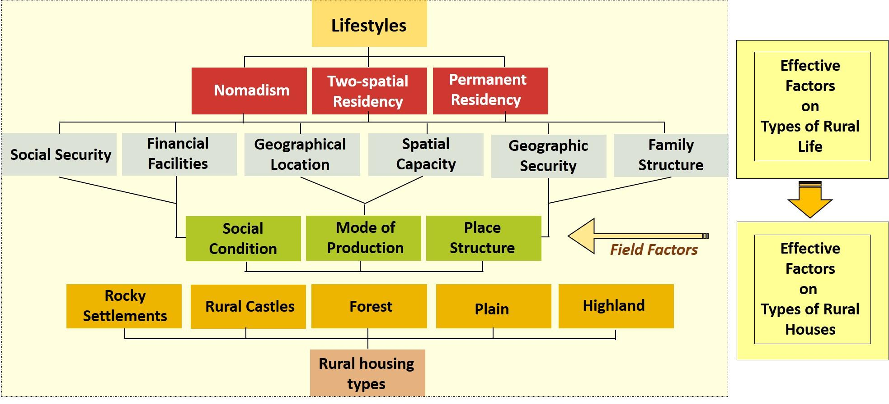

**Fig. 2.**

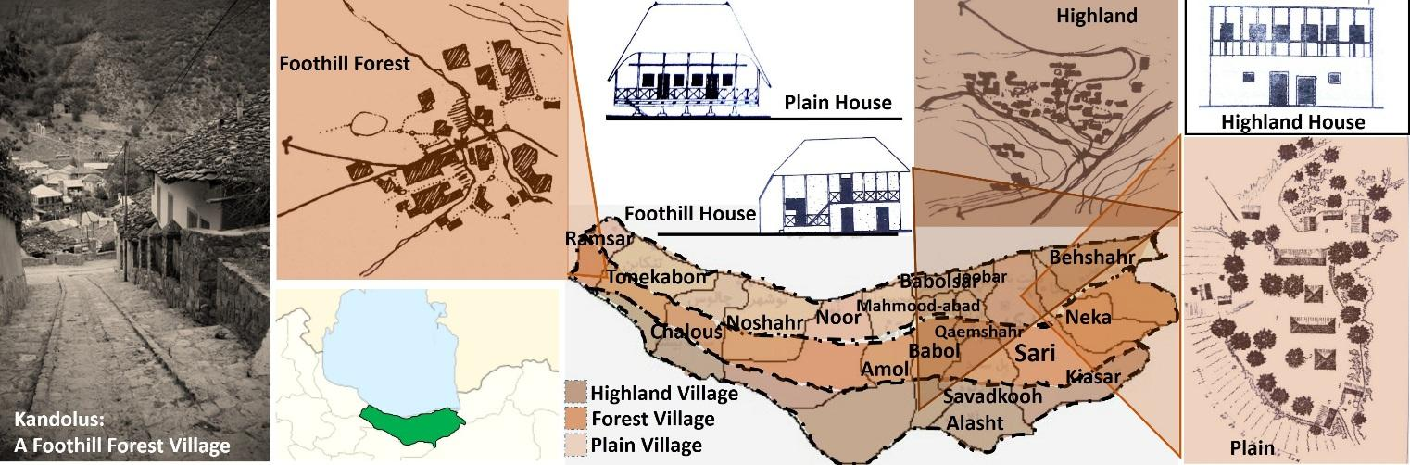

**Fig. 3. Fig. 4.**

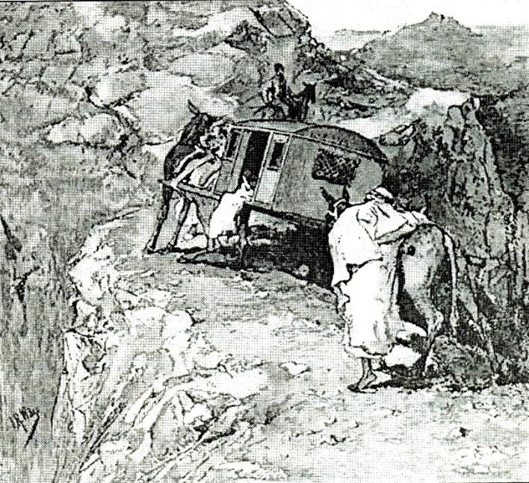 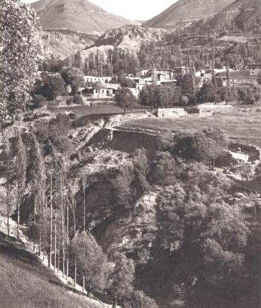

**Fig. 5. Fig. 6.**

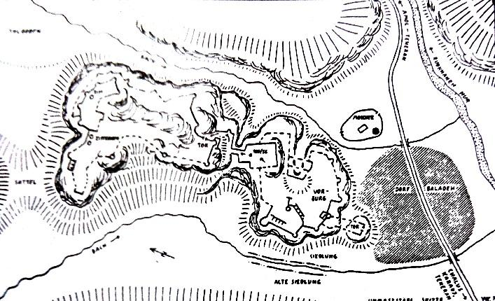 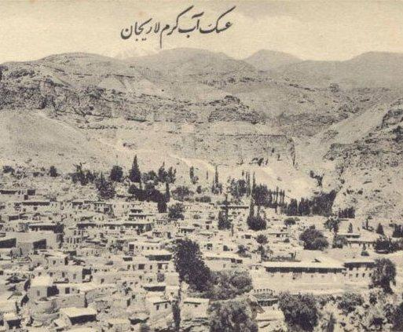

**Fig. 7.**

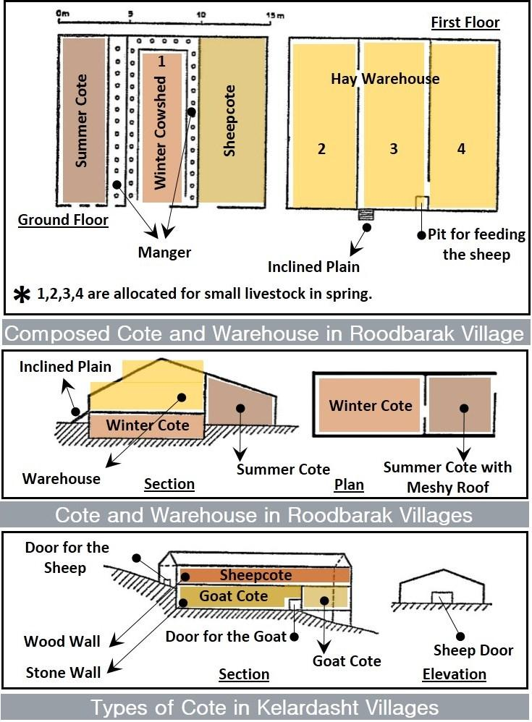

**Fig. 8.**

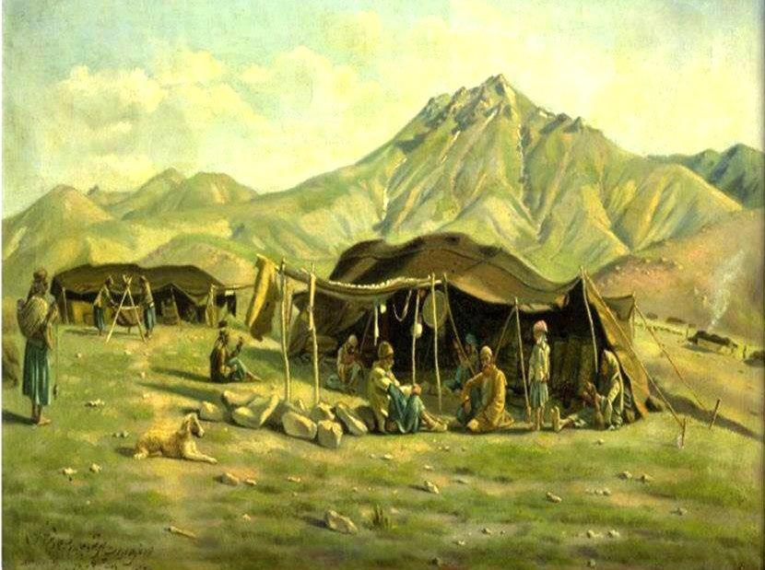

**Fig. 9. Fig. 10.**

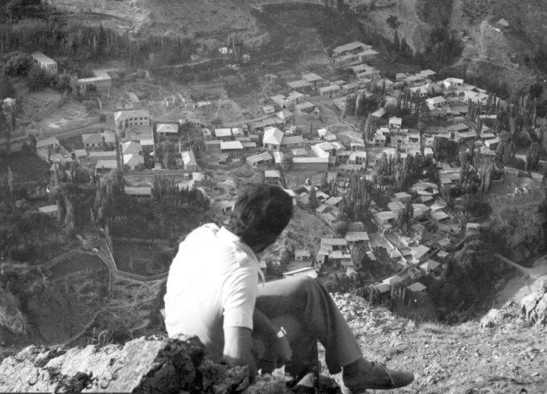 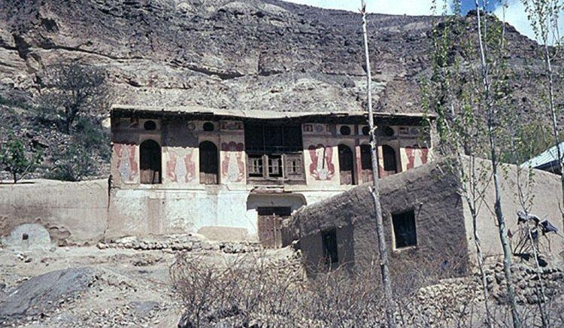

**Fig. 11.**

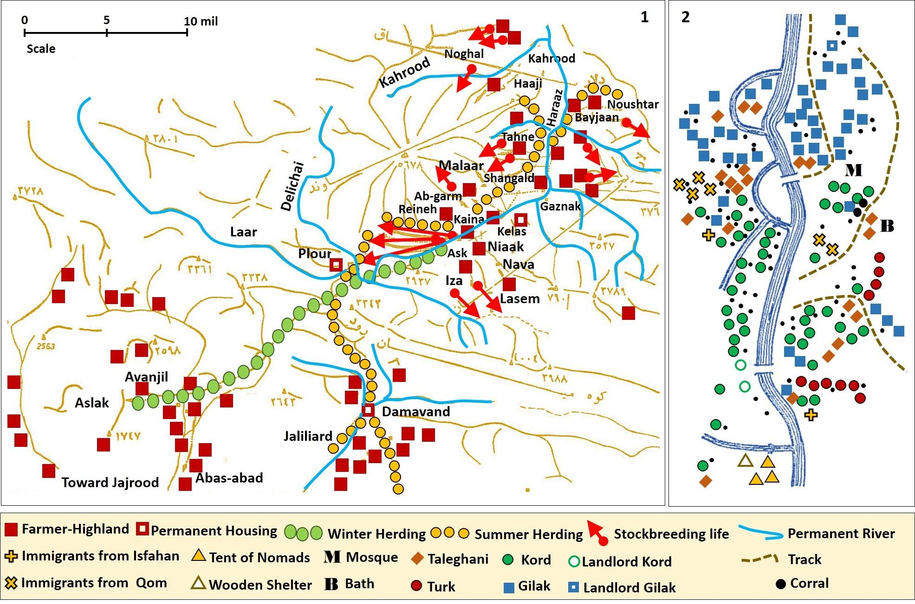

**Fig. 12.**

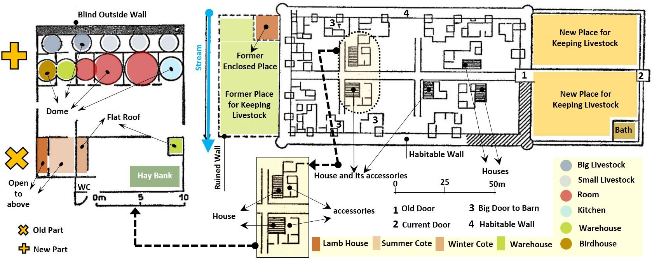

**Fig. 13.**

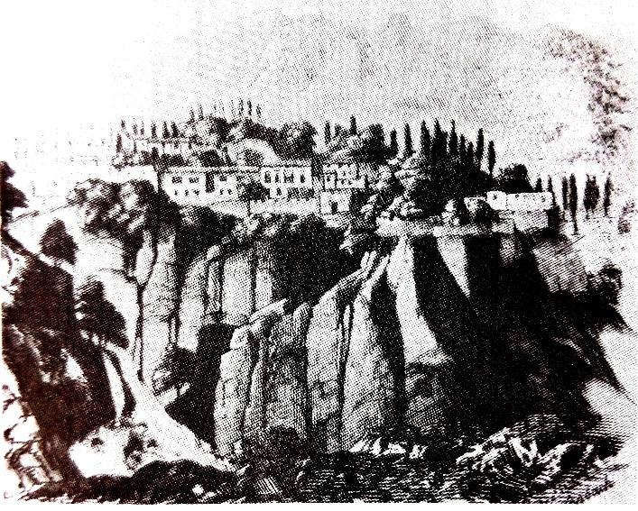

**Fig. 14.**

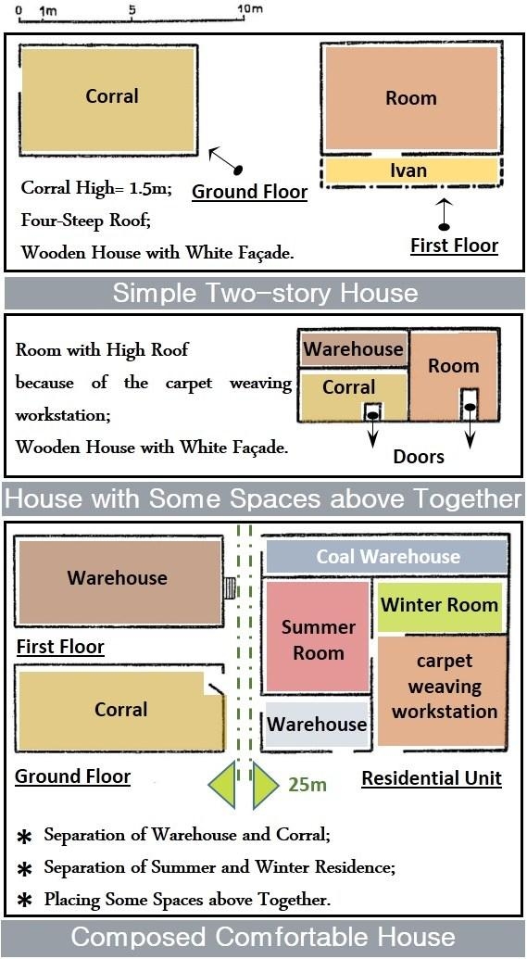

**Fig. 15.**

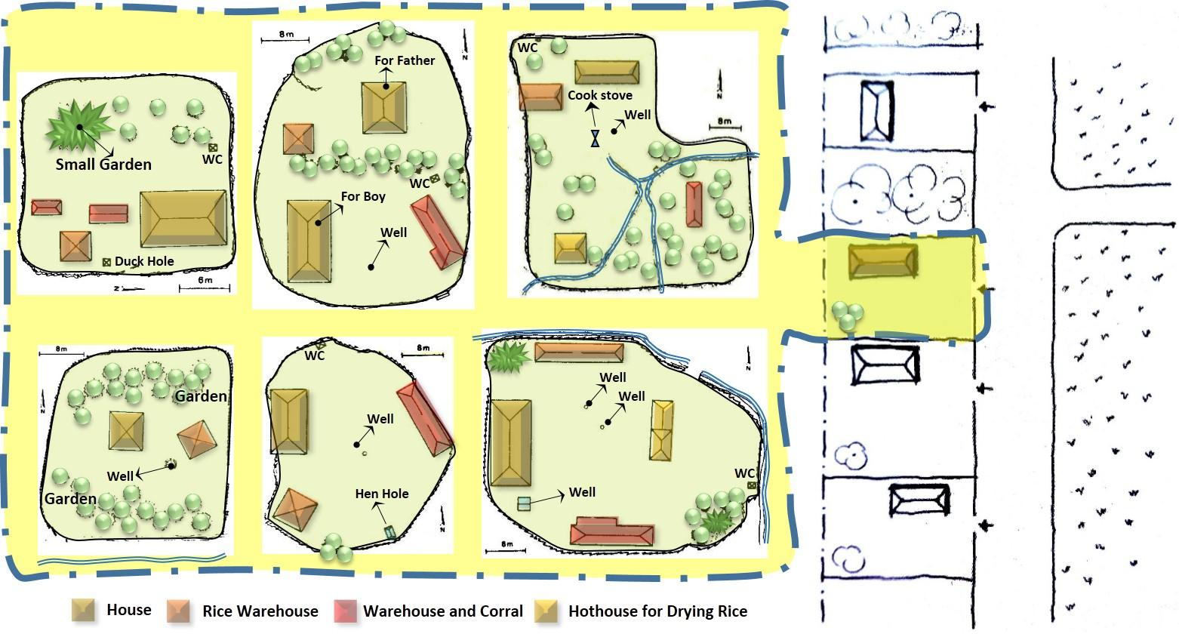

**Fig. 16.**

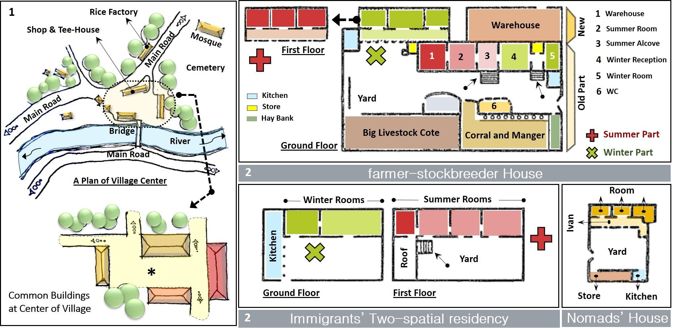

**Table Caption:**

**Table 1.** Lifestyle theories and concepts derived from them

**Table 2.** Affective Factors on the Form of Rural Housing

**Figure Caption:**

**Fig. 1.** Effective factors on types of rural life and rural houses (Source: Author, 2019)

**Fig. 2.** Typology of villages in terms of geography (Source: Author, 2019)

**Fig. 3.** Passing the palanquin from the meandering gorge of Afjeh village (Source: [11])

**Fig. 4.** An old view of Niaak village (Source: [44])

**Fig. 5.** Castle of Baladeh borough, Noor, Mazandaran (Source: [45])

**Fig. 6.** A view of Larijan at the old postal card (Source: [44])

**Fig. 7.** Various building types for keeping livestock in Kelardash (Source: Author, 2019)

**Fig. 8.** Kamal al-Mulk's painting from nomads in Laar plain (Source: [46])

**Fig. 9.** A different view of Ask village in 1970 (Source: [44])

**Fig. 10.** A view of landlord's house in Ask village in 1970 (Source: [44])

**Fig. 11. 1.** Pastoral immigrants in Larijan. **2.** Construction and composition of Roodbarak village's population (Source: Author, 2019; base maps: [9])

**Fig. 12.** New castle's map and transformation of houses in this castle. (Source: Author, 2019)

**Fig. 13.** A view of Ask village (Source: [13])

**Fig. 14.** Types of rural houses in Roodbarak area (Source: Author, 2019)

**Fig. 15.** Types of enclosures of rural houses in plain area (Source: Author, 2019; some of base plans: [47])

**Fig. 16.** Types of houses in Reineh village (Source: Author, 2019; base map: 1. [48]; 2. [9])

1. *Corresponding author: h.varmaghani@qiau.ac.ir*