**THE IMPACT OF DIGITAL ARCHITECTURE ON CITYSCAPE**

Dr. Morteza Mirgholami *

Seyedeh Mahsa Ghamkhar **

Maryam Farokhi ***

Digital architecture, as a proceeding architectural style, has caused fundamental evolutions in architectural design and building appearance via applying complex geometries and topologies. Computers and digital tools have truly altered the design process and architectural concepts. These changes in architectural design geometry have led to emerging avant-garde architectural forms which have influenced the features of cities and cityscapes. In this paper, the impact of digital architecture style on cityscapes is studied. By means of these digital tools we can revitalize the cityscape of ancient cities, which may be buried today. Digitally designed spaces have an impact on contemporary cityscapes and view sights because of their complicated geometry and free forms, expecting cities to become avant-garde architectural element museums. These digital tools will have a deep influence on future cities via parametric design, shape grammars, digital façade fabrication systems, and other methods.

1. Dr . Morteza Mirgholami **:** Assistant Professor of urban design at Tabriz Islamic Art University . Email : [Mirgholami@gmail.com](mailto:Mirgholami@gmail.com)
2. Seyedeh Mahsa Ghamkhar **:** Architect , The Department of Architecture at Tabriz Islamic Art University Email : [Mahsaghamkhar@yahoo.com](mailto:Mahsaghamkhar@yahoo.com)
3. Maryam Farokhi **:** Urban designer **,** The Department of Architecture at Tabriz Islamic Art University . Email : [Farokhy.m@gmail.com](mailto:Farokhy.m@gmail.com) **( Corresponding Author )**

<Tel:+989131692501>

**The Impact of Digital Architecture on Cityscapes**

**Abstract :**

Digital architecture, as a proceeding architectural style, has caused fundamental evolutions in architectural design and building appearance via applying complex geometries and topologies. Computers and digital tools have truly altered the design process and architectural conception facilitating production of new eye catching forms. Avant-garde architectural forms have emerged from these changes in architectural design geometry which have influenced visual, physical and morphological features of cities .

In this article, the impact of digital architecture and various architectural types (topological, isomorphic, motion kinematics, metamorphic architecture, parametric, genetic) on cityscapes of different periods (ancient, contemporary and future cities) is explored. Through these digital tools, the cityscape of ancient cities, which are not available to us today, can be revitalized. Digitally designed urban spaces and forms can influence contemporary cityscapes and urban landscape due to their complex geometry and free forms, assisting cities to become museums of avant-garde architectural elements and attractive magnets for capital and tourism in globalizing world. These digital tools will have a profound influence on future cities with their parametric design, morphological patterns, digital façade fabrication systems and other methods. This paper is mostly focused on digital production of forms and urban landscape by elite groups (designers, planners, digital experts etc) and thus the effects of other economic, policy-making and more procedural aspects of urban design on the final product (city scape, urban morphology etc ) are not applied here.

**Keywords** : Digital architecture, Cityscape, Parametric design, Computational design.

**1. Introduction**

Flying over Olympic park in Beijing- China, one can see a museum of avant-garde and spectacular architectural elements. The area’s mega structures and diverse forms are quite different from other spaces in conventional cityscapes. London 2012 Olympic Site with diverse forms generated by a complex geometry similar to Beijing’s case provides another example of such emerging new urban forms. Designing complex architectural forms via computational design and non-Elucide geometries is spreading all over the world thanks to new digital tools and software as cities are competing more over achieving a higher rank among other global cities to attract capital and tourists. This article aims to explore the impact of this new style and various architectural types on three types of cityscapes (ancient, contemporary and future) to provide a framework for analyzing their different features.

**2. Digital architecture**

Digital thinking and design encompasses most stages of architectural design process; from initial concept and designs to building information management (BIM) and detailing , these days. Possessed with such method of architectural space creation, it seems that architectural design method is shifting from traditional ones to more innovative modeling and simulation techniques. Avant-garde styles can be interpreted and evaluated as new scientific paradigms for choosing new conceptual framework and taking new aims, methods and values [9] .

The emergence of advanced digital architecture tools has resulted in enrichment of architectural ideas and concepts and change of design methodology. Digital methodology helps to enhance generative and performative processes. It creates forms, that were impossible to generate on paper before. Therefore, the architectural culture has changed and digital architecture replaced new geometries and non-Euclidean geometry to create innovative forms and spaces. Until two decades ago, complex geometric researches for form production in architecture was limited to presence of parabolids or hyperbolids used in concrete shells, tensile or pneumatic structures. But now, the extension of CAAD (computer aided architectural design), creates a new pattern in architectural design which leans on new surface modeling techniques such as mesh or NURBS (Non Uniform Rational B-Spline) that are basic design tools in AutoCAD, Rhino, 3D Max and Digital Project softwares. Thus, with the change of geometry, architectural forms have also transformed resulting in a rapid evolution in the appearance of buildings. Therefore, digital architecture has transformed the urban land scape [7] .

Diagram 1 : The impact of digital architecture on geometric shapes , architectural forms and cityscapes ( Authors ) .

The evolution and effects of digital architecture on cityscape are studied in this article across three contexts:

1. Ancient cities
2. Contemporary cities
3. Future cities

**2-1. The application of digital architecture in regeneration of ancient cityscape**

To define the impact of digital architecture on regeneration of ancient cityscapes, we can refer to the possibility of virtual regeneration of ancient cities with little or no trace or signs due to different disasters like earthquake, war and other.

One of the most appropriate methods for regeneration of these cityscapes in an accurate way is to use digital modeling and simulation. By creating a detailed 3D model of a heritage site, its physical environment can be reconstructed virtually which is faster and cheaper than a physical one.

An example of such application of digital architecture, is remodeling of Bam City which was destroyed immensely on 26th December 2003 after an strong earthquake. Old Bam was one of the most important cities of the state of Fars-Iran and the biggest muddy complex in the world. The origins of Bam can be traced back to the Achamendian Period.

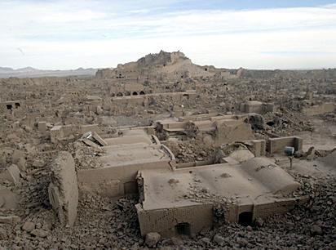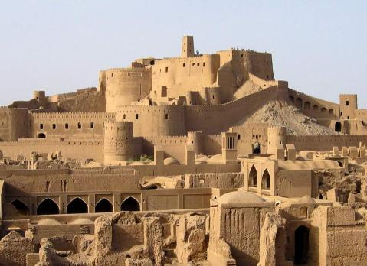

Figure 2: the Citadel of Bam after earthquake . <http://explow.com/2003_Bam_earthquake> .

Figure1: the Citadel of Bam, before earthquake . http://www.pbase.com/roozbeh/image/71827166.

Bam and its cultural landscape represent an exceptional testimony to the development of a trading settlement in the desert environment of the central region of Asia. The historical Citadel of Bam was and urban landmark in for the whole city and its surrounding landscape.

After the earthquake, a team including some Iranian and Japanese experts, worked on 3D modeling of Bam. They produced a virtual reality space of Bam. Now, the regenerated model of Bam city and its urban landscape enables tourists and interested people to have a virtual tour of this missing city. The team used data such as 2D-maps, photos, cartography maps, movies, textural explanations and sketches in order to create 3D models of the ruined city. Then, they did analytical and comparative research on these data to complete the basic resources for modeling and finally developed a 3D simulation of city buildings by using state-of-the-art 3D modeling techniques and tools like AutoCAD and 3D-MAX studio softwares [2] .

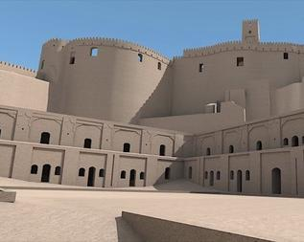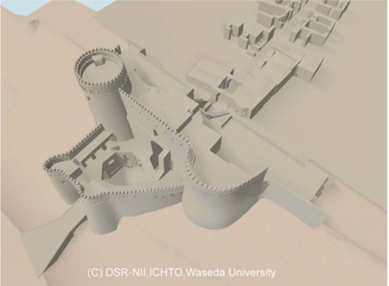

Figure 3: 3D model of Citadel of Bam and its landscape [2] .

Figure 4 : [Introductory Walk-through Video of 3D CG Reconstruction of the Citadel of Bam , From west of Saabaat House to Barrack](http://dsr.nii.ac.jp/bam/virtual/walkthrough-20110723.m2v) [2] .

Nowdays, to create 3D models and produce data on entire urban fabric, a method is proposed by Avideh Zakhor which involves scanning of the urban landscape using fast 2D laser scanners and digital cameras mounted on a truck or plane. By means of this method, 3d models of ancient cities can be created and saved so whenever necessary they can be rebuilt and their landscapes can be retrofit And indeed, this way, ancient urban landscapes can be reserved for ever [5] .

**2-2. Digital architecture in its impact on contemporary cityscapes**

Cityscape is a complex composition of architectural forms and other urban components in the city. Today, we are wittnessing a series of architectural elements and buildings which interact with other urban components and shape the hole cityscape.

Nowadays, because of variation in architectural forms, as a result of a big revolution in design processes, various cityscapes have evolved. Digital design of buildings and structures in contemprory urban environments and new developments such as waterfronts, urban regeneration projects, themed urban landscapes, residential and corporational complexes etc create a visual diversity and difference in their landscape. Several type of computational architectures in urban environments can be identified based on the underlying design concepts such as topological space (topological architecture), isomorphic surfaces (isomorphic architecture), motion kinematics and dynamics (animate architecture), keyshape animation (metamorphic architecture), parametric design (parametric architecture) and genetic algorithms (evolutionary architecture). Because of basic differences in geometry and use of free and complex forms, this diversity can proceed until converting the digitally designed buildings to an urban avant-garde element [7] .

Therefore, this new architectural language is making fundamental revolutions in cityscape due to its dynamic curve-linearity geometry. For instance, the Olympic Game Park in Beijing-China, has played a major role in Beijing’s urban landscape metamorphosis. Construction of digitally designed speculated olympic venues turned to be outdated and it change from traditional socialist capital to an avant-garde architectural museum. Now, this eye catching sight of metropolis has changed into a city brand which is a gateway for political and economic proceedings for china [15] .

Meanwhile, there are some questions which need to be speculated: What will happen to cityscape’s regular system if the number of these structures increases? Does it seem to be a sign/predictor of disorder in landscape? Undoubtedly to answer these questions, it should be noted that, by increasing the number of digitally designed buildings, the number of these unrepeated urban elements will be increased. And if we construct digitally designed structures as individual architectural designs, without predicting their relations with the the rest of city landscape, because of the significant (great) differences among geometry, form, design methods and applied materials that are not similar to each other, we will be witnessing new features of cities. For instance, in Beijing two digitally designed mega-structure projects (water cube and bird nest) are stood adjacent without any harmony, just as two urban avant-garde (spectacular) elements. While each of them, individually, has unique design philosophy, visual and mental reaction are not seem to be quite different and un-familiar to each other. Thus in today’s urbanism and cityscape design we will be expecting a new era which provides us two choices for cityscapes: acceptance of different urban spaces in any shape or refusing such diversity and achieving a unique , coherent and harmonious landscape. This phenomenon has been predicted by Relph [17] in his book as he mentions as characteristics of post-modern urban landscapes .

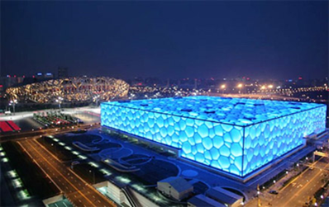

Figure 5: water cube and bird nest in Beijing-China ( Photo via Wikipedia ) .

Digital architectural design method, styles and tools are not the only factors to be blamed for this emerging diverse, flexible, less-controllable urban landscape as in post-fordist cities flexible transition of capital, human resource and commodities has made rigid planning less effective, but it can be said digital design has facilitated and encouraged this flexibility and diversity.

Now, digital architecture is going to create cities with turbulent, different and diffused contents and full of urban avant-garde elements. This phenomenon of the late twentieth-century urban landscape has been predicted by Relph (1992: 236-7) as “eclectic cityscape” [17] within which:

“almost any type of urban landscape has become both possible and popularly acceptable-old and quaint, new and quaint, modernist, decorated modernist, flashy, hi-tech, sleek, vernacular or frankly fake …the consequence in the near future could easily be urban landscapes which are a chiaroscuro of increasingly flashy, unrelated and pointless patches, a post-modern, late-modern monotony-in variety”.

Relph identifies two co-existent types of urban landscape in 20th century cities which he terms “modern cityscape” and “postmodern townscape”. A post modern townscape in Relph’s view has qualities such as quaint space, textured facades, stylishness, reconnection with the local setting and pedestrian/automobile split. The impact of digitally designed urban forms however has received little attention in Relph’s analysis of cityscapes.

Acceptance of eclecticism and patchy types of digitally designed buildings will result in emergence of urban landscapes without harmony , coherence and order can have a deep effect on urban landscape. On the other hand, we cannot ignore advances in digital architecture and conceal (mask) it behind ordered cities. Thus proper digital architecture and decisions, altogether, can result in optimum outcomes.

If we consider digital design as subset of digital urbanism such as parametric urbanism, we can construct digitally designed structures with a deep harmony with their environment and landscape. It should be noted that an ordered cityscape is not a linear one. In fact digital design does not disorganize the orders. It just uses an alternative geometry and due to this change, the implicit order behind it will change too, and a new different order will emerge. A good example to describe the essence of the new geometrical order is nature. In nature, we have nearly no straight line; and no two exactly similar elements. The nature is made of fractals and other shapes with non-Euclid geometries. But considering the nature’s organic order, we can redefine cities urban landscapes and ordered landscapes [10] .

**2-3. Digital architecture in cityscape of future cities**

Digital technologies will make a great impact on urbanism and cityscape design in the future. Avant-garde architecture and urbanism are going through a new era of refashioning the discipline.

Among digital design methods, parametricism is a new style based on advanced parametric design systems, computational and scripting methods. Parametricism has some taboos and dogmas which formulates its design approach? Its taboos include avoiding rigid geometric primitives and Euclidean shapes like squares, triangles, circles and also putting unrelated systems together and repeating systems in a simple way. Parametricism dogmas are designing parametrically flexible forms and juxtaposition related systems which differ at varying rates .

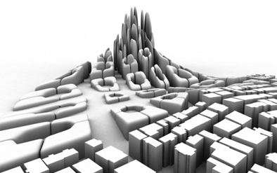Parametricism uses advanced computational geometrically free forms and complicated computation in order to design optimum urban cities and cityscapes. Today, we can design continuous and harmonic landscapes. Parametric modeling tools like GC or DP and computationally advanced design scripting tools like (in Mel-script and Rhino-script) come to enhance the quality of urbanism and landscape design. For instance Zaha Hadid’s architectural style has developed a parametric master plan for modeling future Istanbul- Turkey to reduce pressure on the city’s historic core. Istanbul has a great memory of the past. In this city, past, present and future are combined together in a unique organism. To achieve the parametric model of the future Istanbul, architects challenged between two primary fabric topologies of the city, modern towers and border blocks. These two objects were considered as generative components which led to producing diverse patterns for the city morphology. To emphasize the path network, towers stand on the cross points. Blocks with a distinct different height from the towers, are located in two path network sides [3] .

Figure 6: parametric design for future Istanbul [9] .

So, Istanbul will have a computed urban landscape made of two types of urban topologies interacting together as much as possible. It is obvious that the complex cityscape in such future cities is the direct consequence of digital design processes.

Another example, as a smaller scale urban project is the design of Federation Square by LAB studio in Melbourne Australia.

Federation Square, the new civic precinct in the heart of Melbourne, was the winning project in an international design competition and Lab architecture studio's first realized buildings. The project covers an area of 3.6 hectares, an entire city block above the railway tracks, and consists of nine separate cultural and commercial buildings with a combined area of 45,000 square meters.

This project consists of a complex of buildings combined with an open plaza which provide a gathering place for people for different events and has become a landmark for Melbourne city. Digital softwares were employed to create the fractal façade of the building. This facade is based on triangular shapes that allow differentiation of individual buildings, whilst maintaining an overall coherence [1] .

Figure 7 & 8 - Federation Square and complex of buildings (the Australian Centre for the Moving Image (ACMI), SBS (Australia's multi-cultural broadcaster), Melbourne's Visitor Information Centre) designed by LAB Studio has given a new character to the urban landscape near Yarra River [1] .

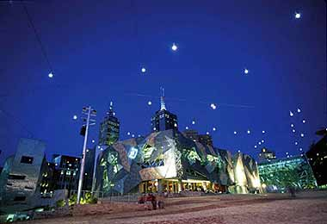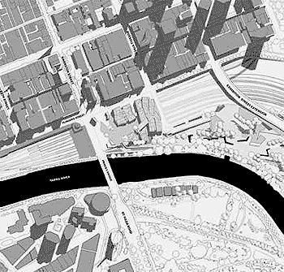

Also, there are some softwares for digitally produced urban design which can affect cityscape in a vast scale. These softwares used for design of regulated feature cities include: CityEngine, CityZoom, CityCAD, CyberCity 3D and AutoCAD Civil 3D and they have some capabilities to incorporate an urban ontology, to respond to the planning regulations and strategies, to include a generative design model and provide an interactive visualization of data. They are used as powerful means to design and develop future cities and landscapes.

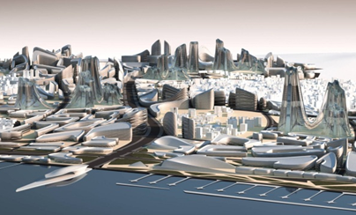

Figure 9 : Impact of digital design on future cityscape of Istanbul [9] .

Besides , great improvements in CAM as a significant outcome of computer soft wares’ usage to control machine tools and related machinery in the manufacturing of façade panels and other building components will lead to vary the appearance of buildings and urban elements which impacts on cityscape texture [18] .

**3. Conclusions**

Today, with emergence of computational design tools and fundamental evolutions in architecture design process, a new window called digital architecture is opened to architects. Innovative computational design tools generate complex geometries and topologies to create building’s forms, facades and spaces and the architectural design process , from initials ideas to construction and final stages has been influenced. These diverse architectural forms has affected the cityscapes and visual/physical features of cities.

Investigation on influences and evolutions made by digital architecture on past, present and future cities indicates that cityscapes are regenerating and going through a new stage by means of digital architecture. Digital architecture can revitalize and recover the ancient demolished cityscapes quickly by constructing 3D models via methods like laser scan and point cloud.

In contemporary cities, digital architecture using complicated geometries and designing unique non-linear architectural free forms has converted the skyline to sky curves and has affected cityscape rhythms. These elements, despite extraordinary eye catching forms, will impose some turbulence on city visual features If their arbitrary design approach regardless to their urban context continue to determine urban cityscapes.

Additionally, digital architecture has some impacts on future cities and future urban design. By processing computational design science and enhancement in tools and facilities of generating complicated forms, applying digital architecture as a new style will assist planners and designers in creating new urban patterns, blocks, morphologies and cityscapes. In this case, because of using new architectural languages such as parametricism or algorithmic design that have a pure order beside their variations will not be witnessed as disordered in cityscapes.

**Refrences**

[1] Allen , Tony. *Lab architecture studio Federation Square* , Melbourne, Australia , 2003 .

<http://www.arcspace.com/architects/Lab/federation_square.html> . April 18,2012 *.*

[2] Andaroodi , Elham , Kinji Ono, and A . Kitamoto. *3dimentional Reconstitution and Virtual Reality Bam and Its Cultural Landscape* , 2008 .

[3] Arkut Ulu , E , B Arkut , and O.Y Gun . Future Community In Istanbul . *an Interpretation of Istanbul To Generate a New Urban Life* . 28th Conference Of Future Cities. eCAADe 28, Zuritch, Switzerland , 2010.

[4] Broudehoux, Anne-Marie. " Spectacular Beijing: The Conspicuous Construction of an Olympic Metropolis" . *Journal of Urban Affairs* 29 , no.4 (2007): 383-399 .

[5] Frueh , Christian and Avideh Zakhor . *3D Model Gereration for Cities Using Aerial Photographs and Ground Level Laser Scans* . IEEE Conference on computer vision and pattern recognition , Kauai . 2001 . pp.ll-31 – 38, vol .2.2.

[6] Gil . J , J Beirao , N Montenegro, and J Daurte. *Assessing Computational Tools For Urban Design . Towards A “City Information Model”*. 28th Conference of Future Cities . eCAADe 28, Zuritch, Switzerland, 2010.

[7] Kolarevic, Branko. *Digital Morphogeneis and Computational Architectures*. Constructing The Digital Space . 2000.

[8] Kontik,Tony. " Digital Architectural Design As Exploration of Computable Functions ". *International Journal of Architectural Computing* 8 , no1(2008) : 1-16 .

[9] Leach , Neil. *Digital Cities . Architectural Design* . 2009 .

[10] Liauw , Laurence. *New Urban China, Architectural Design* . 2008.

[11] Macros , C.L . *New Materiality: Digital Fabraication and Open Form, Notes On The Arbitrariness of Architectural Form and Parametric Design* . International Conference On Innovative Methods In Product Design, Venice, Italy .2011.

[12] Mc Grath , Brian. *Digital Modelling For Urban Design* . 2008.

[13] Ono, Kinji , E . Andaroodi , A.Einifar , and M . M*atini. 3DCG Reconstitution and Virtual Reality of UNESCO World Heritage In Danger : The Citadel Of Bam* . Progress In Informatic . 2008.

[14] Oxman , R . " Digital Architecture As a Challenge For Design Pedagogy:Theory ". Knoeledge . Models and Medium, *Design Studies* 29 , no 2 (2008) : 99-120.

[15] Ong, Ryan. " New Beijing, Great Olypics: Beijing and Its Unfolding Olympic Legacy ". *Stanford Journal Of East Asian Affairs* 4 , no 25 (2004) : 35-49 .

[16] Picon , Antoine. *Digital Culture In Architecture*. Birkhäuser Architecture . 2010.

[17] Relph , Edward .*The Modern Urban Landscape* . The Johns Hopkins University Press, Baltimore. 1992 .

[18] Steino , N*. Parametric Thinking In Urban Design* .28th Conference of Future Cities . eCAADe 28, Zuritch, Switzerland . 2010.

[19] Turkienicz .B , B.B Goncalves ,and p Grazziotion . *city Zoom : a Visualization Tool For The Assessment of Planning Regulations* .