**The Impact of Wind on Summer Ambient Temperature to Improve Thermal Comfort through Wind Catcher by Employing PMV-A Case of Salehi's House in Shiraz, Iran**

Zahra Barzegar, Instructor, Department of art & Architecture, Islamic Azad University, Shiraz Branch

zahrabarzegar86@yahoo.com

Mohsen Mohammadi, PhD Candidate, Department of art & Architecture, Islamic Azad University, Shiraz Branch

mohammadi.mohsen62@ gmail.com

**Abstract**

Wind catchers are one of the most prominent masterpieces of Iranian traditional architecture. In arid climate, it can improve thermal comfort through natural ventilation. With the aim of recognizing the impact of this masterpiece on thermal comfort, this research examined the effect of wind on summer ambient temperature by employing PMV. To this end, wind catchers of Salehi's House was selected. To investigate the function of wind catchers in Shiraz, enjoying a semi-arid climate, temperature, humidity and wind were measured by data logger TA120 between 9:00 to 16:00. Afterwards, PMV and PPD were obtained through Fanger Formula. The results based on wind and in the case when the wind catcher and openings are close and open showed that the amount of thermal comfort was directly related to the amount of wind coming from the wind tower. It was also concluded that the average ambient temperature in ground was declined by 0.8 °C and in the first floor it was declined by 0.9°C.

**Keywords**: Thermal Comfort; Wind Catcher; Wind; Natural Ventilation; PMV.

**Introduction**

Thermal comfort is the condition of mind that expresses satisfaction with the thermal environment. According to ASHRAE, thermal comfort of each person is the mental condition showing his/her satisfaction of thermal environment (Haydari,1388,6). A more precise definition of these conditions can be summarized in three groups. The psychological definition relates to the brain's satisfaction of the ambient temperature. The thermal-physiological definition relates to the biological response of the body and the nervous system to externalities imposed upon the thermoreceptors. The third definition relates to the balance between the heat flow inside and outside the body (Table and Taleb,2014,254). Furthermore, there are also some other definitions with regard to cold or warm spaces lacking comfort (Hoppe,2002,662). In general, the thermal comfort depends upon air temperature, humidity, water vapor pressure, air movement, radiation from internal walls (average radiant temperature), human (age, gender), type of human physical activity and his/her clothing(Ashrea,1993)(Qiabakloo,1380,69)(Mohammadi,1386). Many factors are taken into account when designing a building. One of the important factors architects should take into account in building design is the physical comfort of a person, which is the result of a thermal energy balance between that person and the his/her surrounding space (Watson&labce,1390,4). In fact, thermal and environmental comfort factors affect the shape and orientation of buildings, streets, alleys and also the selection of materials (Khodakarami,1389,59). As a result, to reach outer and inner thermal comfort, the architects' and urban planners' designs should be in accordance with the surrounding environment, enjoy the maximum existing natural potential of the site, and provide a good natural environment for users (Kasmaei,1369). Therefore, the architects and designers have provided specific solutions based on different climatic conditions.

One of the architects' solutions for reaching thermal comfort in the arid climate is to create a natural ventilation by air and wind flow. Natural ventilation can modify indoor humidity and temperature (Razjoyan,1367). Of course, the ventilation has also some problems. Due to the air temperature entering the building from outside, it can be considered as a damaging factor for thermal comfort (Bahadorineajad,1387,19). Natural conditioning solutions can be divided into three types: Physical ones on the ceiling, in the facade and the body of the building, and a combination of the two (CIBSE,2005,15-20).The element used by Iranian architects to ventilate in arid climate is called wind catchers . In addition to the beauty and decorating of the building, wind catchers have played a vital role in the ventilation of the interior space of buildings naturally and without energy consumption (Pirnia,1384,91). They are used to receive cool air passing from the roof according to the direction of the winds (Mehdizadeh Seraj,2008). It can be said that wind catchers play a significant role in controlling the flow of wind and using the clean energy of nature to modulate the temperature and also bringing the temperature of the living space to the temperature needed for human's comfort (Mahmodi,1387,29). The elements that make up the wind catchers are its head; column; main blades and side blades; and openings some are used aesthetically and some have important functions (Bahadoryneajad,1387) (Mahmodi,1382,343).

The Iranian wind catchers are divided into three categories: Ardakani (uni-directional), Kermani (bi-directional) and Yazdi (four-directional) (Shariatzadeh,1374,224-223)(Zamershidi,1373,119-123)(Bahadorynejad,1387,29)(Mazidi and Mazidi,39,1387) (Mostafavi, 1377, 6-335). The main factor driving the air in a wind catcher is gravity (Swang, 1991,17).The wind catchers can function in two ways. They can direct airflow downward or/and direct airflow upwards. If the hot air is pulled through the pressure difference, the wind catcher acts as a chimney (McCarthy, Battel, 1381).The amount of air flow generated by the buoyancy force in the wind catchers is very low and the wind catcher does not have a significant role in the absence of wind (Bahadorynejad,1387,15). Vertical ventilation is effective when the wind speed is over 2.5 m/s (McCarthy, Battel, 1381,24). It can be said that the amount of air flows inside the building and the moisture cycle are factors affecting the evapotranspiration efficiency or the performance of the wind catchers (Mahmoudi, Mofidi,1387,34).The use of wind in the past architecture and the vernacular buildings of each area not only contributes to the consumption of fuel and energy, but also, most importantly, improves the quality of men's comfort and health of residential and natural environments (Mirlatti et al,1391,31). The effect of wind is important in the natural ventilation of the buildings and the creation of favorite inner air temperature and ultimately thermal comfort for the inhabitants (Kasmaei,1378). The wind pressure increases with the wind speed ratio by the shape of the building (Khaledi,1374). Kasmaei (2006) determined the human response to the air flow rate between 0 m/min and 240 m/min. The present study examines the internal thermal affecting by wind catcher and without it in the traditional Salehi's house in Shiraz. The analysis has been done in two different positions: all openings closed and all openings open. This investigation is done in semi-arid climate of Shiraz regarding direction and speed of summer wind. The values of temperature, humidity, wind, etc. are taken by data logger AT120 between 9:00 to 16:00 with an interval of one hour. Finally, PMV and PPD are calculated through Fanger Formula. Some solutions are also recommended for reaching thermal comfort in residential buildings.

1. **Literature Review**

The importance of the thermal comfort is to a great extent addressed by many scholars and scientists from various fields, including architecture, urbanism, geography,mechanics,energy,etc(Olgyay,1963)(Konya,1980)(Ensley,1980)(MIntyre,1982)(Fanger,1985)(Gagge1986)(Henson,1990)(Karyono,1997)(Oke,1998)(deDear&Reicharth,1998)(Brager,2001)(Qyabakloo,2001)(Nicol,2002)(Charles,2003)(Bentley et al,2003) (Kasmaie,2005) (Kamali&Moradi,2006) (Haan et al,2007) (Tahbaz,2007)(Sadeghiravesh et al,2009) (Ashrea,2010) (Vanhooff,2010) (Delfani et al,2010) (Hashemi&Haydari,2011) (Hejis,2012) (Saghafi,2012) (Monshizadeh et al,2012) (Moalemikhiavi&Marefat,2014)(Barzegar,2014) (Haydari et al,2017). In general, there are many things done in Iran regarding comfort and convenience: (Kasmaie,1363)(Razjoyan,1367)(Kavyani,1371)(Gholamibiraghdar,1377)(Hejazi et al,1380) (Asgari&Moeini,1381)(Qobadian&Mahdavi,1384)(Payandeh,1384)(Pordehimi,1390). There has been a lot of research on the importance of the climate on architecture (Thompson&perry,1997)(Sam&chung,1997)(de la Espriella,2002)(Tsutsumi,2007) Some studies worked on thermal comfort have examined factors such as energy loss(Corganti,2008((Martin,2008)(Holz,1997), temperature(Chun,2008) and the amount of humidity (Kosar&Dumitrescu,2005). Researchers have divided the thermal comfort investigations into two important subsets of thermal comfort in open spaces (Jendritzky et al,1990) (Hoppe,2002) (Qyabakloo,2003) (Emmanuel,2005) (Johansson,2006) (Tahbaz,2007) (Honjo,2009) (Haydari&monaam,2013) (Jalili,2013) (Rozati,2014) (Baghay et al,2015)(Ahmadpourkalhrodi et al,2017) and closed spaces (Pritus&erond,1984)(de dear,1998)(Humphrese&nicol,2002)(Charlz,2003)(Oleson,2004)(Salighe,2004)(ha j.k,2006) (Qyabakloo,2007)(Nasrolahi,2008)(Tavoosi et al,2008)(Lin et al,2009)(Altanet al,2009)(Peters et al,2009)(Haydari,2009)(Lomas&graidharan,2012)(Frantini2012)(Moradi et al,2013)(Javanrodi&Mahdavinejad,2013)(Ansarimanesh&Nasrolahi,2014)(Andreou et al,2014)(Eslami,2014)(zareh et al,2015)(Dibniski et al,2015)(Zomorodian et al,2016)(Hayati,2016)(Harimi,2017). For example, in terms of thermal comfort in closed spaces, the first heat balance model was proposed by Fanger (1972) on Predicted Mean Vote(PMV) and Predicted Percentage of Dissatisfied (PPD) for ventilation engineers in indoor climate condition. Nicol and Humphreys also have considered the adaptive thermal comfort and sustainable thermal standards for buildings and compared it with rational indicators; they found out using rational indicators to be difficult in real situations. Qiabakloo devoted his paper to examine the methods for estimating thermal comfort zone, and the main factors affecting the man’s physical comfort regarding his/her environment. She states that factors such as age, gender, color of space and climatic conditions do not have much effect on the thermal comfort (Barzegar et al,1395,193). There have been many studies on the issue of thermal comfort as well as natural ventilation (Yaghobi,1975)(Karakatsanis,1986)(Zomershidi,1994)(Shariatzadeh,1995)(Bahadorinejad,1977)(Mostafavi,1998)(Mazidi&mazidi,1999)(Battle McCarthy,2002)(Nayebi,2002)(Mahmodi,2003) (Dehghani&Aghanajafi,2004)(Mahmodi et al,2008)(Bahadorinejad2008)(Mahmodi,2009) (Kalantar,2009)(Montazeri,2009)(Mahdavinejad,2011)(Bouchahm et al,2011)(Pourahmadi,2012)(Ahadi et al,2014).For example, Mahmoudi investigated the cooling behavior of wind catchers in the city of Yazd through modeling of wind catchers and presented a typology of wind catchers based on this analysis(Mahmudi,2009,574-579). Employing numerical modeling of the wind catchers in different conditions, Bouchahm et al(2011,898-906). concluded that increasing the tower height and reducing the width of the winders can increase the air flow and ventilation. Others have addressed the function of natural ventilation in wind catchers and using wind as well as calculating and estimating wind power (Maybodi,1981)(Khaledi,1994)(Kasmaei,1999) (Richard&dayvis,2002) (Omidvar,2004) (Chang,2006) (Chen et al,2007)(Shaykhbigloo et al,2007)(Chan,2009)(Adrij,2011)(Van Hooff&blocken,2012) (Hezbei,2014) (Memarian et al,2017). Studies have shown that attention has grown considerably in the case of "indoor air flow" in recent decades (Hezbei et al,1393,38). Natural ventilation is an important factor in improving the tolerability and health of indoor environments that are carried out by wind power or buoyancy force or often by combining these two forces (Chang, 2006 Van Hooff and Blocken, 2012; Chen et al., 2007). One of the most popular wind catcher species is the four-directional wind catcher that is famous as Yazdi. It is more complete than other kinds of wind catchers . Its channels are divided into several sections with bricks, wood or plaster blades in the entrance and the fountains as well as the interior sections. In some samples, under the channel there is a basin which absorbs the dust of dry air and cool the room in summer heat. In areas where there is no possibility of a basin on the ground floor, the buildings enjoy aqueducts installed underground and the end of wind tower's channel extend along the stream of water. These spaces were the place where people gathered.

The wind catcher examined in this research is a four-directional one. However, the entrance and basin of channel is covered by galvanized sheet. There is also no blade in the inner parts as well as no basin and aqueduct. There is a little research done on thermal comfort provided by wind catchers especially the four-directional ones. This investigation, therefore, aimed at examining the impact of wind on summer ambient temperature to improve thermal comfort through wind catchers by employing PMV in Salehi's House located in Shiraz, Iran.

1. **Methodology**

There are two main approaches to assessing thermal comfort. First, the heat balance approach based on the results of Fanger's research (1970) in laboratory conditions; and second, an adaptive approach. The theoretical basis of the heat balance approach is the close connection between the thermal sensation with the body temperature control system (Van Hoof,2008). In this research OMV and PPD are used.

Fanger (1970) defined a criterion as the sense scale through the relationship between the senses of heat with the power of the individual based on the experimental results obtained from researches. This criterion is referred to as the PMV index representing a quantitative measure of the thermal comfort of a group of people at a particular thermal environment. This index is the most important indicator of physiological temperature, which in addition to studies on urban and regional planning, especially in determining the thermal component of urban micro-climates, has also been widely used in tourism and climate studies (Yaghobi,1385). The Fanger model is based on the ISO 7730 standard in thermal comfort (Qyabakloo,1390). The PMV index is expressed as the following formula:

(1)

(2)

(3)

(4)

(5)

*H* isdirectly measurable and can be calculated by the following equation:

(6)

Where

*Crec* = Convective heat loss from respiration (w/m2);

*Erec* = The evaporation heat exchange in respiration (w/m2);

*Ec* = The heat exchange by evaporation on the skin;

*Icl* = Basic clothing insulation (clo);

*M* = Metabolic rate of human body (w/m2);

*tcl* = Clothing surface temperature (°C);

*tsk* = Average skin temperature (°C);

*W* = Rate of effective mechanical work (w/m2);

*e* = Respired vapor loos on skin (w/m2);

*H* = the sensitive heat losses;

*Pa* = Water vapor partial pressure (Pa);

*Ta* = Ambient air temperature (°C).

The PMV is expressed in a seven point scale varying from -3.5 (cold) to +3.5 (hot). Zero is neutral (See Table 1). In order to calculate this criterion easily some software has been design, one of them is Ray Man (Zolfaghari,1386) (Yaghobi,1385).

|  |  |  |  |  |  |  |  |  |
| --- | --- | --- | --- | --- | --- | --- | --- | --- |
| Table 1: PMV sensation scale (source: Matzarakis et ai,1999) | | | | | | | | |
| **Degree of physiological stress** | Extreme cold stress | Moderate cold stress | Slight cold stress | No thermal stress | Slight heat stress | Moderate heat stress | Very strong heat stress | Extreme heat stress |
| **sensation** | cold | cool | slightly cool | neutral | slightly warm | warm | hot | very hot |
| **PMV** | -3.5 | -2.5 | -1.5 | -0.5 | +0.5 | +1.5 | +2.5 | +3.5 |

The PPD index is also used to predict the percentage of dissatisfied people in a given thermal environment. It is designated based on the PMV index. In the index, the PMV is expressed as a percentage in the case where the percentage of people ranked -2, -3 or less and +2, +3 or more. PPD is calculated through the following formula ():

(7)

Figure 1: Instruments used in research (source: authors)

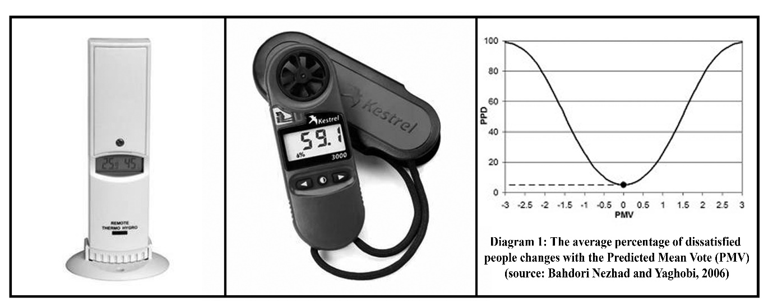

Using Data Logger TA120, the data were collected in two months and in two consecutive days (June 29-30). In the first day, June 29, the data collected while the wind catcher and all closings were closed. In the second day, however, the data collected while the wind catcher and all openings were open. Data gathering occurred once per hour from 9:00 to 16:00. The field variables collected included: air temperature (T), relative humidity (RH) and wind velocity (V). As the building is a two-storey one, therefore, the data collected for each storey separately. To collect data, the data logger, in the ground level, was put on the floor at the height of 1.00 m (since the height of floor to the ceiling is 2.00 m) from the floor once at the beginning of the wind catcher and once in the center of gravity. In the upper floor as the height of floor to the ceiling is 3.00 m, it was done in the height of 1.50 m from the floor, once at the beginning of the wind catcher and once in the center of gravity. In Figure 2, the place of data logger is shown with (ₓ). The size of indoor openings, the geographic orientation, and place of the rooms compared to the yard, the area of the spaces, the dimensions of the wind catcher and its openings, and finally the materials of the walls were simulated by Ecotect Software 2011. The temperature of the special points was calculated in from 9:00 to 16:00 once per hour in June 29-30. In the next step, the values of clothing and metabolism were determined by ASHRAE Standard. According to the calculation, the amount of clothing insulation was 0.5 (clo). The value of Met in siting position was 1.0. Finally, the PMV was obtained by CBE Thermal Comfort Tool.

1. **Case Study**

Iran has different climates; the arid climate is the most important one. Most cities in Fars province also enjoy this kind of climate. Shiraz, the capital of Fars Province, is built in a green plain nearly 1491 meters (4891.7 feet) above sea level, at 29°32´N 52°35´E (Kasmai, 2003). With respect to Köppen climate classification, this city is located in a semi-arid climate (Barzegar, 2014). Table 2 shows the climatic information of Shiraz reported according to GPA Statistics (1951-2010). In the winter, climate of Shiraz is fairly moderate with rainfall, and in summer, it enjoys semi-arid climate. Iran Meteorological Organization (between the years 1999 to 2009), the mean maximum temperature of Shiraz is 38.53°C in June or July and the minimum is nearly 0.43°C in December or January. The wind speed is also 5.21396 Nat in July (Iran Meteorological Organization, 1393).

Based on the Köppen climate classification, Shiraz is in the BSH group (Peel, et al. 2007). City core, with an approximate area of 360 hectares is located in the heart of the city. This area accounts for 2.8% of the total area of the city; buildings with central courtyards are the main element of its residential sector (Memarian, 1997,13 154). There are over 2,000 different houses date back to Qajar era among them 192 houses registered in the Cultural Heritage Organization (Fars Cultural Heritage and Tourism Organization,1390). According to Iranian Cultural Heritage Organization, there are limited numbers of houses with wind catcher in Shiraz. Among the historical houses those enjoying wind catcher are Tavakoli House, Dokhanchi House, Salehi House, Manteghinezhad House, Forough-ol-Molk House, and Basiri Owji House. Among these houses, the wind catcher of Manteghinezhad House was ruined; Dokhanchi House and Forough-ol-Molk House are inhabitable; Basiri Owji House and Tavakoli House also are not available. Therefore, the research is done in Salehi House.

Figure 2: Case study introduction(Source: authors)

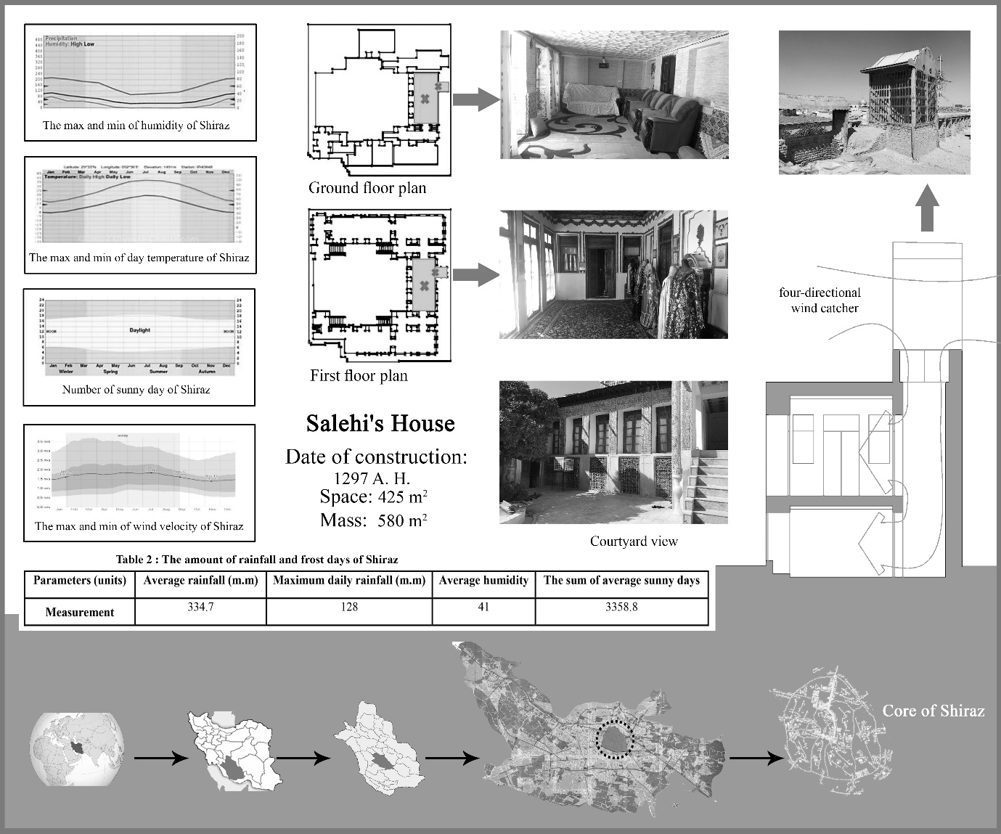

1. **Results and Discussion**

As explained before, the indoor temperature of Salehi's house was examined for both ground floor and first floor separately. The result obtained can be interpreted as follow.

**4-1- Environmental Factors**

1. *The Comparison of air temperature changes*

Temperature is one of the most effective elements in thermal comfort. In Shiraz, the average temperature to comfort is 19.92 °C.

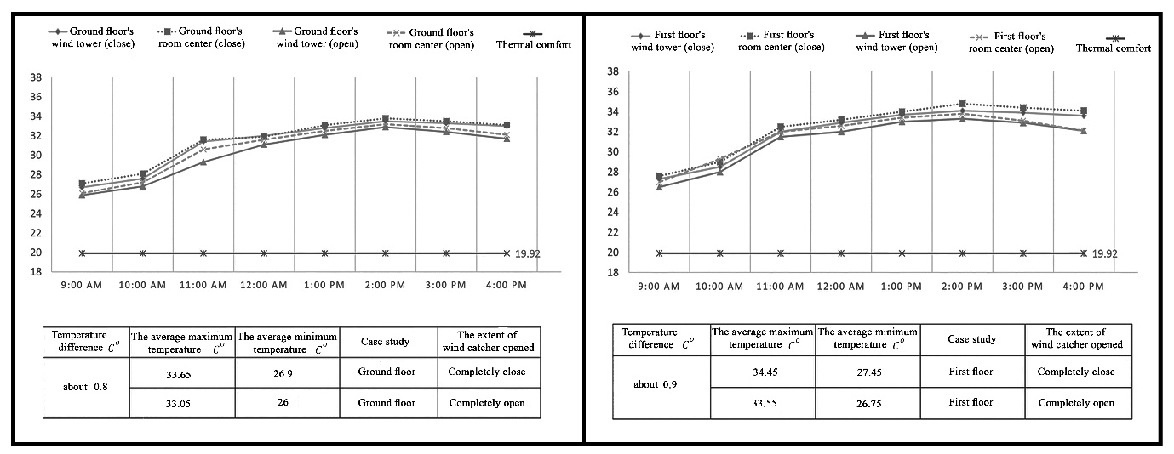

Diagram 2: The comparison of indoor air temperature collected by data logger based on open and closed wind catcher and openings in Salehi House from 9:00 to 16:00 once per hour (source: authors)

According to the data obtained for the ground floor, when the wind catcher and openings are closed, the average maximum temperature is 33.65 °C, and the average minimum temperature is 26.9 °C. When the wind catcher and openings are open, the average maximum temperature is 33.05 °C, and the average minimum temperature is 26 °C. In the first floor, when the wind catcher and openings are closed, the average maximum temperature is 34.45 °C, and the average minimum temperature is 27.45 °C. When the wind catcher and openings are open, the average maximum temperature is 33.55 °C, and the average minimum temperature is 26.75 °C. According to the Diagram 2, when the openings are open in the ground floor, the temperature is about 0.8 °C colder than when they are closed. The research also shown that, the difference is about 0.9 °C in the first floor.

1. *The Comparison of humidity changes*

Humidity is one of the environmental elements that make the air cool. Air humidity does not directly affect human body temperature. However, the evaporation and, consequently, the amount of body drying is determined by the rate of evaporation (Kasmaei,1385,14). In Shiraz, according to meteorological data, average humidity is 32%. It should be noted that, when the data collected, the pond located in the middle of the central courtyard was empty of water; it may be responsible for the low humidity. The traditional architects of Iran understood that the presence of water and plants makes the environment wet and more pleasant. Therefore, they put the ponds in the middle of central courtyards. The ponds make the spaces that are directly facing the yard cooler and more enjoyable.

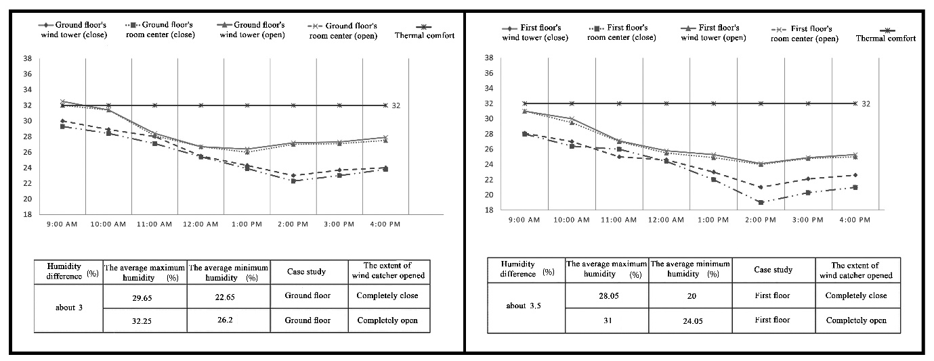

Diagram 3: The comparison of indoor air humidity collected by data logger based on open and closed wind catcher and openings in Salehi House from 9:00 to 16:00 once per hour (source: authors)

According to the data obtained for the ground floor, when the wind catcher and openings are closed, the average maximum humidity is 29.65%, and the average minimum humidity is 22.65%. When the wind catcher and openings are open, the average maximum humidity is 28.05%, and the average minimum humidity is 20%. In the first floor, when the wind catcher and openings are closed, the average maximum humidity is 28.05 %, and the average minimum humidity is 20 %. When the wind catcher an d openings are open, the average maximum humidity is 31%, and the average minimum humidity is 24.05%. According to the Diagram 3, the difference between open and closed openings is 3% in the ground floor. The research also shown that, the difference is about 3.5% in the first floor.

1. *The comparison of wind velocity*

Wind is a major element in design for architects. It has a major impact on the thermal comfort by changing the thermal exchange of a building's space either as a condensation phenomenon, or from the influence of air on the building (Ahmadinejad,1385,18). The flow of air affects body heat regulation, and men's thermal comfort in two ways: 1) it affects the amount of conduction and heat transfer between the skin and the environment; 2) it effects body cooling through moist skin cell. Increasing air velocity increases the amount of heat transferred (Qobadian&Mahdavi,1382,33). Air temperature and velocity, in the heat exchange through convection, depends on each other.

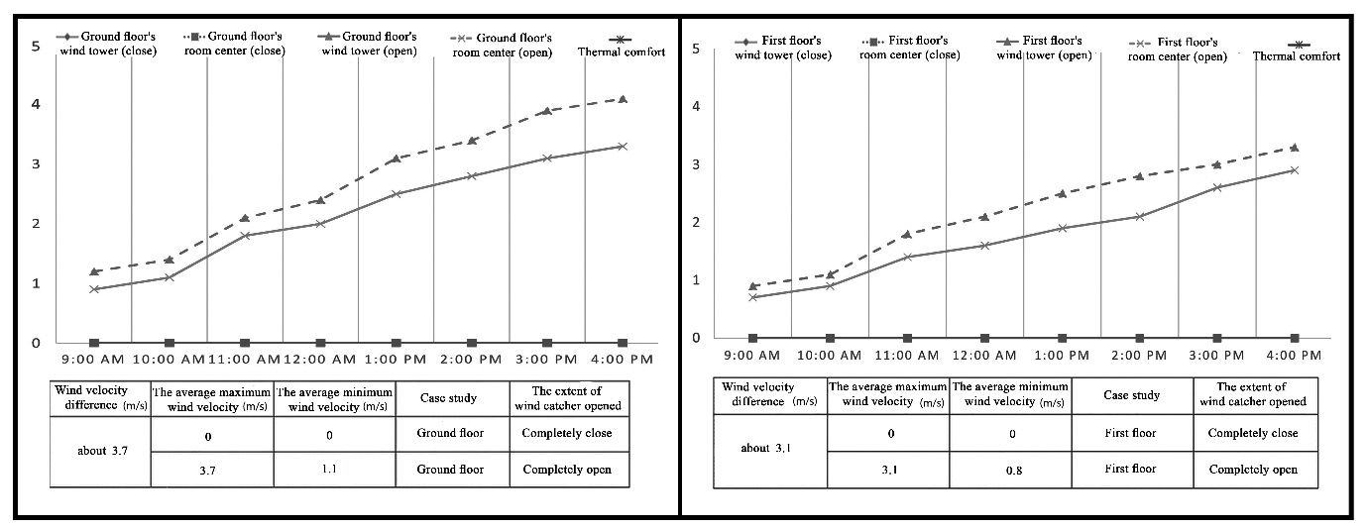

Diagram 4: The comparison of indoor air velocity collected by data logger based on open and closed wind catcher and openings in Salehi House from 9:00 to 16:00 once per hour (source: authors)

As seen in Diagram 4, when the wind catcher and openings are closed and in the absence of mechanical instrument, the wind velocity is zero. In the case when the wind catcher and openings are open, in the ground floor the amount of 1.1m/s and 3.7 m/s were observed. However, in the first floor the amount is about 0.8 and 3.1 m/s. Therefore, the difference of wind velocity in the ground floor is 3.7 m/s. In the first floor, it is 3.1 m/s. the environment becomes colder due to air conditioning that happens.

1. *The comparison of radiant temperature changes*

Heat is exchanged between the body and the environment through thermal radiation. The mean radiant temperature can be defined as the constant temperature of an imaginary black room, in which the radiant heat transfer from the human body is equal to the radiant heat transfer in the environment. In other words, the mean radiant temperature is the average radiation of all surface which is almost constant for most construction materials (Qobadian&Mahdavi,1382,35).

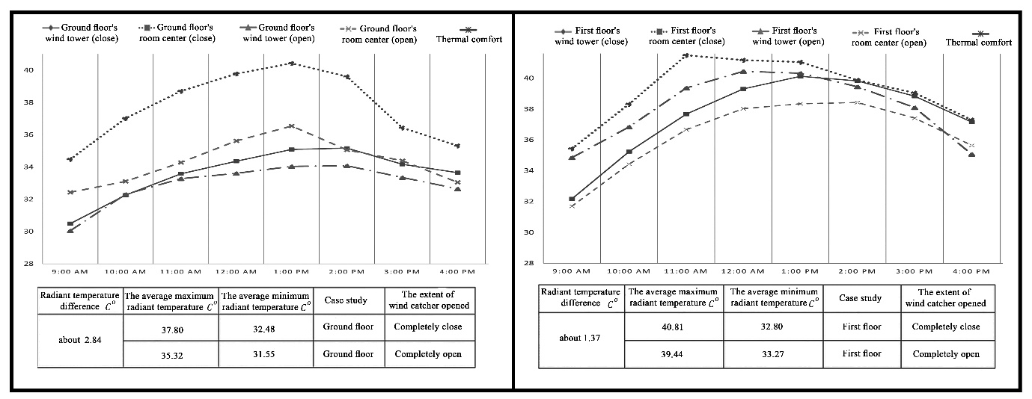

Diagram 5: The comparison of radiant temperature by Ecotect 2011 (source: authors)

According to Diagram 5, in the ground floor, when the wind catcher and openings are closed, the mean radiant temperature is 37.8 and 32.48 °C. When the wind catcher and openings are open, the mean radiant temperature is 35.32 and 31.55 °C. In the first floor, when the wind catcher and openings are closed, the maximum mean radiant temperature is 40.81 °C, and the minimum mean radiant temperature is 33.80 °C. When the wind catcher and openings are open, the maximum mean radiant temperature is 39.44 °C, and the minimum mean radiant temperature is 33.27 °C. According to data obtained, the difference in the ground floor is 2.84 °C. It is, however, about 1.37 °C in the first floor.

**4-2- Thermal Comfort**

Fanger presented thermal comfort range based on human body's heat exchange and its interaction with the surrounding (Fanger,1972,43-55).Since this method contains many of the comfort criteria, it is considered as a perfect method. That was offered as PMV in which comfort criteria such as climatic variables, type of clothing and activity are examined together. According to Table 1, PMV boundary is between +3.5 and -3.5. Those between +1 and -1 are in the comfort zones. The other ranges can cause dissatisfaction (Qyabakloo,1380,73). The CBE Thermal Comfort Tool is used to calculate PMV. As Diagram 6 represents, on the ground floor, the maximum and minimum values of the average comfort temperature is between +3.34 and +1.19, while the wind catcher and openings are closed. When they are open the values are between +0.67 and -0.96.

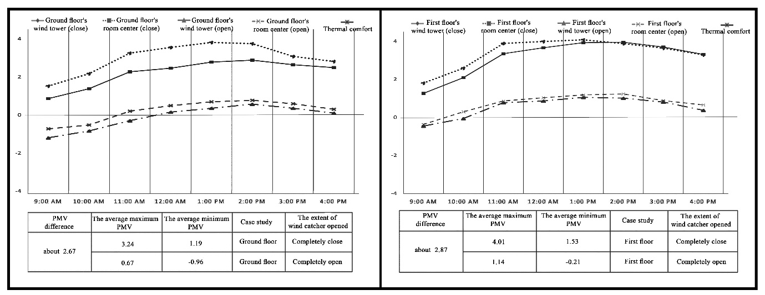

Diagram 6: the comparison of PMV through CBE Thermal Comfort Tool (source: author)

In the ground floor, the difference is about +2.67. In the first floor, however, the max and min of thermal comfort is +4.01 and +1.53 respectively, when the wind catcher is closed. When it is open, the difference the max and min are +1.14 and -0.21 respectively. The difference between the open and closed wind catcher is approximately +2.87.

Table 3: PMV in different hours (source: authors)

|  |  |  |  |  |  |
| --- | --- | --- | --- | --- | --- |
| **Cases** | **Time** | **Closed wind catcher** | | **Open wind catcher** | |
| **Beginning of wind catcher** | **Middle of room** | **Beginning of wind catcher** | **Middle of room** |
| **Ground floor** | 9:00 AM | 1.52 | 0.86 | -1.2 | -0.73 |
| 10:00 AM | 2.17 | 1.38 | -0.84 | -0.53 |
| 11:00 AM | 3.25 | 2.27 | -0.3 | 0.2 |
| 12:00 AM | 3.55 | 2.46 | 0.15 | 0.49 |
| 1:00 PM | 3.81 | 2.78 | 0.35 | 0.69 |
| 2:00 PM | 3.75 | 2.88 | 0.57 | 0.77 |
| 3:00 PM | 3.08 | 2.64 | 0.35 | 0.59 |
| 4:00 PM | 2.81 | 2.49 | 0.1 | 0.3 |
| **First floor** | 9:00 AM | 1.80 | 1.26 | -0.46 | -0.37 |
| 10:00 AM | 2.59 | 2.09 | -0.06 | 0.29 |
| 11:00 AM | 3.89 | 3.35 | 0.77 | 0.86 |
| 12:00 AM | 3.99 | 3.66 | 0.86 | 1.03 |
| 1:00 PM | 4.08 | 3.93 | 1.05 | 1.18 |
| 2:00 PM | 3.88 | 3.95 | 1.01 | 1.23 |
| 3:00 PM | 3.64 | 3.70 | 0.80 | 0.88 |
| 4:00 PM | 3.29 | 3.31 | 0.37 | 0.65 |

According to Table 2, one can understand when the wind catcher and the openings are closed, the warmest hour of the day is 13:00 and the coolest hour is 9:00. This is different when the wind catcher is open. In fact, in this case, the warmest hour is 14:00 and the coolest hour is 9:00. In the ground floor, the thermal comfort is in the range of very hot between 11:00-15:00. It is hot between 10:00-16:00. It is warm in 9:00. However, when the wind catcher and the openings are open, the values change, and all day long the temperature is within comfort range.

In the ground floor, when the wind catcher and the openings are closed, thermal comfort is in the range of very hot between 11:00-16:00, and in the hot range between 9:00-10:00. When the wind catcher and the openings are open these values have changed. It is in comfort range between 9:00-12:00 and 15:00-16:00. It is, however, warm between 13:00-14:00.

**4-3- Thermal Dissatisfaction**

ASHRAE Standard 55-2010 of PMV model can be used for determining the prerequisites for indoor conditions. At least 80% of residents' satisfaction is necessary. It means, PPD is better to be in a range of 0-20. As it can be seen in Diagram 7, in this research, the PPD was calculated through CBE Thermal Comfort Tool for Met=1 and clo=0.5.

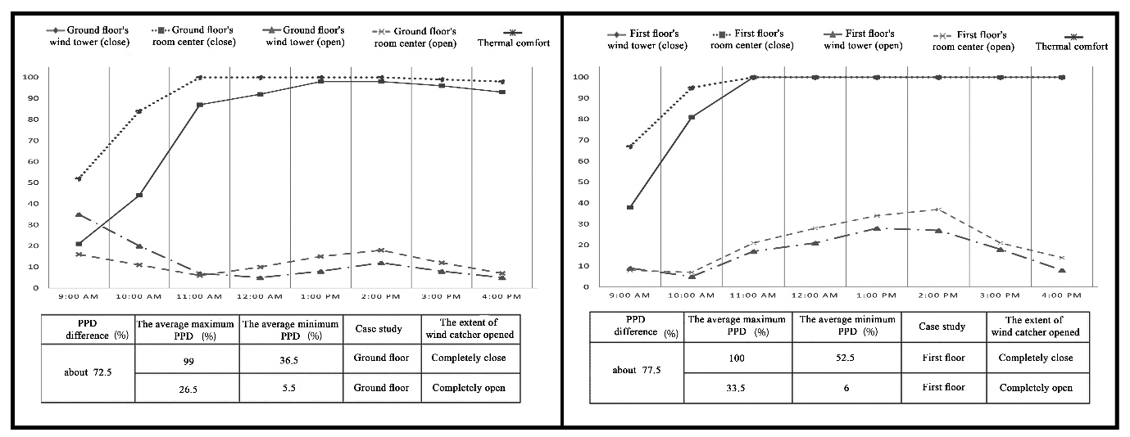

Diagram 7: The comparison of PPD via CBE Thermal Comfort Tool

According to Diagram 7, in the ground level, when the wind catcher and the openings are closed, the average maximum of PPD is 99% and the average minimum is 36.5%. When the wind catcher and the openings are open, the average maximum and minimum are 26.5% and 5.5%, respectively. The difference is 72.5% between open and closed wind catcher. In fact, it can be said that the amount of dissatisfaction reaches its minimum when the wind catcher is open; and this amount is acceptable.

In the first floor, similarly, when the wind catcher and openings are closed the average maximum of PPD is 100% and the average minimum is 52.5%. When the wind catcher and the openings are open, the average maximum and minimum are 33.5% and 6%, respectively. The difference is 77.5% between open and closed wind catcher. Based on the results, one can say the amount of dissatisfaction reaches its minimum when the wind catcher is open; and this amount is acceptable except between 13:00 and 14:00.

**Conclusion**

Due to its experiences and creativity, the traditional architect of Iran, has made a huge masterpiece, which is still in use in the new era and modern architecture. In this research, aimed at assessing the vernacular architecture, the effect of wind in thermal comfort of the houses enjoy wind catcher was examined. According to the analysis of the effect of wind velocity on the indoor condition of the building in Shiraz, some points were concluded through PMV and PPD diagrams.

When the wind catcher is open, the movement and wind speed will reduce the air temperature of the environment. Furthermore, it creates air conditioning and brings out moist air out into the building. The change in environmental factors has a direct effect on the thermal comfort and the level of dissatisfaction of individuals. An environment that is in an unfavorable thermal comfort environment can enter into the desirable range to prepare a habitable environment and minimize the percentage of people dissatisfied. This research certifies that this innovative technique is useful in structures. It also suggests that wind catcher to be used in modern buildings, especially in arid and semi-arid climate, to save energy and to prevent air pollution and to make buildings better place to live.

**Sources and references**

1. Ahadi, Aminallah, Alirezaee, Babak and Safaderani, verno, 2014, The study of the appropriate roof shape and the usefulness of using windward(Bodgir) and windage (Badkhour) in the natural ventilation of Chabahar, Housing and rural environment, No. 148, 33-44
2. Ahmadpour,Narges&Pourjafar,Mohammadreza,Mahdavinejad,Mohammadjavad,Yousefian,Samira(1396) The Role and Impact of Design Elements on the Quality of Thermal Comfort in Urban Open Spaces Case Study: Design of Pedestrian Way in Tamghachiha Pathway in the City of Kashan, Two quarterly articles of the University of Art and Architecture, No. 18, 59-79.
3. Andreou, E. (2014), The effect of urban layout, street geometry and orientation on shading conditions in urban canyons in the Mediterranean, Renewable Energy 63, 587 - 596.
4. ASHRAE Standard. 2011. “Heating, Ventilating, and Air-Conditioning Applications, American Society of Heating”, Refrigerating and Air-Conditioning Engineers, Inc.
5. Ataee, Houshmand, Fanae, Raziyeh, 2015, Impact of climatic elements in architecture and design of urban settlements Case study of Isfahan city, Urban and Regional Studies and Research, No. 61, 27-80
6. Bahadori,Nezhad,Mehdi(1985)"An Improved Design of Wind Towers for Natural Ventilation and Passive Cooling"; Solar Energy;vol35;No.2
7. Bahadori,Nezhad,Mehdi(1994)"Viability of wind towers in achieving summer comfort in hot ari dregions of the middle east" ;Third World Renewable Energy Congress, United Kingdom
8. Bahadori, Nezhad, Mehdi(1981) "Pressure coefficients to Evaluate Air Flow Patterns in Wind Towers" ;International Passive and Hybrid Cooling Conferences; Miami Beach; Florida
9. Bahadori Nezhad, Mehdi, 2008, iranian engineering masterpiece Winward(Bodgir), Yazda, First Edition, Tehran
10. Battle McCarthiy Consulting Engineers, 2002,Translation by Mahmood ahmadi Neghad, khak publishing, Tehran
11. Barzegar, Z., Mirshamsi, M. 2014. “Drawing the Timetable of Climatic Need by Means of Determining the Olgyay Method Thermal Comfort Zone in Shiraz Semi-Arid Climate in Iran, ICSAUD 2014: International Conference on Sustainable Architecture and Urban”, Istanbul, Turkey, accepted, on July, PP 30-31.
12. Bouchahm, Yasmina, Bourbia, Fatiha, Belhamri, Azeddine (2011), Performance analysis and improvement of the use of wind catcher in hot dry climate, Renewable Energy, Vol 36, pp 898-906.
13. Brager, G. S and R. d. Dear )2001(, Climate, Comfort & Natural Ventilation: A new adaptive comfort standard for ASHRAE Standard 55 Thermal Comfort Standard, In Proccedings: Moving Thermal Comfort Standards into the 21st Century )pp.59-78(,Windsor,UK.
14. Chen, Q., Glicksman, L.R., Lin, J., Scott, A., (2007). Sustainable urban housing i van Hooff, T., Blocken, B., (2012). Full-scale measurements of indoor environmental conditions and natural ventilation in a large semi-enclosed stadium: possibilities and limitations for CFD validation. J. Wind Eng. Ind. Aerodyn. 104-106, 330-341. n China. J. Harbin Inst. Tech. (New Ser.) 14, 6-9.
15. Chen, Q., (2009). Ventilation performance prediction for buildings: a method overview and recent applications. Build. Environ. 44(4), 848-858.
16. CIBSE (Chartered Institution of Building Services Engineers). (2005), Natural ventilation in nondomestic buildings. London: CIBSE.
17. de la Espriella, Carlos, "Improving Comfort by Using Passive Climatic Design: The Case of an Existing Mediumscaled Institutional Building in Bogotá, Colombia", (2002), Architecture, Energy & Environment HDM – Housing Development and Management, Lund University, Sweden, pp. 1-14.
18. Fanger, P. O. Ipsen, B. M. Langkide, G. Olesen, B. W. Christensen N. K. and Tanabe, S. 1985. “Comfort Limits for Asymmetric Thermal Radiation”, Energy and Buildings, Vol. 8, PP. 225 – 236
19. Ghobadian, Vahid, 1998, Climate study of traditional Iranian buildings, Tehran University, Third Edition, Tehran
20. Ha, J.K, Ha, E., (2006), “ Climatic Change and Interannual Fluctuation in the Long-term Record of Monthly Precipitation for Seoul’’ Int. J. Climatol, 26: 607-618.
21. Hejazizadeh, Zahra and Karbalaei Dari, Alireza, 1394, Thermal comfort in Iran, Geography, Journal of the International Geographical Society of Iran, no. 46, thirteenth, 22-39
22. Heijs, W. 1994. “The Dependent Variable in Thermal Comfort Research: Some Psychological Considerations, Thermal Comfort: Past, Present and Future”, Proceedings of a conference held at the Building Research Establishment, Garston, 9-10 June 1993, PP. 40-51.
23. Henson, J. L. M. 1990. “Literature Review on Thermal Comfort in Transient Conditions”, Building and Environment, Vol. 25, No. 4, PP. 309-316.
24. Höppe, P. )2002( "Different aspects of assessing indoor and outdoor thermalcomfort," Energy and Buildings, 34, 661-665.
25. Huang, C. J., & Wang, W. (2007), Climate Variability in the Equatorial Pacific Ocean Induced by Decadal Variability of Mixing Coefficient. Journal of Physical Oceanography, (37), 3–16.
26. Jendritzky, G.; Menz, G.; Schirmer, H. & Schmidt-Kessen, W. )1990( "Method of a regionoriented assessment of the thermal component of human bioclimate )UpdatedKlima-Michel model(," 114. Hannover: Beiträge Akad RaumforschungLandesplanung, 7-69.
27. Johansson E, (2006), Influence of Urban Geometry on Outdoor Thermal Comfort in a Hot Dry Climate: A Study in Fez,Morocco,Building and Environment 41, 1326-1338.
28. Karyono, T.H. )1997( "The Applicability of the ISO7730 )fangers comfort model( and adaptive model of thermal comfort in Jakarta,Indonesia," Proceedings of CLIMA 2000.
29. Kasmaie, Morteza, 1990, Climate and architecture of Khuzestan, Publication of Building and Housing Research Center.
30. Khodakarami, Mahnaz, 2000, The study of traditional architecture compatible with cold climate (Sanandaj City) Amayesh Geographic Quarterly, No. 10
31. Mahdavi Nezhad, Mohammad Javad and Javanroudi, Kavan, Comparative Study of Airflow Effect on two winward(Bodgir) Yazdi and Kermani Species,2011, Fine Art Journal, Architecture and Urbanism, No. 48,69-80
32. Mahmoodi, Behnaz, Mofidi Shemirani, Seyyed Majid, 2008, An Analysis of the Typology of Yazd Windwards(Badgirs) Architecture and Finding Optimal Functional Species, fine arts Quarterly, No. 36, 27-36
33. Mahmoudi Zarandi, Mahnaz (2009), Analysis on Iranian Wind Catcher and Its Effect on Natural Ventilation as a Solution towards Sustainable Architecture (Case Study: Yazd), World Academy of Science, Engineering and Technology, Vol. 54, pp. 574-579.
34. Matzarakis, A., & Mayer, H. (2000). Atmospheric conditions and human thermal comfort in urban areas. In: 11th Seminar on Environmental Protection. Environment and Health, (18), 10-24.
35. Mazidi, Mohsen, Mazidi, Mohammad, 2008, Numerical analysis of windwards(Bodgirs) operation as passive cooling systems in hot and dry areas, Iranian Journal of Energy, year 11, No.27, 39-46
36. McIntyre, D. A. 1982. “Chamber studies- reductio ad absurdum”, Energy and Buildings. Vol. 5, No. 2, PP. 89-96, 1982.
37. Memarian, Gholamhossein, Mohammad Moradi, Asghar, Hosseinali pour, Seyyed Mostfa, Heydari, Abolfazl, Doodi, Saeedeh, 2017, Wind(Analysis of wind behavior in natural ventilation of native housing in Qal'e Noi Sistan village with the help of CFD, Housing and rural environment, No. 157, 21-36
38. Matzarakis, A., (2007),"climate. Thermal comfort and tourism", Meteorological Institute, University of Freiburg, Germany.
39. Mehdizadeh Seradj, F. (2008), ''Using Natural Resources for Ventilation: Teh Applicaticn of Bodgirs in preservation'', APT Bulletin, Vol. 4, NO. 4, : 39-46.
40. Mirlotfi, Mahmoodreza, Tavakoli, Morteza, Bandani, Meisam, 2012, Comparative Study on the Situation of Settlement of Geographical Directions of Rural Housing and Energy Consumption in Sistan Area, Housing and Rural Environment Quarterly, No. 138, 32-52
41. Mohammadi, Hossein,2007, Applied Meteorology, Tehran University Publication, 186
42. Mostafavi, Mohammad Taghi, 1992, Windwards(Bodgirs) are the easiest and most popular phenomena in Iranian authentic architecture, First Volume, Jodaganeh Publication, Tehran.
43. Nicol, J. F., Humphreys, M. A. 2002. “Adaptive Thermal Comfort and Sustainable Thermal Standards for Buildings”, Energy and Buildings, Vol. 34, PP. 563-57
44. Olgyay, V. 1978. “Design with Climate: Bioclimatic Approach to Architectural Regionalism, Princeton University Press”, Princeton, New Jersey.
45. Pirnia, Mohammad, 1990, Iranian architecture practices, Islamic Art Publishing Insitute
46. Pirnia, 2005, Familiar with Islamic Architecture of Iran, soroush danesh, Tenth Edition, Tehran
47. Pourahmadi, Mahboubeh, Ayatollahi, Mohammad Hossein, 2012, Revival solutions for windwards(Bodgirs) of the village of Aghda, Housing and Rural environment, No. 140, 29-38
48. Qaybakloo, Zahra (2001) Estimation Methods for Thermal Comfort Range, Journal of Fine Arts, No. 10, 68-74
49. Razjoyan, Mahmood, 1988, Comfort by Architecture compatible with the climate of Tehran, Shahid Beheshti University
50. Sam .C.M ., Chung, K.P, (1997), Climatic data for building energy design in Hong Kong and mainland China, In proc; of the CIBSE National Conference 1997, London.
51. Shariat Zadeh, Ali asghar, 1995, The role of windward(Bodgir) in the southern part of Kavir Desert, First Congress on The historty of Urban Architecture of Iran, Kerman, 221-231
52. Swang, N.Y.C (1991), Air flow in and around buildings, Workshop on building energy management, Bangkok, pp. 17.
53. Taleb, H. & Taleb D. )2014( "Enhancing the thermal comfort on urban level in a desert area: Case study of Dubai, United Arab Emirates," Urban Foresty & Urban Greening, 13, 253-260.
54. Thompson, R.D. and Perry, (1997), A. "Applied Climatology", Principles and Practice, Rutledge.
55. Vakili Nezhad, Roza, Mahdizadeh Seraj, Fatemeh, Mofidi Shemirani, Seyyed Majid, Principles of Static Cooling Systems in Traditional Iranian Architectural Elements, 2013, No. 5, 147-159
56. Watson, donald and Labs, Kenneth (1983), Climate Design (Energy-Efficient Building Principles and Practices), Vahid Ghobadian and Mohammad Feiz Mahdavi, University of Tehran, Tehran.
57. Yaghoubi, M.A (1975), Twodimensional numerical simulation of wind flow and ventilation in a single building using the k-e turbulent model, Iranian journal of science and Technology, Vol 20, No 1, Transaction B, pp. 519-529.
58. Zomershidi, Hasan, 1994, Execution of traditional building, Zomorod Publication, Tehran