**Improving Results of Urban Design Research by Enhancing Advanced Semi-Experiments in Virtual Environments**

Amir Shakibamanesh

*Assistant professor of Urban Design, Department of Urban Planning and Design, School of Architecture and Urban Studies, Tehran Art University, Tehran*

***Email:***

[*shakibamanesh@ut.ac.ir*](mailto:shakibamanesh@ut.ac.ir)

**ABSTRACT:**There is abundant literature regarding virtual reality as a technology of interest in the present age. However, there are few comprehensive studies on strategies that can improve the level of urban design research using this technique. To investigate the issue, this paper first reviews the concept of virtual reality. Next, the opinions of experts in the field of virtual reality technology are summed up and key elements needed to create a virtual reality experience and key operators that establish the actual interaction of users with virtual environments are discussed. The use of Virtual Reality Modeling (VRM) in the urban design process and is also elaborated on. Uses of this technique in urban projects and advantages and limitations of its use in the field are discussed. Finally, the paper attempts to provide practical solutions and strategies to improve the quality of semi experiments developed virtual environment. This can improve the results and findings of research conducted with the technique. Strategies discussed in this article have been mostly derived from practical experience and research in recent years by the author. They can help provide a more robust analysis and reduce the errors made ​​in the virtual environment.

**Key words:** Urban Design, Virtual Reality (VR), Virtual Environment, Semi -experiment, 3D Digital Modeling.

INTRODUCTION

In the past few years, researchers in planning have taken full advantage of advances in three-dimensional (3D) graphics, computer simulations, digital video, interactive maps, virtual reality, and the Web, at least at the stage of prototypes, if not in actual planning practice. Some have argued that the possibility of modeling the built environment and being able to interact within it represents a paradigm shift in the urban design process that may fundamentally change the way in which designers communicate ideas and developments to the public. However, facilitating public participation by computer modeling is just one of the major benefits of digital modeling in urban design. Since the goal of the article is to engage in the effects of virtual reality technique, as an advanced level of computer 3D digital modeling, in urban design, we need to investigate the concept of virtual reality modeling and then discuss about its uses in urban design in detail.

**CONCEPT OF VIRTUAL REALITY**

*Virtual reality (VR)* can be defined as a medium composed of interactive computer simulations that sense the participant's position and actions and replace or augment the feedback to one or more senses, giving the feeling of being mentally immersed or present in the simulation (a virtual world) [1]. Indeed, in virtual environments, participants are immersed and surrounded by information, which is to scale and, which is 3 dimensional. The interface is very intuitive to use for exploring virtual environments because it is tightly coupled to the way people explore real environments. Viewers can look around in the model by turning and moving their heads, as they do naturally in real spaces. Because of the specific attributes of virtual interfaces, people develop a sense of actually being somehow present inside the model. And with this sense of presence, viewers could potentially, for the first time, perceive the modeled spaces as they would the real spaces [2]. So virtual reality provides urban designers, planners and architects with the ability to almost “experience” a proposed structure or site plan before it is built.

Virtual environments bring two domains together: the digital environment and users who participate in some way within such environments. Both the environment and users must be represented and of course connected together. Environment and users interact and within such interaction, various behaviors can be modeled. Moreover, the environment itself might be modeled independently of users and vice versa although to affect virtuality, these processes must come together [3].

*Key Elements that Create a Virtual Reality Experience*

The key elements in experiencing virtual reality are as following: [1], [4], [5]

***Virtual World.*** A virtual world is the content of a given medium. It may exist solely in the mind of its originator or be broadcast in such a way that it can be shared with others. On the other hand a virtual world can be defined as the description of objects within a simulation. When we view that world via a system that describes a collection of objects in a space and the rules and relationships governing those objects for us in a physically immersive, interactive presentation, we are experiencing it via VR.

***Immersion.*** The first steps towards VR involved building digital simulations as close as possible to single users, ‘immersing’ them within the environment in such a way that they were connected directly, through peripheral devices such as headsets, data-gloves and the like. Indeed immersion into [virtual reality](http://en.wikipedia.org/wiki/Virtual_reality) is a perception of being physically [present](http://en.wikipedia.org/wiki/Presence_(telepresence)) in a non-physical world. The perception is created by surrounding the user of the VR system in images, sound or other [stimuli](http://en.wikipedia.org/wiki/Stimulation) that provide an engrossing total environment. Immersion or sense of presence in an environment can be completely mental or can be completed by physical immersion:

***A. Physical immersion*** is a defining characteristic of VR, and it means bodily entering into a medium; synthetic stimulus of the body's senses via the use of technology; this does not imply all senses or that the entire body is immersed/engulfed. Examples of these VR interactive experiences could be achieved by using data gloves and multi-media head mounted display devices (HMD).

***B. Mental immersion*** is probably the goal of most media creators, and it is the state of being deeply engaged; suspension of disbelief; involvement.

In VR the effect of entering the world begins with physical, rather than mental, immersion. Because physical immersion is a necessary component of VR, our simple definition is not specific enough and many other media meet its parameters. So according to the degree of immersion virtual reality could be classified into two main types in the synthetic environment: Immersive and non-immersive virtual reality systems (Fig.1).

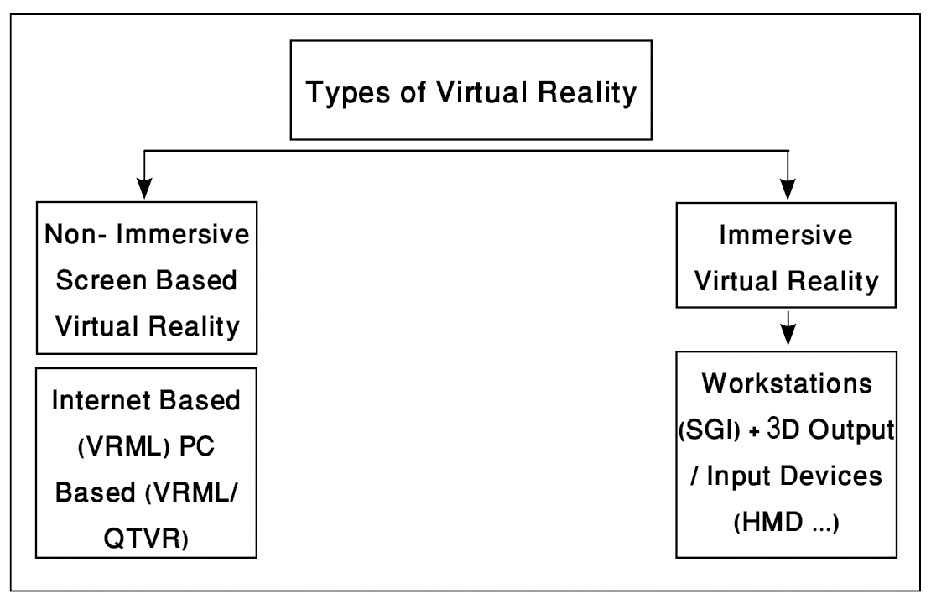

**Fig.1.** Types of Virtual Reality Systems [6]

***Sensory Feedback.*** Unlike more traditional media, VR allows participants to select their vantage point by positioning their body and to affect events in the virtual world. Indeed the VR systems provide direct sensory feedback to the participants based on their physical position. In fact, in a virtual reality system, usually eye, head or body movements are tracked and appropriate sensory feedback is produced and immediately presented for the subject.

***Interactivity.*** For virtual reality to seem authentic, it should respond to user actions, namely, be interactive. So interactivity can be defined in terms of the user/player's ability to interact with a world by changing locations, picking up objects and setting them down, flipping switches, and so on. For example, in an interactive environment when the user pushes a door, it will be opened.

Main Protocols for Interaction with Virtual Environment

The real power to interact in such environments would come from a very wide array of modelling types, which might be activated by users. Four kinds of protocols are as following: [3]

- Navigation Protocols

- Decision Protocols

- Analytical Functions

- Manipulation Functions

These protocols are explained briefly in table 1.

**Table 1.** Key protocols used in virtual reality; Source: [3]

|  |  |
| --- | --- |
| **Description of Protocol** | **Protocol** |
| Navigation protocols use for traversing and exploring virtual environments in the broadest sense. Navigation protocols do not deal simply with movement in 3D space but with the entire way in which users explore the information contained within the virtual environment. For example, a user may literally move across a map, accessing 3D scenes, photos, video clips, textual information, sounds and so on, and it is the overall process of access that is part of this domain. Note as well that part of the process of developing such environments involve logging and charting navigation so that the history of the ways in which users have interacted with their environment can be used positively to direct further interaction. | Navigation Protocols |
| Decision protocols use for interacting with other users and reaching agreement or otherwise over common problems and goals. The interaction that we are concerned with involves the analysis and design of urban systems and thus interaction that is important must involve extracting various abstractions from the urban scene. A good deal of this might be concerned with single user interaction with the environment itself but when users are required to jointly engage in some task, then the interaction of people with each other and with the environment in which the events occurred in it must be closely specified [1]. | Decision Protocols |
| Analytical protocols use for analyzing information, using a variety of formal and informal ‘scientific’ procedures, many of which might be part of conventional desktop software. Traditionally VR systems have hardly any analytical functions which users can employ to make sense of their environment because the emphasis, as we have seen, has been upon 3D representation and modeling through visual navigation[2]. | Analytical Functions |
| Manipulation protocols deal with ways in which information might be changed and combined, and new information introduced into the environment. In short, manipulation of any kind must be to some purpose and therefore is likely to involve the use of functions which indicate how this purpose is being achieved. | Manipulation Functions |

Finally, all four of these modeling functions - navigation, decision, analysis and manipulation - cannot be easily separated from one another for to implement one is only possible through the others.

**USING VIRTUAL REALITY MODELING IN URBAN DESIGN PROCESS**

Indeed, virtual reality takes 3D visualization a step further. When VR systems were developed in the late 1980s, a further window of opportunity opened for architectural and urban visualization, and it holds promise for public participation planning as well. VR tools can be used to communicate the experiential nature of urban settings [7]. Hence Virtual environments are poised to be the perfect representation tools for helping urban designers take decisions about urban spaces before they are built. Virtual reality supports the design process in several ways, enabling team members to analyze and navigate through the urban elements and spaces interactively, provide input into a simultaneous discussion of a proposal from the earliest stages onwards, and explain design proposals to a far wider audience than has been possible hitherto [8]. The major advantage of its usage as an analysis /design tool is increasing the engagement in and experience of the spatial configuration of the built environment. Consequently, it minimizes the probability of misconceptions that may result from conventional representations [9].

VR technology has produced artificial worlds that are increasingly more complex and detailed. It not only provided an easy way to visualize the site but also allowed individual urban designers to design, add buildings, and make changes to the plan [7]. Current VR programs for urban designing can be improved. As VR systems for public participation evolve, it will be important to develop ways to record the feedback of citizens as they interact with the virtual environment. The program should enable them to record thoughts, emotions, and preferences at different points along the way as they evaluate a proposed development. A Java applet could be used to interactively add nodes and attach annotations to the virtual world.

Everything about virtual interfaces seems to indicate that they would be perfect tools for simulating urban spaces. They seem to satisfy all the criteria for the perception of motion and space, as defined by Appleyard et al (1964). These factors are as following: [9]

***Apparent self-motion:*** speed, direction, and their changes (stop-go, accelerate decelerate, up-down, right-left).

***Apparent motion of the visual field:*** passing alongside, overhead, or underneath; rotation; translation; spreading or shrinking of outline or texture; general stability or instability; apparent velocity or lack of it.

***Spatial characteristics:***

- Presence and position of enclosing objects or surfaces, their solidity and degree of enclosure,

- General proportions of the space enclosed; scale with respect to the observer; position of the observer,

- Quality of the light which makes the space apparent; intensity and direction,

- Relationship of spaces in sequence: jointing and overlapping,

- Direction of principal views, which draw the eye toward different aspects of the spatial enclosure".

The convincing sense of presence and of being in the models need the same qualities required for assessing the feel of urban spaces. Indeed, these are the attributes missing in the other forms of traditional modeling and computer visualizations. The problems plaguing the previous forms of space representations were scale and depth cues. Because the models were viewed on a 2D screen, the third dimension (depth) of spatial information was diminished [2]. But in virtual modeling the stereoscopic vision used in virtual interfaces can recreate the third dimension of space and by using body tracking, the sense of presence and scale relative to the model emerges.

**Applications of virtual reality in urban design process**

According to the conclusions drawn by the author from the scientific literature on the subject of virtual reality, the most important functions and uses of virtual reality and its uses in the Urban Design process can be classified into six main categories including visualization, navigation functionalities, communication and participation functionalities, simulation functionalities, analytical functionalities and manipulation functionalities (Table 2).

**Table 2.** Uses of Virtual Reality in Urban Design Process; Source: [10]

|  |  |  |
| --- | --- | --- |
| **Utilization Benefits** | **Explanation** | **Usage** |
| * **Viewing** the visual configuration of an existing urban pattern; * **Visualizing** the impact of proposed urban design; * **Generating** 2D Visualizations (e.g. maps & perspectives) at various levels of realism; * **Extruding** spatial features in 2D GIS maps to create 3D perspectives; * **Generating** Interactive and dynamic 3D virtual reality models by VRML ; * **Representing** the study area at different geometrical and geographical scales; and * **Representing** the study area with different types of media. | Using virtual reality techniques to create 2D and 3D visualizations to represent the study area. | **Visualization** |
| * **Promoting** navigation ability in virtual environments and creating similarity in terms of perception between modeled urban spaces and real one; and * **Giving** a choice to the subjects in order to achieve preferred position in virtual environments. | Traversing and exploring the urban environment in the broader sense, including exploring the information contained within the virtual environment. | **Navigation Functionalities** |
| * **Communicating** project-specific design data and information within the design team; * **Offering** an opportunity to recognize and understand the technical and visual aesthetic data easily; * **Communicating** design concepts-or scenarios- within the design team and help selecting the best design alternative-scenario; * **Assessing** the proposed development(s) within the design team; * **Communicating** and assessing the proposed development with city authorities; * **Carrying out** the major reviewing process to city authorities; and * **Breaking down** the psychological barriers to participation that the public may face when expressing their points of view at public meetings; | VR city models can be used to facilitate the dialogue with the local authority and the other stakeholders involved for a specific scheme and allow general debate on the city’s future developments. VR urban models can be used at two levels of complexity/engagement; low level, as a presentation and evaluation tool as well as a planning support - analytical tool, more advanced, real-time editing tool to be used by specially trained professionals. | **Communication and**  **Participation Functionalities** |
| * **Supporting** the decisions in form of checking the effects of main and special actions on urban environments; * **Simulating** pedestrian movement/vehicular traffic; * **Investigating**, assessing and forecasting the visual effects of alternatives or scenarios; * **Investigating**, assessing and forecasting the effects of urban design guidelines on the study area; and   - **Testing** economic and physical impacts of a proposed design. | Virtual reality can be used effectively to simulate the effects of changes in project variables, in form of dynamic processes. For example, using simulations in a virtual reality environment, the researcher can simulate and predict movements of pedestrians and vehicles in an urban environment as affected by certain changes in key components (e.g. removing, adding or making changes to the network structure, surrounding streets land uses, etc.). Using sophisticated computer graphics in conjunction with relational databases and GIS, and creating a virtual reality simulation prepare an opportunity for the public to see the future of cities, neighborhoods, streets etc after implementation of plans. | **Simulation functionalities** |
| * **Modeling** **and analyzing** spatial/structural relationships between physical components; * **Analyzing** the study area systems (circulation, Land-use, site analysis, etc.); * **Analyzing** the visual/3D characteristics (townscape, skyline, building views, etc.); * **Graphic reduction** in order toisolating visual information to reveal spatial relationships; * **Layering and delayering**: Synthesizing multiple sets of spatial relationships; * **Structured query** of data to generate new layers of data and information; * **Overlay analysis** of different spatial data layers; * **Thematic mapping** of various design aspects; and * **Comprehensive analysis** of a planning scenario. | Grouping, ordering, and transforming information using a variety of formal and informal scientific procedures to abstract, generalize, and distinguish information. These can help to Integrate geometric and non-geometric information of various entities in an urban setting to facilitate both spatial and statistical analysis that help the analyst to discover and understand its characteristics. | **Analytical Functionalities** |
| Decision – support and testing the effects of certain important decisions on urban environments. |
| * **Manipulating** details of proposed design, such as color, material, light, etc., * **Modeling** proposed guidelines for newly developed areas; * **Manipulating** the structural and physical configuration of proposed design, by changing, for example, street patterns, building scales etc., * **Replacing** some design elements with another; for example A type windows with B type. | Editing, adding, erasing, and changing information such as in creating or modifying a design alternative. | **Manipulation Functionalities** |

The definition of each category has created a coherent, well-defined framework which allows classifying the array of modeling functionalities and techniques with minimum overlapping or duplication. However, classifying the array of modeling methods and applications involves a certain extent of overlap and duplication.

**Benefits and Limitation of Using Virtual Reality Systems in Urban Design Process**

In Table 3, some of the benefits and limitations of using virtual reality in urban design projects are presented. Obviously, the advantages and limitations listed in Table 2 are not limited to what stated here and with the advancement of technology and tools used in this area as well as new research on different topics, the related knowledge can develop.

**Table 3.** Benefits and barriers of implementing virtual reality models in urban design; Source: [2], [7], [12], [13], [18]

|  |  |  |
| --- | --- | --- |
| **Explanation** | **Considerations** | **Benefits / Barriers** |
| What makes virtual environments distinct from all other computer interfaces is that the human being has the illusion of being completely surrounded by spatial information. In these computer generated environments, the human being becomes a participant. The illusion is sufficiently compelling for participants to develop a sense of actually being present within the synthesized space/place. It makes the interpretation of the information and interaction with the environment, particularly easy because it requires the same spatial perceptual skills as does the interpretation of real environments. | **Sense of presence in a place/space and interactivity** | **Benefits of Implementing Virtual Reality Urban Models** |
| For comparing the traditional visualization with new computerized visualization we should consider virtual reality, in front of traditional 3D models. It's clear that with attention to costs of variables such as human work efforts, technologies, tools and materials that should be used, and also the scale of a project, virtual reality will be cost lower than traditional methods.  On the other hand, in more cases building a virtual environment can be less expensive than building or arranging access to an special situation in a real-world environment. | **Cost** |
| A critical advantage of virtual environment is that it provides the capacity to selectively display information. Indeed virtual reality allows for the exploration and communication of more complex systems. It can facilitate direct depiction of movement and change, multiple views of the same data, user interaction with maps, and realism through 3D views. On the other hand virtual reality can facilitate public participation through the ability of presenting complex data. | **Ability to epresent complex contextual data** |
| For different purposes (educational, municipal, commercial, etc.) various qualitative data can be attached to the VR models. This empowers the model to be used by a multiple usages for different circumstances and users. This also enables a user to have instant access to diverse data. | **Ability to attach qualitative data to the models** |
| Traditional tools tend to be inflexible in terms of scale. On the other hand, computerized visualization methods which are implemented in a virtual environment have the ability to present various scale shifts. The ability to zoom in on a small area and then to zoom out beyond the immediate neighborhood is very useful; a model of the region can quickly be replaced with a model of the city, a neighborhood, or even a specific house. The capacity of VR systems to move between scales is crucial to understanding how conditions beyond the study area affect site design decisions. This capacity enables users to interact with data in a completely new way, seeing patterns that were hidden before understanding spatial relationships that were previously unclear. | **Scale flexibility** |
| In contrast to the animations and pre-determined fly through, photomontages, etc., VR Urban models provide freedom of movement to its user. This freedom enables users to see and experience the model from their own viewpoint with no external participation. Being able move in and out of the model (bird’s eye view to human scale) also enables users to see the model in different levels of details as well. | **Freedom of movement (movement between various spaces with different levels of details)** |
| Traditional methods work well when the planning issue is simple, when the aim is to create a general vision for a community’s plan, or when it is early in the planning and design process. They are much less effective when the goal is to evaluate potential designs and to decide between various elements in a design. None of the traditional methods allow the participants to visualize realistic representations of potential design alternatives of a proposed development, along with an ability to see many alternatives at different scales. Virtual reality 3D models allow participants to view a fairly realistic model of what the potential designs may look like in the actual context. | **Evaluating potential designs** |
| Another drawback to using traditional tools is that they make it difficult to annotate and record the negotiation and discussion process as it is under way. Comments and discussion may be lost. But virtual reality techniques, by using hypermedia systems and attaching the recorded voices, videos, explanation texts, etc., can solve this drawback. | **Annotating the designing process** |
| Using VR urban models on different platforms like networks, intranets, etc. enable quick and accurately updated information sharing. Furthermore, because it is portable different parties involved can easily access it and give feedback at the same time. | **Formally, and informally sharing data with diverse stakeholders** |
| It is much easier to control and modify situations in a virtual environment than in a real-world environment. | **Control** |
| By using a virtual environment, any real danger, harm, or risk to human subjects can be avoided but still achieve many of the dynamics of a real-world environment. | **Safety** |
| VR city models like a real city can bring together various experts from wide range of disciplines to contribute to make a better city (from planners to architects to landscape architects to infrastructure constructions to traffic engineers to health care works to academics to surveyors to real estate marketing etc.). | **Ability to involve diverse disciplines together under one roof** |
| The lack of needed software, hardware compatibility, etc. | **Technical issues** | **Barriers to Adopting Virtual Reality Urban Models** |
| One drawback to virtual reality visualization technology, however, is that the images can be so realistic and persuasive that they become misleading for people. With the capability of creating very concrete, realistic images, there is the danger that audiences may understand a given created an image to constitute reality. Indeed Just as these tools can be used to create compelling representations of future urban development, they can create compelling misrepresentations as well. | **Seduction of virtual environment** |
| Virtual Reality systems aren't pervasive yet and a large amount of users are unfamiliar or can't communicate with the modern tools. It is impossible for everyone to personally interact with the virtual reality systems. Furthermore, many people are still quite intimidated by computers and will retreat from a computer-dominated process. Indeed, virtual reality visualization technology is not widely accessible. | **Virtual Reality systems aren't pervasive yet** |

**ADVANCED SEMI EXPERIMENTS: AN ATTEMPT FOR INTRODUCTION OF SCIENTIFIC AND EMPIRIC METHODS TO THE FIELD OF URBAN DESIGN.**

By using virtual reality techniques urban designers can direct their qualitative studies toward quantitative researches. This can lead to elimination of much of the guesswork in urban design projects. Indeed, in an urban design project for implementing some experimental researches in a proposed urban space, urban designers should have an ability to recognize and control the main effective variables. Doing such experiments is extremely hard and often impossible in a real environment. However, virtual environment creates an ability to test ideas in "real time" in a "three-dimensional" space during the design process.

Such an approach to virtual reality can, to a huge extent, change many traditional techniques in urban design and create the possibility of extensive studies in this area. Obviously, such an approach can create and develop virtual reality laboratory to perform exact qualitative and quantitative studies with supplementary results.

Actually, "virtual reality experimental laboratories" provide a semi-real ground for architectural environments or urban spaces in the virtual environment and can promote knowledge and analyses as well as power in decision and policy making in Urban Design. Many researchers have tried to use such as laboratories to do logical and scientific tests on semi-real samples simplified from the real world and come to conclusions based on the results of such tests. Therefore, often, the term "semi experiment" is used to refer to these studies. They mostly use correlation[3] and causal (experimental) research[4] (with laboratory semi- experiment field approach[5]). Thus, research in Urban Design based on virtual reality technique provides an environment for laboratory studies (with the ability to control experimental variables). Moreover, as these studies are done in a semi-real context, they can be classified as causal (semi)field studies.

**ENHANCING URBAN DESIGN RESEARCH THROUGH IMPROVING SEMI EXPERIMENTS CONDITIONS IN VIRTUAL ENVIRONMENTS**

The paper is an effort to improve the quality of results via using some strategies to reduce errors and increase the possibility of having a stronger scientific analysis in tests simulating urban spaces in the virtual environment. To this end, some of these strategies which are mostly taken from practical research by the author will be discussed.

**Maximum semi - reality of the environment**

In urban design studies, effort should be made to provide maximum realism in visualization of virtual environment. In this regard, ensuring maximum reality in visualizing building components and modeling materials and textures used in building facades, floors etc. can cause the urban space to look more natural and realistic [10].

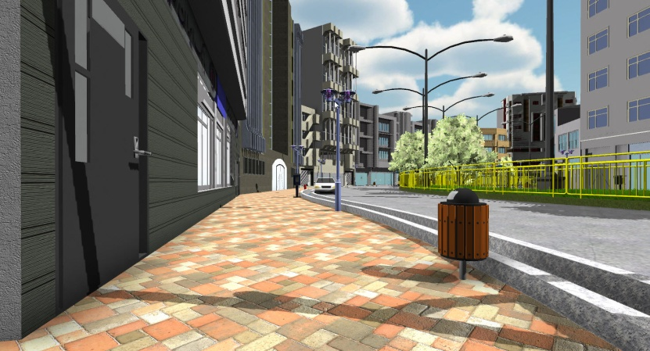

**Fig.2.** Creating realistic virtual environments through visualization measures; Source: [11]

**Improving the quality of experience through simulation of events expected in an urban space**

One of the limitations in this regard is that including all real environmental events in urban simulation in virtual environments is impossible. However, efforts should be made so that in testing simulation of urban spaces in virtual environments, opportunities are created for common urban space events. This will make the results more realistic. If in urban simulations, for example, displayed virtual environments do not look dynamic and vibrant through the movement of their elements (such as cars), they will not be able to convey the feeling and experience of a realistic urban space to observers. In this regard, measures such as adding human personage (characters) with expected movements in urban spaces, simulating natural movements of cars on roads being tested and providing natural movement for elements and details in the environment (such as flags, trees and grass in the median strip) help the urban space looks more natural. In fact, these events can enrich the individuals' perception of the virtual environment and contribute to generalizability and reasonability of results [10].

**Improving the quality of human navigation in virtual environments**

**Providing semi real navigation speed.** To increase generalizability of findings of urban design studies carried out in virtual environments to real conditions, they should maximize the similarity between movements in virtual spaces and those in real spaces. A key issue in this regard is that of navigation speed in virtual environments which should be consistent with natural navigation speed in real urban environments. Though such speed in the real environment is largely dependent upon factors like age, height, weight, physical condition, culture, gender, pavement materials, etc., based on the findings in the literature, average walking speed is about 5 km/h (1.38 meters per second) [14]. On the other hand, since the movement speed in the virtual environment is often perceived slightly faster than in the real space, in order to achieve the maximum level of confidence in test results of urban design research, lower navigation speed than that in real environments (about 1.27 meters per second) can be calculated and included in the navigation system of a subject's avatar [10].

**Simulating human natural walking cycle on** **sine wave.** In urban design research, to make subjects' navigation in the test environment as much realistic as possible, walking cycle in successive steps should be simulated in the virtual environment similar to that in the real environment. In other words, in urban simulations process, the path seen from the observer's eyes in the virtual environments should not be like that seen from a fixed camera, but the camera (like the eyes) should be set at a height equal to the height of a man in movement conditions with appropriate steps taken. This way, a completely natural sine wave is passed along the vertical axis (vertical position of the observer's body) (Fig.3).

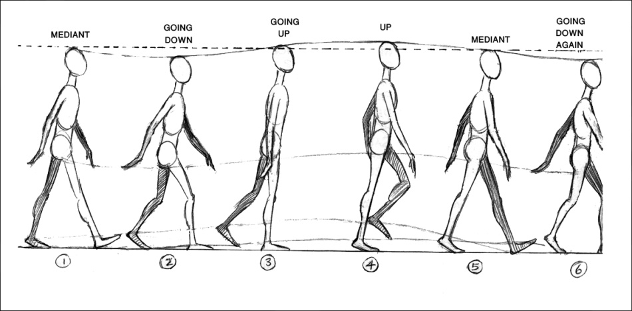

**Fig.3.** The natural cycle of human movement in virtual environment simulations; Source: [15]

**Preparing high levels of immersion in virtual environment by movement simulation.** Possibility of real-life-like modeling of environment, along with motion simulation in urban design studies makes it possible for a participant to navigate in space and perceive the desired qualities, and achieve the sense of presence in place. Obviously, such a tool could be used to make changes to the existing urban design environment and to make new designs for a clear context in a more purposeful fashion. Thus, urban designer can, before establishing the design, put design alternatives in the virtual environment under investigation in order to measure the behavior and ensure public acceptance of space before preparing the action plan for implementation of the project in the real context.

In this paper, for creating a fully immersive urban model and also better simulating viewer movements, which can be efficaciously implemented in urban design surveys, the author introduces a new technology which is called Virtusphere (Fig.4). Virtusphere is a virtual reality system, which fundamentally changes the way of human-computer interaction. Virtusphere consists of a large hollow sphere located on a special platform allowing the sphere to rotate at 360 degrees. A user wearing a virtual helmet on his/her head can walk inside the sphere. The sphere allows the user to move in any direction for any distance avoiding collisions with real world objects. A sensor under the sphere determines user’s movement in space. A computer builds a corresponding three-dimensional image based on live data from all sensors and the manipulator and transmits it to the display and the user's virtual helmet. Virtusphere is a natural user interface. It allows users to go deeper into virtual space and interact with it.

Indeed this tool can simulate the participant physical movements in different directions and with various rhythms (such as walking, running, jumping, etc.). On the other hand, because of its sphere form, the user can navigate along an indefinite length. Hence according to these features, virtusphere can be used in urban design researches for analyzing and investigating users behavior, perception and movement desires in urban spaces.

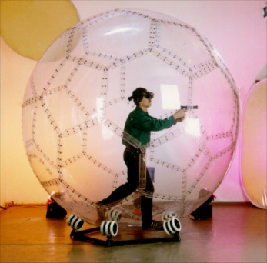

**Fig. 4.** Using a Virtusphere can create high levels of immersion in virtual environment. Source: [16]

**Facilitating the subject's movement in the scene to find a preferred perspective**

One of the factors influencing people's perception of their surroundings is that of preferred distance and physical position and orientation relative to the three-dimensional space. In general, as the observer walks through an environment, the view gives rise to a scene gist, that changes slowly as the observer walks [17]. In fact, in a given scene, some perspectives are better than others and observers can obtain a sense of how to walk through it to get the best perspective.

Obviously, finding such a position in the tests conducted in virtual environments can help make a better sense of navigation in the space. It is therefore recommended that in urban design research, hardware systems with greater efficiency and powerful game engines be used in virtual environment simulations so that individuals can simply change their position, distance and directions relative to the space[6] [10].

**Dubbing according to the real sounds of an urban environment**

In order to improve the quality of simulated environments in urban design studies, effort should be made to record real sounds of an urban space to be played for the subject when passing the pathway. Moreover, game engines (such as Unity 3D) can be used to create a high quality audio simulation for the street space. Therefore, when a car approaches the moving subject, its sound should seem closer to the individual and fade away slowly as it goes away. This software can also help to include the sounds of the subject's steps so that when the pedestrian takes steps in the space, the appropriate step sounds reach his ears. Results of past studies show that tests in which special attention is paid to dubbing and soundscape can give a sense of walking in an urban pathway more effectively [11].

**Controlling the movement zones**

One of the important strategies that can be used in urban design simulations to make the results more logical and reliable is that of providing maximum operating authority for subjects in the virtual environment. In this regard, subjects should be able to use virtual reality technology to move in different directions by their own free will and move their heads to view and perceive different perspectives. However, in many cases, to ensure logical results from the designed tests, subjects' movement conditions must be controlled indirectly. For example, if the subject moves abnormally across the street, goes up and down the steps leading to the test road for sake of curiosity or likes to enter and watch the interior of all simulated buildings, the validity of the researcher's expected results is undermined. Therefore, to solve this problem, measures should be taken in simulations so that subjects can move only in specific, targeted areas or their entry to some simulated buildings is deliberately limited [10].

Conclusion

As mentioned in the article, few studies have been carried out concerning practical ways of promoting urban design in virtual environments. In this regard, in the first part of this paper, the concept of virtual reality is discussed and the elements, conditions and requirements necessary to create a correct and scientific virtual environment are addressed. Then the virtual reality is investigated not only as a general issue, but also as a practical and operational process within the urban design framework. Since the paper has discussed about the utilizing virtual reality in the context of urban design studies, and focused on virtual reality applications in urban design projects, and advantages and limitations of this technique in this area.

As discussed in the paper, by using city experimental labs, urban designers can create new opportunities for analyzing urban 3D spatial structures. Implementing such labs make it possible to evaluate, experiment and analyze the effects of proposed plans by "Semi Experiments". These labs can create new tools for urban designers to involve in designing 3D structures more precisely and prepare a novel methodological framework for studying in this field. Hence the author suggests some practical methods which lead to promoting the quality of semi experiments in virtual environments and hereby improves the findings of researches. Indeed, the paper attempts to provide practical solutions and strategies to improve the quality of semi experiments developed virtual environment. These strategies can improve the results and findings of research conducted with the technique.

Maximizing semi - reality of the environment, simulating events expected in an urban space, improving the quality of human navigation in virtual environments (through some considerations such as providing semi real navigation speed, simulating human natural walking cycle on sine wave, and preparing high levels of immersion in virtual environment by Movement Simulations), facilitating the subject's movement in the scene to find a preferred perspective, dubbing according to the real sounds of an urban environment and finally controlling the movement zones are the proposed methods of the paper.

However, despite all the advantages and strengths of using virtual reality in urban design, there are questions and issues in this regard to be investigated and answered in the form of future studies and research. Among these, the following points and questions can be mentioned:

- Are the perceptual errors in virtual environments a level that allows the results of studies in these environments to be generalized to the real ones? For example, can the errors caused by perception of depth in virtual space be considered negligible? Furthermore what techniques can be used to decrease, to a reasonable extent, these errors in such studies?

- How much do charm and appeal of the masses and spaces built in the virtual environment help attract the users' attention and makes the perception in the virtual environment distinct from the real space?

- Obviously, conducting all studies in an urban context without the presence of its major players, i.e. people, lacks scientific value. Thus the line of studies can be done to show how presence of people's avatars can be facilitated and also to provide real-life conditions for simulating social interactions in the real world and virtual environments.

- Can we facilitate the participation of individuals and groups involved in urban design projects, and at the same time, allow users in the virtual space to make changes in such an atmosphere? Clearly, in this way we can implement people' views about the environment in the form of a new type of partnership, in which people can directly model and implement their comments in the environment.

It goes without saying that answering the above questions can allow for the implementation of scientific techniques of virtual reality in urban design studies and help this area compete with other scientific advancements.

**REFERENCES**

[1] R. Sherman W and B. Craig A.: 2003, Understanding Virtual Reality; Interface, Application, and Design, Elsevier Science Press, USA.

[2] Henry D.: 1992, Spatial Perception in Virtual Environments: Evaluating an Architectural Application, thesis for the degree of master of science, University of Washington, Weshington DC.

[3] Batty M; Dodge M; Doyle S and Smith A.: 1998, Modelling Virtual Urban Environments, Center For Advanced Spatial Analysis (Casa), University College London, London.

[4] Bourdakis V.: 1997, Virtual Reality: a Communication Tool for Urban Planning in A. Asanowicz and A. Jakimowitz (eds), "CAAD - Towards New Design Conventions", Technical University of Bialystok, Poland, 1997, pp.45-59. Available at: <<http://fos.prd.uth.gr/vas/papers/CAAD-TNDC/>>

[5] El Araby M.: 2002, Possibilities and Constraints of using Virtual Reality in Urban Design, Proceedings of the 7th International CORP Symposium, Vienna, Austria. Available at: <<http://www.corp.at/archive/CORP2002_Araby.pdf>>

[6] Mahmoud, A.H.A.: 2001, Incorporating Virtual Reality to establish a more tangible process of Landscape Architectural Design for its participants: bridging the socio-professional gap between them, Ph.D. Dissertation, University of Sheffield, UK.

[7] Al-Kodmany, K.: 2002, Visualization Tools and Methods in Community Planning: From Freehand Sketches to Virtual Reality, Journal of Planning Literature, Vol. 17, No. 2.

[8] Fraser M. and Bjornsson H.: 2004, Real-time Modeling in Design Education and Practice, Urban Design International, Vol.9, pp. 187-196.

[9] Appleyard D, Lynch K & Myer J. R.: 1964, The View from the Road, M.I.T Press, Cambridge.

Gottig R, Newton J, and Kaufman S, 2004, "A Comparison of 3D Visualization Technologies and their User Interfaces with Data Specific to Architecture", in: J. Leeuwen, and H. Timmermans (Eds.) "Recent Advances in Design and Decision-Support Systems", Dodrecht, The Netherlands, Kluwer Academic Publishers.

[10] Shakibamanesh A.: 2013, The Effects of Spatial Configuration and Physical Structure on Pedestrians' Subjective Experience of Time Perception Using Virtual Reality, PhD Thesis, Department of Architecture and Environmental Design, Iran University of Science and Technology, Tehran, Iran.

[11] Shakibamanesh A and Ghorbanian M.: 2014, Using Advanced Approaches in Urban Design Researches; a Mutation from 3d Digital Models to Virtual Reality, in: Brusaporci, Stefano (Eds.) "Emerging Digital Tools for Architectural Surveying, Modeling, and Representation", Pennsylvania, IGI Global (in Press).

[12] J. Park A; W. Calvert T; Brantingham P and Brantingham P.: 2008, The Use of Virtual and Mixed Reality Environments for Urban Behavioural Studies, PsychNology Journal, Vol.6, No.2, pp. 119-130.

[13] Thompson E. M, Horne M & Fleming D.: 2006, Virtual Reality Urban Modelling-an Overview, CONVR2006 6th International Conference on Construction Applications of Virtual Reality, Orlando, Florida.

[14] Aspelin K.: 2005, [Establishing Pedestrian Walking Speeds](http://www.westernite.org/datacollectionfund/2005/psu_ped_summary.pdf), [Portland State University](http://en.wikipedia.org/wiki/Portland_State_University).

[15] Williams R.: 2009, The Animator's Survival Kit--Revised Edition: A Manual of Methods, Principles and Formulas for Classical, Computer, Games, Stop Motion and Internet Animators, Macmillan.

[16] Virtusphere.: 1999,Virtusphere, [on line]. [Accessed 7th Jun 2014]. Available at: <<http://www.virtusphere.com>>

[17] Oliva A; Park S, and Konkle T.: 2011, Representing, Perceiving, and Remembering the Shape of Visual Space in "Vision in 3D Environments", (ED) by L. R. Harris and M. Jenkin. Published by Cambridge University Press.

[18] Whyte [J](http://www.google.com/search?tbo=p&tbm=bks&q=inauthor:%22Jennifer+Whyte%22).: 2002, Virtual Reality and the Built Environment, Architectural Press, Oxford.

**ENDNOTES**

1. There is some work on collaborative spatial decision-making using GIS which heralds this kind of interaction, but there are few case studies as yet.
2. There is extensive research about combining GIS-based analyses based on interactive simulations of virtual reality.
3. The main purpose of correlation research is to determine whether there is a relationship between two or more quantitative (measurable) variables and if so to measure the extent of that relationship. The purpose of a correlation study is to establish a relationship and use correlations to predict.
4. In this type of research, the causal relationship between two variables is studied. Causal studies are often carried out through experiment designs. Depending on the type of variable control they are classified into "laboratory" and "field" studies.
5. Laboratory experiment is a type of causal research where the variance and distribution of all potential independent variables affecting the variable under investigation are kept at a minimum. This is done by limiting the study to a physical location separate from the normal conditions. On the other hand, in the experimental research following a field experiment approach, research is done in actual situation where one or more independent variables are manipulated by the researcher under carefully controlled conditions and the effects of these changes are examined.
6. It should be noted here that this occurs in real space involuntarily with the least amount of focused attention based on psychological habits, established routines and crowd presence.