***Article title:***

*An inquiry in historical evolution and retrieval of the process of formation and transformation of Shah Nimatullah Wali complex, Taft, Iran*

***Author’s name:***

**Karim Mardomi**

Assistant Professor, Department of Architecture & Environmental Design,

Iran University of Science & Technology

K_[Mardomi@iust.ac.ir](mailto:Mardomii@iust.ac.ir)

**Mohammadreza Noghsanmohammadi**

Assistant Professor, School of Art & Architecture, Yazd University

[Mohammadi@yazduni.ac.ir](mailto:Mohammadi@yazduni.ac.ir)

**Mohsen Dehghani Tafti**

Master Architecture, Department of Architecture & Environmental Design,

Iran University of Science & Technology

[Mohsen_dehghani@arch.iust.ac.ir](mailto:Mohsen_dehghani@arch.iust.ac.ir)

Tel: (98)9381868022

*An inquiry in historical evolution and retrieval of the process of formation and transformation of Shah Nimatullah Wali complex, Taft, Iran*

**Abstract**

*The recent study aims to explain and retrieve the process of formation, and deals with the morphological evolution of the historic centre of Taft town, Shah Nimatullah Wali complex, that belongs to the thought of Nimatullahi Sufism. This complex has always been under construction, development, change and continuity during 6 centuries and with the close interaction with natural, social, religious and political morphologies of context. To achieve this purpose, the first step to encounter the complexity of the form of the complex, was the statement that "****it seems necessary that all constituent parts and components of Shah Nimatullah Wali complex as a whole be coordinated with the natural bed, the longitudinal form of the town and water direction****". Then, according to this statement , we proceed the chronology of the complex with regard to the definition of sequence of building acts in different historical eras. In addition the process of formation and spatio-temporal formation of the historic center of a town, what is obtained from the study, includes finding the place and date of formation, changes and continuity of different constituent parts and components of Shah Wali complex based on its evolution, which means the demolition of the old Takiyya in Timurid Era (belonging to Sufi thought in accordance with natural form of Taft town) and construction of new Takiya (belonging to Shi'a thoughts contrary to the natural form of the town and compatible with religious and social desires of citizens and policies of Qajar government).*

***Keywords****: historical evolution, process of formation, Shah Nimatullah Wali complex, Taft town, old Takiyya, new Takiya*

1. **Introduction**

The historic complex of Shah Nimatullah Wali 1 (Shah Wali complex) in the town of Taft, as a whole, is made of a set of forms and components in a process of formation that was founded, developed and changed in 6 centuries. Shah Wali complex has been well known as an active town center due to its close interaction with its bed and natural and social environments since long ago. The part and parcel of such stability is appropriate responses to concepts, needs, desires, governmental policies and requirements of each time period. The dynamic nature of the present town center is the result of adaptability and interaction with cultural, historical, and physical properties of the context. According to this, to have a research on this process of formation from the foundation of the complex in Timurid Era and the developments, transformations and changes happened to it in Safavid, Qajar, Pahlavi, and the present time, it seems necessary to do it from temporal aspect in chronological method and present the results from different historical eras in a classified way in the framework of some plans that include special formation of constituent components in the Shah Wali complex. Such thought based historical analysis introduces history as the system of spatio-temporal sequences through the process of formation [1].

Although few studies have been done so far with regard to history of some parts of Shah Wali complex, the present study is different with regard to morphological approaches to recognize the form. In this article Shah Wali complex is introduced as a whole, and as a result a form, but in previous studies only some parts of the complex were considered that led to defective results. In the present study Shah Wali complex is introduced as a scenario presented in different sequences.

The first stage of analyzing the historical evolution of Shah Wali complex can be started by a statement. Such statement has remained unchanged due to natural structure of Taft town (the features of form position bed, water direction, elongation and longitudinal form of Taft town at the extension of floodway) and is introduced comparing with the form of Shah Wali complex. It continues to prove this statement and after that spatial formation of constituent components of the complex in different eras is analyzed. During the analysis of process of formation we achieved some historical findings which were the result of changes (addition, subtraction, and deformation). These changes are due to some political, social, and religious alternations. In the other words different stages of the present study is just like an equation. On one side we have natural structure of the Taft town and on the other side, as a result, we have the form of the complex but the unknown of the research is the process of formation of the complex.

1. **Theoretical basis**

In order to specify and have a better understanding of the process of formation of historic city centers as a whole in middle- scale in which common values of citizens are kept and consist of public buildings as parts [2], it seems necessary to consider historical evolution of the relationship between “human and town” and “urban complex”. That’s why “urban morphology” is an appropriate approach to analyze the form of such places as continuing dynamic [3,4] that includes foundation, development, change, and transformation. The primary assumption of urban morphology recognition is that form, as a whole, is the result of process of formation. In this way, the basis of a research with urban morphology approach is to analyze three basic elements of form, time, and scale [5].

The process of formation of historic complexes of city centers can be analyzed from different aspects. The most important aspect in analyzing process of formation and transformation of an urban complex seems to be temporal in which the most important issue is perception of time as uni-directional. Explaining form from temporal perspective is based on chronology and evolution .These two are in relation with continuity and change of form in different time sequences of building acts and ideas in which forms have been developed and changed [6]. Such an approach is a logical method looking for hidden process of formation of forms [7]; in addition, parallel to analysis of spatial sequences in process of formation, it investigates the development of ideas and concepts as effective factors on form [6].

1. **An introduction to Taft town and Shah Wali complex**

Mountains of Shirkuh are located within an arid region adjacent to Iran’s central deserts which have all ecological requirements for residency with excellent characteristics in the neighborhood of surrounding deserts. Therefore, Shirkuh region is among the Iranian old residential areas which can be inferred from ancient relics and historical inscriptions [8]. Although accurate date of establishment and socioeconomic/ spatial investigations of Taft town is unknown before 14th century, following historical indications and evidence explain appearance and residency of Taft during pre-Islamic era:

1. In the past, natural factors, particularly water direction, have played a significant role as the infrastructural element in appearance of residences. Simultaneous establishment of Taft and Yazd can be justified by theory of “Water and Residence [9]” and also by location of Taft in the water route of Yazd City [10] (Fig.1).
2. Existence of ancient castles and towers of silence is indicative of pre-Islamic residency in the region [8].
3. Presence of Taft Zoroastrians who are probably the native residents of Taft is another reason for residency in Taft from ancient era [8].

Among history books and written sources which have been remained from 14th century, one might encounter the name of Taft and its water and gardens in the “Tenement of Rashidi” and “Comprehensive goodness” deed of endowments for the first time [8].Taft is then introduced at the beginning of 15th century by supreme mystic of Timurid period, Shah Nimatullah Wali. Presence of this religious celebrity as well as initiatives and developments implemented by him and later by his descendants, situated Taft town in the turning point and beginning of new developments [12]*.* Table one summarizes historical story and description of Taft in 14th century and addresses reasons for establishment of Shah Wali complex in this place (Table1)(Fig.2).

1. **Process of formation of Shah Wali complex**

In a morphological view, Taft’s longitudinal form may seem parallel to the floodway which has divided the town into two parts or micro-climates namely “Garmsir” (*The northern side and warm-region of Taft town*) and “Sardsir” (*The southern side and cold-region of Taft town*). Neighborhoods in this structure are constructed gradually within the alluvial bed beside floodway which is extended up to hillsides on both sides of the town with rocky-cliffy appearance. Thus, Taft reveals a linear structure, in which the floodway shows growing path of neighborhoods and development of town as its main form. Shah Wali complex on the alluvial bed has been constructed in the center of the old town besides the floodway. It has been developed in coordination with longitudinal structure of Taft (Fig.3). Therefore, “All the constituent components and parts of Shah Wali complex in Taft including components related to courtyard of Khanqah (*Sufi hospice*), Husayniyya 2 and bazaar are formed in a linear structure parallel with the floodway and next to it. These constituent components follow dominant general principle of the town and the complex”. Based on this statement, only new Takiya 3 of Husayniyya does not obey the longitudinal form of the town as a linear element whose elongation is perpendicular to the longitudinal form of the town (Fig.4).

1. **Chronology and historical evolution of Shah Wali complex**

*5-1.Timurid and Qara Qoyunlu Era (1370-1506)*

Beginning of the 15th century (*1409-1414*) can be considered as the introduction of Shah Wali Khanqah. Basic cores of this square Khanqah were palace and A‘li Iwan, domed structure of sepulcher (*over tomb of Shah Nimatullah Wali)* 4*,* underground crypts, chambers, bath and big kitchens for traveler or resident dervishes [17]. Construction of this complex was initiated by Shah Wali (*when he passed through Taft to reach Abarkuh and Kerman*) [18] and the expenditure was provided through payment of taxes from Taft region for 4 years by Soltan Eskandar Ibn Umar Shaykh Mirza son of Timur 5to Shah Nimatullah Wali [19]. Therefore, structures of palace,­­ A‘li Iwan*,* domed sepulcher, underground crypt, chambers, bath, kitchen, and garden of Khanqah were constructed before 1457 A.D (*year of writing “New history of Yazd”*).

Establishment of Khanqah and settlement of some of his descendants later in Taft rendered this place as one of the most important religious-political bases for Nimatullahi dynasty [12]. As this Khanqah gained more fame, following structures were gradually made in years of 1457-1514 A.D. in the region:

*-* Mosque of Khanqah (Shah Wali mosque);

Different dates have been reported for construction of mosque of Khanqah. “Encyclopedia of Mofidi” has attributed construction of the mosque to Shah Na‘im al-Din Nimatullah Baghi 6 (Fig.5) and his wife Khanesh Beygom (*sister of Shah Tahmasb 1 Safavid* 7) [15]. Date of its construction would be in mid 16th century on the basis of this claim, while mihrab inscription (*1468*) and the inscription around wooden grid door (*1484*) are indicative of its construction in mid 15th century.

- Safa Iwan;

It was built by Amir Nezam al-Din Abdul Baghi 6 during his chancellery in the government of Shah Ismail 1 Safavid 8 at the beginning of the 16th century in courtyard of Khanqah and facing Shah Wali mosque [10]. He was one of the grandchildren of Shah Nimatullah Wali who was killed in Chaldoran war in companion with Shah Ismail 1 Safavid at 1514 A.D [20].

Thus, Shah Wali mosque and Safa Iwan were formed in the courtyard of Khanqah toward qibla (*toward Mecca*), while courtyard of Khanqah was completed using structures such as palace (*middle of the courtyard of Khnqah*), A‘li Iwan, mosque (*towards qibla*), Safa Iwan (*facing the mosque*), bath, and kitchen (*corners of the courtyard*), small chambers for residency and implementation of religious ceremonies for dervishes (*all around the courtyard*), as well as trees, and creeks in the courtyard facing palace, mosque, and Safa Iwan.

- Old Takiyya 9 with its facing square;

Almost at the same time of building the mosque and completing the courtyard of Khanqah, Takiyya was being formed behind the mosque parallel with the floodway and facing to it. This Takiyya was most likely a Khanqah in relation to ceremonies and ethic of Sufis and dervishes which was located at the southern side of Husayniyya and perpendicular to the current Takiya.10 This Takiyya was demolished years later when Shi'a became the formal sect in the country concurrent with safavid Era at the time when Sufis were isolated. Another Takiya was established on the western side as a Husayniyya in mourning ceremonies for “Husayn Ibn Ali” during Muharram 11.Although, discovering exact time of demolishing the old Takiyya and its usage requires further investigations; it seems that this structure was demolished during Qajar Era.

Therefore, we can refer to two major parts along with distinct elements adjacent to each other in order to have a general view to the time from beginning and establishment of Shah Wali complex in Taft up to Safavid Era. Table 2 has listed the precise place and time of building architectural elements of the complex based on descriptions, historical stories, and inscriptions of Shah Wali complex before Safavid Era as well as all existing documents (Fig.6) (Table 2).

*5-2. Safavid Era (1501-1722)*

At the beginning of Safavid Era with the presence of “Shah Na‘im al-Din Nimatullah Baghi” and his wife (*Khanesh Beygom, sister of Shah Tahmasb I*) [15], the conditions were prepared for development of Shah Wali complex (*Takiyya and courtyard of Khanqah*) as a landmark for evolution of Taft and present complex. Meanwhile, it was possible to use experiences of Safavid style in urbanism, architecture, and landscaping.

- Mansuriya mansion;

At the beginning of the 17th century, Mansuriya mansion was built in the courtyard of Khanqah [15] so that architectural elements of palace, Safa Iwan, Mansuriya, mosque, and garden of Khanqah, confined a square of a large area proportionate with the town.

- Nawwabi complex (*including bazaar, caravansary, and water mill*) and Safi Qoli Beyg mausoleum;

Constituent components such as Nawwabi bazaar, Nawwabi caravansary, and Nawwabi water mill gradually took the role of a connection and filling between courtyard of Khanqah and Takiyya. Therefore, Shah Wali complex had a significant fame and boom during 17th century. Moreover, this region attracted governors of Yazd and Sufis of the era due to existence of numerous gardens and appropriate weather. As a result, the Sufi governor of Yazd, “Safi Qoli Beyg”, reserved a tomb for himself next to the old Takiyya before his death. This structure was constructed in 1653 A.D. behind the current Takiya at the western side of Takiyya. Another initiative of Safi Qoli Beyg in Taft was endowment of gardens and also a bazaar called Agha bazaar [15]. This name does not refer to its construction in the 17th century, though existence of such a bazaar in that time is certain. Number of stores and location of this bazaar in Taft is unclear in the literature but it seems that the bazaar was a part of Shah Wali bazaar [8]. Thus, it can be presumed that Agha bazaar was placed somewhere in current Takiya of Husayniyya adjacent to the mausoleum of its benefactor, Safi Qoli Beyg. It is possible that the Agha bazaar was unavoidably demolished by demolition of the old Takiyya south of the current Husayniyya in order to build the new Takiya.

- A pool in the middle of the Khanqah;

Shah Abul Mahdi 6 constructed a big pool called Daryache (*means Lake*) in 1663 A.D [15] which was another sign for existence of the courtyard for this Kanqah.

Shah Wali complex was completed at the end of Safavid Era having architectural elements in the courtyard of Khanqah (*including mosque, Safa Iwan, A‘li Iwan, palace, Mansuriya, pool, domed sepulcher, kitchen, bath, and chambers for dervishes*), old Takiyya (*including Takiyya, Agha bazaar, and mausoleum of Safi Qoli Beyg*), and Nawwabi complex (*including caravansary, bazaar, and water mill*) (Table 3) (Fig.7).

*5-3. Qajar Era (1794-1925)*

The most important historical transformation in Shah Wali complex and Taft were demolition of Takiyya from Timurid dynasty in the southern side and construction of new Takiya in the western side of current Husayniyya. It seems that the event was occurred due to dissensions between Nimati and Heydari12 or in other words opposition of Shi'a clergymen against Sufism. These oppositions demolished many Takiyya as and clubs of Sufism and they were common from Safavid Era until the end of Qajar Era [21]. By construction of the new Takiya, linear structure and development of the complex was altered which caused several changes in the body of Husayniyya; for example, construction of cistern in the southern side, demolishing Agha bazaar next to Safiya mausoleum (*current place of Takiya*), and building chambers in the northern side of Husayniyya facing the floodway. The new Takiya was certainly in relation to ceremonies of Muharram and ritual-dramatic ceremony of “Taaziya (*performing passion plays*) and Rowzeh Khani (*ritual performance - mourners express their sorrow in a complex of public and private ceremonial gatherings*)” (Fig.8).

*5-4. Pahlavi (1925-1979) and Current Era*

Mausoleum of Safi Qoli Beyg behind the current Takiya was demolished as a result of cultural changes in Pahlavi Era with Shahpur madrasa being replaced using Pahlavi styles and special ornaments. Part of the Nawwabi bazaar, which was placed in the southern side (*on front of Nawwabi caravansary* *and water mill*), and also Kalak 13, which was located in the symmetrical axis of the old Takiyya, were demolished in order to make Husayniyya more consistent with the new Takiya and structure, and “Nakhl-Gardani” 14 ceremony during Muharram. Nawwabi caravansary and water mill were also demolished in recent years for building “Office of Communication”. Some parts of Khanqah such as pool and side opposite mosque within the Khanqah have been demolished by presence of two streets beside the floodway and behind the complex so that the Khanqah has lost its previous coherence (Figs.9 and 10).

As previously discussed in this section, historical evolution of Shah Wali complex from Timurid Era up to current era can be investigated in four distinct historical periods (*Timurid, Qara Qoyunlu, Safavid, Qajar, and contemporary*) in terms of their political, cultural, social, and economical conditions (Fig.11).

1. **Demolition of old Takiyya and construction of new Takiya in the western side of Husayniyya**

On the basis of documents and evidence obtained by various researchers, old Takiyya in the southern side of current Husayniyya facing toward both floodway and “Takiya of Garmsir neighborhood” (*Takiya of the neighborhood opposite to Shah Wali complex but on the other side of the floodway in the warm-region of Taft*) along with linear development of the complex, elongation of Taft and path of aqueducts. This Takiyya was demolished because of religious and ideological conflicts. Instead, a new Takiya was built later in the western side of Husayniyya. This event can be deduced from the following points:

1. Haji Ebrahimi deed of endowment belongs to some chambers and stores of the Husayniyya which have been devoted to supply expenditures of the Husayniyya and its other affairs. Description of the devoted items addresses a number of stores and describes them with respect to the mentioned Husayniyya and Takiya (*the new one*). Finally, it points to Ali Ebrahimi store next to the old Takiyya. Thus, there was some clear information about the old Takiyya at the time of writing the deed of endowment in 1845 A.D. A part of explanations in this deed of endowment is as follows:

*“… since the Husayniyya is located in the Sardsir (cold-region) district of Taft village, which is situated on the edge of the area, channels and dependencies of the five parts of aqueduct of the mentioned village including the specific and identified deeds of there were endowed for the fuel of the Husayniyya and the explanation of the endowed stores are as follows:*

*Café located on the chamber in the wall of Husayniyya is now barn and the entire parts of a old druggist store situated in the chamber, which is placed under the mentioned Takiya of Husayniyya and its now store of which sells zinc dishes and the entire part of dyer store situated in the mentioned Husayniyya and the entire part of a druggist store located at the first storehouse of the bazaar… and the entire parts of two barns and the space in front of it, which is placed under the veranda and the whole part of a room belonging to the well-known Ali Ebrahimi located* ***next to the old Takiyya****; the mentioned stores are enamored of writing, describing and explaining… written in the 22, Rabi’ al-Sani, 1261 (April 29, 1845)”*.

It worth mentioning that the author of the deed of endowment does not call neither Husayniyya nor new Takiya with Shah Wali. In the other words, at the time of writing the deed of endowment the trustee attributes the new Husayniyya and Takiya to Sardsir neighborhood and doesn’t accompany them with name of Shah Wali (Fig.12).

1. Existence of a Kalak 4-5 meter far from the southern wall of Husayniyya, facing towards the stores was one of the issues certified in contribution with people and tradesmen of bazaar. Location of this Kalak besides the southern side and its position toward the new Takiya indicates that its existence was independent from the new Takiya. Therefore, it is clear that the Kalak was located on the symmetry axis of the southern old Takiyya which was demolished years before (Fig.13).
2. The book titled “Monuments of Yazd” quotes that some tiles exist in “mourning house of Shah Wali’s Takiya” 15 was belong to the 15th century. They are believed to be transferred from another place to the new Takiya of Qajar Era. It seems that tiles of the old Takiyya of Timurid Era were removed during its demolition in order to be reused in construction of the new Takiya.

*“Wall of the meddle chamber known as mourning house has been covered with hexagonal tiles common in Yazd during the 15th century. This kind of tiles has also been used in mosques of ‘Bondarabad and Abrandabad’ and some other structures in Yazd. A mosaic tile decorated with patterns of flower has been installed on the central wall of this chamber. People in the neighborhood believe that the tiles have been transferred to their current location after demolishing house of Amrullah Khani* [12]*”*.

Based on the abovementioned indications it can be declared that Takiyas of Garmsir neighborhood (*located in the warm- region of Taft*) and Shah Wali (*cold-region of Taft*) were located opposite to each other. An instance of this case can also be seen in Takiyas of Amir Chakhmagh and Shah Tahmasb 1 square in Yazd. Two complexes of Amir Chakhmagh and Shah Tahmasb 1 Square were connected directly through “Qiam” Street at the time of “Rezakhan’s regime” (*Pahlavi Era*) and in coincidence with creation of cross shaped streets in historical textures (Figs.14 and 15).

1. **Conclusion**

This study dealt with the process of formation of Shah Wali complex -belongs to the Nimatullahi Sufism- as an appropriate case study along with an evolutionary analysis of the construction, changes, and continuity of its formation in a period of about 6 centuries with regard to the needs, concepts, desires, and natural bed. The result from the present study includes a series of pure morphological information that could generally be used for the aims of various fields like architecture, urban design, geography, history. In addition, it particularly includes having access to the exact date and place of construction of constituent components and also spatio-temporal retrieval of various parts of the form of Shah Wali complex. In this regard and above all historical research we can refer to demolition and omission of old Takiyya from Timurid Era related to Nimatullahi's thoughts, in accordance with physical properties of the terrain, longitude structure of Taft town, and the formation of underground and surface water. 0n the other hand, constructing a new Takiya in west side of Husayniyya in Qajar Era is with regards to Shi'a thoughts. So, the position of the old Takiyya has been in accordance to construction of natural bed. However, the position of the new Takiya is contrary to construction of natural bed and its construction was due to adaptation with state policies, religious and social system.

The recent study also has another achievement that comes from paying attention to the formation of Shah Wali complex as a whole with morphologic approach:

1. For site selecting of Shah Wali complex, special attention has given to the role of water of Sa’dabad and Nasiri aqueducts, adjacency with Palace Garden, floodway of Taft as the main road of transportation and also effective element on silhouette of the city, and settlement and presence of people next to the complex as well as observing general and basic points.

2. Shah Wali mosque was developed and repaired in various eras. However, basic core of the mosque according to its oldest inscription has been founded in 1468 A.D.

3. Palace of Khanqah (*now called Mausoleum*) was located within garden and courtyard of Khanqah behind of which those demolished crypt and domed sepulcher used to exist.

4. Identifying location of Agha bazaar in Taft was another result of this research. It seems that Agha bazaar is placed in the present location of new Takiya.

**Notes**

1. Shah Nimatullah Wali is the complete name of complex which has been briefly termed Shah Wali in this paper.
2. A Husayniyya is a ritual hall, room or public open space where the Shi'a gather to commemorate the martyrdom of the third Imam, Husayn Ibn Ali (*d.680*).
3. Takiya is a linear element in ziggurat shape in relation with mourning ceremony of Imam Husayn Ibn Ali in Muharram. The public open space in front of Takiya is called Husayniyya. Takiya does not resemble the Takiyya or Tekke and Khanqah (*Sufi hospice*), where Sufis gather at appointed times to remember God and honor the memories of Muhammad and the Sufi saints and spiritual masters.
4. Shah Nimatullah Wali (*1329-1421*) was a mystic poet and dervish of Nimatullahi. He was buried in Mahan, Kerman and the domed sepulcher (*demolished*) with his name in Shah Wali Khanqah of Taft was just symbolic.
5. One of Iranian kings in Timurid Era.
6. For additional introduction of Nimatullahi dynasty one can refer to the pedigree of this family in each case (Fig.5).
7. Tahmasb I (*1514 –1576*) was an influential [Shah](http://en.wikipedia.org/wiki/Shah) of [Iran](http://en.wikipedia.org/wiki/Iran), who enjoyed the longest reign of any member of the [Safavid dynasty](http://en.wikipedia.org/wiki/Safavids). He was the son of [Ismail I](http://en.wikipedia.org/wiki/Ismail_I).
8. Shah Ismail was a [Shah of Iran](http://en.wikipedia.org/wiki/Shah_of_Iran) (*1502*) and the founder of the [Safavid dynasty](http://en.wikipedia.org/wiki/Safavid_dynasty) which survived until 1736. He [converted Iran](http://en.wikipedia.org/wiki/Safavid_conversion_of_Iran_from_Sunnism_to_Shiism#Ismail_I) from [Sunni](http://en.wikipedia.org/wiki/Sunni_Islam) and [Ismaili](http://en.wikipedia.org/wiki/Ismailism) Shi'i Islam.
9. Dervishes lodge or meeting place for dervishes.
10. The term “Takiya” with its Sufi meaning and implication has entered from Ottomans and Turks to Iran. It has gradually lost its abbey meaning and found a new meaning. Afterwards, clubs termed Takiya and Husayniyya appeared in various regions of Iran.
11. The fourth part of this article will deal with this issue in the history of Taft and Shah Wali complex.
12. Branches of Sufism belonging to Shah Nimatulla Wali and Sultan Heydar.
13. Kalak is the structure built in the middle of Husayniyya and on the axis of Takiyas. It was used as a place for putting lamps and light in the past.
14. The symbolic ceremony in the Ashura (*10th day of the first Islamic month, Muharram*). Nakhl is a wooden structure as the symbol for coffin of Imam Husayn Ibn Ali which is trolled during Nakhl-Gardani ceremony by residents of Taft in the Husayniyya.
15. Mourning House of Husayniyya, is the central loge of Takiya which is usually decorated by mirrors and tiles.

**References**

[1] Caniggia, G., Maffei, G. L.:1979, Composizione architettonica e tipologia edilizia, Marsilio Editori, Venice.

[2] Norberg-Shulz, C.: 1984, The concept of dwelling on the way to figurative architecture, Rizzoli international publication, New York.

[3] Mugavin, D.: 1999, A philosophical base for urban morphology, International journal of Urban Morphology, 3, 95-99.

[4] Casey, E.S.: 1997, The fate of place, University of California Press, Berkeley.

[5] Moudon, A. V.: 1997, Urban morphology as an emerging interdisciplinary field, International journal of Urban Morphology, 1, 3-10.

[6] Kropf, K. S.: 1993, An inquiry into the definition of building form in urban morphology, unpublished PhD thesis, University of Birmingham, UK.

[7] Conzen, M. R. G.: 1969, Alnwick, Northumberland: A study in town plan analysis, Institute of British Geographers, London.

[8] Momeni, M.: 1986, Endowment and deed of endowment in Taft, Seminar of Geography 3, Astane Ghodse Razavi, Mashhad, 25-94.

[9] Papoli Yazdi, M.H. Sanajerdi, H.: 2007, The theory of urban and surrounding, Tehran.

[10] Ayati Tafti, A. H.: 1938, History of Yazd or Yazdan fire temple (*Tarikh-e Yazd Ya Atashkade Yadan*), Golbahar, Yazd.

[11] www. Maps.google.com: 2011.

[12] Afshar, I.: 1995, Monuments of Yazd, Tehran.

[13] Fazlullah Hamadani, R.: 1977, Tenement of Rashidi (*Rabe Rashidi*), (ed.) Minawi, M., Afshar, I., Deed of endowment, Tehran.

[14] Husayni Yazdi, S. R.: 1962, Comprehensive goodness (*Jame Alkhayrat*); Sayyed Rukn al-Din Yazdi deed of endowment, (ed.) Afshar, I., Daneshpazhuh, M. T., Deed of endowment, Tehran.

[15] Mostowfi Bafqi, M. M.: 1963, Encyclopedia of Mofidi (*Jame-e Mofidi*), (ed.) Afshar,I., Asadi, Tehran.

[16] Noghsanmohammadi, M. R, Dehghani Tafti, M.: 2012, The Shah Nimatullah Wali complex; the everlasting monument of Taft city, Research-Scientific Journal of Soffe, 55, 140-154.

[17] Kateb, A. H.: 1978, New history of Yazd (*Tarikh-e Jadide-e Yazd*), (ed.) Afshar, I., Amirkabir, Tehran.

[18] Noorbakhsh, J.: 1957, Life and works of Shah Nimatullah Wali, Tehran.

[19] Shirazi, M. M.: 1960, True ways (*Taraegh Alhaghaegh*), (ed.) Mahboob, M.J., Tehran.

[20] Beygromlu, H.: 2005, The Best Histories (*Ahsan Altavarikh*), (ed.) Nawai, A. H., Asatir, Tehran.

[21] Kiani, M.: 1990, History of Sufi hospice in Iran, Tahoori, Tehran.

[22] <http://www.negarestan-taft.blogfa.com>; 2005.

[23] Tawasoli, M.: 1993, Principles and techniques of urban design in Iran, Center for Architectural and Urban Studies and Research, Tehran.

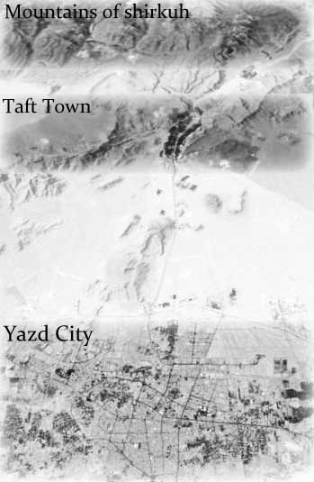

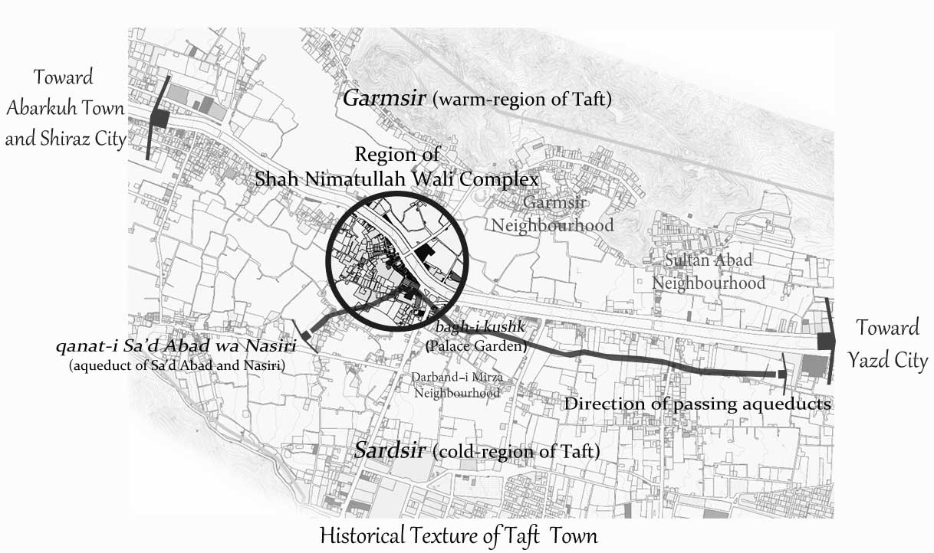Fig.1. Shirkuh and direction of passing aqueducts from Taft town to Yazd city [11]

Fig.2. Basic cores of Taft in 14th century with the boundaries of established Shah Wali complex

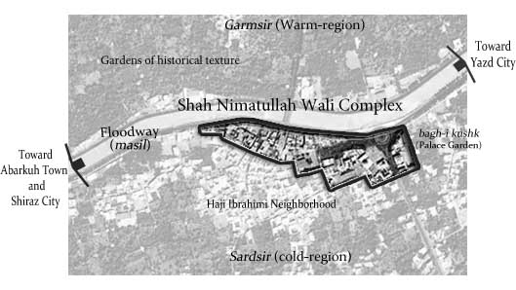

Fig.3. Formation of Taft along the floodway with Shah Wali complex in the center of town (present time) [11]

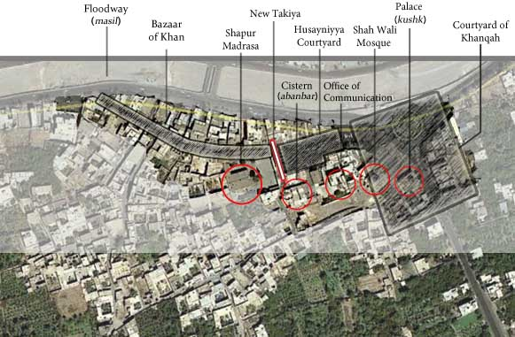

Fig.4. All constituent components of Shah Wali complex except Takiya of Husayniyya are located on floodway path which follows longitudinal structure of the town (present time) [11]

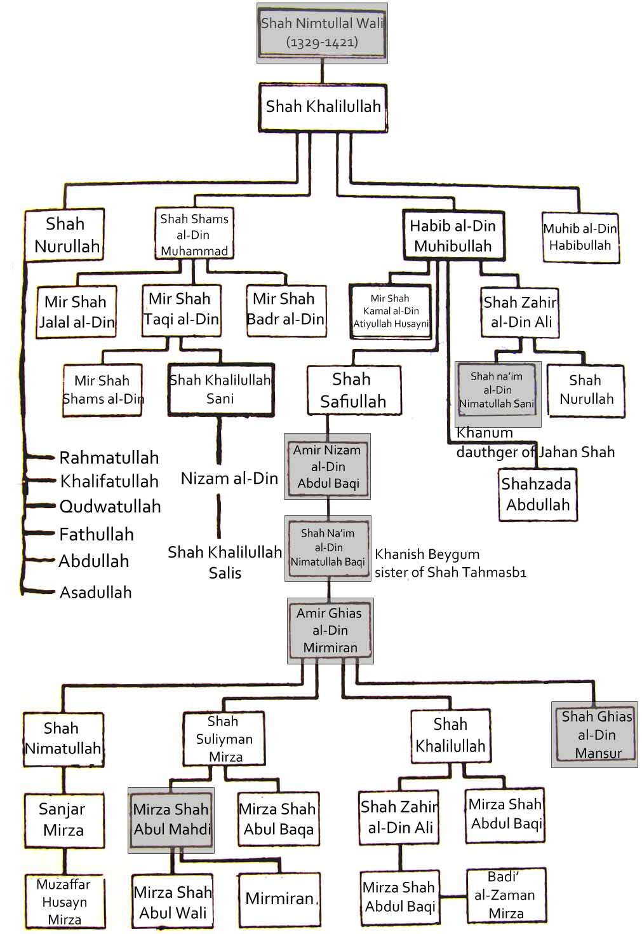

Fig.5. The pedigree of Shah Wali family [18].

Key FOR FIG.6

1. Palace 6- Courtyard of Khanqah
2. Shah Wali sepulcher (holy shrin) 7- Takiyya
3. A‘li Iwan 8- Old Takiyya
4. Safa Iwan 9- Khan bazaar
5. Shah Wali mosque

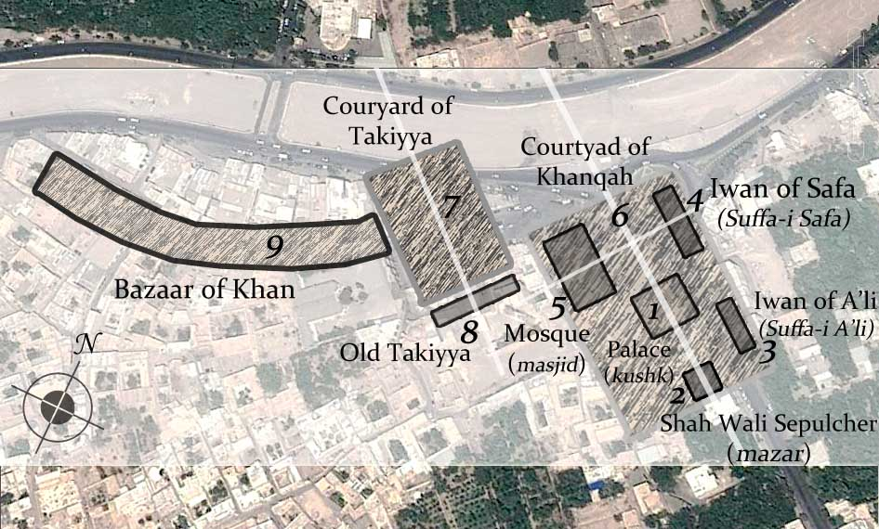

Fig.6. Initial cores of Shah Wali complex (Khanqah and old Takiyya) [11]

Key FOR FIG.7

1. Palace 9- Khan bazaar
2. Shah Wali sepulcher 10- Safiya mausoleum
3. A‘li Iwan 11-Agha bazaar
4. Safa Iwan 12-Nawwabi caravansary
5. Shah Wali mosque 13-Nawwabi water mill
6. Courtyard of Khanqah 14-Nawwabi bazaar
7. Takiyya 15-Pool
8. 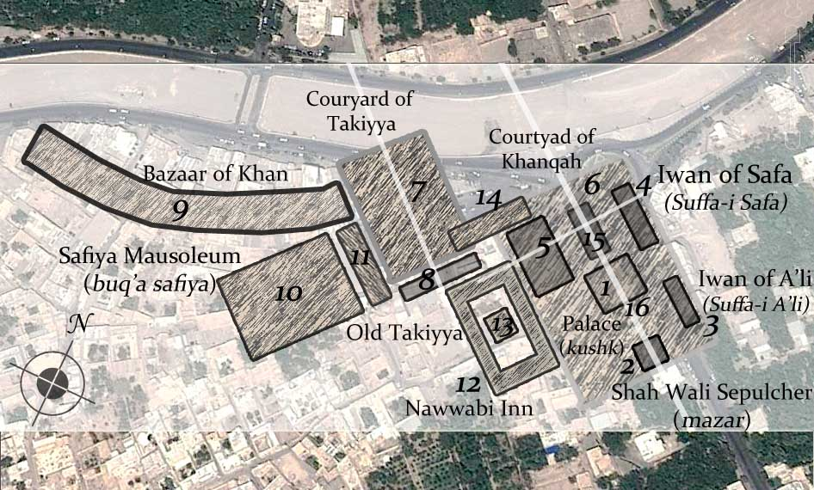Old Takiyya 16-Mansuriya mansion

Fig.7. Khanqah and Takiyya were completed at the end of Safavid Era along the extension of Taft and its floodway, and on the other side of it. Afterwards, Nawwabi bazaar, water mill, and caravansary were constructed as the connecting elements between these two parts [11].

Key FOR FIG.8

1. Palace 9- Khan Bazaar
2. Shah Wali sepulcher 10- Safiya mausoleum
3. A‘li Iwan 11- Agha bazaar
4. Safa Iwan 12- Nawwabi caravansary
5. Shah Wali mosque 13- Nawwabi water mill
6. Courtyard of Khanqah 14- Nawwabi bazaar
7. Husayniyya 15- Pool
8. Haji Ebrahimi bazaar (Deed of Endowment) 16- bazaar and North Side Chambers

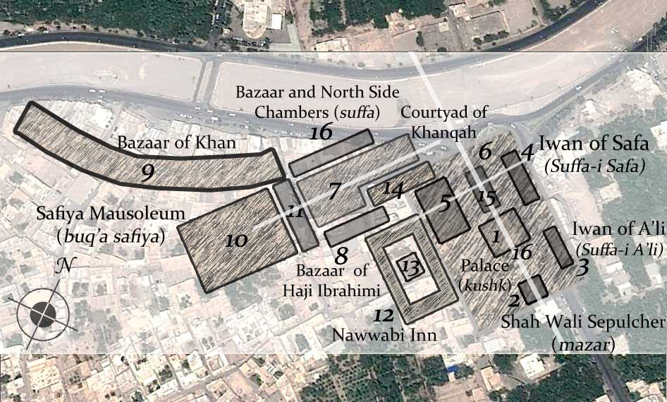

Fig.8. Demolishing old Takiyya of Timurid Era located in the southern side; construction of new Takiya in the western side; and organization of the Husayniyya with the new structure is among the changes created during Qajar Era [11].

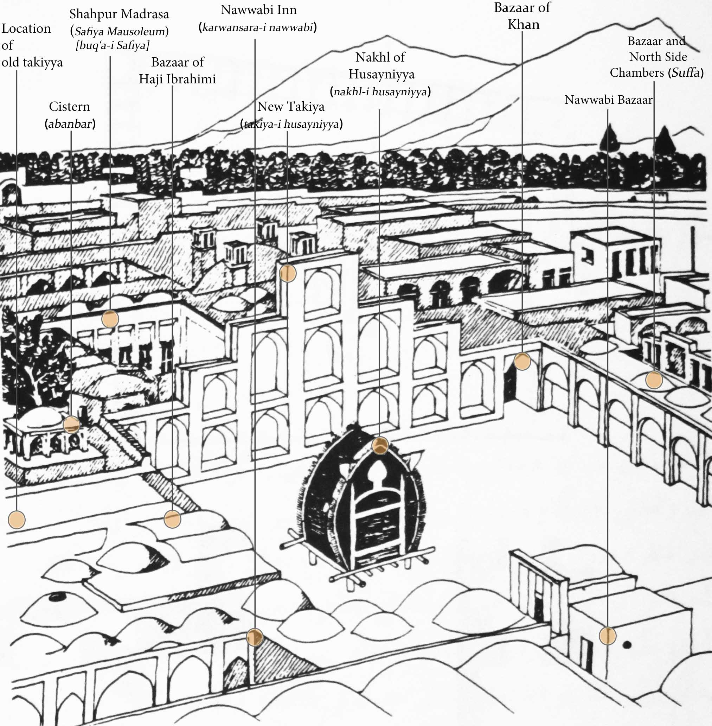

Fig.9. Structures in the Husayniyya in Pahlavi Era (bazaar and northern chambers, Nawwabi bazaar, Khan bazaar, Nakhl, new Takiya of Husayniyya, Nawwabi caravansary, Haji Ebrahimi bazaar, Shahpur madrasa, Qajar’s cistern, and demolished old Takiyya) [22]

Key FOR FIG.10

1. Palace 6- New Takiya of Husayniyya
2. Shah Wali mosque 7- Husayniyya
3. Khan bazaar 8- Bazaar and North side Chambers
4. Shahpur madrasa 9- Office Of Communication
5. Haji Ebrahimi bazaar

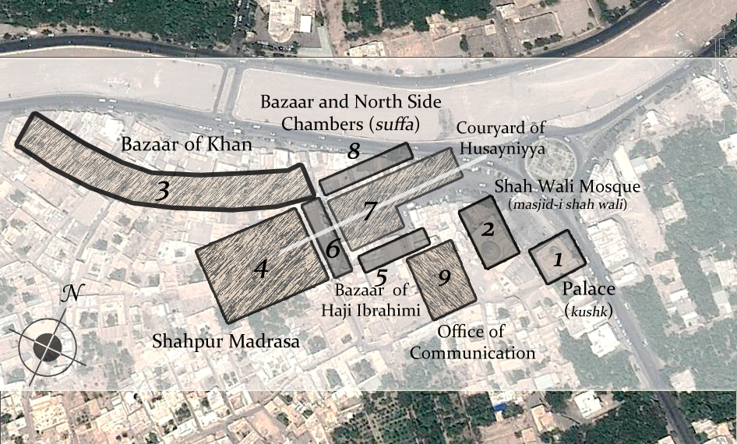

Fig.10. Demolition of sepulcher, pool, and Safa Iwan in the present streets of the town has caused courtyard and garden of Khanqah to lose its original structure while demolishing Safi Quli Biyg mausoleum, Nawwabi bazaar, Nawwabi caravansary, and Nawwabi water mill as the results of changing cultural and historical structure of Takiyya for coordination with the new structure (Husayniyya) [11].

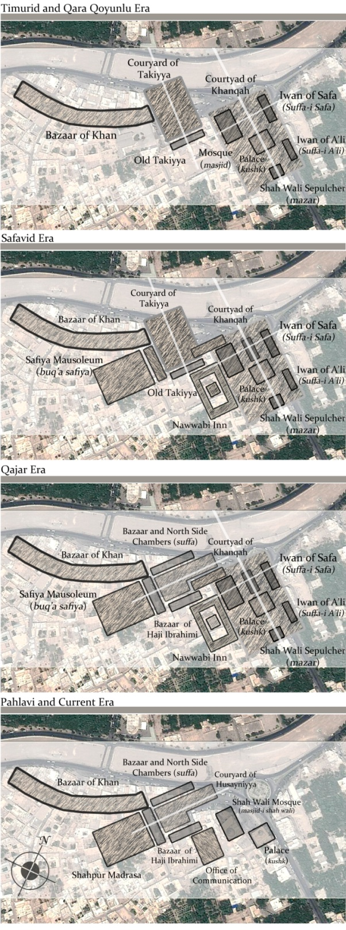

Fig.11.Chronology and process of formation and transformation of Shah Wali complex from Timurid Era to the current era

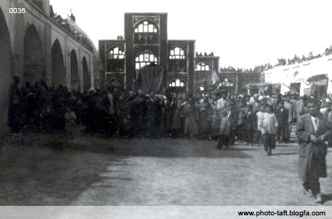

Fig.12. The oldest image of Husayniyya taken by “Andre Godard”. Nawwabi bazaar and entrance of caravansary can be seen completely intact in the left. Nakhl of Husayniyya is located on top left corner of the photograph while the court facing toward the old Takiyya can be imagined to some extent. Recently built chambers can be seen in the right. The floodway of Taft was easily observed from this point before the construction of these chambers [23].

C:\Users\user\Desktop\12.tif

Fig.13. Kalak was placed on the axis of old Takiyya and its location besides Nawwabi bazaar was completely independent of the new Takiya in western side [23].

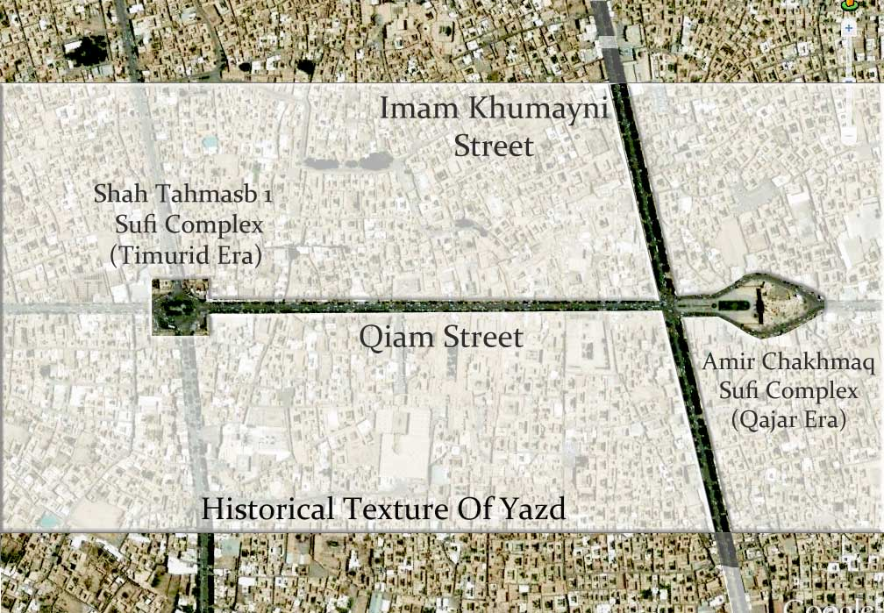

Fig.14. Takiyya of Shah Tahmasb 1 Sufi complex (Timurid Era), Takiya of Amir Chakhmagh Sufi complex (Qajar Era) and Qiam Street at the time of Pahlavi [11]

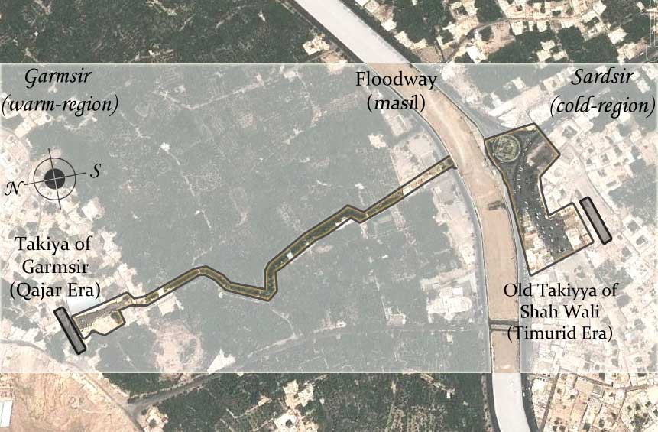

Fig.15.Takiya of Garmsir (located in the warm- region of Taft) and demolished Takiyya of Shah Wali (Sardsir parish of Taft) were located opposite to each other [11].

Table.1.Historical descriptions of Taft in 14th century with the reasons for location and establishment of Shah Nimatullah Wali complex there

|  |  |
| --- | --- |
| *Tenement of Rashidi* Deed of endowment  (1309 A.D) | “The entire of a garden located in the village of Taft which is known as Plain garden [13]”.  “Whole of the garden known as Fire Garden is also situated in the same village of Taft [13]”. |

|  |  |
| --- | --- |
| *Comprehensive goodness*  Deed of endowment  (1331 A.D) | “… The entire one thousand quotas out of the sum of 8840 quota, the original aqueduct of Taft village are among the dependencies of Yazd's parishes… [14]”. |

|  |  |
| --- | --- |
| *Encyclopedia of Mofidi*  (1671-1679 A.D) | “… and when it was the time for reign of Nosrat al-Din Shah Yahya Ibn Shahzada Amir Mozaffar Ibn Mobarez al-Din Mohammad (14th century), a moat was dug … and “Kushk Garden” (*palace garden*) was established (*now, Darband Mirza District*) [15]”.  “… and other regions were yielded to be controlled by those serving Mobarez al-Din Mohammad Mozaffar (*1318-1357*)… among the villages and hamlets observed by me from history books the followings can be mentioned: Mohammadabad, …, Sultanabad of Taft, and Dehshir … [15]”. |

|  |  |
| --- | --- |
| *History of Yazd or Yazdan fire temple*  (1938 A.D) | “Taft is certainly one of the old villages of Yazd which has always been concomitant with Yazd. This can be inferred from historical relics in addition to its natural conditions which means that Taft has been established at the same time with Yazd as its source of water conduits [10]”. |

|  |  |
| --- | --- |
| Results of Authors | 1. Taft town has always had suitable weather and prosperous gardens. Some of these gardens are so large and famous which have been listed as national heritage. 2. One of the main reasons for establishment of Shah Wali Sufi complex in Taft by Shah Nimatullah Wali was the existence of suitable weather, its ecologic/strategic conditions and adjacency with Yazd, as one of the main bases for dervishes of different sects. Taft has always been attended by Governors of Yazd. 3. Two streams of aqueducts namely Sa‘dabad and Nasiri have been regarded as the most important and oldest aqueducts of Taft. These two aqueducts were extended to Yazd passing through its important points and buildings. The aqueducts have been mentioned in many old deeds of Endowments. Shah Wali complex has also been located through the route of these two aqueducts. 4. Khanqah (*Sufi hospice*) of Shah Wali was first created and established in the neighborhood of Kushk garden in Darband Mirza District. 5. Influence and role of Taft in the 14th century (*water, geomorphology, residency, gardens, communications, and climates*) can be generally identified on the location of Shah Wali Khanqah [16]. |

Table.2. Results of investigations on historical sources and field studies in Shah wali complex including Timurid Era, Qara Qoyunlu Era and beginning of Safavid Era

|  |  |
| --- | --- |
| Results of Authors | 1. At the time of building mosque of Khanqah, the old Takiyya (*in southern side of the current Husayniyya)* was formed behind the mosque, along with the Floodway and facing to it. This Takiyya was demolished years later in order to construct a new Takiya in the western Husayniyya. The old Takiyya was used for ceremonies and ethics of Sufis and dervishes. 2. All literatures which have assigned the current Takiya in the western side of Husayniyya to the 15th and 16th centuries (*Iraj Afshar, Abdul Husayn Ayati, and …*), and attributed the old descriptions to it, have made mistakes because the old Takiyya has been demolished at the late Safavid Era or beginning of Qajar Era. 3. Shah Wali mosque of Khanqah has been developed and repaired in various eras. Basic core of the mosque according to its oldest inscription has been founded in 1468 A.D. with iwan and dome (Certainly, there was no mosque earlier than 1457 A.D. since Ahmad Ibn Husayn Ibn Kateb has not pointed to it). Thus, all sources which believe that basic core of the mosque belongs to Khanesh Beygom, sister of Shah Tahmasb 1 and wife of Shah Na‘im al-Din Nimatullah Baghi (*Middle of 16th century*), have had an incorrect understanding. It can demonstrate date of the inscriptions, too. 4. Palace of Khanqah is in fact the current mausoleum whose dome has been reconstructed during Pahlavi Era. |

Table.3. Results of investigations on historical sources and field studies in Shah Wali complex during Safavid Era

|  |  |
| --- | --- |
| Results of Authors | 1. Location of Safiya mausoleum was in the current school behind the new Takiya according to historical books, existing documents in deed of endowment and evidences obtained from elders of Taft. 2. Location for Agha bazaar has not been identified in Taft so far. It seems that this bazaar has been placed in the current location of Takiya, because some chambers and stores (*with common style of other Iranian traditional architectures)* were located in the western side of Husayniyya (*current place of the new Takiya*). On the other hand, adjacency of tomb and mausoleum for Safi Qoli Beyg (*benefactor of Agha bazaar*). 3. Based on interviews and field studies done, the two floored (*ground floor and underground*) Mansuriya mansion (*sepulcher of Shah Ghias al-Din Mansur* 6 *and his wife*) was located near the current monument. Further explorations are needed to confirm this fact. |