**The role of housing in small cities  
in the approach of regional development**

Ali Yaran. Phd, Hamed Mohammadi Khoshbin, M.A

**Abstract:**

House is considered as one of the most main needs of human being and also one of the best determinant characteristics of living scale. Housing shortages is one of the most acute problems is in developing countries. Today, large cities and their suburbs are growing rapidly in developing countries. These areas swallow all of the opportunities, services and funds of the country, however, still struggling with a variety of urban problems such as : housing shortages, high unemployment rate, the issue of marginalized, urban transportation problems and failure to supply other services, as well as environmental destruction. On the other hand, the rest parts in these country including small cities and rural areas have fallen behind the balanced development and have become stagnate and stopped in their progress.

Development of small cities been raised to deal with the lack of balance and harmony caused by unbalanced growth of cities as a solution to thereby development can be extended to other regions, as a result urban and regional development planning was developed based on the emphasis on dynamism of small cities.

Small cities development can effect on region only if these cities' development is sustainable, so sustainable urban development is one of the requirement for this regional development approach. Housing and its appropriate development is one of the affecting and important factors in achieving urban development and realization of sustainable development in small cities.

This article discusses housing's place and role in the process of achieving sustainable urban development in small cities according to the characteristics and indicators of it, with Refer to the function of these cities in regional development planning

**Keywords :**

Housing, small cities, urban sustainable development, regional development

**Introduction:**

The purpose of this article is analyzing the role of housing in small cities with regard to the role of these cities in regional development process. In this study considered housing and its characteristics due to achieve urban progress and development. The paper theoretical approach is the regional development theories in relation to small cities. One of the concepts of this approach is its integrated and comprehensiveness in balance economic - social areas within countries that in light of it all the focal habitat, must considered with the pervasive preparation view. Providing necessary facilities in small cities, make settlement’s systems balanced in region and this system, plays an essential role in of social development - national economy, therefore the outcome relations in urban and rural development deploy in everywhere settlement.

With the rapid growth of large cities in developing countries, emerging shortage of residential units and high unemployment rates, some of researchers suggested that urban and regional development planning develop based on the emphasis on dynamism of small cities. Because due to job opportunities, education and other basic needs in large cities, these cities are the final destination of immigrants from villages and small cities. Supporters of the theory of the role of small cities in the regional development believe that if such needs supply in small cities, rural immigrants' final destination would be these cities, thus absorption of immigrants in small cities could decrease the flood of immigration and population of major cities and reduce problems of adjustment to these cities.

Poor urban distribution (Despite the large number of small cities, only a small percentage of the population are living in them), and also the importance of balanced population distribution Has led to that in production and welfare's planning, given higher priority to small cities in order to increase appropriate share of urban population. Nowadays the approach to regional development planning goes to the decentralization and the Integrated Regional Development which settlements can be formed as regular, balanced and integrated. Small cities as the main element in this approach are located as the attracter and the active interaction point between the cities and rural areas loop. The regional development theories with the spatial approach and with the aim of Giving authenticity to settlements establishing system in the integrated development process are based on principles and views, these principles within a process with central Place, centre-surrounding, Growth pole and rural-urban development theories begin and eventually small cities and middle approach was raised. Housing and its appropriate development in small cities is one of the affecting factors in realization of proper and sustainable development in these cities. Also the small cities development has a significant role in the region's balanced and sustainable development. As a result represent a proper pattern for housing development is an initial step to accomplish this.

Therefore, the aim of this study is to search and analyse the role of housing development in small cities in order to impress regional development.

**1- The research framework**

Analysis of the role of housing in small cities require considering some concepts That in theoretical principles will be referred, In this section first regional development, the concept of small city and the principles of its sustainable development and then housing and indicators and variables affecting its development is Being introduced. In the next step the relationship between these four concepts is considered which first the position and role of small city in the regional development and planning and then the role of housing and its development in the sustainable urban development has been analyze. With analysis and summary of issues that proposed the role of housing in small cities, with emphasis on role of these cities in regional development and planning is analyzing and a model will be provided based on issues that discussed.

**2- Theoretical Principles**

**2-1- Regional Development**

Definitions and concepts of region and area relating to purposes of planning and development is used differently. In general region is: Space or part of the earth or part of the country which natural, social and economic factors, has been separated it from their surroundings. (Shieh, 2009, P.89) Region is part of a country that its unity is for the climate, vegetation, economic, political, administrative and cultural.

Planning areas can be defined based on proposed objectives planned, methods and the expected development.

Metropolitan area consists of a constellation of cities and towns in a certain geographic area, with established political and administrative boundaries or metropolitan area is composed of a number of cities that its largest city in that area, called Metropolis.

Regional development is planning not the concept of national development, which at the national level, including development plans for all of the land and not the concept of a partial and local planning which are conducted only for problems and potentials of a village or sector or city and province, regardless of other areas, but is this concept that how to have a regional planning so in national and international levels will achieve the relative advantages that authorities and politicians desired about that Region and this balance in development and growth will benefit homogeneously that Region. Regional planning can be considered as an organized and systematic effort to choose the best ways and methods to achieve specific objectives in a Region. (Shieh, 2009, P.90)

Regional development theories, mainly are rooted in three science branches of regional science, regional economic and theoretical geographic. Regional development is a multi-order system and interdisciplinary which its preliminaries and foundation falls back to four categories of theories and perceptions that each are trying to impose their theory. These four trends are:

1. Place theories that trend towards local and regional development and land preparation concepts and are defining the manner of positive and negative effects of market centers to the nearby and far areas' development

2. Geographical theories that rely on the local homogeneity and used in terms of natural geographical areas, economic, social and cultural areas resorting to some geographical criteria.

3. Theories of physical planning which relied on standards physical that are governing planning and urban design come in the field of regional planning and most aspects of engineering, architecture, construction, house building, establishment of the urban infrastructure and beautification is ruling.

4. Economic theories which is the concept of application of principles and economic analysis in certain geographic areas (regions) and primarily deals economy in connection with national land and only consider the region's economic development. (Paiely Yazdi, 2010, P.39)

Theories of regional or spatial development are also can classified in two other general categories.

1. The first group is theories that are separable based on the division of economic / social activities to the functional parts and rely on partial planning for regional development

2. The second group is theories that based on the primacy of human spatial territorial and the integrity of their activities on the environment, are rely on spatial planning for regional development.

Economic sector growth, the center - surrounding, growth pole theory and hierarchical system of settlements which originated from central Place theory are theories that belong to first group and Theories of environment / region, the informal sector and protectionism belong to the latter. (Mirmohammadi, 2007, P.166)

The regional spatial development means the arrangement of spatial organized components in a region and is going away from the process of imbalances and polarization of spatial structure. In terms of spatial development, there is an organic link between the spatial organization and structure of consumption and production and circulation and transportation of resources in the region. (Titkanlou, 2002)

In general, regional development policies for growth and development in the region were developed and plan as a whole. With execution of some of these policies and the unbalanced regional development and the imbalance system establishment of housing and economic indicators in the region, studies went to focus on the balance of the settlement points and comprehensive regional growth and development.

According to this theory, if one area's distribution is balanced and harmonic, villages wouldn't exploit and swallowed by the cities and their development can be done objectively and balanced. Execution regional planning and development provides a better chance to administration of justice rather than develop the programming, and especially the partial – polar. Proper regional development requires optimal growth of small cities and optimum use as an intermediate space between rural areas and large cities. Small cities also are considered as a center of settlements that can partly controlled population growth and migration.

**2-2- The concept of small City**

Small city like some of words is a relative concept, because it depends to the Level of urbanization, development and economic structure of a country and consequently within a country may vary from region to region.

From two aspect can define small cities, first the function (Activity and role) and also from the size (small and large). The main characteristics of these cities are:

* + Is in the last level of a country's population urban network
  + The main activity of the small city, mostly is associated with agriculture and especially related services and activity of sectors processing and small-scale industries and are in the next order
  + have a clear territory and rural influence and usually with an organization function for the agricultural sector

The most common indicator for the level of cities is population. In Iran, generally, urban Land Development projects have known population-based criteria for identifying domain and small city areas sufficient. In this article the cities between twenty to fifty thousand people considered as small city, and has been evaluated and analyzed.

**2-3- Different aspects of urban sustainable development**

Sustainable development is the kind of development which the needs of present generations will be supply without damaging on the ability of future generations to meet their needs or in another definition is providing solutions to physical, social and economic development patterns which could prevent problems such as destruction of natural resources and biological systems, global pollution, climate change, uncontrolled growth in population, injustice and low quality of human life. The development which could provide current needs of society, without sacrificing the needs of their future generations, and without damaging the environment, is Sustainable and viable development. (Azizi, 2009, P.105)

One of the main issues discussed in sustainable development is the prerequisite of local development to national development. Proponents of endogenous development are demanded the development from bottom to top. Sustainability is now a top priority in development planning codifications, which play a crucial role in the development of urban settlements in the design of environment.

Urban development can be considered the basis for renewed economic, social, political, cultural and civil rights structures that it aims primarily to improve the process of urbanization and city orientation, environment, urban restoration, organization of urban economy and strengthen the political, social and cultural aspects of urban life. Urban development as a spatial concept can be defined in significant changes in land use and density levels, meet the needs of residents in housing, transport, leisure, food and etc.

Urban sustainable development takes place with solving structural problems such as, social and institutional change, infrastructures and services development, and pollution control and ecosystems management. In general, a sustainable city should have four aspects of environmental, social, economic and political. (Pugh, 2004, P.20)

Therefore, to achieve a sustainable city must first resolve the raised problems and then establish four different aspects of a sustainable city.

Sustainable urban development in areas of environmental, social and economic based on natural resources, urban environmental quality and function patterns indicators and planning in this regard are include the following aspects :

- Economic incentives to decentralization of industries, encourage to small industries and self - employment and changing patterns of production, distribution and consumption

- Social - cultural: central role of human, poverty alleviation, women's participation and role of cultural identity

- Physical: attention to the waste disposal and sewage systems, use of natural energies and making terms in urban design and planning , urban public facilities, develop terms in use of materials, design multi-purpose spaces and compact contexts and attention to the pedestrian movement.

- Environmental: pollution, health and health planning and safety of the city against natural disasters

- Decision making and executive methods management: reform in the planning, role of participating of institutions, professionals, designers and planners, the role of education, information, exchange of sustainable development data and use of technology in data analysis. (Lagha'e, 2003)

Achieving sustainable urban development required urban planning and design actions that in the physical aspect support these objectives. The focus of this research is designing of housing and neighborhood units which have great contribution in making the fabric of the city and an important role in individuals and also different social groups.

**2-4- Housing and Its indicators**

Housing life has been introduced as one of the basic human needs and in the performed studies, it is mentioned as a factor for the development. Housing vast research and planning territory makes that a variety of sciences examine it from different angles of economic, social, political and physical aspects. Most governments in response to shortage of housing units use housing planning in national, regional and urban planning in order to solve citizens' housing problems.

Within providing necessary space to accommodate human comfort housing is not only a existence of material that its realization requires knowledge of engineering But also is a spatial quality which is in charge of meeting the psychological needs. In this context, in addition to the residential unit, neighborhood units, district, village and city are also considered housing. (Sartippi Pour, 2004)

Basic material needs of man have been divided into three categories: biological needs, economic needs and social needs, housing has a special role in meeting each of these needs.

- Biological needs: shelter, food, protection against noise, pollution and disease

Housing such as food is a fundamental and biological need and a social right of every individual and family. Proper shelter is the most essential human need each individual's access to housing, is the signs of social justice and also one of indicators of development and welfare. A shelter is proper that can protect humans against outside conditions and also provide residents comfort, health and vitality.

- Economic needs: improving living standards, access to daily activities and infrastructure facilities;

Nowadays housing is considered as a kind of investment and increased income and has an economic concept. Housing economic aspects is determined with being proposed as one of the major economy's sectors. Housing accounted for the greatest enterprise.

Therefore, you can see direct relationship between macroeconomic and investment in housing sector and its policies in housing investment and development, housing investment and employment, housing policy and organizational structure and also approach to housing as a production and not consumption social - economic investment. (Azizi, 2004)

In fact, the best, most lucrative, fastest and safest private sector area of investment is enterprise in land and housing. During inflation and price rise, housing construction or purchase is a positive measure to stabilize assets and is considered a secure investment for the household. Housing has an important role in economic stability and family welfare, because poverty and economic insecurity is a factor of social instability.

- Social needs: opportunities for intellectual development, preservation of cultural traditions, satisfying emotional needs; (Dallal Pour, 2000, P.27)

The main function of housing in addition to its primarily role as shelter, is providing ideal conditions for families in order to do family activities. Stability and cohesion of family is one of its positive consequences.

Housing also has an effect on family participation in the community. This effect especially can be seen among poor urban families who are more committed to neighborhood associations. House is the closest environment associated with human and man tests his first experiences in relationship with others in it and in fact is a background for entering into the larger community.

Housing social indicators are in fact the needs that housing met. Housing in addition to the physical structure which a family can be used as a shelter, include whole residential environment which includes all services and social facilities and amenities necessary for a better family life and people's employment, education and health schemes. In other words, housing is more than just a physical shelter and applies to all services and public facilities that is necessary for man to live better and its users should have a relatively long and reliable possession to it.

Physical aspects of housing can be investigated from two angles. First, housing skeleton as a residential unit and second, the physical relation of housing with its environment, that has been considered as a social indicator and is raising the role of housing in the urban development program. External aspect of housing is very important. The profound impact of housing on residential environment and city community is noteworthy.

Housing is not only a construction volume and a shelter but in the context of social development can bring a sense of social belonging and attachment to the neighborhood. Housing should provide ground for interaction between people with architectural elements scheme. Role of housing in physical development of cities throughout history have a variable process and in recent periods, housing and the environment are the main factor in shaping the cities. Housing has always been the largest function of cities and the provision and production of housing is the quantitative factor in determining the physical development of cities. This is especially more important and has more impact in small cities, due to the physical development and population increase in these cities the need for more housing is more compared to other functions and plays a more fundamental role in formation of the identity and fabric of the city. Among the most important housing physical issues is the provision of infrastructure. Land preparation and provision of infrastructure can define the relationship between the housing and residential environment and convert shelter to the actual housing and urban expansion to the urban development. (Azizi, 2004)

**3- Theoretical framework**

**3-1-Position and role of small city in regional development**

City needs to build relationships with the region continue his life, but the relation volume does not remain constant and therefore it lead to growth of the city. This growth affects areas surrounding or in connection with a city which can be considered as the influence area or influence space of the city. This influence on one hand, make the transition of city's achievements to the region and on the other hand, lead to the city physical growth. In general, the influence area of a big city is small cities and large villages around it. (Shieh, 2009, P.90)

As a result, in many cases the major cities with growth and infiltration to the adjacent areas taken down the neighboring villages and even small cities and destroy the biological, social and economic balance of region.

Given the lack of balanced development in the region due to excessive growth of large cities, deliberate and incentives policies developed to accelerate the spatial centralization and supporting small and medium urban centers and supporting the model of "spatial decentralization of development," especially in favor of small cities is evident in regional policy in developing countries. (Fanni, 2009, P.40)

The main reasons for raising small cities in the regional development planning in these countries are:

1 - Despite having the rural population and rural interaction is rarely considered while these aspects are important components of the city in any successful urban-rural development programs.

2 - The failure of the mechanisms of gradual growth from large cities to small towns, this growth is more inclined to continue into the center. Measured initiatives to strengthen small cities can be influence over time on the spatial distribution of development in urban system.

3 - Due to the political role of these cities and restricted to needs and demands of region population, small cities can affect in allocation of resources at higher levels and be effective in meeting the needs of local development issues.

Another regional development strategy in rural areas is considering the effect that small cities have on their influenced rural areas. Development and strengthening of small cities in addition to the decentralization is causing the regional development, with providing urban facilities and services to influenced rural areas maintain the organic relationship between urban and rural areas and the stability of rural population and therefore decrease the problems of large cities.

Small cities interact with the smallest element in settlements that is village, and also connection with intermediate and large cities play an important role in the regional development and balance such as population, activities and investment stability.

**3-2 Role** **of housing** **development** **in** **urban** **sustainable development**

The needs of each city can be divided into five categories:

1 - basic needs 2 - functional and artistic requirements 3 - Communication and Networking, 4 – Infrastructure 5 - ecological considerations

Housing as one of the basic needs of people with clothes, food security and is placed in basic needs of the city. But to assess this role and place in the process to city development must note housing features and performance of these indicators in planning and influencing factors in sustainable urban development.

As was stated, to achieve a sustainable city must first resolve the structural problems such as social and institutional change, infrastructures and services development, pollution control and ecosystems management and then establish four different aspects of a sustainable city.

Housing in terms of resource allocation has a high capacity and effectiveness (Pugh, 2004, P.20), and is considered as an economic good and a relatively safe investment context in third world countries. Housing also requires a heavy early investment, for this reason is one of the primary things that many people are wanted. Therefore, its development can lead in development in economic sector by expanding economic activities and poverty reduction.

Economic growth, comes with employment and security, these two factors follow growth in influenced area and, ultimately, the political development of small cities due to increase role of these cities in the balanced regional development. Therefore, development in housing with proper investment and targeted planning can help achieve this goal. Thus housing development not only will help to develop the infrastructure but also provide a stable and relative growth in the urban economic with political development, but economic and political growth cannot improve and promote social and environmental aspects on their own

Providing biological needs and promoting social situation of households play an important role in the improvement and promotion of human (social) and the Environmental indicators. In social terms location, shape and type of materials used in residential units bringing the social status for its owner. Improper and out of standard housing in addition to have direct and indirect adverse psychological effects, also has social outcomes such as crime, and violations of laws and regulations. (Dallal Pour Mohammadi, M, 2000, P 37) Attention to the quality indicators and life needs in construction and development of housing is also important from this angle.

Population growth and migration follow rapid urban development and consequently problems, such as employment a large group of new workers occurs in economy. Also, due to population growth, pollution and environmental destruction and need to social services will be more. In addition to the monetary poverty, housing and urban poverty occurs. Poverty in housing means overcrowding of population size, non-healthy houses and high rent to income ratio and urban poverty also means high price urban infrastructure, forcible seizure of land and the real value and social costs such as pollution, etc. With development in housing, small cities can respond to their population growth needs and the potential migrations that will migrant from rural to urban and also partly help to the urban economy and employment. Also all where settlements development which is one way to balanced develops in region is needed to provide appropriate and adequate housing in these cities.

**4 - Summary, Analysis Model presentation**

Large cities the focus and planning point related to development in recent centuries now reached to their ultimate growth and physically are not able to extend.

Lack of sufficient resources, poor economic management, absence of comprehensive plans for housing and other infrastructure failures that are in the economy in one hand and the rapid increase of urban population in the other hand made providing shelter an obscure problem in these countries. Beside the expansion and uncontrolled growth of cities and high density in the urban area has led the development and construction of housing for the growing population in these cities is not practically possible. As a result urban and regional development planning was developed based on the emphasis on dynamism of small cities. Development of small cities been raised to deal with the lack of balance and harmony caused by unbalanced growth of cities as a solution to thereby development can be extended to other regions. In this approach, urban and regional development planning were prepared based on the emphasis on the dynamics of small cities

Therefore regional development requires growth and optimal utilization of small cities and proper use of them as an interface between villages and big cities. Small cities are noteworthy as a settlements focus as well and can also partly control the population growth and migration, so for a proper regional development, proportional and sustainable development of small city is essential.

City with development of four aspects of environmental, social, economic, and political will can achieve sustainable development. Housing and its development has an essential role in achieving growth and stability of these four aspects. Housing development considering having a big capacity in allocation of manpower and financial can contribute to economic growth and affect lower poverty indicators, proper housing growth provide residents biological needs in cities and improve social conditions in households and as result will have a very important role in the improvement and promotion of human (social) and environmental indicators.

The coming together of these has contributed to political and economic stability of small cities and leads to the urban sustainable development.

Fig.1: The relationship between the concepts of research

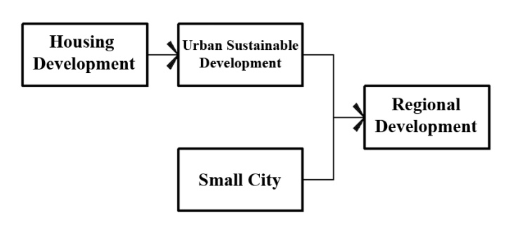

According to the conducted studies and due to the characteristics and indicators of housing and its role and place in the city and urban sustainable development, the following model was obtained.

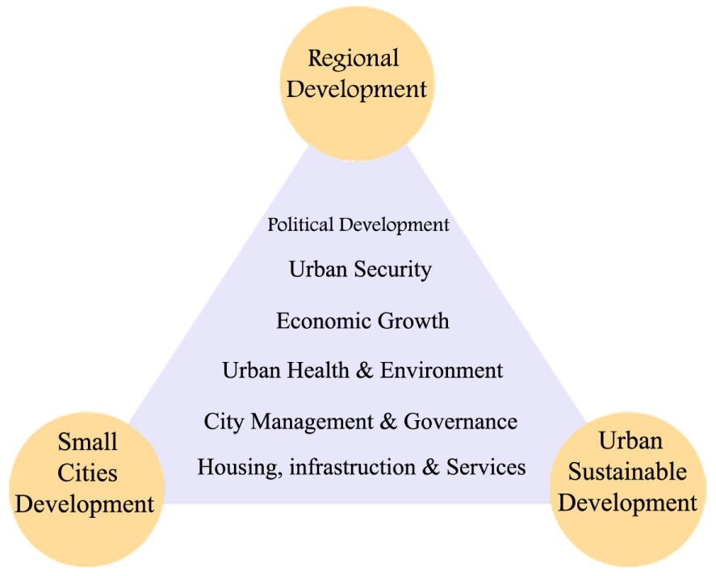Fig 2.Housing and its position in region

**References**

1. Amkachy, Hamideh, Small cities and their role in national development framework, Urban Studies Center of Iran , Bita
2. Paugh, Cedrick, Sustainable Cities in Developing Countries, Naser Mohammad Nejad, Research Center for Urban Studies and Architecture Publications, 2004
3. Payely Yazdi, MH, and H. Rajabi Snajrdy, The Theory of Urban and surrounding, organization of research and development of Universities human science books (Samt), R & D Center for the Humanities, 2010
4. Ziari, Keramatollah, Regional Planning Principles and Methods, University of Yazd Publications, 2006
5. Dallal Pour Mohammadi, M., Housing Planning, Samt publication, Tehran, 2000
6. Sartippi Pour. Mohsen, pathology of the housing problems in Iran, Soffe Journal, No. 39,
7. Shieh, Ishmael, Introduction to the Principles of Urban Planning, Iran University of Science and Technology, 2009
8. Fanni, Zohre , Small cities another approach in regional development, Azarakhsh Publications, 2009
9. Azizi, MM, Density in Urban Planning principles and criteria for Density Determination, Tehran University Publications, 2009
10. Azizi, MM, The Place of Housing indicators in the process of housing planning, Fine Arts magazine, No. 17, 2004
11. Lagha'e, Hassan Ali & mohammadzadeh, An Introduction to the concept of sustainable urban development and the role of urban planning, Fine Arts magazine, 2003
12. Mohammadzadeh Tytkanlou, Hamideh, the average capacity in cities and regional spatial development, fine arts magazine, No. 12
13. Mirmohammadi, SM, land preparation and economic security concerns, Tadbir economic research institute, Tehran, 2007