**A Method for Microclimate Observation and Thermal Analysis -Tropical Condition of Kuala Lumpur**

**Mansoureh Tahbaz** (PhD Architect, Professor Assistant)

School of Architecture & Urban Planning, Shahid Beheshti University, Evin, Tehran, Iran

**Abstract**

Using outdoor public spaces as a place of social interaction is in a great consideration these days. Providing tolerable thermal condition as long as possible is one of the primary stage for people’s presence in these places. Outdoor thermal indices are introduced to help architects making appropriate decisions in climate responsive design procedure.

By doing some field study research in extreme climatic condition of tropical city of Kuala Lumpur, this article will introduce a research method of data collecting and data analyzing using outdoor thermal indices. How to do an effective and helpful research for design requirements is the aim of this method. Field data are collected by a Kestrel portable weather station in different outdoor spaces of the city centre. Weather data are analyzed in three levels of meso, local and microclimate. Architectural properties of the place are explained as the respective climatic design solution. Software named SIKRON is designed to speed up the analyzing process.

Keywords: thermal indices, UTCI, heat stress, microclimate, kestrel weather station.

**1- Introduction**

To explore an appropriate and effective research method for outdoor field study observation this article is trying to find answer to the following questions:

1. How much the outdoor thermal indices are accurate to evaluate thermal condition (especially in extreme thermal conditions)?
2. Which index has the most accuracy for a specific climate? Is there any available index that can be used accurately? (UTCI is examined in this regard)
3. What are the differences between meteorology, local and microclimate data?
4. How much the constructed area base on climatic architectural design will help to modify the outdoor thermal condition?
5. What is the definition of different outdoor thermal conditions according to the people’s behavior?

Field study research in September 2010 was done in tropical city of Kuala Lumpur as an example for finding a method to answer these questions.

**2- Research method**

Public outdoor spaces and walkways are some of the most important places used by many citizens everyday. Preparing amazing and comfortable condition to attract people to these places are important keys to successful design. According to different climatic conditions in a period of a year, predicting outdoor thermal condition is one of the basic requirements for designers. To help architects and designers in this regard, laboratory researches have proposed several indices for outdoor thermal analysis.

The first group of indices is based on thermal stress model. Heat stress indices such as heat index (HI), Humidex, Tropical Summer Index (TSI), Discomfort Index (DI) and Wet Bulb Globe Temperature (WBGT) are prepared for hot conditions. Cold stress indices such as Wind chill Index (WCI) and Wind Chill Equivalent Temperature (WCET) are prepared for cold conditions. Some of outdoor indices are prepared base on heat budget model. They are capable to evaluate both cold and hot conditions such as Perceived Temperature (PT), Temperature Humidity Index (THI), Physiological Equivalent Temperature (PET) and Universal Thermal Climate Index (UTCI). The last one is being prepared by a group of specialists (Cost Action 730). It is supposed to cover all shortcomings of other indices. To be able to work with these indices and have a comparison opportunity, all of them are converted on a psychrometric chart (Tahbaz 2011) and the software called SIKRON is prepared to speed up the data input (Tahbaz & Amini 2011).

In this article the data are gathered in the city centre of Kuala Lumpur in the tropical climate of Malaysia. The field data are collected by a Kestrel personal weather station that is able to collect the data of temperature, humidity and wind, the three out of four important climatic elements of thermal condition. The data is collected each 30 second to show the microclimate changes in different outdoor spaces. Using outdoor thermal indices to interpret these data, the thermal condition of observed places are defined on psychometric chart provided for each index. Sikron software is used to accelerate the process of data transfer to psychometric chart.

People’s behavior in different thermal condition, is recorded by taking appropriate photos. Special attention is paid to the children, ages and disables as the most sensitive people to the thermal condition. Behavior is identified by clothes, activities, foods and exposure time in each condition. Comparison between people’s behavior and thermal condition predicted by outdoor indices will help to determine the accuracy of the indices’ assessment. The most accurate index for a specific type of climate will be distinguished in this way.

To control the intervening factors affecting the observation method, the collected data of moving Kestrel weather station as the microclimate representative, is compared with three other climatic data in three levels: 1- the meteorology data of the city in a long term period as the representative of the meso-climate, 2- the meteorology data of the observation days as the representative of the city climate in those days, 3- the collected data of the reference point (the fixed Kestrel weather station) as the representative of the local climate. Comparing the long term meteorology data with the meteorology data of the chosen days will show the condition of these days as ordinary, cold or hot days. According to monotone climate of Kuala Lumpur in a year, this level of comparison is eliminated in this article. Kuala Lumpur as a tropical city has only one hot season and the few changes are made in rainy condition. Comparing the meteorology data of the observation days with the data of reference point will show the changes of the local climate according to the urban construction. Comparing the data of the reference point with the data of the observation points (moving Kestrel weather station) will show the microclimate changes according to the architectural design of the outdoor public spaces.

Constructed condition of the observed palaces is considered as the modifier of the local and microclimate situation by providing appropriate sunshade or sunlit spaces, leeward or windward spaces, heat transfer controllers, moisture and saturation controllers. These conditions will show the thermal modification ability of the architectural design.

**3- Tropical climate of Kuala Lumpur**

Kuala Lumpur the capital city of Malaysia is located in the 3.12 north latitude and 101.55 east longitude with elevation less than 100 meter in the centre of [Selangor](http://en.wikipedia.org/wiki/Selangor) state of Malaysia. Its location on the west coast of [Peninsular Malaysia](http://en.wikipedia.org/wiki/Peninsular_Malaysia), which has wider flat land than the east coast, has contributed to its faster development relative to other cities in Malaysia. (<http://en.wikipedia.org/wiki/Kuala_Lumpur>)

Kuala Lumpur has a [tropical rainforest climate](http://en.wikipedia.org/wiki/Tropical_rainforest_climate) which is warm and sunny, along with abundant rainfall, especially during the [northeast monsoon](http://en.wikipedia.org/wiki/Monsoon) season from October to March. Temperatures tend to remain constant. Maximums hover between 31 and 33 °C and have never exceeded 39.3 °C, while minimums hover between 22 and 23.5 °C and have never fallen below 14.4 °C ("[World Weather Information Service – Kuala Lumpur](http://worldweather.wmo.int/020/c00082.htm)" & "[Extreme Temperatures Around the World"](http://www.mherrera.org/temp.htm)).  Kuala Lumpur typically receives minimum 2600 mm of rain annually; June and July are relatively dry, but even then rainfall typically exceeds 133 millimeters per month (Fig 1) ("[World Weather Information Service – Kuala Lumpur](http://worldweather.wmo.int/020/c00082.htm)" & ["Climate in Kuala Lumpur"](http://www.healism.com/destinations/malaysia/climate_in_kuala_lumpur/)). [Flooding](http://en.wikipedia.org/wiki/Flood) is a frequent occurrence in Kuala Lumpur especially in the city centre and downstream areas. Dust particles from forest fires are the major source of pollution in the city together with emission from motor vehicles and construction work. (["Kuala Lumpur Environment"](http://www.dbkl.gov.my/pskl2020/english/environment/index.htm) & ["Hazardous haze shrouds Kuala Lumpur"](http://www.msnbc.msn.com/id/8908221/))

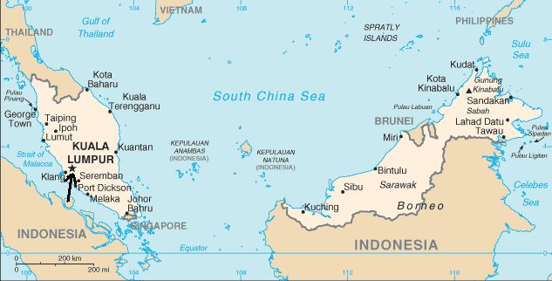 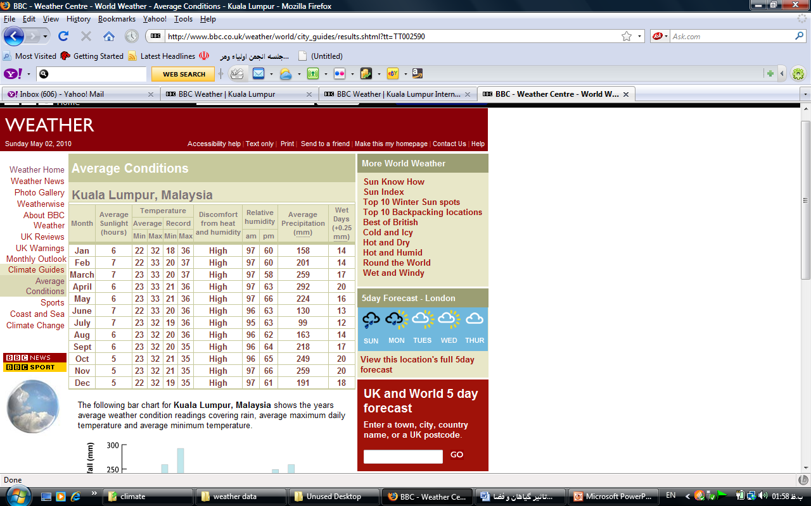

*Fig 1: Kuala Lumpur location and climatic data (*[*wikipedia.org*](http://en.wikipedia.org/wiki/Kuala_Lumpur)*,* *[bbc.co.uk/weather](http://www.bbc.co.uk/weather/world/city_guides/results.shtml?tt=TT002590" \t "_parent))*

Fig 2 (a to g) shows the thermal situation of this city according to outdoor thermal indices. It is clear that during the year the temperature swing is very low and humidity is very high and most of the time heat stress happens. According to Fig 2 thermal analysis of the indices will be explained in three categories. The first group is Heat Index (Fig 2a) and Temperature Humidity Index (Fig 2b) that define the warmest condition as dangerous ([tpub.com](http://www.tpub.com) 2008 p 1-56 & Kyle 1994). The second group is UTCI (Fig 2c) and Humidex (Fig 2d) that analyze the warmest condition as intense or strong heat stress (Bröde et al 2010 & [csgnetwork.com](http://www.csgnetwork.com) 2008). The third group is Tropical Summer Index (Fig 2e) that interprets the warmest weather as slightly warm (Sharma & Sharafat 1986). Fig 2 (f & g) shows the Climatic calendar and sun-path chart of Kuala Lumpur based on UTCI. All the psychrometric charts of Fig 2 are generated by SIKRON software (Tahbaz and Amini 2011) and Weather Data of Kuala Lumpur available at EnergyPlus website.

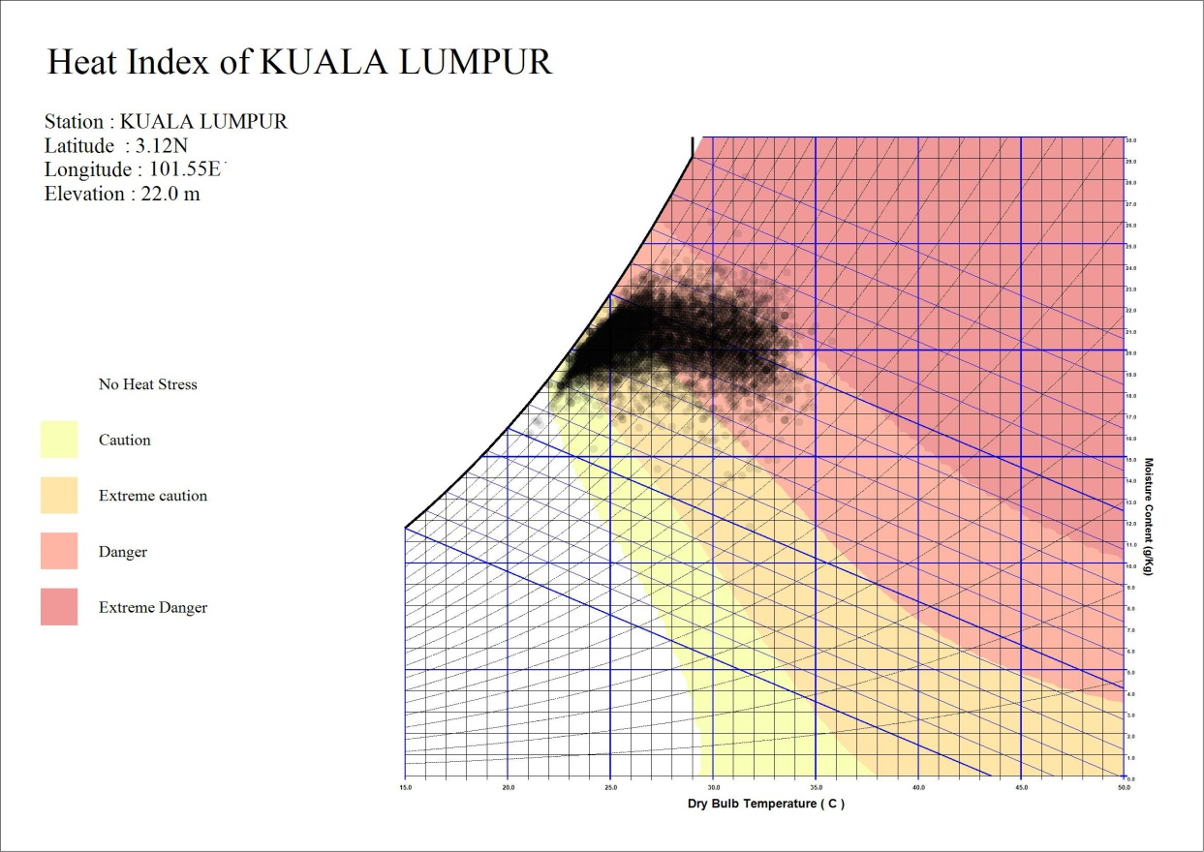

*Fig 2(a): Kuala Lumpur outdoor thermal condition in a year based on Heat Index* psychrometric chart

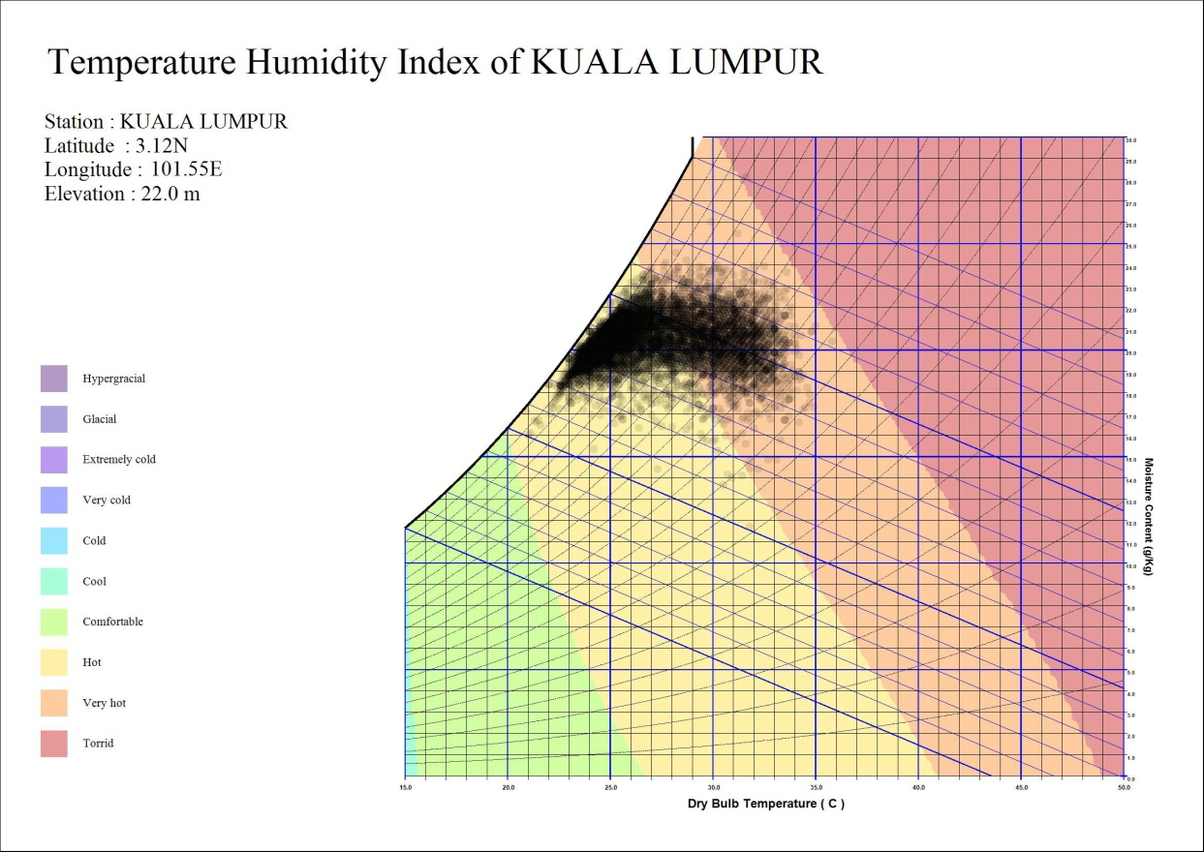

*Fig 2(b): Kuala Lumpur outdoor thermal condition in a year based on THI* psychrometric chart

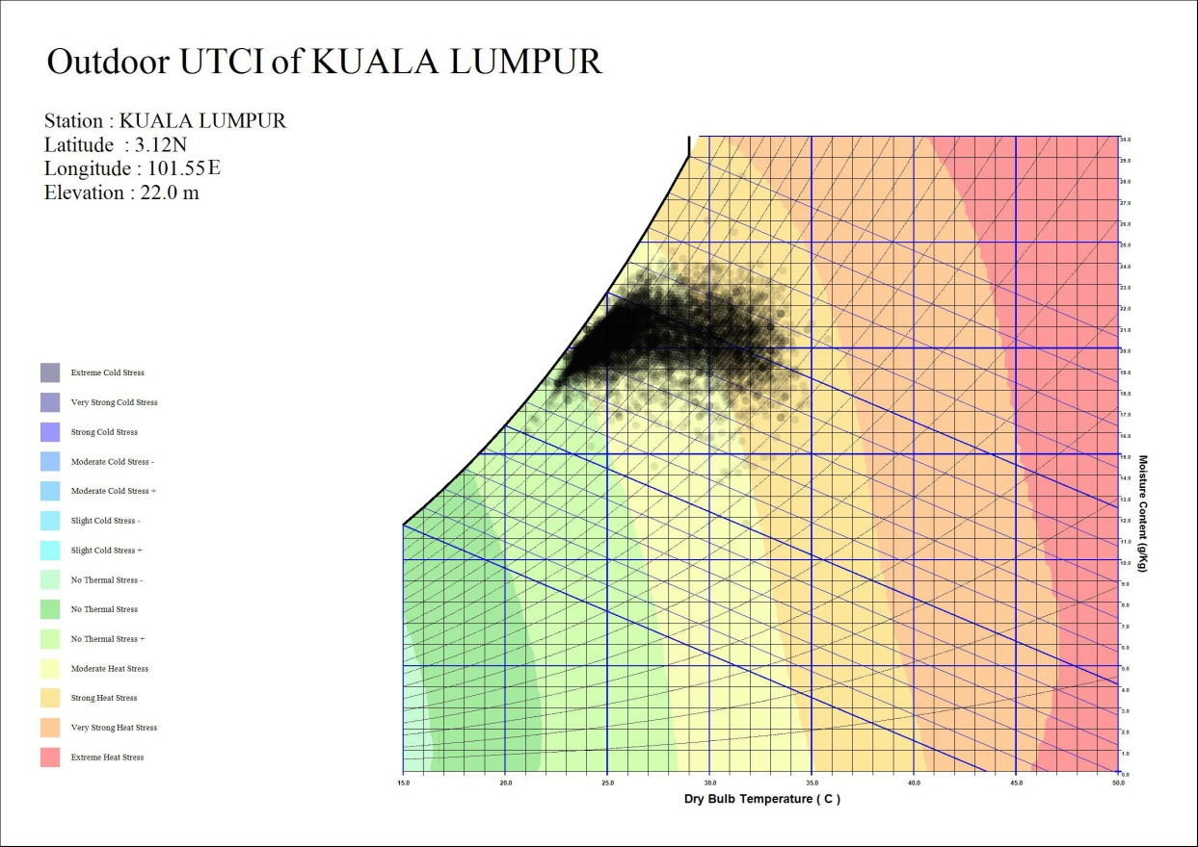

*Fig 2(c): Kuala Lumpur outdoor thermal condition in a year based on UTCI* psychrometric chart

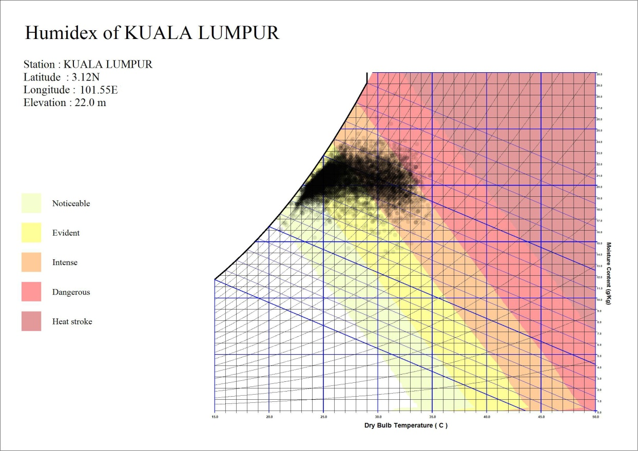

*Fig 2(d): Kuala Lumpur outdoor thermal condition in a year based on Humidex* psychrometric chart

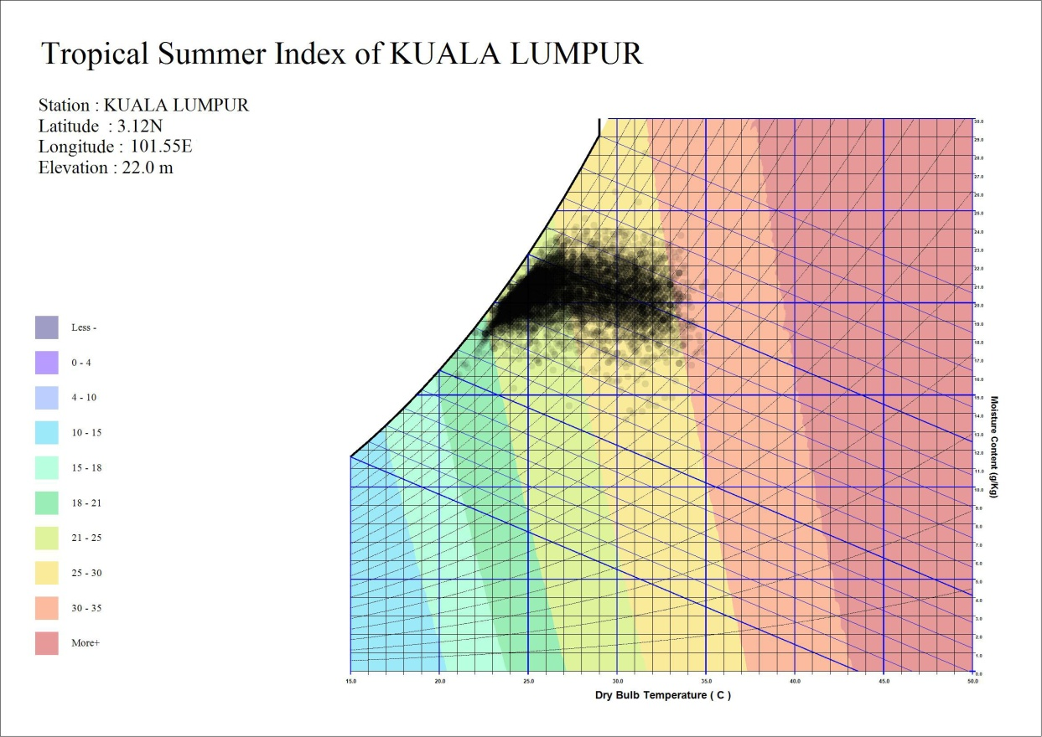

*Fig 2(e): Kuala Lumpur outdoor thermal condition in a year based on TSI* psychrometric chart

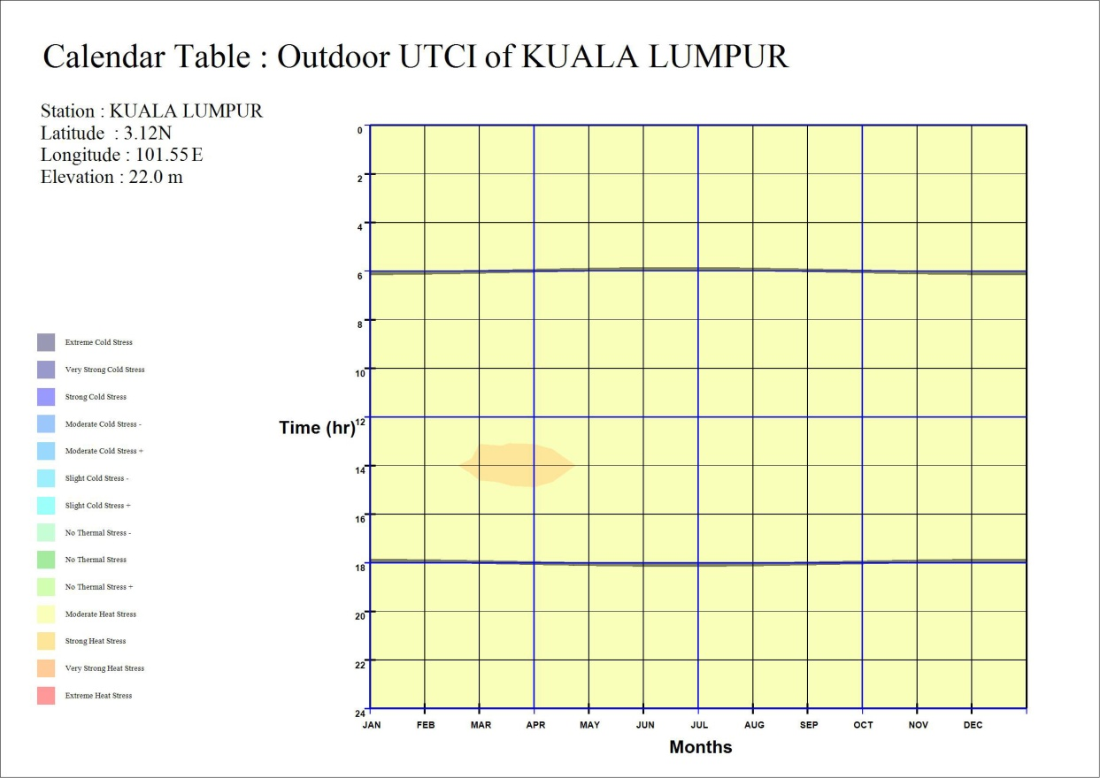

*Fig 2(f): Climatic needs calendar of Kuala Lumpur for outdoor thermal condition based on UTCI*

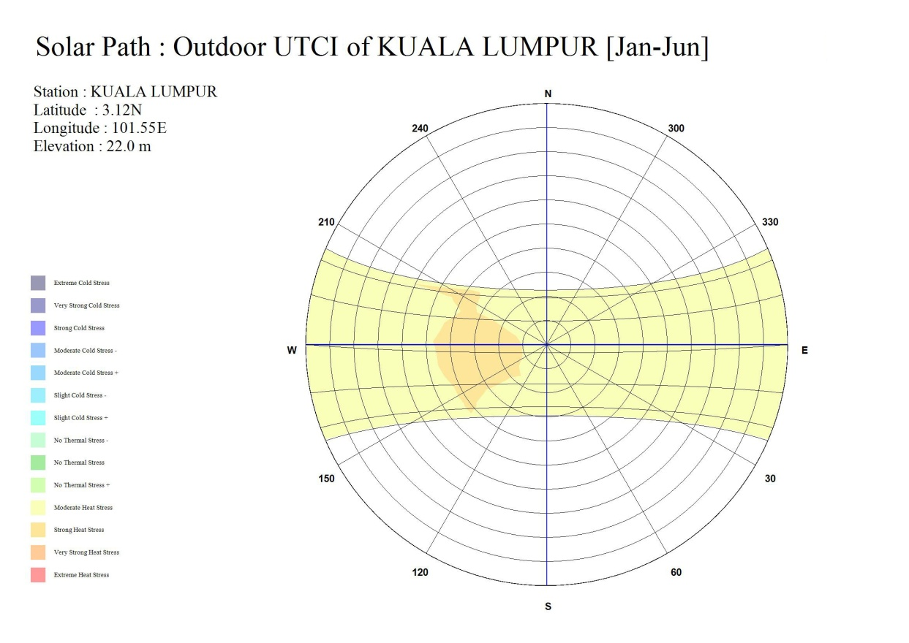

*Fig 2(g): Sun-path chart of Kuala Lumpur for outdoor thermal condition based on UTCI*

**4- Field Data Collection**

To realize which of the thermal definitions of different outdoor indices are more reliable for this city, a field study observation was done in the summer of 2010. It shows the local people’s reaction to warm weather and clarifies which of these indices are more appropriate for tropical climate. The filed study was done in two days of 3rd and 5th September 2010 as a sunny and rainy day respectively.

Local and micro weather data was gathered by a Kestrel WS-4500-KIT portable weather station data logger. As the comparison of different weather stations kits shows, it has a good overall rating and has an acceptable accuracy for outdoor weather data collecting.

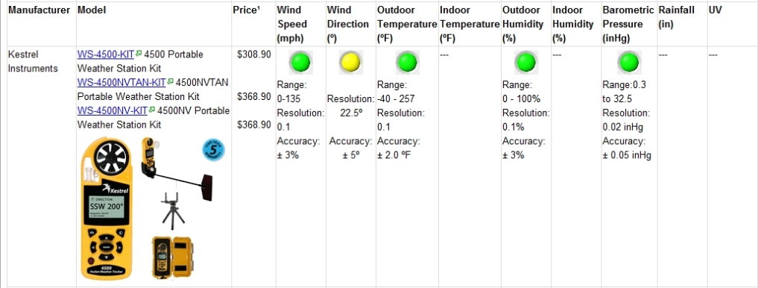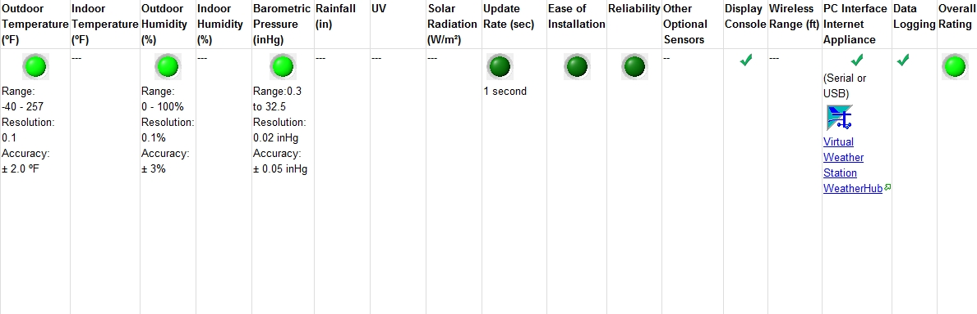

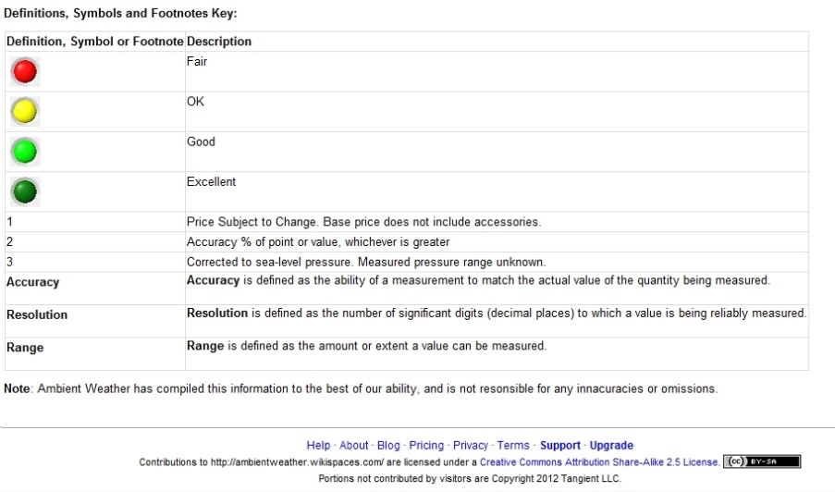

*Fig 3: Kestrel portable weather station data logger WS-4500 (*<http://ambientweather.wikispaces.com/Weather+Station+Comparison+Guide>)

The reference Kestrel data logger was located in the balcony of the seventeenth floor of a building in the city center. The path of observation was chosen for the most popular outdoor spaces in that area. (Fig 4)

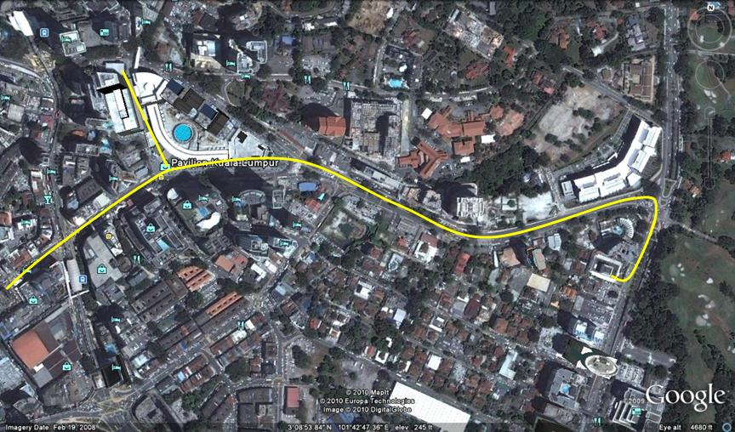 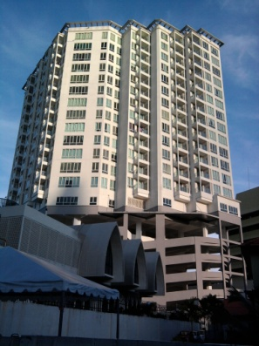 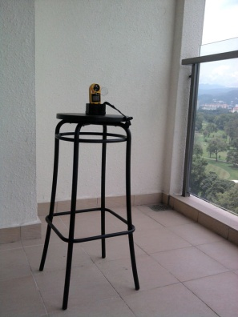

*Fig 4: The path of observation - city centre (left) and the Kestrel weather station (right)*

**5- Meso, Local and Microclimate Climate Analysis**

The meteorology station of Kuala Lumpur is considered here as the meso climate. Comparing the meso and local data shows that the local weather of the city is dryer than the meso (meteorology) data. This shows the effect of city heat island that makes the weather dryer, lowers the temperature swing and makes the nights warmer. (Fig 5)

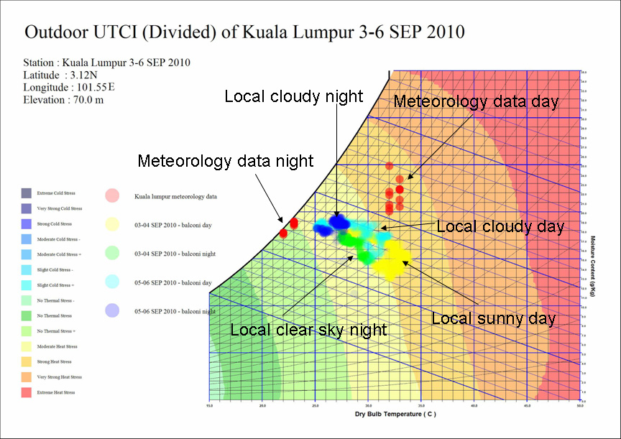

*Fig 5: Comparison of meso and local climate at observation day and night of 3-6 SEP 2010*

The observations identify the local and microclimate condition of the city centre. The microclimate condition in most observed points is warmer than local climate. It may be the result of the special location of the reference Kestrel data logger that is located in a very high and protected position in a roofed balcony. The other reason may be the effect of solar absorption of constructed surfaces in the city centre. It also shows that the sunny days have the warmest condition and may reach the strong heat stress situation if the constructed spaces do not support human thermal needs. Rainy and cloudy days have better thermal condition and with climate responsive design will lower thermal sensation one level to moderate heat stress (Fig 6). At night time the weather is in moderate or no heat stress condition that is the best thermal situation in this climate. As a result nightlife is a custom in this city and several outdoor activities are done at night. (Fig 7)

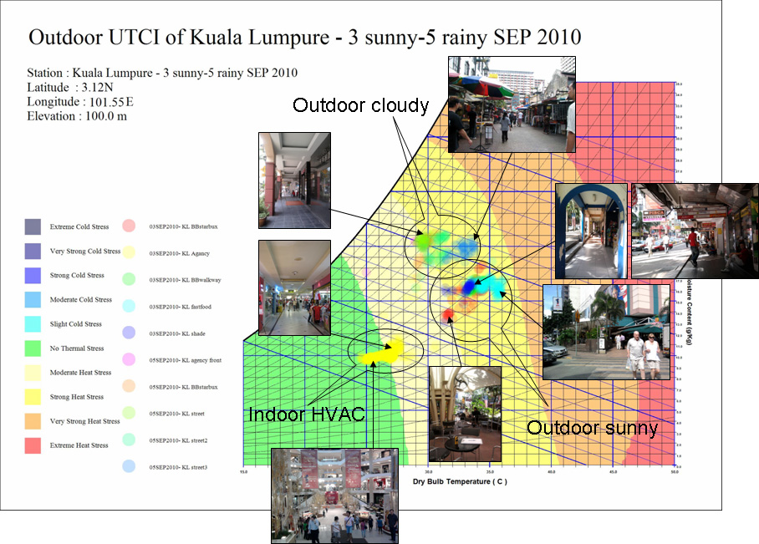

*Fig 6: Sunny and cloudy thermal situation on UTCI index in 3rd and 5th SEP 2010*

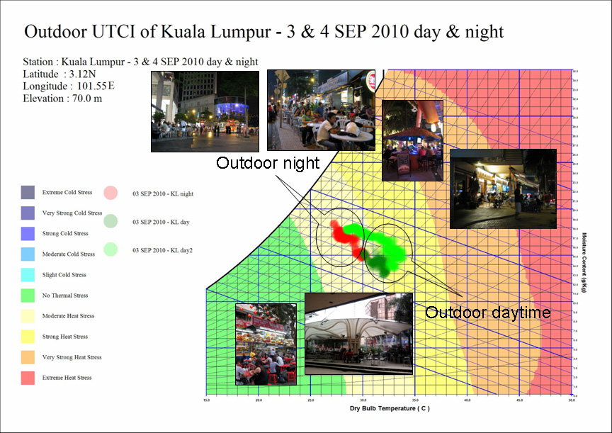

*Fig 7: Day and night thermal situation on UTCI index in observed days, SEP 2010*

**6- Data Analysis in Outdoor Public Spaces**

In spite of warm weather in daytime that is defined as strong and moderate heat stress, outdoor areas are full of population and lots of long term activities such as eating and shopping is done outdoor. In very hard conditions especially in sunny days, some of the outdoor spaces with intolerable microclimate condition will remain empty, while others with better climatic design will continue their activities by costumers. Some of these outdoor shops use outdoor HVAC systems such as fans and cold water spray to modify microclimate under a sunshade (Fig 8a & 8b). In cloudy days although the humidity is higher than sunny days, thermal condition falls one level down from strong heat stress to moderate heat stress. Therefore it feels more tolerable than sunny days. (Fig 9a & 9b)

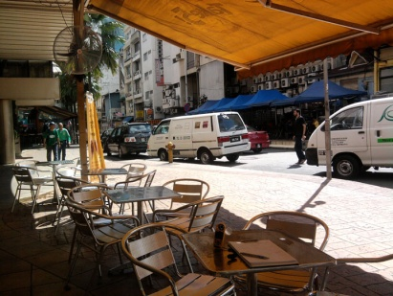 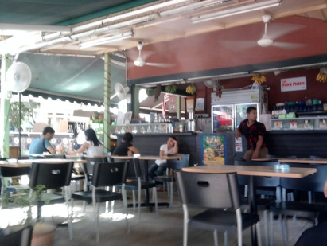 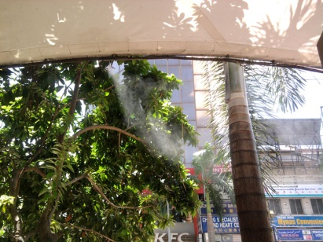

*Fig 8 (a): Different population in different microclimate conditions provided by appropriate design or outdoor HVAC in sunny day of 3rd SEP 2010*

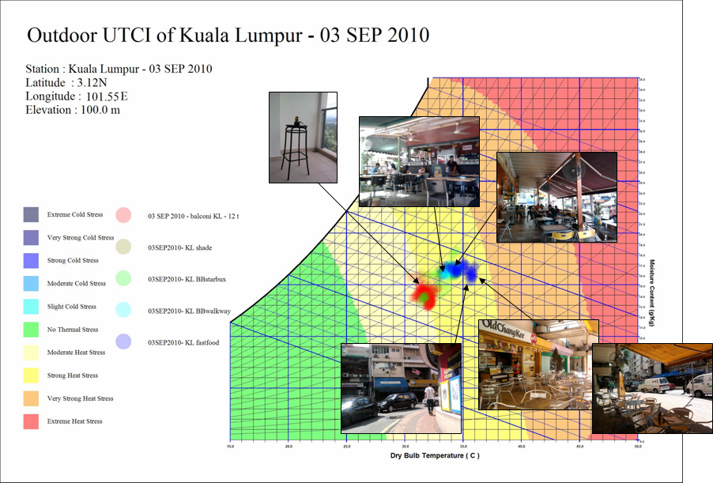

*Fig 8(b): Thermal condition of different microclimate outdoor spaces in sunny day of 3rd SEP 2010 at 12-15pm*

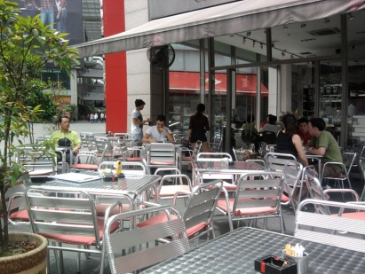 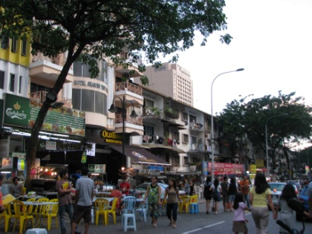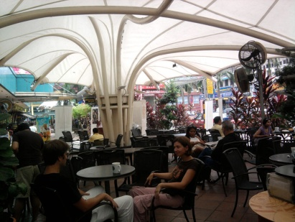

*Fig 9 (a): Different population in different microclimate conditions provided by appropriate design or outdoor HVAC in cloudy day of 5th SEP 2010*

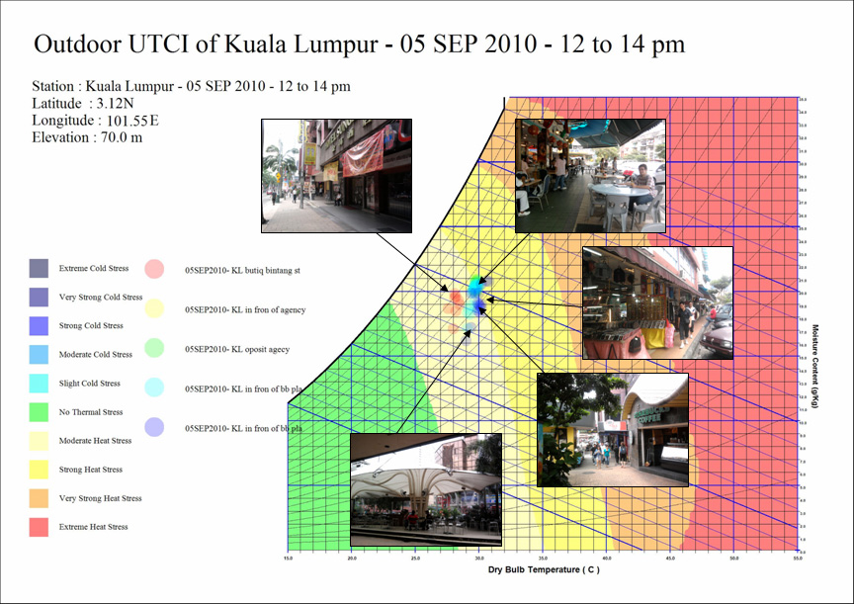

*Fig 9 (b): Thermal condition of different microclimate outdoor spaces in cloudy day of 5th SEP 2010 at 12-15pm*

Walkway is another outdoor space that needs special climatic design for difficult thermal condition. In sunny days walking under sun for a long time is dangerous and preparing shaded walkways is required (Fig 10a). Rain as a frequent phenomenon is another reason for shelter requirement. Therefore covered walkways and entrances are very common in this city and are used as shelter from heavy tropical rains (Fig 10b). These spaces have provided appropriate microclimate situation for shopping facilities and are crowded with people in all sunny and rainy conditions. Underground walkway is another solution to this requirement. (Fig 11)

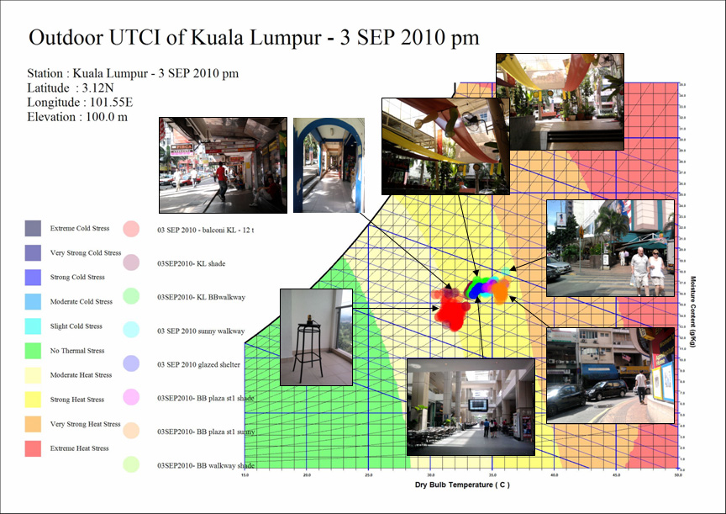

*Fig10 (a): Thermal situation of different walkways in sunny day of 3rd SEP 2010*

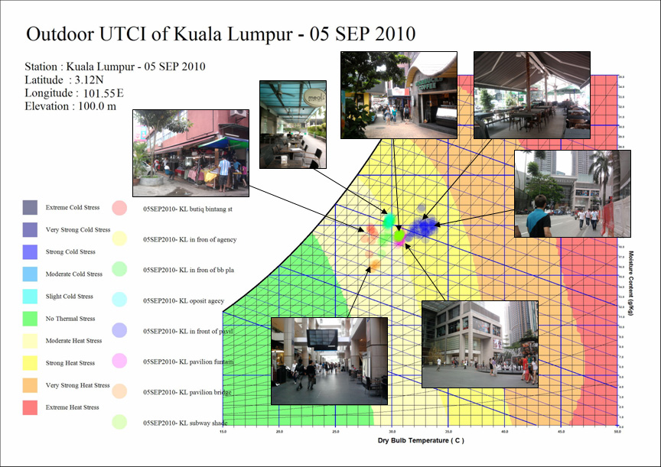

*Fig10 (b): Thermal situation of different walkways in cloudy day of 5th SEP 2010*

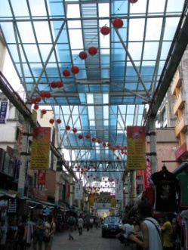 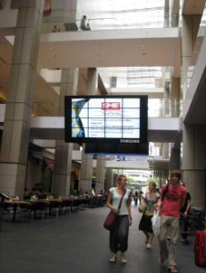 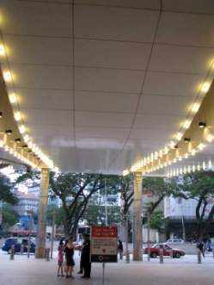 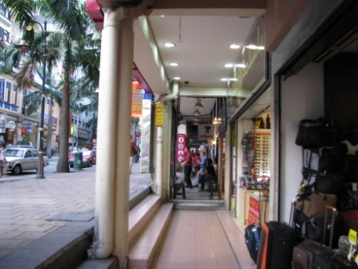

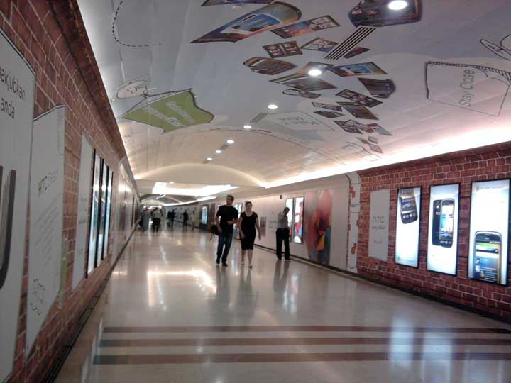 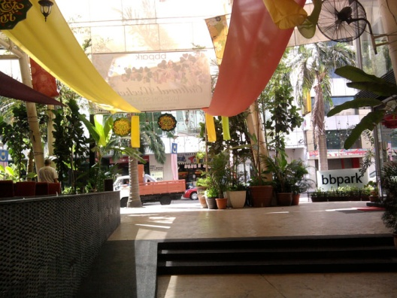

*Fig11: Different solutions for covered and shaded walkways in Kuala Lumpur*

In streets with shopping facilities, temporary sunshades that are provided by the sellers or hawkers help to produce better microclimate for pedestrians and costumers. (Fig 12)

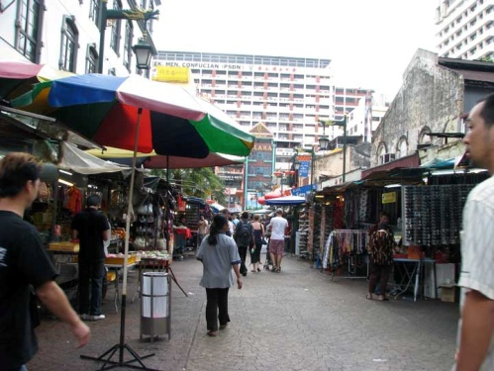 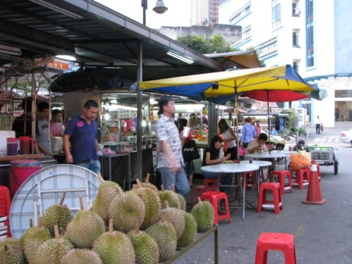 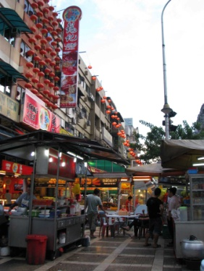

*Fig12: Temporary sunshades provided by shopkeepers and hawkers in walkways*

The final strategy for long term outdoor stay is using HVAC systems such as outdoor fans and cold water spry for small areas. They can not improve thermal condition to comfort zone but because of providing continues ventilation and evaporative cooling, they can increase tolerable exposure time. (Fig 13)

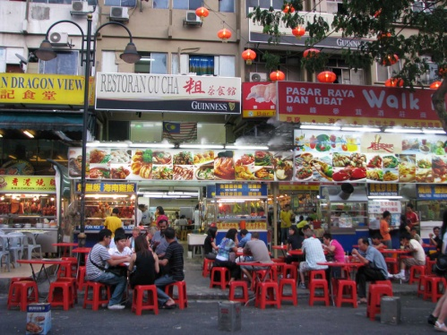 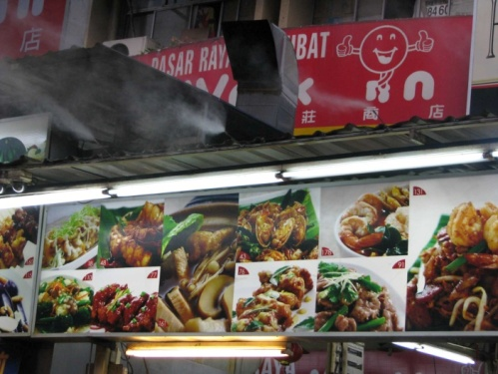 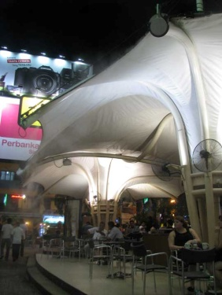

*Fig13: Creating tolerable microclimate using*

Large open spaces are not appropriate for long term stay. They can receive maximum solar energy and rain fall. Providing besieged fences and using green plants and water surfaces will lower the ambient temperature as heat sink. Kuala Lumpur as a tropical city with huge yearly rain has very good potential for this solution. Water play games and green surfaces in luxury open spaces such as modern shopping malls has helped to provide better microclimate for long term outdoor stay in sunny days. (Fig 14)

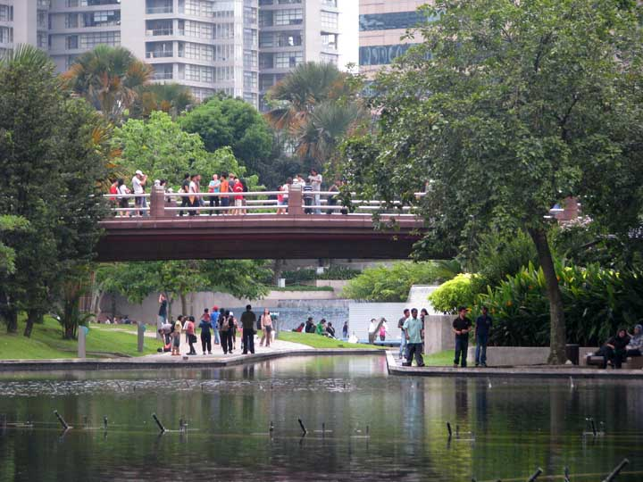 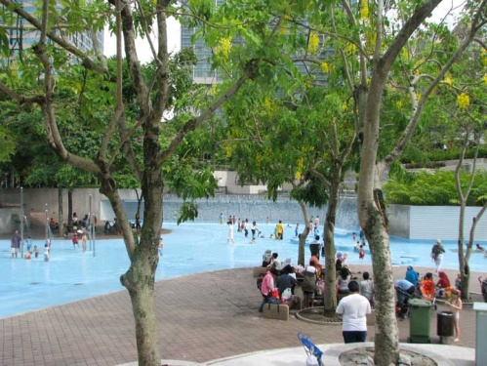 

*Fig14: Using green plants and water surfaces as thermal condition modifiers*

Vehicle station is another place that is used as a short term outdoor stay. It will be used in all thermal conditions and people have no choice to leave it for a better situation. Providing tolerable microclimate for these places is the responsibility of designers. In Kuala Lumpur with tropical hot climate, stations are designed as great sunshades. They are made of light color materials with the lowest solar absorption and thermal mass. Although their temperature will not decrease to the lower heat stress level but natural ventilation under the sunshade helps to increase thermal transfer and decrease feeling temperature. (Fig 15)

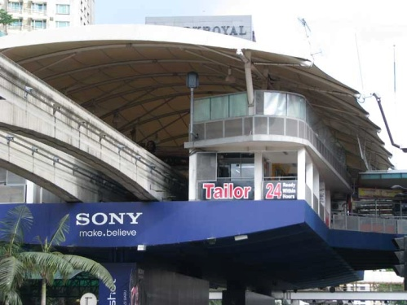 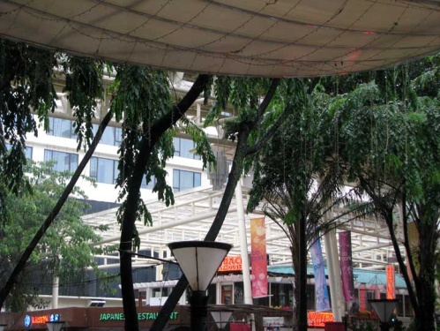 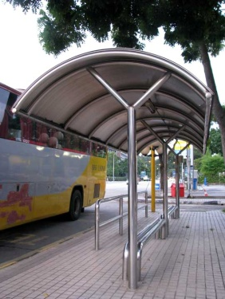

*Fig15: Using light color materials with low thermal mass in station as a sunshade*

**7- Discussion**

Observing different outdoor places in city centre of Kuala Lumpur, people’s presence and their behavior shows that for local citizen thermal situation are tolerable in most conditions. Existence of different tourists from different climatic origins proved that tropical climate of this city is not as hard as it is analyzed by the first group of outdoor thermal indices such as Heat Index (Fig 2a) and Temperature Humidity index (Fig 2b). The second group of the indices such as UTCI (Fig 2c) and Humidex (Fig 2d) defined thermal situation in middle noon as strong heat stress while people’s presence and their long term stay in outdoor spaces shows that they are able to tolerate this weather. The only index that defined this weather as slightly warm for acclimatized people is tropical summer index (Fig 2e) (Sharma & Sharafat 1986). It shows that the thermal zones that are introduced by these indices need to be clarified by some more researches to find out the exact and reliable interpretation of design strategies.

Two main results can be summarized here: 1- Acclimatization gives local people the ability to learn how to adapt their body and their behavior with hot condition. For example my self-experience of 6 months living in Kuala Lumpur shows that taking a shower before going out in very hot weather will clean the skin pores and prepare it for a better convection and evaporation heat loss. 2- Long term presence of people in some outdoor spaces shows that strong heat stress condition in hot humid tropical climate has the ability to be modified by appropriate climatic design and/or outdoor HVAC systems.

**8- Conclusion**

In this article hot tropical climate of Kuala Lumpur was studied considering outdoor thermal requirements of pedestrians. Using field study observation the microclimate data of different urban open spaces in the central city was collected by Kestrel personal weather station. The results were compared by higher climatic levels of meso (meteorology data) and local climate (fixed Kestrel in reference location). The comparison showed that: 1) the local climate is dryer than the meso climate, 2) the temperature swing is less and 3) night temperature is higher because of heat island effect. According to the outdoor thermal indices the local weather in sunny days is in strong heat stress level while in cloudy days it is more tolerable and in good climatic design places will lower to moderate heat stress.

Constructed places in open spaces will play a great role to modify thermal situation. In places such as outdoor shopping areas and coffee shops with long term stay, even in strong heat stress condition, it is possible to provide better microclimate by good climatic design and at last using outdoor fans and cold water spray. In walkways, appropriate shade and cover is required to protect pedestrians from sunshine and heavy rain. Temporary shades or underground walkways are another solution in this regard. Great open spaces require green plants and water surfaces to reduce solar gain in sunny days. Vehicle stations as short term outdoor stay should be in special consideration because they are used in all weather conditions. Light color materials with low thermal mass are needed to create shade and natural ventilation simultaneously.

How to interpret the definition of thermal outdoor indices was another result of this article. It was proved that strong heat stress condition in tropics has the ability to be modified by a good climatic design or outdoor HVAC system as a final solution.

**Reference:**

Bröde, P., G. Jendritzky, D. Fiala and G. Havenith (2010), The Universal Thermal Climate Index UTCI in Operational Use, Windsor Conference, UK, 9-11 April 2010.

["Climate in Kuala Lumpur"](http://www.healism.com/destinations/malaysia/climate_in_kuala_lumpur/). Retrieved 2010-09-18. Available at: <http://www.healism.com/destinations/malaysia/climate_in_kuala_lumpur/>, cited in <http://en.wikipedia.org/wiki/Kuala_Lumpur>

Cost Action 730, Available at <http://www.utci.org>

[csgnetwork.com](http://www.csgnetwork.com) (2008), Canadian Humidex Calculator, Available at: <http://www.csgnetwork.com/canhumidexcalc.html>

EnergyPlus Weather Data, available at: <http://apps1.eere.energy.gov/buildings/energyplus/cfm/weather_data3.cfm/region=5_southwest_pacific_wmo_region_5/country=MYS/cname=Malaysia>

"[Extreme Temperatures Around the World"](http://www.mherrera.org/temp.htm). Maximiliano Herrera. Retrieved 2010-09-18. Available at: <http://www.mherrera.org/temp.htm>, cited in <http://en.wikipedia.org/wiki/Kuala_Lumpur>

["Hazardous haze shrouds Kuala Lumpur"](http://www.msnbc.msn.com/id/8908221/). MSNBC. 2005-08-11. Retrieved 2007-12-13. Available at: <http://www.msnbc.msn.com/id/8908221/#.T3EFZIcgeYU>, cited in <http://en.wikipedia.org/wiki/Kuala_Lumpur>

Kyle W.J. (1994), The Human Bioclimatic of Hong Kong, Contemporary Climatology, Proc. of COC/IGU Meeting, Masaryk University, Brno, Czech Republic, 15-20 August 1994, pp 345-350.

["Kuala Lumpur Environment"](http://www.dbkl.gov.my/pskl2020/english/environment/index.htm). Kuala Lumpur City Hall. Retrieved 2007-12-12. Available at: <http://www.dbkl.gov.my/pskl2020/english/environment/index.htm>, cited in <http://en.wikipedia.org/wiki/Kuala_Lumpur>

Sharma, M. R and A. Sharafat, (1986), Tropical Summer Index – A Study of Thermal Comfort of Indian Subjects, Building and Environment, Vol. 21, No. 1, pp. 11-24.

Tahbaz, M (2011), Psychrometric Chart as a Basis for Outdoor Thermal Analysis, International Journal of Architectural Engineering & Urban Planning, Vol. 21, No. 2, pp 95-109.

Tahbaz, M and P. Amini Behbahani (2011), SIKRON Software, Designed in Shahid Beheshti University, Tehran, Iran.

[tpub.com](http://www.tpub.com) (2008), Aerographer/Meteorology, Integrated Publishing’s Archive Service, Available at:

<http://www.tpub.com/content/aerographer/14269/css/14269_67.htm>

["World Weather Information Service – Kuala Lumpur"](http://worldweather.wmo.int/020/c00082.htm). August 2010. Retrieved 2010-09-18. Available at: <http://worldweather.wmo.int/020/c00082.htm>, cited in <http://en.wikipedia.org/wiki/Kuala_Lumpur>

<http://www.bbc.co.uk/weather/world/city_guides/results.shtml?tt=TT002590>

<http://en.wikipedia.org/wiki/Kuala_Lumpur>

<http://ambientweather.wikispaces.com/Weather+Station+Comparison+Guide>

<http://www.ambientweather.com/kews4500kit.html>