Code: 355

Abstract:

Analyzing Effect of Organizational Strategies on Organizational results using system dynamics based upon EFQM model

In order to evaluate the relationship between Organizational Strategies and Organizational results, a comprehensive model is required, which should be able to capture all aspects of business excellence. The EFQM model is suitable tool to observe these factors. The EFQM model consists of two main domains: Enablers and Results. The first domain which includes processes and systems in general, "enable" the organization to have higher performance or "results". On the other hand, the feedback from the results makes the organization to correct the system. Hence, a dynamic model could be appropriate in analyzing the interrelated behavior of the two main domains as well as those within the criteria and sub-criteria. This research is an effort to find the relationship between Strategies and results through system dynamics tool based upon EFQM model. In other words, this research exploits system dynamics in order to measure the effects of Strategies on Organizational results using a dynamic model. The advantage is that by changing one parameter in the Strategies, one can find how it could affect key results especially financial outcomes.
Keywords: Organizational Strategies, Organizational results, Business Excellence Model, EFQM, System Dynamics

1. Introduction
In today competitive world, in where there are deep and fast changes in field of scientific-technical areas and continuous challenges in economical-social systems on the sense of international competition, we can see many firms which have suitable position. They are flexible, pure and customer-oriented by desirable using of available facilities and suitable utilization of new sources for producing goods and introducing desirable services with suitable quality. Firms must establish an efficient and stable system using standard model for Function evaluation in order to find their weak and strong points (recoverable areas) by regular assessment of their function and comparing with rivals. Then they can identify priorities of planning and then they can recovery recoverable areas continuously by using corrective actions. So they can pass organizational transcendence levels by raising their function gradually. In recent years among standard models of function evaluation, organization excellence models have smoothed the road of obtaining the world class function and the way of recovering the job function. They have also stimulated special attention in different organizations and firms, and among these models, EFQM organizational excellence model developed as a framework for organizational self-assessment which has focused on continuous recovering and it has used from self-assessment process as a powerful tool for reaching to this aim. General aim of self-assessment is obtaining and analyzing strong points and recoverable areas. Therefore for reaching to this goal, EFQM excellence model has been used with cause and effect relationship between enablers and results in self assessment process. In this line, the main problem of organization is due to little or weak identification about cause and effect structure of EFQM model. Systemic approach can clear the cause and effect structure. EFQM observation from systemic sight is according to primary assumptions of its development. Systemic approach suggests that all different aspects and organization areas relate to each other and one cannot recover an area or a total without affecting on other relative areas. On the other hand among several observable variables and their relations, special cause and effect loops are only prevailing in determining general behavior of system. Review On various articles about using EFQM model in organizations shows that they could be divided to two general groups. First group includes articles that only have applied and implemented EFQM model and consequently resulted in guidance to and movement in the excellence path(V. Anderson et al [1], Flego [2], Wu and Wang [3], Radim [4], Leticia Santos-Vijande and I. Alvarez-Gonzalez [5], Michalska [6], Shafaei and Dabiri [7], Bou-Llusar [8], Stok et al [9],Nazemi [10],Nikolaidis and Terpos [11] ). Second group is consisted of articles trying to improve the effectiveness of EFQM model by combining it with other models and tools such as DEA(Shahroudi [12]), Intellectual Capital Management(Kim et al [13]), and DEMATEL technique(Sadeh and Arumugam [14]).
So far, several papers and numerous case studies have been compiled about dynamic application of systems for increasing performance of models such as BSC which each of them have used from dynamic capability of systems for compensating systemic weaks of BSC (Yim et al [15], Todd [16], Sterman [17], Sterman [18], Akkermans and von Oorschot [19], Rydzak et al [20], Bianchi and Ontemaggiore [21]). But there is no material about using dynamic systems for recovering the EFQM excellence model in literature. So, EFQM model analysis has been made in this paper using system dynamics for utilization of capability of system dynamics. In order to obtain a dynamic structure for EFQM model, it’s necessary at first to identify each of main elements of model i.e. problem variables. Then the cause and effect diagram is developed and later it’s necessary to extract dynamic model for EFQM model with explaining relations between variables.

2. Theoretical bases
2.1. The EFQM excellence model
The EFQM Excellence Model was created in 1991 by the European Foundation for Quality Management (EFQM) as a framework against which applicants for the European Quality Award are judged, and to recognize organizational excellence in European companies. Nowadays, EFQM brings together more than 700 members located in many countries across the world. The EFQM Excellence Model is made up of nine elements grouped under five enabler criteria (leadership, policy and strategy, people, partnerships and resources and processes) and four result criteria (people results, customer results, society results and key performance results). Carlos Bou-Llusar et al [22]

2.2. System dynamics
System Dynamics is a methodology aimed at studying the structures of social or organizational systems by representing the causal relationships among their elements and the evolution of a system over time. Its objective is to elucidate the general behavior of a given system, based on behavior patterns among its parts and on the structures determining those patterns.
The basic idea in system dynamics is that a system’s dynamic behavior obeys a principle called the accumulation principle. This principle states that a system’s dynamic response derives from the transition of the resources accumulated in stocks and that those transitions are controlled by entry and exit flows of resources in and out of the stocks. This principle leads to a specific causal representation known as stock-and-flow diagrams. Edson Crescitelli et al [23]

3. Benefits of analyzing EFQM model, by using dynamic systems
There are three significant disadvantage of EFQM model without using and developing system dynamics:

3.1. Unidirectional causality too simplistic
In using FEQM model, most organizations consider Unidirectional causal relations .the use of causal-loops alone is seen as problematic and is opposite of fact. Instead of a causal relationship, this model believes that the relationship is more one of interdependence, or bi-directional causality. Because in actual world causal relationships is seldom Unidirectional.
In provided dynamic model in this paper, it's considered the effect of the criteria of the Enabler domain on results criteria. These effects act as bi-directional so that improves of Performance Indicators and Perception Indicators effect on enablers, separately.

3.2. Does not separate cause and effect in time
The problems arising from the fact that the time dimension is not part of the assessment, because in some cause and effect relationships a time lag exists between cause and effect. This is not shown by the BSC since it measures cause and effect at the same time. The simply looking at different measures simultaneously is not enough. The linkages between them must also be understood.
In provided dynamic model in this paper according to what happens in reality, a time lag exists between enabler criteria and result criteria.

3.3. No mechanisms for validation
The analysis of EFQM excellence model using system dynamics provides the mechanism for maintaining the relevance of defined measures. the problem for managers is usually not identifying what could be measured, but reducing the list of possible measures to a manageable (and relevant) set. Thus, the advantage of checking just a few numbers may become a disadvantage when not the right numbers are selected for the EFQM.
Furthermore, the analysis of company strategy based on the EFQM model approach considers the causal relationships between performance variables only in qualitative terms. This implies that managers should rely on mental simulations and heuristics in order to quantify the results of their strategy and, hence, evaluate its efficiency and effectiveness. This task is even tougher when the company system is characterized by a high degree of complexity, non-linear relationships among variables, and delays between causes and effects.
The validity of EFQM’s assumptions about causal relationships between the criteria has been also questioned by the system dynamics. In particular, it has been demonstrated that the hypothesized links between quality and financial indicators may be not confirmed in reality. For instance, it has been remarked that the commonly assumed causal relationship according to which a higher customer satisfaction leads to higher financial results may not have any empirical evidence. On the contrary, it may happen that the costs of policies aimed to increase customer satisfaction are higher than the related benefits, both in the short and long term. For such reason, the lack of rigorous validation of the EFQM’s assumptions may lead the management to the selection of performance indicators, which imply desirable perception indicators.

4. Modeling process
The purpose of Dynamic System modeling is to establish the relation between the various variables which make up the system and are used to analyze decision-making policies in the realm under study. The Dynamic System modeling is an essential tool which helps in modeling the real world in the form of feedback links.

4.1. Modeling and Model structure
After recognition of key variables, made a simplified and stylized version of the qualitative model. Thereafter this structure divided into 3 section. This sections are improvement regarding people, partnerships and processes.

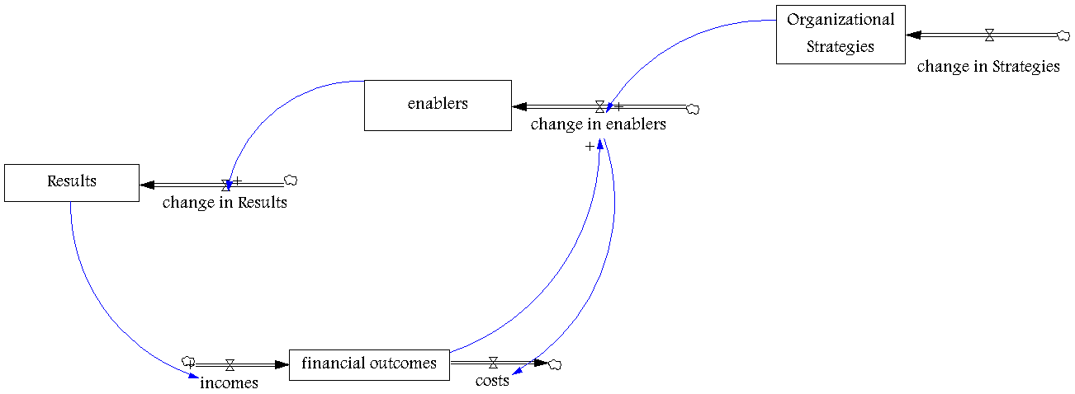

Diagram 1- overall image of Model structure

Overall model is shown in Diagram 1. In this diagram, four interconnected elements are shown that together determine the dynamic behavior of the model. These elements make one overall feedback loop. This feedback loop is “reinforcing” or positive feedback loop.
Diagram 1 shows the relation between the Strategies and Financial outcomes. The key effectiveness variables in this relation are Strategies, Enablers, results and financial outcomes. Expanded relations between the Strategies and Financial outcomes can be described as follows:
- The relationship between Strategies and Enablers.
- The relationship between Enablers and results.
- The relationship between results and financial outcomes.
- The relationship between financial outcomes and Strategies.
Due to the expanded relations defined above, in this article the relationships between model’s variables are used in drawing the model. This is described as follows:
It is believed in the enterprises that reaching the better results regarding customers satisfaction, people satisfaction and society satisfaction, requires the grown enablers, which itself begins with putting together the changes in Organizational Strategies. Therefore, the Strategies changes are effective on all model variables. An organization can attain the better financial outcomes only when it reaches suitable results in the field of improvement customers, peoples and society satisfaction. By achieving the better Enablers, acquires the more financial outcomes. Therefore, interaction between these factors improves Organizational excellence.

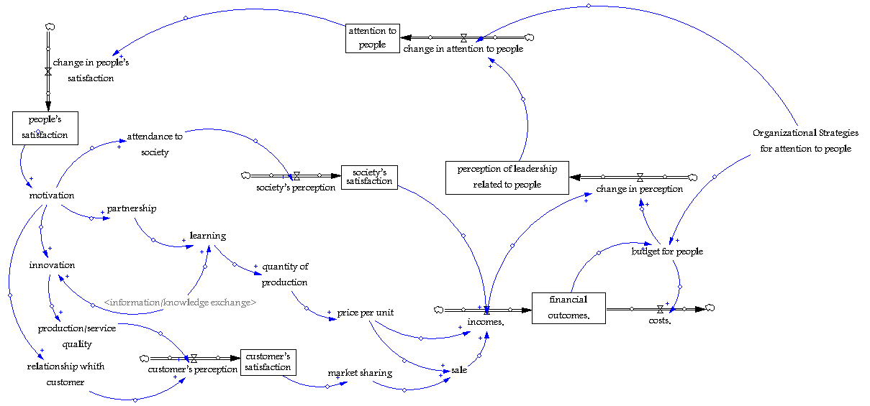

Diagram 2- attention to people

Diagram 2 shows the relation between the people strategies and financial outcomes. The key effectiveness variables in these feedback loops are attention to people, people’s satisfaction, customer’s satisfaction, society’s satisfaction, financial outcomes and perception of leadership related to people. Due to the expanded relations defined above, in this article the relationships between model’s variables are used in drawing the Diagram. This is described as follows:
It is believed in the enterprises that reaching the better results regarding people satisfaction requires the grown attention to people, which itself begins with putting together the changes in people Strategies. Therefore, the people strategies changes are effective on all this diagram variables. When organization acquires suitable results in the field of improvement people satisfaction, it can follow the better customer’s satisfaction. Also, an organization can attain the better financial outcomes when it reaches suitable results in the field of improvement customer’s satisfaction. By achieving the more financial outcomes, acquires the better perception of leadership related to people. For completion of this feedback loop, the improvement in the leadership perception raises people strategies.

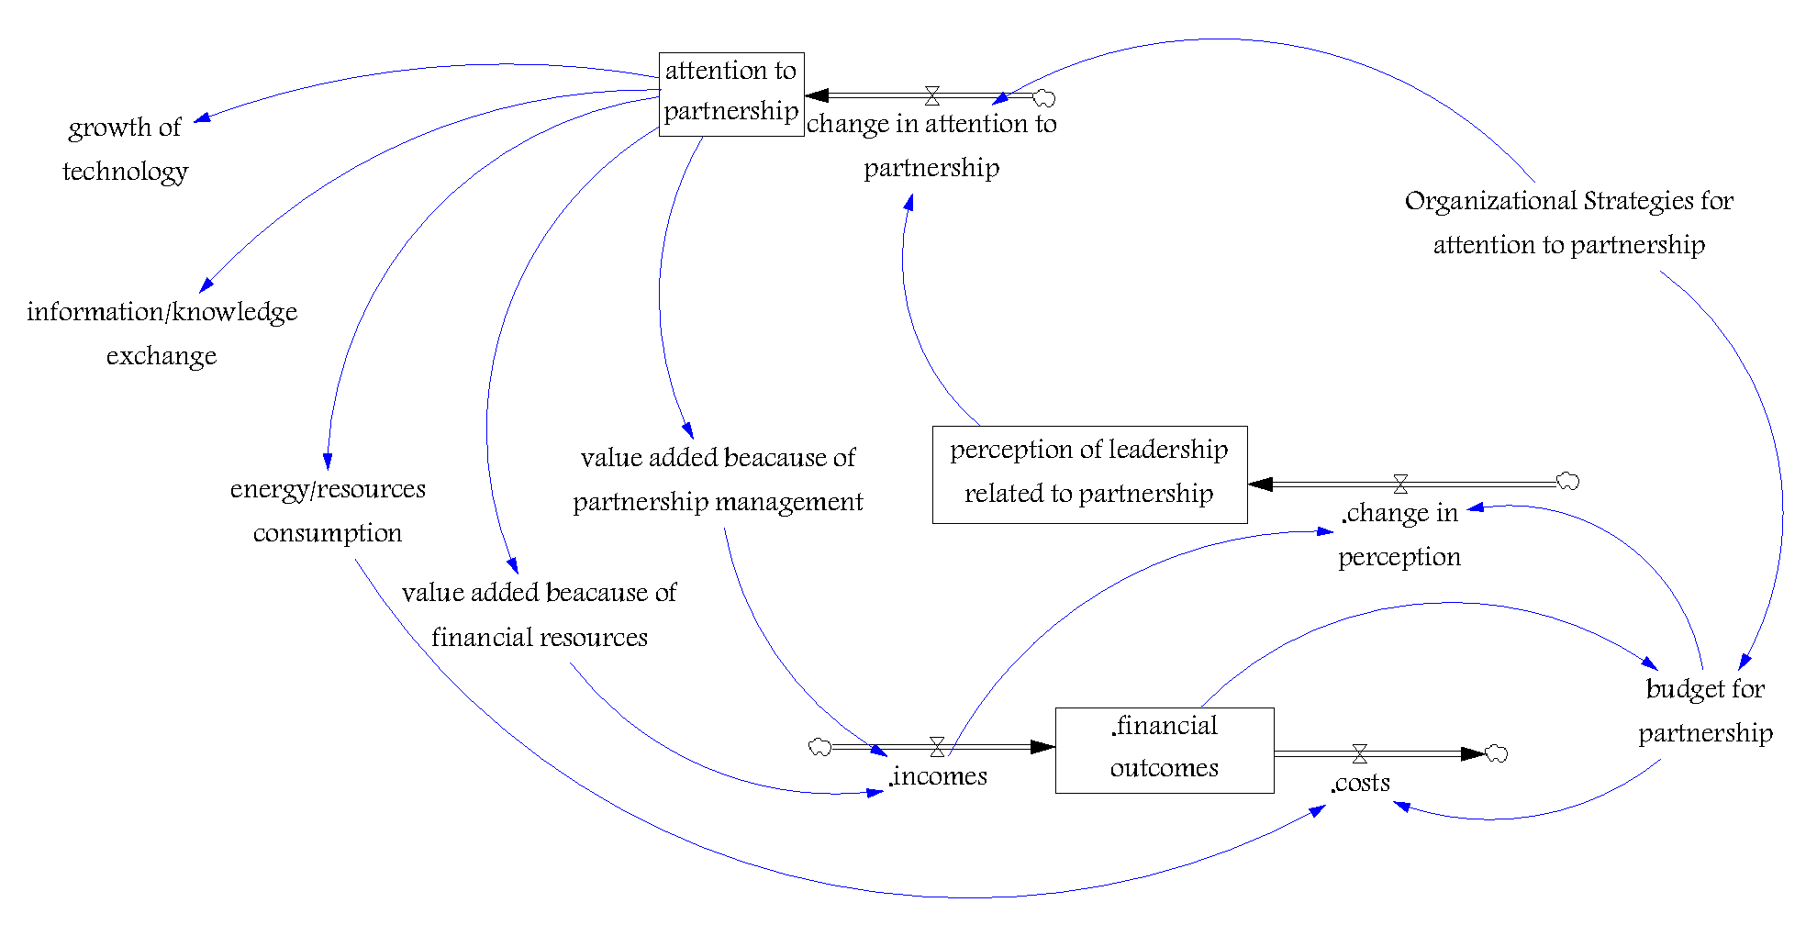
Diagram 3- attention to partnerships

Diagram 3 shows the relation between the partnership strategies and financial outcomes. The key effectiveness variables in these feedback loops are attention to partnerships, financial outcomes and perception of leadership related to partnerships. Due to the expanded relations defined above, in this article the relationships between model’s variables are used in drawing the Diagram. This is described as follows:
It is believed an organization can attain the better financial outcomes when it reaches suitable results in the field of more attention to partnerships. By achieving the more financial outcomes, acquires the better perception of leadership related to partnerships. For completion of this feedback loop, the improvement in the leadership perception raises partnership strategies.

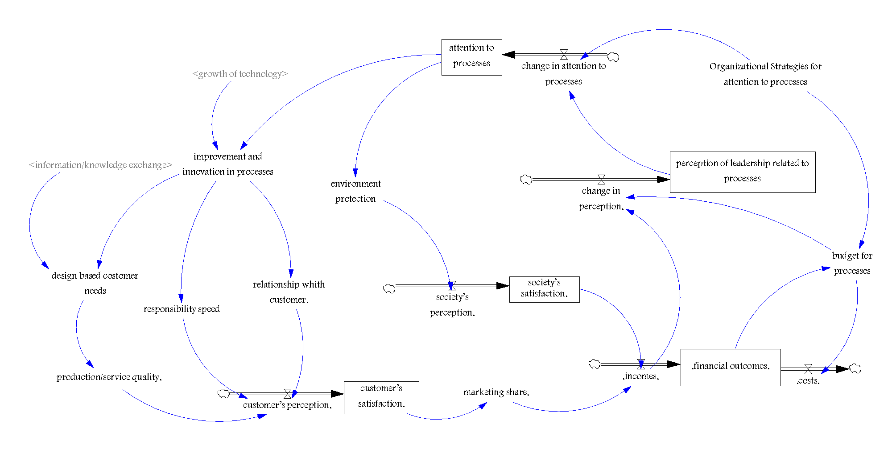
Diagram 4- attention to processes
Diagram 4 shows the relation between the processes strategies and financial outcomes. The key effectiveness variables in these feedback loops are attention to processes, customer’s satisfaction, society’s satisfaction, financial outcomes and perception of leadership related to processes. Due to the expanded relations defined above, in this article the relationships between model’s variables are used in drawing the Diagram. This is described as follows:
It is believed in the enterprises that reaching the better results regarding customer’s satisfaction and society satisfaction requires the grown attention to processes, which itself begins with putting together the changes in processes Strategies. Therefore, the processes strategies changes are effective on all this diagram variables. An organization can attain the better financial outcomes when it reaches suitable results in the field of improvement customer’s satisfaction and society satisfaction. By achieving the more financial outcomes, acquires the better perception of leadership related to processes. For completion of this feedback loop, the improvement in the leadership perception raises processes strategies.

4.2. Formulating the Model structure
Now according to the above structures, the stock and flow diagram of the EFQM Model is performed by using Vensim PLE software. Some of dynamic model relations are presented in appendix. Time unit is taken year and the model is run for 10 years beginning from 2011. For studying the trend of organization development, customers’ satisfaction, people satisfaction, society satisfaction and financial outcomes are defined. these levels indicate the effects of policies, systems, processes, and organization activities during time.
For linking between model variables, Kind of these variables in Vensim PLE software is lookup. They’re used for relationship between the performance indicators and perception indicators of the Results domain. For example, for link between “learning” variable and “cumulative production” variable, lookup function is defined, which shows the relationship between cause and effect. it is expressed as a diagram. In this diagram, “learning” places on the x-axis and “cumulative production” places on y-axis.

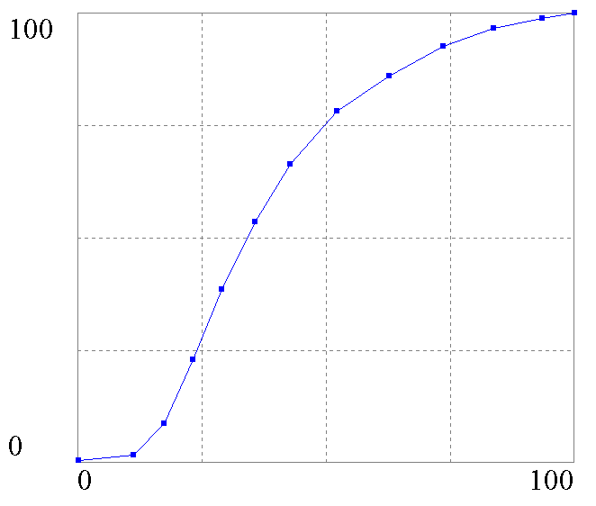

Fig .1. relationship between “learning” variable and “cumulative production” variable

5. Performance test of dynamic model
In order to validate the EFQM model, some conventional tests are used like boundary efficiency, units’ consistency, parameter evaluation, Cumulative error test and extreme value test.
- Unit consistency test: Our model passed this test while all of its units were approved by Vensim software when the Unit Check option was active.
- Collaborative error test: the proposed model is independency to time unit. For example, if the time unit is assumed “one year” initially, if it is changed to “Quarter” the model should generate quite similar results. The results indicated no changes in the behavior of the mentioned variable in different time units as illustrated in figure 2.

Figure 2. behavior of financial outcomes in different time units

- Scope sufficiency test: This test was passed through further surveying the EFQM model, which involve defined criteria, sub-criteria, and indexes.
- Parameter evaluation test: the expert opinion is used in all the variables of the model as an estimation of all parameters.
- Structure evaluation test: This test was passed by the consistency of models behavior with its structure. Because the variables of the model create negative feedback loops, they should be goal-seeking. For example, the goal-seeking behavior of the variable financial outcomes is illustrated in figure 3.

Figure 3. Goal-seeking behavior of variable financial outcomes

- Boundary conditions test: This test was conducted for the model and its performance was approved in the boundary conditions. For example, the amounts of policy, strategy, and leadership variables were tested in the boundary values of 0 and 100 and their effect of Customer Result (b) variable was captured. The results indicated no changes in the mentioned variable in the boundary conditions as illustrated in figure 4.

Figure 4. Behavior of Customer Results (b) in boundary conditions

6. Policy making
In provided dynamic model “organizational strategies” variables are defined for people, customers and society Enablers in order to evaluate different policies which are based on these criteria improvement (these exogenous variables improvement are determined based on future goals and policies of the organization).
Now we discuss and compare three different policies and scenarios to find actions by which the firm can achieve its objectives. “Financial outcomes” variable is the main variable to which special attention must be paid. We consider following four scenarios:

- Policy 1: We name the first scenario “people strategy based approach” which concentrates efforts to improve attention to people. It causes to people’s satisfaction increases. afterwards customer’s satisfaction and society’s satisfaction become more. In conclusion financial outcomes grows. Therefore we assume the desired value of “people strategy” variable improvement is in their ideal values i.e. 50%.
- Policy 2: the second policy is called “partnerships strategy based approach” which concentrates efforts to improve attention to partnerships. It causes to value added increases and costs decreases. In conclusion financial outcomes grows. Therefore we assume the desired value of “partnerships strategy” variable improvement is in their ideal values i.e. 50%.
- Policy 3: We name the third scenario “processes strategy based approach” which concentrates efforts to improve attention to processes. It causes to customers’ satisfaction and society’s satisfaction become more. In conclusion financial outcomes grows. Therefore we assume the desired value of “processes strategy” variable improvement is in their ideal values i.e. 50%.
- Policy 4: the fourth policy is called “total based approach” which insists on people, partnerships and processes criteria. In this state, organization must strike a balance between these three above criteria and improve all of these variables but improvement is less than previous Policies because resources are limited. Therefore, the related desired values of these variables are taken 20% as well.

The results of applying each of above policies for the “financial outcomes” variable are shown in figure 5.

Fig.5. The results of applying four policies for the “financial outcomes” variable

As it is obvious from figure 5, “financial outcomes” has an exponential growth in the four scenarios. In the first years of the simulation results, “financial outcomes” in the four scenario increases faster than of the next years, it grows less in the next years and this behavior continues forever.
In comparison between four scenarios it’s observed that four scenario follows the better trend than other scenarios. The better performance of the fourth scenario is that conventionally the one criterion alone has not significant impact on the organization excellence. Activities, processes, and systems in general, enable the organization to have higher performance or results. Therefore, all the criteria of the Enabler domain have more significant impact on the organization excellence. Hence it had better that firms should strike a balance focus on all the criteria. Even if it’s necessary to take smaller improves.

7. Concluding remarks
In this paper we presented a new integrated dynamic approach which investigates real performance of EFQM in enterprises and gives rise to a comprehensive and holistic viewpoint. Since this approach fills existing gap among previous incomplete models, this model specially is appropriate for analysis, description and comparison of different enterprises. The proposed model is able to measure and monitor effect of Strategies on results through system dynamics tool based upon EFQM model as well. Hence, Scenarios extracted from this model can steer enterprise toward improving decision making in strategic level.
Therefore, in the proposed model, we indicated the effects of powerful factors on organizational results by using the system dynamics’ model, and we obtained and analyzed the trend of changes in terms of different values utilizing software.
Analysis of technology effectiveness on lean manufacturing considering the dynamic behavior of the system provides a group of advantages which the most important of them are as follows:
- Simulating the effect of Strategies on enterprise results.
- Performing the “what’s if” analysis for learning from future potential threats and scenes.
- Capability of visual representation for relations between values of the model.
- Reducing the risk of performing plans. Through simulating and studying of the results and the conclusions of different policies before using.
Also, obtaining the dynamic model, provides advantages for recovering of evaluations, including to provide time dimension between cause and effect. With respect to evaluations which made base on the developed model, it’s indicated the effects of changes in powerful enablers on the results are indicated simultaneously. However, its effects appear during the next period not during the same period. We can say obtained dynamic model is a suitable tool for modeling the situation of organizations and for predicting the effect of their existence strategies.
Following fields can rise for the next researches:
- More complete performance tests of the developed model.
- Sensitivity analysis is one of the possible developments of this work. Sensitivity analysis increases the possibility of having precise scrutiny on different scenarios and policies.
- Performing of more simulations for different policies with different analysis of their results which leads to more exact conclusion.
- Inviting experts of manufacturing systems and system dynamics in order to more studying on the developed model, for improving the relationships and equations in the model for more using in organizations.
- Modeling and measuring cannot be suitable only for organizations. These techniques must be considered in social-economical systems. If the developed model be combined with organization policies can raise efficiency of this model. Also, discussion and developing about the developed model and implementing it at different positions can be guidance for researcher in the future investigations.
8. References
[1] V. Anderson Henrik, Lawrie Gavin, Shulver Michale, “The Balanced Scorecard vs. the EFQM Business Excellence Model-Which is the better strategic management? ” 2GC Active management, 2000.
[2]Flego, A, “Methadone and Treatment Quality. The EFQM Excellence Model. Heroin Add & Rel Clin Probl, vol.8, no. 3, 13-36, 2006.
[3]Wu, Chuan-Cheng, Shi-Hao Wang. “Using the EFQM Model to share the Experience of TQM and develop Improvement Strategies for SMEs”, 2007.
[4]Radim. “Application of EFQM Excellence Model at the Faculty”, Seminar ASR '2007 “Instruments and Control”, Farana, Smutný, Kočí & Babiuch (Eds), 2007.
[5]Leticia Santos-Vijande, Maria, Luis I. Alvarez-Gonzalez, “TQM and firms performance: An EFQM excellence model research based survey”. Internat.J.Business Science and Applied Management, vol.2, no. 2, 2007.
[6]Michalska, J., “Using the EFQM excellence model to the process assessment”, Journal of Achievements in Materials and Manufacturing Engineering, vol.27, no. 2, 2008.
[7]Shafaei, Rasoul, Nooraddin Dabiri, “ An EFQM Based Model to Assess an Enterprise Readiness for ERP Implementation”,J. Industrial and Systems Engineering, vol.2,no. 1, pp. 51-74,2008.
[8] Bou-Llusar Carlos, J., Ana B. Escrig-Tena, Vicente Roca-Puig, “An empirical assessment of the EFQM Excellence Model: Evaluation as a TQM framework relative to the MBNQA Model,J.Oper. Manag , 27, pp. 1–22, 2009.
[9]Stok, Zlatka Mesko ; Maja Mesko; Mirko Markic, “The advantage of the EFQM excellence model in business management and leadership ”,Internat. J.Entrepreneurship and Small Business, vol.8,no. 3, pp. 399 – 410, 2009.
[10] Nazemi, Jamshid, “a process model for improvement through EFQM”, World applied science. J, vol.8 no. 3, pp. 279-287, 2010.
[11]Nikolaidis, Yiannis, Christos Terpos, “The evolution of quality management in DOKPY, Magnesia – Greece: from basic quality initiatives to EFQM”, Internat.J.Productivity and Quality Management, vol.5, no. 4, 2010.
[12]Shahroudi, K,“The Application of Data Envelopment Analysis Methodology to Improve the Benchmarking Process in the EFQM Business Model, IJO, vol.1 ,no. 3, 2009.
[13]Kim, Dong-young, Vinod Kumar, Uma Kumar, Young-ha Hwang, “A linkage model for the integrated application of intellectual capital management and the EFQM business excellence model: the case of an ISO 9001 certified public R&D organization. ”, Internat. J.Learning and Intellectual Capital, vol.6, no. 4, 2009.
[14]Sadeh, Ehsan, Veeri Chettiar Arumugam. “Interrelationships among EFQM Excellence Criteria in Iranian Industrial SMEs”,Eur.J.Economics, Finance and Administrative Sciences,19 1,450-2887, 2010.
[15]Yim, N.H., Kim S.H., Kim H.W., and Kwahk K.Y, “Knowledge based decision making on higher level
strategic concerns: system dynamics approach”, Expert Systems with Applications, 27, pp. 143–158, 2000.
[16]Todd, David Paul. “A ‘Dynamic’ Balanced Scorecard, the Design and Implementation of a Performance Measurement System in Local Government”. A thesis submitted in partial fulfillment of the requirements for the degree of Master of Commerce in Management Science and Information Systems. University of Auckland, 2000.
[17]Sterman, J.D, “Business Dynamics: Systems Thinking and Modeling for a Complex World”, Irwin McGraw Hill. 2000.
[18]Sterman, J. D, “All Models Are Wrong: Reflections on Becoming a Systems Scientist”, System Dynamics Review, vol.18, no. 4, pp. 501-531, 2002.
[19]Akkermans, H., von Oorschot K, “Developing a Balanced Scorecard with System Dynamics”, J. Oper.Res. Soc, 2002.
[20]Rydzak, F., Magnuszewski P., Pietruszewski P., Sendzimir J., Chlebus E, “Teaching the Dynamic Balanced Scorecard”. Proceedings 22nd Internat’l Conf, System Dynamics Society, 2004.
[21]Bianchi, Carmine, Giovan Battista ontemaggiore, “Building dynamic balanced scorecards to enhance strategy design and planning in public utilities: key-findings from a project in a city water company “, Revista de Dinámica de Sistemas, vol. 2, no. 2, pp. 3-35, 2006.
[22] J. Carlos Bou-Llusar, Ana B. Escrig-Tena, Vicente Roca-Puig, Inmaculada Beltra´ n-Martı´n, “An empirical assessment of the EFQM Excellence Model: Evaluation as a TQM framework relative to the MBNQA Model “, Journal of Operations Management 27 (2009) 1–22.
[23] Edson Crescitelli, Júlio Bastos Figueiredo, “Brand Equity Evolution: a System Dynamics Model“,BAR, Curitiba, v. 6, n. 2, art. 2, p. 101-117, Apr./June 2009.

Data Envelopment Analysis
Decision Making Trial and Evaluation Laboratory
Balance Score Card

