INTERNATIONAL JOURNAL OF OPTIMIZATION IN CIVIL ENGINEERING
Int. J. Optim. Civil Eng., 2012; 2(1):29-45

Seismic Design of Double Layer Grids by Neural Networks

S. Gholizadeh*, †, M.R. Sheidaii and S. Farajzadeh
Department of Civil Engineering, Urmia University, Urmia, Iran

Abstract
The main contribution of the present paper is to train efficient neural networks for seismic design of double layer grids subject to multiple-earthquake loading. As the seismic analysis and design of such large scale structures require high computational efforts, employing neural network techniques substantially decreases the computational burden. Square-on-square double layer grids with the variable length of span and height are considered. Back-propagation (BP), radial basis function (RBF) and generalized regression (GR) neural networks are trained for efficiently prediction of the seismic design of the structures. The numerical results demonstrate the superiority of the GR over the BP and RBF neural networks.

Received: 15 January 2012; Accepted: 30 March 2012

KEY WORDS: double layer grids; seismic design; neural network; back propagation; radial basis function; generalized regression

1. Introduction

Double layer grids are one of the most popular types of space structures. Analysis and design of such structures are normally time-consuming since a large number of nodes and members is involved. Configuration processing and data generation for these structures is also a problem, which can be simplified using the concepts of formex algebra or theory of graphs [1]. The difficulty will be compounded when the earthquake time history loading is considered. According to the codes of practice for seismic design of structures, time history analysis shall be performed with appropriate ground motion time history components that shall be selected and scaled from not less than three recorded events. Due to high computational efforts of such processes it is necessary that a viable approximate method to be presented to decrease the amount of computations needed.
In the last two decades, neural network techniques provide promising solutions for complex problems in any fields of science and engineering. Neural networks are functional abstractions of the biologic neural structures of the central nervous system. They are powerful pattern recognizers and classifiers and robust function approximation tools. They are suitable particularly for problems too complex to be modeled and solved by classical mathematics and traditional procedures. They operate as black box, model-free, and adaptive tools to capture and learn significant structures in data [2]. Their computational merits have been proven in the fields of prediction static and dynamic responses of structures [3–11].
However the neural network techniques were widely used to predict the structural responses but they rarely used to predict the design of the structures and the work of Kaveh and Servati [1] is the first study in this field. In the present paper, the computational performance of the back-propagation (BP), radial basis function (RBF) and generalized regression (GR) neural networks are checked in predicting of the seismic design of double layer grid space structures. For seismic loading of the double layer grids, as the horizontal components of the earthquake may not produce significant dynamic stresses in the structural elements, only the vertical components of three various earthquake records are considered. The selected records are scaled according to the Iranian seismic design Code, Standard 2800 [12] and then used in the design process.
The first step in neural network design is data generation. In this paper a number of square-on-square double layer grids are randomly selected and designed for the seismic loading. During the design process the selected structures are subjected to the three scaled earthquake records and the response parameters are determined at each time increment. The final response of the structure at each time increment is considered as the maximum response obtained from the analysis of each of the three records. After analysis the structural elements are designed using AISC-ASD [13]. The data set is divided into two groups: training set and testing set. In the second step, the neural network models (BP, RBF, and GR) are trained using the training set and their generalization ability are checked using the testing set. The numerical results demonstrate that the performance generality of the GR is better that that of the RBF and BP neural networks.
In this study, all of the required programs are coded in the MATLAB platform [14].

2. Structural Model

In this study a model of square-on-square double layer grid with bar elements which connected by MERO type of joints is considered. In top layers, each span contains 11 equal bays. The structure is assumed to be supported at corners in bottom layer. Figure 1 shows the geometry of the structure.
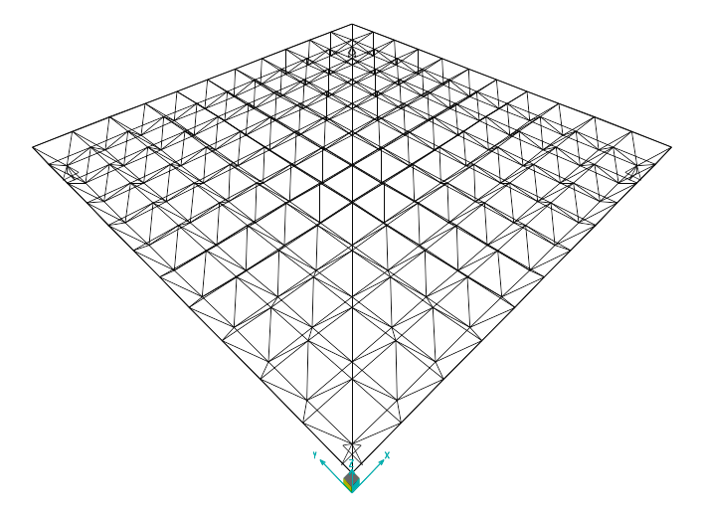
Figure 1. Geometry of the double layer grid

The length of the spans in bottom layer L, is varied between 10 and 50m, and the height H, is varied between 0.035L and 0.095L. The members are divided into seven groups.
The following assumption in seismic analysis and design process are considered:

- The sum of dead and live load of 250 kg/m² is considered.
- Loads are applied to the nodes of the top layer. Four nods located at the corners of top layer and also side nodes are loaded respectively with the one-fourth and one half of the middle nodes corresponding loads.
- One hundred selective different tube sections available in STAHL are used for design.
- Linear static and dynamic analyses are performed.
- Structural design task is carried out according to AISC-ASD [13] code.

The top layer includes two groups shown in Figure 2, the web layer includes 3 groups shown in Figure 3 and the bottom layer includes 2 groups shown in Figure 4.
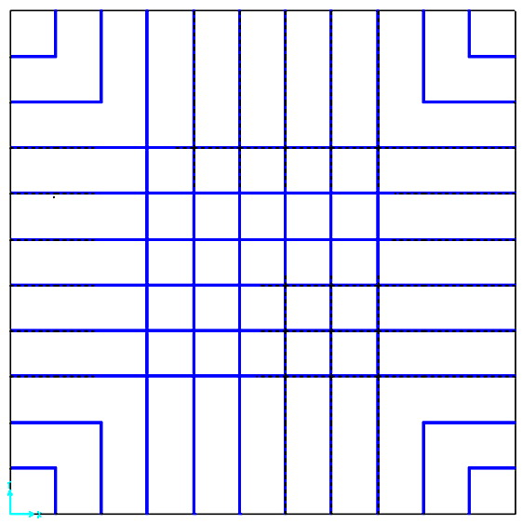 | 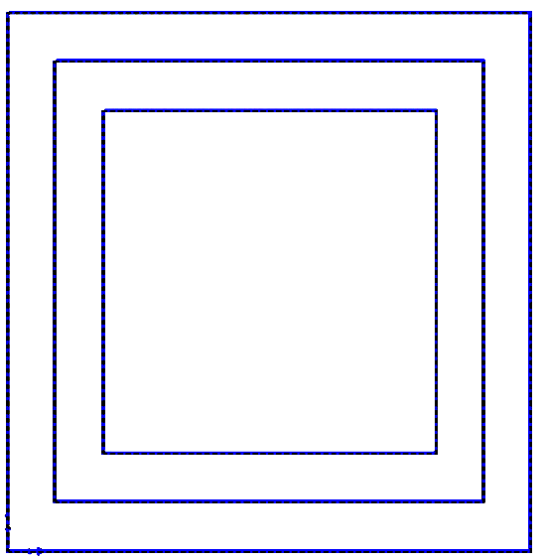
(a) | (b)
Figure 2. Element groups of top layer: (a) group 1 and (b) group 2

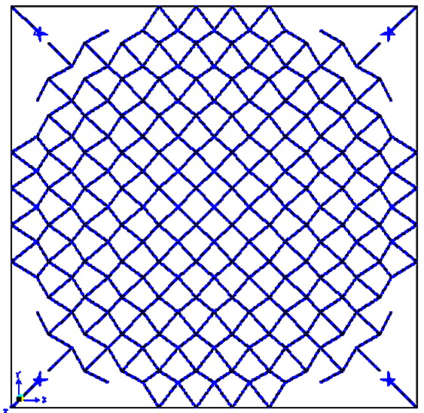 | 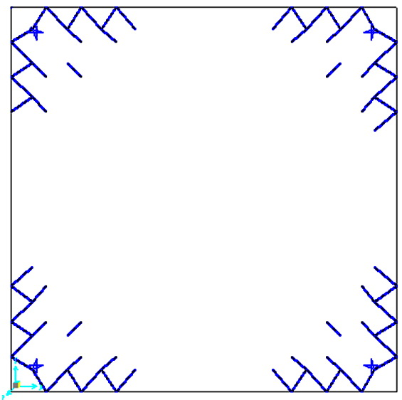 | 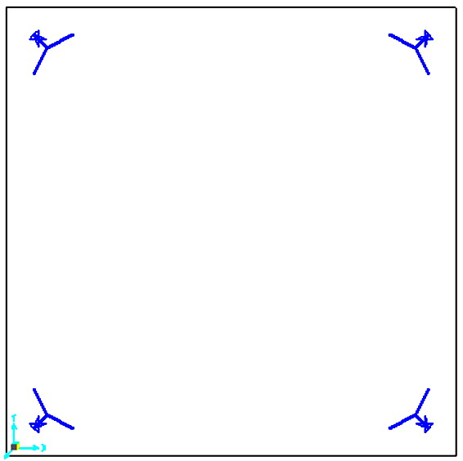
(c) | (d) | (e)
Figure 3. Element groups of web layer: (c) group 3, (d) group 4 and (e) group 5

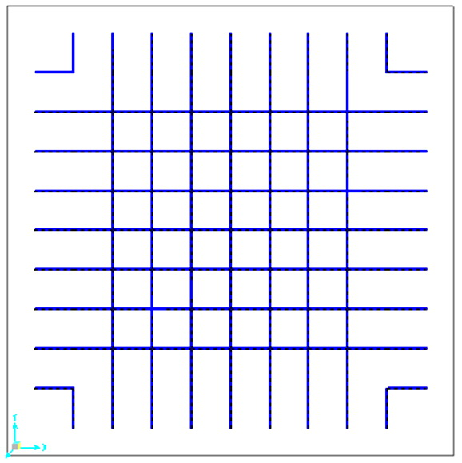 | 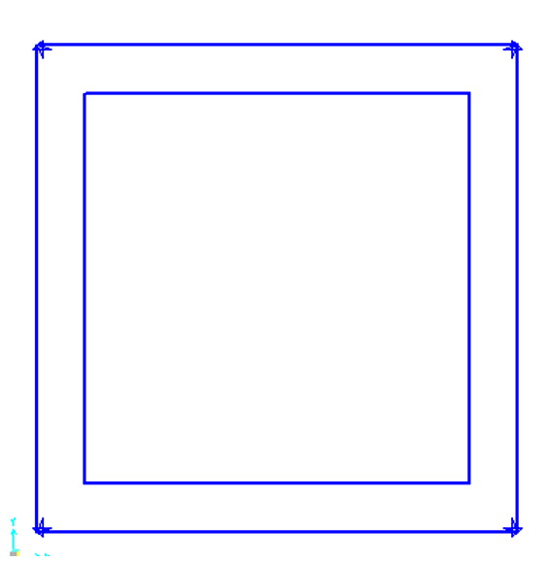
(f) | (g)
Figure 4. Element groups of bottom layer: (f) group 6 and (g) group 7

3. Seismic Analysis and Design

In this study elastic linear time history analysis is involved. Scaling all the involved ground motion records is necessary in order to make all records compatible with the design spectrum of the Iranian Seismic Design Code, Standard 2800 [12]. For double layer grids subject to vertical component of earthquake, time history analysis shall be performed with ground motion time history vertical components that shall be selected and scaled from not less than three recorded events. Here, Bam, Kobe and Loma-Perieta records are considered. According to provisions provided in [12, 15] the selected records are scaled as follows:
- Each record is scaled to its maximum value, so its peak value will be equal to the gravity acceleration, g. The scaled Bam, Kobe and Loma-Perieta records are shown in Figures 5 to 7.
- For each record the 5 percent-damped response spectrum is developed.
- The motions shall be scaled such that the average value of their spectra does not fall below 2/3 times the Standard Design-Spectra for periods of 0.2T sec to 1.5T sec, where T is the fundamental period of vibration.
- The resulting scale factor is applied to the scaled records to be used in dynamic analysis.

Figure 5. Vertical components of the Bam earthquake

Figure 6. Vertical components of the Kobe earthquake
Figure 7. Vertical components of the Loma-Perieta earthquake

The double layer grid is first analyzed for the sum of dead and live load and then time history analyses are performed for the three mentioned scaled records. The internal stress of each structural element is the sum of static stress and the maximum stress among the three dynamic ones. In the seismic design process the cross-sectional area of each element is such determined that the internal computed stress is not greater than its allowable values. The allowable tensile and compressive stresses are used according to the AISC-ASD [13] as follows:

$\begin{aligned}\left\{σ_{\text{ia}}=0\text{.}6F_{y} \text{for tensile stress} | \right.\end{aligned}$ (1)

$F_{\text{cr}}=\begin{aligned}\left\{\left[(1−\frac{λ_{i}^{2}}{2C_{c}^{2}})F_{y}\right]/\left[\frac{5}{3}+\frac{3λ_{i}}{8C_{c}}−\frac{λ_{i}^{3}}{8C_{c}^{3}}\right] λ_{i}<C_{c} | \right.\end{aligned}$ (2)

where E is the modulus of elasticity; F_{y} is the yield stress of steel; C_{c} is the slenderness ratio (λ_{i}) dividing the elastic and inelastic buckling regions (C_{c} =√2π²E/F_{y}); λ_{i} is the slenderness ratio (λ_{i}= kl_{i}/r_{i}); k is the effective length factor; l_{i} is the member length and r_{i} is the radius of gyration.
For seismic design of a double layer grid with a specific L and H three time history analyses should be performed. Our main aim is to determine the seismic design of the double layer grid for any combination of L and H in the ranges of 10 m ≤ L ≤ 50 m and 0.035L ≤ H ≤ 0.095L and this will of course requires tremendous computing time. Due to the tight computing budget it is necessary to somehow achieve this spending low computational cost. In this paper neural network techniques are utilized to fulfill this task.

4. Neural Networks

In this study, the BP, RBF and GR neural networks are employed for predicting the seismic design of double layer grids. A brief description of the theoretical aspects of the above mentioned employed neural networks is given below.

4.1. Back-propagation neural networks
For training of back-propagation (BP) neural networks the gradient descent algorithms are usually employed. Second-order methods, such as Newton’s method, often converge faster than first-order methods, such as conjugate gradient methods. Using the second-order methods the weights are adjusted as follows:

$W_{k+1}=W_{k}−A_{k}^{−1}G_{k}$ (3)

where $W$ is a vector of current weights, $G_{k}$is the current gradient, and $A_{k}^{−1}$is the Hessian matrix of the performance index at the current values of the weights.
Unfortunately, it is complex and expensive to compute the Hessian matrix for feed-forward neural networks. In this study, Levenberg-Marquardt (LM) [16] algorithm is employed to adjust the weights. The LM algorithm was designed to approach second-order training speed without having to compute the Hessian matrix. When the performance function has the form of a sum of squares, then the Hessian matrix can be approximated as:

$H=J^{T}J$ (4)

$G=J^{T}\text{Err}$ (5)

where J is the Jacobian matrix that contains first derivatives of the network errors with respect to the weights, and Err is a vector of network errors.
The LM algorithm uses this approximation to the Hessian matrix in the following Newton-like update equation:

$W_{k+1}=W_{k}−[J^{T}J+μI]^{−1}J^{T}\text{Err}$ (6)

where μ is a correction factor. The value of μ is decreased after each successful step and is increased only when a tentative step would increase the performance function. In this way, the performance function is always reduced at each iteration of the algorithm [17].
In this paper to prevent from over-fitting the performance function of the network is modified by adding a term that consists of the mean of the sum of squares of the network weights as follows:
${\text{Err}}_{\text{reg}}=\frac{γ}{m}\sum_{i=1}^{m}{({\text{Err}}_{i})^{2}}+\frac{(1−γ)}{n}\sum_{j=1}^{n}{W_{j}^{2}}$ (7)

where $γ$, m and n are the performance ratio, the size of Err_{i} and the number of network weights, respectively.
Using this performance function causes the network to have smaller weights, and it forces the network response to be smoother and less likely to overfit [14].

4.2. Radial basis function neural networks
Radial basis function (RBF) neural networks due to their fast training, generality and simplicity are popular. They are two layers feed-forward networks. The hidden layer consists of RBF neurons with Gaussian activation functions. The outputs of RBF neurons have significant responses to the inputs only over a range of values called the receptive field. The radius of the receptive field allows the sensitivity of the RBF neurons to be adjusted. During the training, the receptive field radius of RBF neurons is such determined as the neurons could cover the input space properly. The output layer neurons produce the linear weighted summation of hidden layer neurons responses.
To train the hidden layer of RBF networks no training is accomplished and the transpose of training input matrix is taken as the layer weight matrix [18].

$W_{1}=Λ^{T}$ (8)

where, $W_{1}$and $Λ^{T}$are input layer weight and training input matrices, respectively.
In order to adjust output layer weights, a supervised training algorithm is employed. The output layer weight matrix is calculated from the following equation:

$W_{2}=Δ^{−1}T$ (9)

in which $T$is the target matrix, $Δ$is the outputs of the hidden layer and $W_{2}$ is the output layer weight matrix.

4.3. Generalized regression neural networks
Generalized regression (GR) neural network is a variant of the RBF neural network. It approximates any arbitrary function between input and output vectors, drawing the function estimate directly from the training data. Furthermore, it is consistent; that is, as the training set size becomes large, the estimation error approaches to zero, with only mild restrictions on the function [19-20]. This network does not require iterative training procedure as in the BP network. Its first layer weight matrix is simply the transpose of input matrix. The second layer weight matrix is set to the desired output (target).

$W_{2}=T$ (10)

GR algorithm is based on nonlinear regression theory, a well established statistical technique for function estimation. Except the approach of adjusting of second layer weights, the other aspects of GR are identical to RBF neural networks. Simple structure of the GR enables learning in stages, gives a reduction in the training time, and this has lead to the application of such networks to many practical problems.
By employing these computational tools, lengthy seismic analysis and design process is replaced by efficient and fast trained neural networks which enable users to determine the seismic design of arbitrary numbers of the double layer grids with any combination of L and H at once.

5. Methodology

In this paper, BP, RBF and GR neural networks are trained to predict the seismic design of the double layer grids. In this case, the input and output vectors of the neural networks are as follows:
$I_{\text{NN}}=\left\{\begin{matrix}L \\ H\end{matrix}\right\}$ (11)

$O_{\text{NN}}=\left\{\begin{matrix}A_{G1} \\ A_{G2} \\ ⋮ \\ A_{G7}\end{matrix}\right\}$ (12)

where I_{NN} and O_{NN} are the input and output vectors of the neural networks, respectively; A_{G1} to A_{G7} are the designed cross-sectional areas of the element groups 1 to 7.
In order to train and test the neural networks, 185 double layer grids with different L and H are randomly selected and are designed to resist the seismic loading. During the design process the cross-sectional areas of the element groups 1 to 7 are selected from one hundred different tube sections of STAHL listed in Table 1. In this table d, t and A are the diameter, thickness and cross-sectional area of the tube sections, respectively. In this case 185 training pairs (I_{NN}, O_{NN}) are provided. From which 160 and 25 ones are chosen to achieve train and test purposes, respectively. The error between exact and approximate cross-sectional areas is computed as follows:
$e_{i}=\frac{\left|A_{\text{Gi}}^{\text{FEM}}−A_{\text{Gi}}^{\text{NN}}\right|}{A_{\text{Gi}}^{\text{FEM}}}×\text{100}\text{ , }i=\text{1,2,}\text{.}\text{.}\text{.}\text{,7}$ (13)

where $A_{\text{Gi}}^{\text{FEM}}$ and $A_{\text{Gi}}^{\text{NN}}$are the exact and approximate cross-sectional area of the ith group, respectively; e_{i} is the error percentage between two mentioned parameters.

The fundamental steps of the methodology employed in this study are as follows:

Data Generation Phase
Selecting of 185 double layer grids based on L, H.
- Grouping of structural elements according to patterns of Figures 2 to 4.
- Selecting one of the structures and saving the vector of L and H as the I_{NN}.
- Scaling of records according to the provisions provided in [12,15].
- Performing static analysis for gravity loads and time history analysis for seismic loads.
- Achieving seismic design of the structure.
- Saving the vector of designed cross-sectional area as O_{NN}.
Table 1. The selective 100 tube sections from STAHL
NO. | d (cm) | t (cm) | A (cm²) | NO. | d (cm) | t (cm) | A (cm²)
1 | 2.69 | 0.26 | 1.96 | 51 | 21.91 | 1.60 | 102.0
2 | 2.69 | 0.32 | 2.38 | 52 | 21.91 | 2.00 | 127.0
3 | 3.37 | 0.26 | 2.54 | 53 | 24.45 | 0.63 | 47.1
4 | 3.37 | 0.32 | 3.07 | 54 | 24.45 | 0.80 | 59.4
5 | 3.37 | 0.40 | 3.73 | 55 | 24.45 | 1.00 | 73.7
6 | 4.24 | 0.26 | 3.25 | 56 | 24.45 | 1.25 | 91.1
7 | 4.24 | 0.32 | 3.94 | 57 | 24.45 | 1.60 | 115.0
8 | 4.24 | 0.40 | 4.83 | 58 | 24.45 | 2.00 | 141.0
9 | 4.83 | 0.26 | 3.73 | 59 | 24.45 | 2.50 | 172.0
10 | 4.83 | 0.32 | 4.53 | 60 | 27.30 | 0.63 | 52.8
11 | 4.83 | 0.40 | 5.57 | 61 | 27.30 | 0.80 | 66.6
12 | 6.03 | 0.32 | 5.74 | 62 | 27.30 | 1.00 | 82.6
13 | 6.03 | 0.40 | 7.07 | 63 | 27.30 | 1.25 | 102.0
14 | 6.03 | 0.50 | 8.69 | 64 | 27.30 | 1.60 | 129.0
15 | 7.61 | 0.32 | 7.33 | 65 | 27.30 | 2.00 | 159.0
16 | 7.61 | 0.40 | 9.06 | 66 | 27.30 | 2.50 | 195.0
17 | 7.61 | 0.50 | 11.20 | 67 | 32.39 | 0.80 | 79.4
18 | 8.89 | 0.32 | 8.62 | 68 | 32.39 | 1.00 | 98.6
19 | 8.89 | 0.40 | 10.70 | 69 | 32.39 | 1.25 | 122.0
20 | 8.89 | 0.50 | 13.20 | 70 | 32.39 | 1.60 | 155.0
21 | 8.89 | 0.60 | 15.60 | 71 | 32.39 | 2.00 | 191.0
22 | 8.89 | 0.63 | 16.30 | 72 | 32.39 | 2.50 | 235.0
23 | 10.16 | 0.40 | 12.30 | 73 | 35.56 | 0.80 | 87.4
24 | 10.16 | 0.50 | 15.20 | 74 | 35.56 | 1.00 | 109.0
25 | 10.16 | 0.63 | 18.90 | 75 | 35.56 | 1.25 | 135.0
26 | 11.43 | 0.40 | 13.90 | 76 | 35.56 | 1.60 | 171.0
27 | 11.43 | 0.50 | 17.20 | 77 | 35.56 | 2.00 | 211.0
28 | 11.43 | 0.63 | 21.40 | 78 | 35.56 | 2.50 | 260.0
29 | 11.43 | 0.80 | 26.70 | 79 | 40.64 | 1.00 | 125.0
30 | 13.97 | 0.40 | 17.10 | 80 | 40.64 | 1.25 | 155.0
31 | 13.97 | 0.50 | 21.20 | 81 | 40.64 | 1.60 | 196.0
32 | 13.97 | 0.63 | 26.40 | 82 | 40.64 | 2.00 | 243.0
33 | 13.97 | 0.80 | 33.10 | 83 | 40.64 | 3.00 | 355.0
34 | 13.97 | 1.25 | 50.00 | 84 | 45.70 | 1.00 | 140.0
35 | 16.83 | 0.50 | 25.70 | 85 | 45.70 | 1.60 | 222.0
36 | 16.83 | 0.63 | 32.10 | 86 | 45.70 | 1.25 | 175.0
37 | 16.83 | 0.80 | 40.30 | 87 | 45.70 | 2.00 | 275.0
38 | 16.83 | 1.00 | 49.70 | 88 | 45.70 | 3.00 | 402.0
39 | 16.83 | 1.25 | 25.70 | 89 | 50.80 | 1.25 | 195.0
40 | 17.78 | 0.63 | 33.90 | 90 | 50.80 | 1.60 | 247.0
41 | 17.78 | 0.80 | 42.70 | 91 | 50.80 | 2.00 | 307.0
42 | 17.78 | 1.00 | 52.70 | 92 | 61.00 | 1.00 | 188.0
43 | 17.78 | 1.25 | 64.90 | 93 | 61.00 | 1.25 | 235.0
44 | 19.37 | 0.63 | 37.10 | 94 | 61.00 | 1.60 | 299.0
45 | 19.37 | 0.80 | 46.70 | 95 | 71.10 | 2.00 | 434.0
46 | 19.37 | 1.00 | 57.70 | 96 | 76.20 | 2.00 | 466.0
47 | 19.37 | 1.60 | 89.00 | 97 | 81.30 | 2.50 | 619.0
48 | 21.91 | 0.63 | 42.10 | 98 | 91.40 | 2.50 | 698.0
49 | 21.91 | 0.80 | 53.10 | 99 | 101.60 | 2.50 | 778.0
50 | 21.91 | 1.00 | 65.70 | 100 | 106.70 | 2.50 | 818.0
Neural Networks Training Phase: When all structures are designed
- Separating the 185 produced (I_{NN}, O_{NN}) pairs to 160 and 25 training and testing sets.
- Selecting a neural network model (BP; RBF; GR).
- Assigning random values for the adjustable parameters of the network (initialization).
- Training the neural network using training set and checking the errors using testing.
- If the generalization ability of the neural network is appropriate the training process is terminated; else the process is repeated from step 3.

It is important to note that the seismic design process of each structure includes: configuration processing, static design, records scaling and seismic design which a total time about 30 min should be spent to achieve this.

6. Numerical Results

All of the employed neural network models possess 2 inputs and 7 outputs. In training phase of the BP neural network 5, 10, 15, 20 and 25 neurons are set to hidden layer and the best results are obtained with 20 neurons. The RBF and GR networks have 160 neurons in their hidden layers. The exact cross-sectional area of element groups1 to 7 (FEM) are compared with their corresponding predicted ones by BP, RBF, and GR neural networks in Figures 8 to 14, respectively.

Figure 8. Comparison of exact A_{G1} with its corresponding predicted ones for 25 training samples

Figure 9. Comparison of exact A_{G2} with its corresponding predicted ones for 25 training samples
Figure 10. Comparison of exact A_{G3} with its corresponding predicted ones for 25 training samples
Figure 11. Comparison of exact A_{G4} with its corresponding predicted ones for 25 training samples
Figure 12. Comparison of exact A_{G5} with its corresponding predicted ones for 25 training samples
Figure 13. Comparison of exact A_{G6} with its corresponding predicted ones for 25 training samples
Figure 14. Comparison of exact A_{G7} with its corresponding predicted ones for 25 training samples

Also the error percentage of the BP, RBF, and GR neural networks in approximation of A_{G1} to A_{G7} are compared in Figures 15 to 21 for all of the 25 training samples.

Figure 15. Error percentage of BP, RBF and GR in prediction of A_{G1} for 25 training samples

Figure 16. Error percentage of BP, RBF and GR in prediction of A_{G2} for 25 training samples

Figure 17. Error percentage of BP, RBF and GR in prediction of A_{G3} for 25 training samples
Figure 18. Error percentage of BP, RBF and GR in prediction of A_{G4} for 25 training samples

Figure 19. Error percentage of BP, RBF and GR in prediction of A_{G5} for 25 training samples

Figure 20. Error percentage of BP, RBF and GR in prediction of A_{G6} for 25 training samples

Figure 21. Error percentage of BP, RBF and GR in prediction of A_{G7} for 25 training samples

A summary of approximation error percentage of the BP, RBF, and GR neural networks in approximation of A_{G1} to A_{G7} is given in Table 2.

Table 2. A summary of error percentage of the BP, RBF, and GR neural networks
error (%) | BP |  | RBF |  | GR
error (%) | mean | max | mean | max | mean | max
e₁ | 13.6417 | 33.5873 | 11.3041 | 32.9080 | 5.1259 | 10.7310
e₂ | 7.9655 | 36.8442 | 6.9785 | 21.1166 | 4.2739 | 9.4255
e₃ | 8.7347 | 49.0345 | 11.9289 | 35.4219 | 3.7860 | 9.9548
e₄ | 11.5429 | 49.9817 | 7.8674 | 23.9309 | 4.9883 | 10.0532
e₅ | 8.0966 | 21.6245 | 6.8295 | 19.7449 | 3.5148 | 8.6369
e₆ | 16.5698 | 48.9247 | 14.4143 | 43.4372 | 6.3016 | 10.7089
e₇ | 6.4298 | 36.9137 | 6.7563 | 26.4488 | 3.9808 | 9.3405
Average | 10.4258 | 39.5586 | 9.4398 | 29.0012 | 4.5673 | 9.8358

The numerical results given in Figures 8 to 21 and Table 2, demonstrate that among BP, RBF and GR neural network models, the generalization ability of RBF is slightly better than that of the BP while the accuracy of the GR is considerably better compared with two other neural network models. It is clear that GR can be effectively employed to predict the seismic design of double layer grids with good accuracy.

7. Conclusions

The computational burden of seismic analysis and design of double layer structures is usually high and one of the best candidates to mitigate this computational rigor is neural network technique. The present paper deals with neural network training to efficiently predict the seismic design of double layer grids subject to multiple-earthquake loading. Square-on-square double layer grids are considered and besides the cross-sectional areas of the element groups, the length of span (L) and the layer thickness (H) of the structure are taken as the design variables while the topology of structure is fixed. A number of 185 double layer grids with various L and H (10 m ≤ L ≤ 50 m and 0.035L ≤ H ≤ 0.095L) are generated and seismically designed. As the required time for designing of each structure is 30 min the main aim is to predict the seismic design while L and H are treated as the inputs. Therefore it can be easily concluded that using neural network to predict the seismic design of various structures in a part of second is very promising for substantially reducing the computational effort. Back-propagation (BP), Radial basis function (RBF) and generalized regression (GR) neural networks are trained to efficiently predict the seismic design of the grids. The numerical results indicate that however the generalization ability of RBF is slightly better than that of the BP, the accuracy of the GR is considerably better compared with two other neural network models. Thus it can be concluded that GR is a powerful computational tool for effectively predicting the seismic design of the square-on-square double layer grids in the span and height range of 10 m ≤ L ≤ 50 m and 0.035L ≤ H ≤ 0.095L with high accuracy at low computational cost.

References

- Kaveh A, Servati S. Design of double layer grids using backpropagation neural networks, Comput Struct, 2001; 79: 1561–8.
- Gholizadeh S, Pirmoz A, Attarnejad R. Assessment of load carrying capacity of castellated steel beams by neural networks, J Constr Steel Res, 2011; 67: 770–9.
- Kaveh A, Laknejadi K, Alinejad B. Performance-based multi-objective optimization of large steel structures, Acta Mech, 2012; 223: 355–69.
- Rofooei FR, Kaveh A, Farahani FM. Estimating the vulnerability of the concrete moment resisting frame structures using artificial neural networks, Int J Optim Civil Eng, 2011; 3: 433-48.
- Kaveh A, Gholipour Y, Rahami H. Optimal design of transmission towers using genetic algorithm and neural networks, Int J Space Struct, 2008; 23: 1-19.
- Gholizadeh S, Seyedpoor S.M. Optimum design of arch dams for frequency limitations, Int J Optim Civil Eng, 2011; 1, 1–14.
- Gholizadeh S, Samavati OA. Structural optimization by wavelet transforms and neural networks, Appl Math Model, 2011; 35: 915−29.
- Gholizadeh S, Salajegheh E. Optimal seismic design of steel structures by an efficient soft computing based algorithm, J Constr Steel Res, 2010; 66: 85–95.
- Gholizadeh S, Salajegheh E. Optimal design of structures for time history loading by Swarm intelligence and an advanced metamodel, Compu Meth Appl Mech Eng, 2009; 198: 2936–49.
- Gholizadeh S, Salajegheh J, Salajegheh E. An intelligent neural system for predicting structural response subject to earthquakes, Adv Eng Softw, 2009; 40: 630–9.
- Gholizadeh S, Salajegheh E, Torkzadeh P. Structural optimization with frequency constraints by genetic algorithm using wavelet radial basis function neural networks. J Sound Vib, 2008; 312: 316–31.
- Iranian Code of Practice for Seismic Resistant Design of Buildings, Building and Housing Research Center, Standard No. 2800, 3rd Edition, 2007.
- Manual of Steel Construction, Allowable Stress Design, ninth ed., AISC, American Institutes of Steel Construction, Inc., Chicago, Illinois, USA, 1989.
- The Language of Technical Computing. MATLAB. Math Works Inc, 2009.
- Iranian Code of Practice for Skeletal Steel Space Structures, No.400, Office of Deputy for Strategic Supervision Bureau of Technical Execution System, 2010.
- Hagan MT, Menhaj M. Training feed-forward networks with the Marquardt algorithm, IEEE Transaction on Neural Networks, 1999; 5: 989−93.
- Hagan MT, Demuth HB, Beal MH. Neural Network Design. PWS Publishing Company, Boston, 1996.
- Wasserman PD, Advanced Methods in Neural Computing, Prentice Hall Company, Van Nostrand Reinhold, New York, 1993.
- Celikoglu HB, Cigizoglu HK. Public transportation trip flow modeling with generalized regression neural networks, Adv Eng Softw, 2007; 38: 71–79.
- Firat M, Gungor M. Generalized Regression Neural Networks and Feed Forward Neural Networks for prediction of scour depth around bridge piers, Adv Eng Softw, 2009; 40: 731–7.

*Corresponding author: S. Gholizadeh, Department of Civil Engineering, Urmia University, Urmia, Iran
†E-mail address: s.gholizadeh@urmia.ac.ir

